Project Report
On
AgriFlux - Smart Agriculture Platform with AI Assistant


Submitted
In partial fulfilment
For the award of the Degree of

PGCP- Advanced Computing (PGCP-AC)

C-DAC, ACTS (Pune)

Guided By: Submitted By:
Ms. Shweta Singh Gaurav Mahadik 260240120061
Harsh Jain 260240120070
Shrutik Choudhary 260240120179
Krushnal Mahajan 260240120092
Vivek Bhogade 260240120043

Centre for Development of Advanced Computing (C-DAC), ACTS
(Pune- 411008)

ABSTRACT

Agriculture is one of the most important sectors in India, but many farmers still face challenges in purchasing quality agricultural products, accessing reliable farming information, and adopting modern digital technologies. AgriFlux is a full-stack agriculture e-commerce platform designed to address these challenges by providing a single platform where farmers can purchase seeds, fertilizers, farming tools, and other agricultural products while receiving intelligent farming assistance.
The system is developed using React and Vite for the frontend, Spring Boot for the backend, and MySQL as the database. It follows a three-tier architecture to ensure scalability, maintainability, and efficient performance. Secure user authentication is implemented using JSON Web Token (JWT), and online payments are integrated through the Razorpay payment gateway.
AgriFlux also provides advanced features such as real-time weather forecasting using the OpenWeatherMap API and an AI-powered chatbot that assists farmers by answering agriculture-related questions in both English and Hindi. A bilingual user interface enables users to switch between English and Hindi instantly, making the platform more accessible to a wider audience.
The platform supports multiple user roles, including farmers and administrators. Farmers can browse products, manage shopping carts, place orders, make secure payments, and view their order history, while administrators can efficiently manage products, categories, inventory, and customer orders.
Overall, AgriFlux demonstrates how modern web technologies, artificial intelligence, cloud-based APIs, and secure payment systems can be integrated into a single platform to simplify agricultural commerce and provide digital support to farmers. The project aims to promote digital transformation in agriculture by improving accessibility, convenience, and decision-making for the farming community.
.
Table of Contents

S. No | Title | Page No.
 | Front Page Acknowledgement Abstract  Table of Contents | I II III  IV
1  1.1  1.2 | Introduction  Introduction  Objective and Specifications | 01-02  01  02
2 | Literature Review | 03-04
3 | Methodology/ Techniques | 05-10
3.1 | Approach and Methodology/ Techniques | 05
3.2 | Dataset | 07
3.3 | Flowchart | 08
4 | Implementation | 9-10
4.1 | Implementation | 9
5 | Results | 11-14
5.1 | Results | 11
6 | Conclusion | 15
6.1 | Conclusion | 15
7 | References | 16
7.1 | References | 16

Chapter 1
Introduction

Detection of text regions either from handwritten or printed document images containing various non-textual information is a difficult task, and it can be more challenging to locate the position of the text regions when we deal with a doctor’s prescriptio
1.1 Introduction
Agriculture is one of the most important sectors of the Indian economy and provides employment to a large population. However, many farmers still face challenges in purchasing quality agricultural products and accessing timely farming information. Traditional methods are often time-consuming and lack modern digital support.
AgriFlux is a full-stack agriculture e-commerce platform developed to simplify the purchase of seeds, fertilizers, pesticides, farming tools, and other agricultural products through a secure online platform. The system also provides real-time weather updates, an AI-powered chatbot for farming assistance, secure JWT-based authentication, Razorpay payment integration, and a bilingual interface supporting both English and Hindi.
The application is built using React for the frontend, Spring Boot for the backend, and MySQL as the database, following a three-tier architecture. It supports two types of users: farmers and administrators. Farmers can browse products, manage carts, place orders, and view order history, while administrators can manage products, categories, inventory, and customer orders.
The main objective of AgriFlux is to promote digital agriculture by providing farmers with a reliable, secure, and user-friendly platform that combines e-commerce with intelligent farming support, making agricultural services more accessible and efficient.

1.2 Objective
The objectives of the project work are as -
- To develop a user-friendly agriculture e-commerce platform for purchasing seeds, fertilizers, farming tools, and other agricultural products.
- To provide secure user authentication and authorization using JSON Web Token (JWT).
- To integrate real-time weather forecasting to help farmers make informed farming decisions.
- To implement an AI-powered chatbot that provides instant answers to agriculture-related queries in English and Hindi.
- To integrate a secure online payment system using the Razorpay payment gateway.
- To provide a bilingual user interface for improved accessibility and ease of use.
- To develop an efficient admin panel for managing products, categories, inventory, and customer orders.

Chapter 2
LITERATURE REVIEW
Ramesh Kumar et al. [1] In this research paper, the authors proposed an agriculture e-commerce platform that enables farmers to purchase seeds, fertilizers, and farming equipment online. The study concluded that digital marketplaces reduce dependency on intermediaries, improve product accessibility, and provide transparent pricing, helping farmers make better purchasing decisions.

Patel et al. [2] This research paper presented a smart farming system integrated with real-time weather forecasting. The proposed system uses weather data to provide recommendations for irrigation, crop planning, and harvesting. Experimental results showed that timely weather information helps farmers reduce crop losses and improve agricultural productivity.

Sharma et al. [3] In this research work, the authors developed an AI-powered chatbot for agriculture that provides instant answers to farming-related queries. The chatbot assists users with crop selection, fertilizer recommendations, pest control, and farming practices. The study demonstrated that AI-based assistance improves access to agricultural knowledge and reduces dependency on experts.

Gupta et al. [4] This paper proposed a secure e-commerce system using JSON Web Token (JWT) authentication. The system ensures secure user login, role-based authorization, and protected API communication. The proposed authentication mechanism enhances data security and protects users from unauthorized access.

Verma et al. [5] In this research paper, the authors integrated an online payment gateway into an e-commerce application to enable secure digital transactions. The study highlighted that online payment systems improve transaction efficiency, reduce cash dependency, and provide a convenient shopping experience for users.

Singh et al. [6] This research focused on multilingual web applications designed to improve accessibility for users from different linguistic backgrounds. The proposed bilingual interface allowed users to switch between languages seamlessly, resulting in improved usability and a better user experience, especially for rural communities.

Chapter 3
Methodology and Techniques

3.1 Methodology:
The development of AgriFlux follows a systematic software development methodology to ensure a secure, scalable, and user-friendly agriculture e-commerce platform. The project is implemented using a three-tier architecture consisting of the presentation layer, business logic layer, and database layer.

1. Requirement Analysis:
The project requirements were gathered by studying the challenges faced by farmers in purchasing agricultural products and accessing farming information. Functional and non-functional requirements were identified before the development process

2.System design:
The overall architecture, database schema, REST APIs, and user interface were designed. Separate modules were created for authentication, product management, cart, orders, payments, weather, AI chatbot, and admin operations.

3. Frontend Development:
The user interface was developed using React and Vite. Responsive pages were created for product browsing, shopping cart, checkout, weather information, and user account management. Redux Toolkit was used for state management.

4. Backend Development:
The backend was developed using Spring Boot. REST APIs were implemented to handle user authentication, product management, order processing, payment integration, weather services, and chatbot communication. JWT was used to provide secure authentication and authorization

.
5. Database Management:
MySQL was used to store user information, products, categories, carts, orders, addresses, and payment details. Spring Data JPA was used for efficient database operation

6. Third-Party API Integration:
The application integrates the OpenWeatherMap API to provide real-time weather forecasts, the Groq API for the AI-powered chatbot, and the Razorpay Payment Gateway for secure online transactions.

7. Testing and validation:
The application was tested to verify the functionality of each module, including user authentication, product management, shopping cart, payment processing, weather services, and AI chatbot. Testing ensured that the system performs efficiently, securely, and reliably under different user scenarios.

3.2 Dataset
AgriFlux uses a MySQL relational database to store and manage application data. The database contains information required for the smooth operation of the platform, including user details, product information, categories, shopping carts, orders, addresses, and payment records.
Product information such as product name, description, category, price, stock quantity, and image is maintained by the administrator through the admin dashboard. User-related data, including registration details, order history, and delivery addresses, is securely stored in the database.
The application also retrieves real-time weather information from the OpenWeatherMap API based on the city entered by the user. Additionally, the AI-powered chatbot generates responses dynamically using an external AI service instead of relying on a locally stored dataset.
Therefore, the system uses a combination of structured database records and real-time API responses to provide accurate and up-to-date information to users.

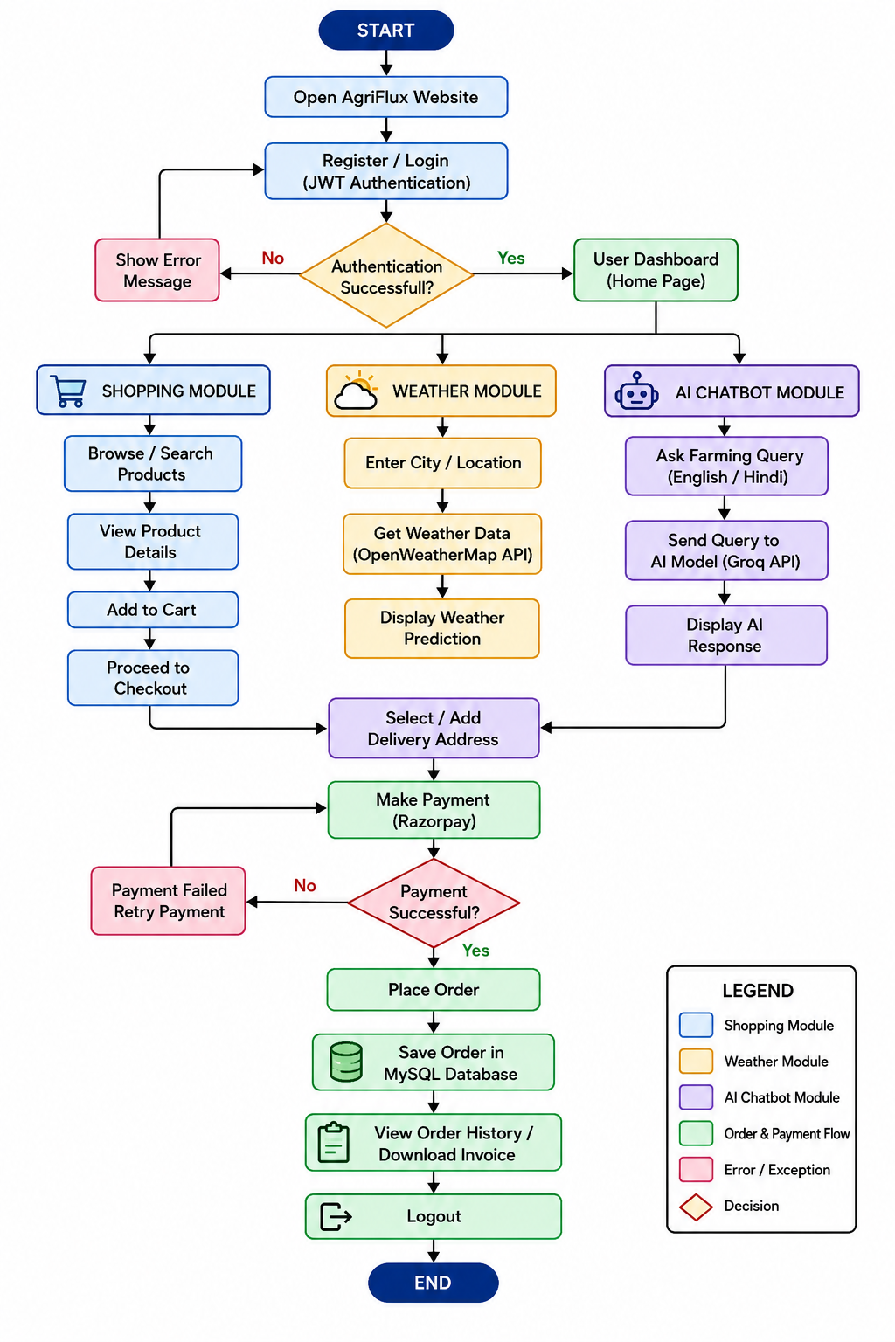
3.1.3 Flowchart

Chapter 4
Implementation

4.1 Implementation
The AgriFlux system is implemented using a full-stack web development approach with React, Spring Boot, and MySQL. The frontend provides a responsive and user-friendly interface, while the backend manages business logic, authentication, database operations, and communication with external APIs.
The implementation is divided into the following modules:

1. User Authentication Module
The authentication module allows users to register and log in securely. User credentials are encrypted, and JSON Web Token (JWT) is used to authenticate users and protect REST APIs. Role-based access control ensures that only authorized users can access specific features.

2. Product Management Module
This module enables administrators to add, update, delete, and manage agricultural products and categories. Users can browse products, search by keyword, filter by category, and view detailed product information.

3. Shopping Cart and Order Module
Users can add products to their shopping cart, modify product quantities, remove items, and proceed to checkout. After confirming the delivery address, an order is created and stored in the MySQL database.

4. Payment Module
The payment module integrates the Razorpay Payment Gateway to support secure online transactions. After successful payment verification, the order status is updated, and the transaction details are stored in the database.

5. Weather Prediction Module
The weather module retrieves real-time weather information using the OpenWeatherMap API. Users can enter a city name to view current weather conditions and forecasts, helping them make better farming decisions.
6. AI Chatbot Module
The AI chatbot provides instant responses to agriculture-related questions in both English and Hindi. It assists farmers by providing information on crop management, fertilizers, pest control, and general farming practices through a simple chat interface.

7. Admin Module
The administrator dashboard provides complete control over the application. Administrators can manage products, categories, inventory, users, and customer orders through a secure interface.

8. Database Implementation
The system uses MySQL to store user accounts, product details, categories, shopping carts, orders, addresses, and payment records. Spring Data JPA is used for efficient database interaction and CRUD operations.
The successful integration of these modules results in a secure, scalable, and user-friendly agriculture e-commerce platform that simplifies online shopping while providing intelligent farming support through weather forecasting and an AI-powered chatbot.

Chapter 5
Results
Login & Sign Up
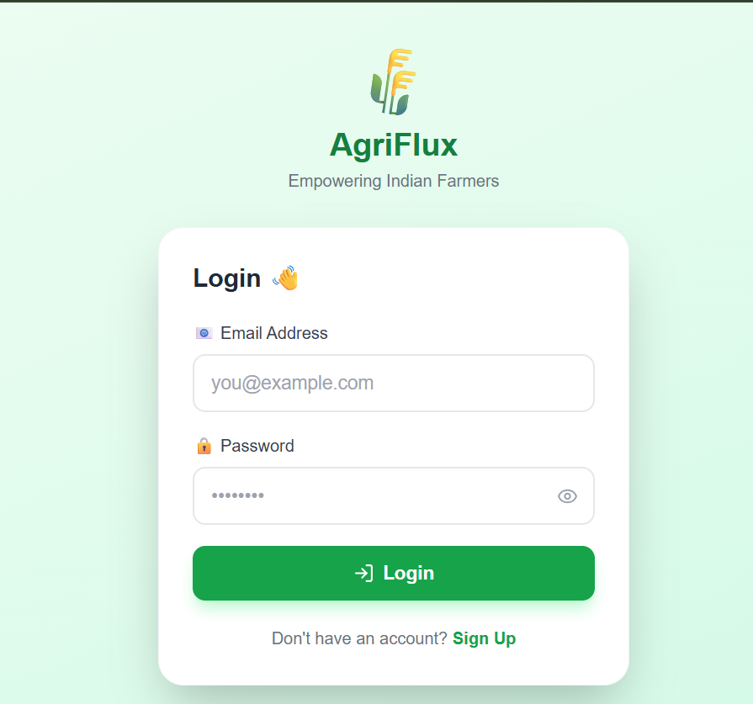

Home Page –
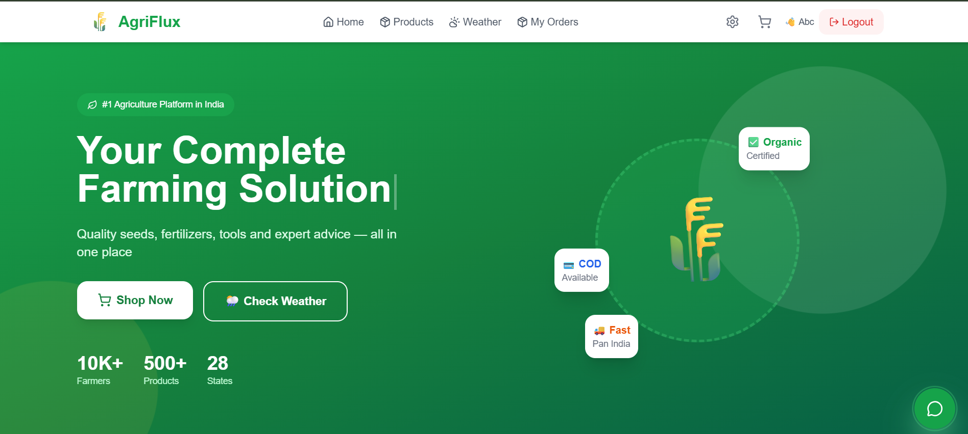

Weather Prediction –

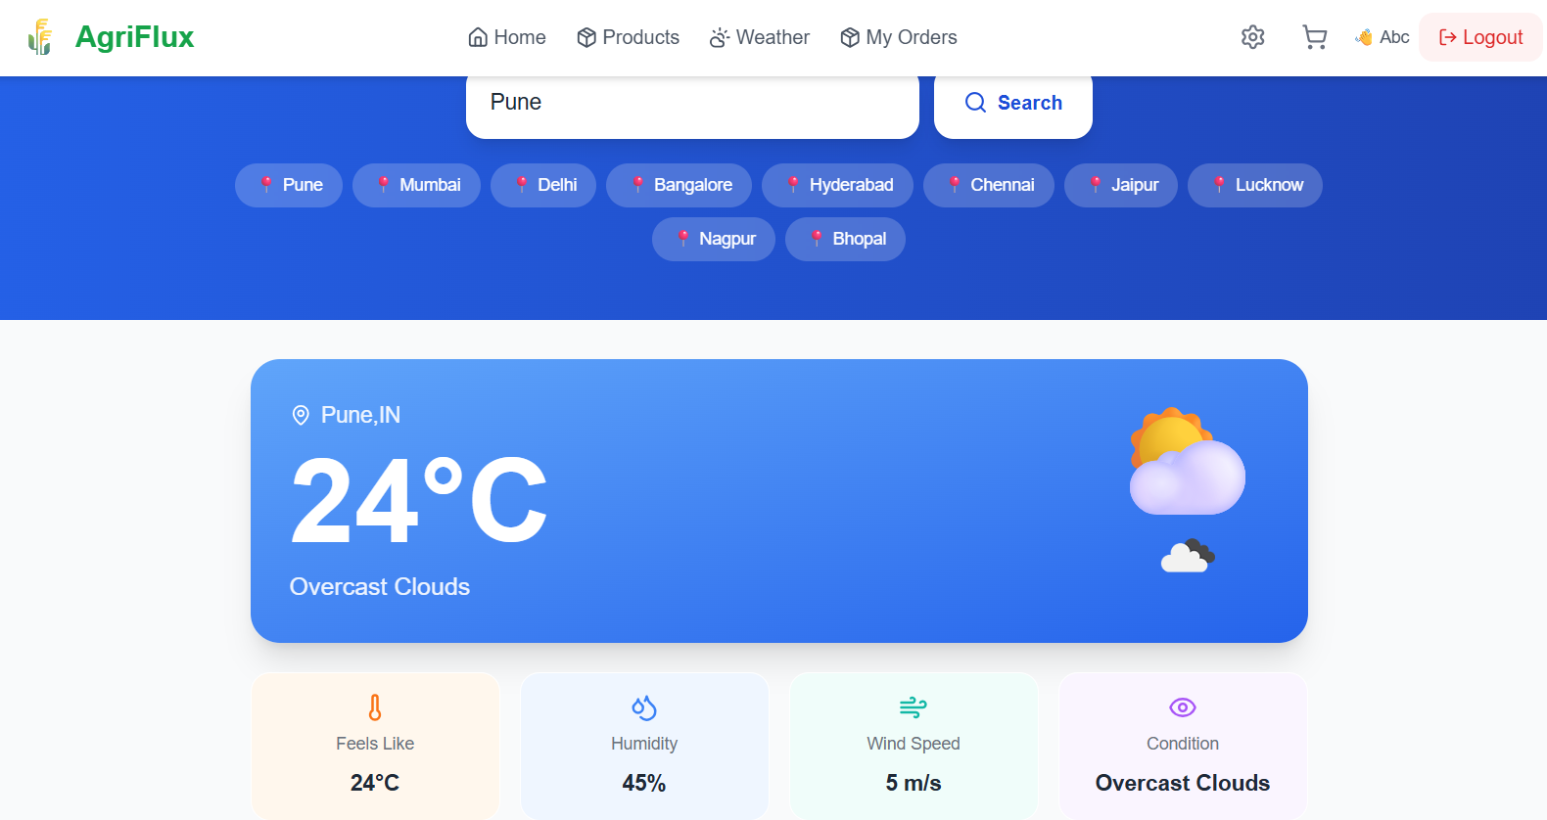

Cart-
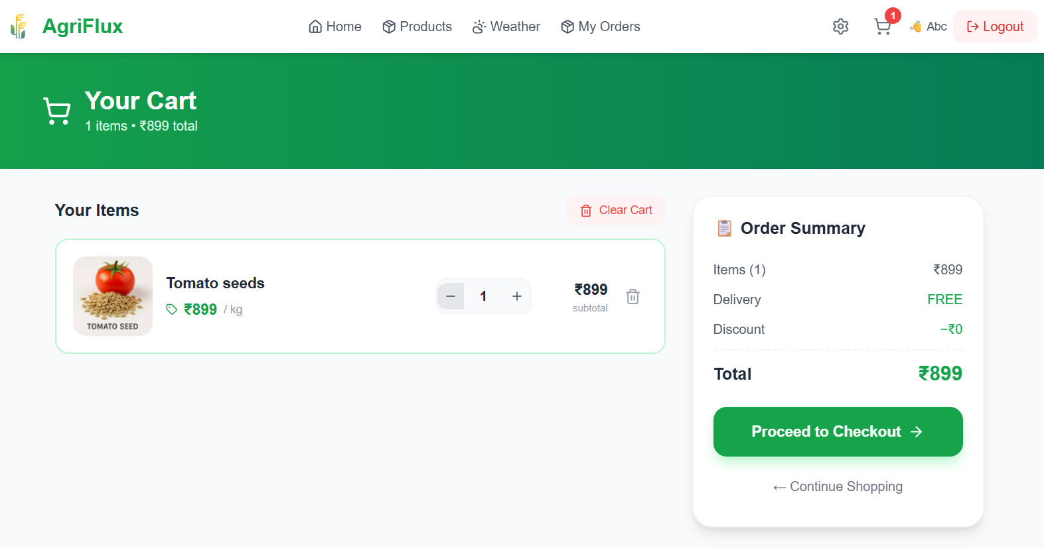
Order Placed-

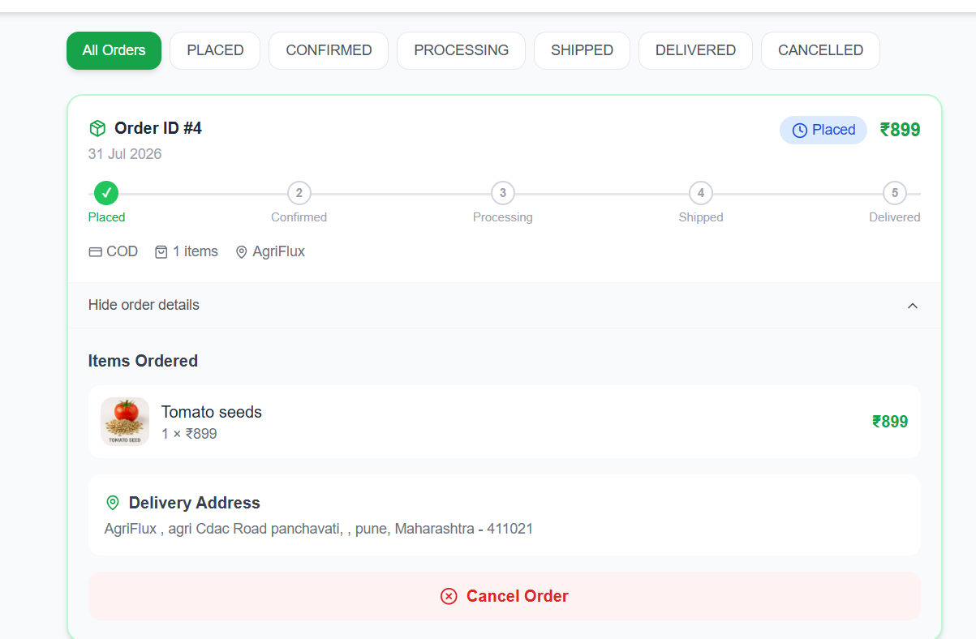

AgriBot-
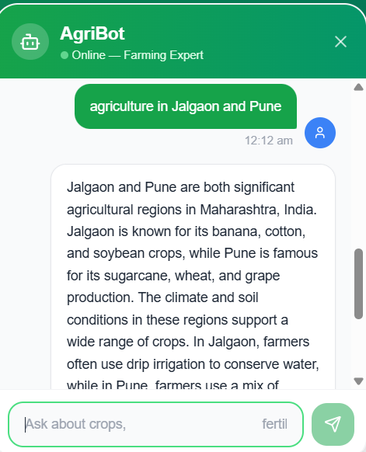
Language Settings-
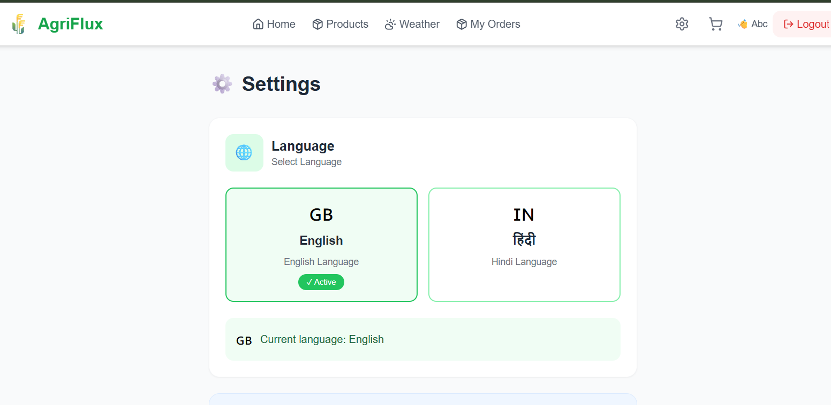

Chapter 6
Conclusion
6.1 Conclusion
AgriFlux is a full-stack agriculture e-commerce platform developed to simplify the purchase of agricultural products while providing intelligent digital support to farmers. The system successfully integrates secure user authentication, product management, shopping cart, online payment, real-time weather prediction, and an AI-powered chatbot into a single web application.
The project is built using React for the frontend, Spring Boot for the backend, and MySQL for database management, following a three-tier architecture. The platform provides a secure, responsive, and user-friendly environment for both farmers and administrators. Farmers can browse products, place orders, make secure online payments, check weather updates, and receive farming guidance through the AI chatbot, while administrators can efficiently manage products, categories, inventory, and customer orders.

6.2 Future Enhancement –
● Develop a mobile application for Android and iOS to provide easier access for farmers.
● Add product reviews and ratings to help users make informed purchasing decisions.
● Integrate email and SMS notifications for order confirmation, payment status, and delivery updates.
● Support additional regional languages to make the platform accessible to farmers across different regions.
● Enhance the AI chatbot with personalized crop recommendations, disease detection, and farming suggestions based on weather conditions.

Chapter 7
References
7. References
[1] React Documentation. "React – The Library for Web and Native User Interfaces." Available: https://react.dev/
[2] Spring Team. "Spring Boot Documentation." Available: https://spring.io/projects/spring-boot
[3] Oracle Corporation. "MySQL 8.0 Reference Manual." Available: https://dev.mysql.com/doc/
[4] Razorpay. "Razorpay API Documentation." Available: https://razorpay.com/docs/
[5] OpenWeather. "OpenWeatherMap API Documentation." Available: https://openweathermap.org/api
[6] Jones, M., Bradley, J., and Sakimura, N. JSON Web Token (JWT). RFC 7519, Internet Engineering Task Force (IETF), May 2015. Available: https://datatracker.ietf.org/doc/html/rfc7519
[7] Tailwind CSS Documentation. Available: https://tailwindcss.com/docs
[8] Redux Toolkit Documentation. Available: https://redux-toolkit.js.org/
[9] Axios Documentation. Available: https://axios-http.com/docs/intro
[10] GitHub Repository – codesplay12. AgriFlux Source Code. Available: https://github.com/codesplay12

