**Assignment-1**

**Name of Student:** Krushnansh Meher

**Batch:** 1  **Branch:** CSE-AIML-SEDA **Roll No:** 09

**Problem Statement**

A VIT Melange committee is conducting auditions to admit interested candidates. You need to implement a Participant class for the dance club based on the class diagram and description given below.

|  |
| --- |
| **C-Participant** |
| * counter: int * registrationId: String * name: String * contactNumber: long * branch: String |
| * **C**Participant(name:String,contactNumber:long,branch:String) * getRegistrationId(): String * getCounter(): int * setCounter(counter:int):void * getName():String * setName(name:String):void * getContactNumber():long * setContactNumber(contactNumber:long):void * getBranch():String * setBranch(branch:String):void |

**Method Description**

**Partcipant(String name, long contactNumber, String branch)**

* Initialize the name, contactNumber and branch instance variables appropriately with the values passed to the constructor.
* Generate the registrationId using the static variable counter.
* The value of registrationId should start from 'D1001' and the numerical part should be incremented by 1 for the subsequent values.
* Initialize the counter in static block.

Implement the appropriate getter and setter methods.

Test the functionalities using the provided Tester class. Create two or more Participant objects and validate that the values of the member variables are proper.

**Sample Input and Output**

**For constructor**

**Input**

For first Participant object

|  |  |
| --- | --- |
| **Parameters** | **Values** |
| Name | Rohit |
| contactNumber | 1234567889 |
| Branch | Computer |

For second Participant object

|  |  |
| --- | --- |
| **Parameters** | **Values** |
| Name | Sayli |
| contactNumber | 1988612300 |
| Branch | Mechanical |

**Expected Output**

|  |
| --- |
| Hi Rohit! Your registration id is D1001  Hi Sayli! Your registration id is D1002 |

**Program:**

|  |
| --- |
| //Participant class class Participant{  //class variables   public static int counter;  static{  counter = 1000;  }  private String registrationId;  private String name;  private String branch;  private long contactNumber;   //Constructor to initialize object  Participant(String name,long contactNum,String branch) {  counter +=1;  this.name = name;  this.contactNumber = contactNum;  this.branch = branch;  this.registrationId = "D"+counter;  }   //class functions  public String getRegistrationId(){  return registrationId;  }  public String getName(){  return name;  }  public void setName(String newName){  name = newName;  }  public int getCounter(){  return counter;  }  public void setCounter(int newCounter){  counter = newCounter;  }  public String getBranch(){  return branch;  }  public void setBranch(String newBranch){  branch = newBranch;  }  public long getContactNumber(){  return contactNumber;  }  public void setContactNumber(long newNumber){  contactNumber = newNumber;  } }  public class DanceClub {  public static void main(String args[]){  //First Object  Participant p = new Participant("Rohit",1234567889,"Computer");  System.out.print("Hi "+p.getName()+"! Your registration ID is "+p.getRegistrationId()+"\n");    //Second Object  Participant p1 = new Participant("Sayli",1988612300,"Mechanical");  System.out.print("Hi "+p1.getName()+"! Your registration ID is "+p1.getRegistrationId()+"\n");  } } |

**Results:**

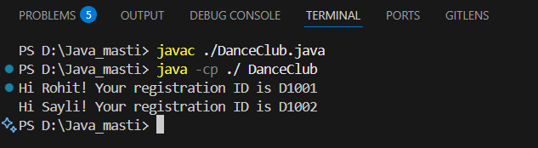**Actual Output:**