COMP4107

Neural Networks - Assignment 1

Group Members: Krystian Wojcicki (101001444), Michael Kuang (101000485)

Date: October 7, 2018

Question 1

Running q1.py, we obtain: 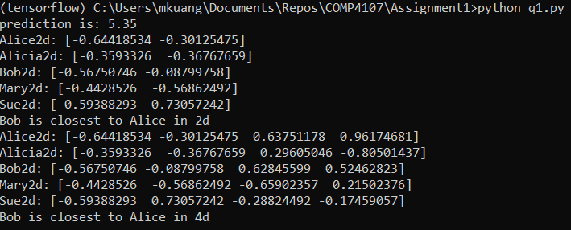

We can replicate the slide entitled “Modelling “Person” – SVD” and obtained a prediction value of 5.35 (or 1.35 if the row average is not added) as expected. Projecting into a 2D space, we see that Bob is closest to Alice, and similarly Bob is closest to Alice in 4D.

Question 2

Running q2.py, we obtain the SVD values for u, s, v as:

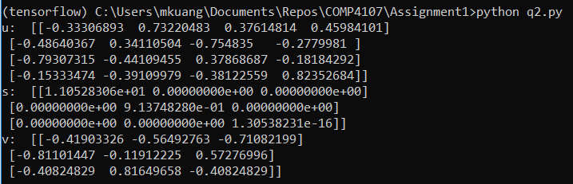

Question 3

Running q3.py, we see that .

Question 4

Running q4.py, we see that the least squares solution to is [-0.14705882 0.05882353 0.26470588].

Running q4tables.py we get a table according to the question specifications:

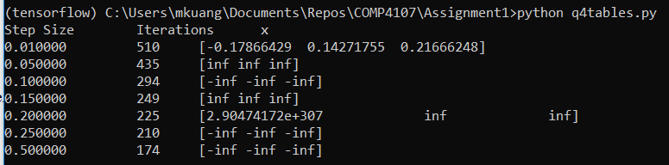

We see that there is a solution for when but no solutions for step size greater than that. This is because when the step size is at 0.05 or larger, the answer cannot converge as we are overshooting each time and thus will never reach a minimum.

Question 5

Running q5.py, we get 2 linearly independent vectors of the nullspace as described below (since the null space rank is 2 both the vectors are linearly independent):

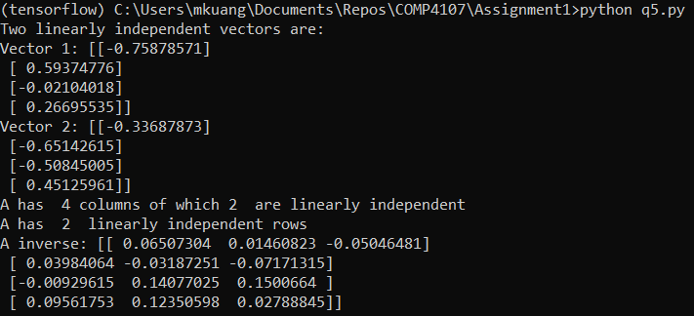

Since the rank of the matrix A is 2 that means that only two of the columns of A are linearly independent and thus the columns are not linearly independent in . The rank of the rows is also 2 which means only two of the rows in A are linearly independent and thus the rows are not linearly independent in . The inverse of A is as described above.

Question 6

Running q6.py with accordance to the specifications in question 6, we get a graph that closely resembles what is shown in figure 4 of the research paper where there is an exponential increase in accuracy then quickly plateaus after the first 10 basis: Each digits A matrix consisted of a randomly picked 500 images, and 100 unknown images (all of the digit 4) were used for accuracy testing.

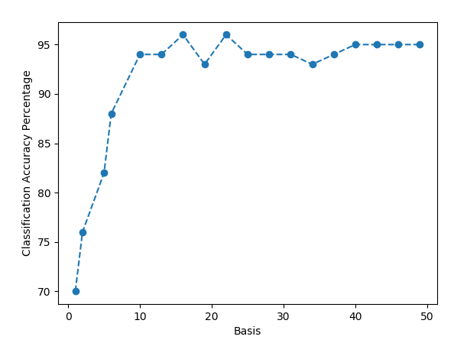

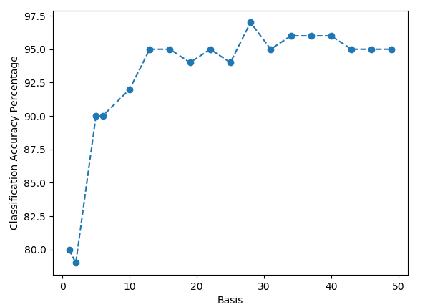

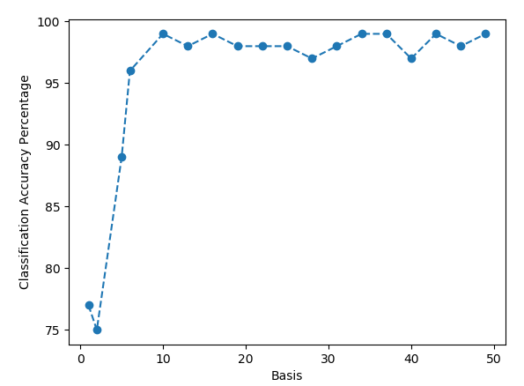

Question 7

Following the specifications to the research paper, we were able to reproduce figure 3 and 4. Running q7.py will demonstrate the results:

