**Practical 4**

**Aim:**

Write a java program using java.net library. Echo Client-Server. (UDP Protocol)

**Description:**

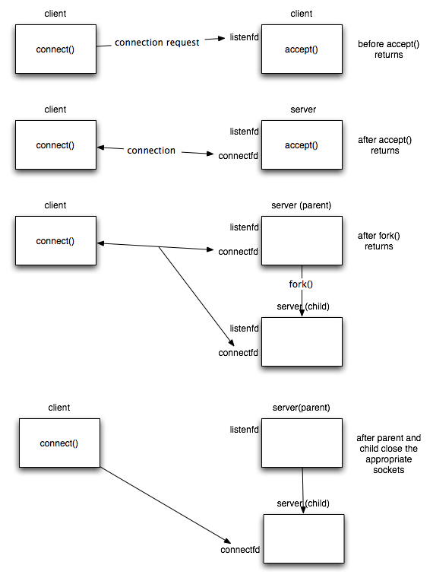

Fig. 1. Concurrent Client Server scenario

**Program code:**

**EchoClientUDP.java**

//UDP Client

**import** java**.**net**.*;**

**import** java**.**io**.*;**

public class EchoClientUDP **{**

public static void main**(**String args**[])** **{**

DatagramSocket datagramSocket **=** **null;**

**try** **{**

datagramSocket **=** **new** DatagramSocket**();**

BufferedReader stdIn **=** **new** BufferedReader**(**

**new** InputStreamReader**(**System**.**in**));**

String userInput**;**

System**.**out**.**print **(**"input: "**);**

**while** **((**userInput **=** stdIn**.**readLine**())** **!=** **null)** **{**

**if** **(**userInput**.**equals**(**"Bye."**))**

**break;**

byte**[]** b **=** userInput**.**getBytes**();**

InetAddress host **=** InetAddress**.**getByName**(**"localhost"**);**

System**.**out**.**println **(**"Attemping to connect to host " **+**

host**.**getAddress**()** **+** " on port 10007."**);**

DatagramPacket dataPacket **=** **new** DatagramPacket**(**b**,** b**.**length**,** host**,** 10007**);**

datagramSocket**.**send**(**dataPacket**);**

System**.**out**.**println**(**"Client: "**+**userInput**);**

byte**[]** buffer **=** **new** byte**[**userInput**.**length**()];**

DatagramPacket reply **=** **new** DatagramPacket**(**buffer**,** buffer**.**length**);**

datagramSocket**.**receive**(**reply**);**

String word **=** **new** String**(**reply**.**getData**());**

System**.**out**.**println**(**"Server: "**+**word**);**

System**.**out**.**print **(**"input: "**);**

**}**

**}** **catch** **(**UnknownHostException e**)** **{**

System**.**err**.**println**(**"Don't know about host: localhost"**);**

System**.**exit**(**1**);**

**}** **catch** **(**IOException e**)** **{**

System**.**err**.**println**(**"Couldn't get I/O for "

**+** "the connection to: localhost"**);**

e**.**printStackTrace**();**

System**.**exit**(**1**);**

**}**

datagramSocket**.**close**();**

**}**

**}**

**EchoServerUDP.java**

//UDP Server

**import** java**.**net**.*;**

**import** java**.**io**.*;**

public class EchoServerUDP **{**

public static void main**(**String args**[])** **{**

DatagramSocket datagramSocket **=** **null;**

**try** **{**

datagramSocket **=** **new** DatagramSocket**(**10007**);**

System**.**out**.**println **(**"Waiting for connection....."**);**

**while(true)** **{**

byte **[]** buffer **=** **new** byte**[**50**];**

DatagramPacket request **=** **new** DatagramPacket**(**buffer**,** buffer**.**length**);**

datagramSocket**.**receive**(**request**);**

System**.**out**.**println**(**"Enroll: 130050130163"**);**

System**.**out**.**println **(**"Connection successful"**);**

System**.**out**.**println **(**"Waiting for input....."**);**

String arrayMsg **=** **new** String**(**request**.**getData**());**

System**.**out**.**println**(**"From: " **+** request**.**getAddress**()** **+** " Port: " **+** request**.**getPort**());**

System**.**out**.**println**(**"Client: "**+**arrayMsg**);**

byte**[]** sendMsg **=** arrayMsg**.**getBytes**();**

DatagramPacket reply **=** **new** DatagramPacket**(**sendMsg**,** sendMsg**.**length**,** request**.**getAddress**(),** request**.**getPort**());**

datagramSocket**.**send**(**reply**);**

String word **=** **new** String**(**reply**.**getData**());**

System**.**out**.**println**(**"Server: "**+**word**);**

System**.**out**.**println **(**"Waiting for connection....."**);**

**}**

**}catch(**Exception ex**)** **{**

**}**

datagramSocket**.**close**();**

**}**

**}**

**Input Output:**

