**Practical 7**

**Aim:**

(Optional) Write a java program using java.net library. Client will read the data from a sample file (SampleFile.txt) and send line by line data to Server. Server will reply the same line in capital letters to the client. Client will display that capitalized line on its own screen. (UDP Protocol)

**Description:**

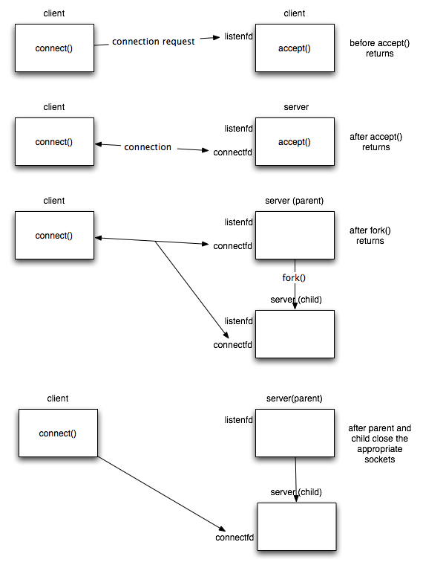

Fig. 1. Concurrent Client Server scenario

**Program code:**

**EchoClientUDP.java**

//UDP Client

**import** java**.**net**.*;**

**import** java**.**io**.*;**

**import** java**.**lang**.*;**

public class EchoClientUDP **{**

public static void main**(**String args**[])** **{**

String read **=** **null;**

StringBuffer line **=** **new** StringBuffer**();**

DatagramSocket datagramSocket **=** **null;**

FileReader fileReader **=** **null;**

**try** **{**

datagramSocket **=** **new** DatagramSocket**();**

fileReader **=** **new** FileReader**(new** File**(**"text.txt"**));**

BufferedReader stdIn **=** **new** BufferedReader**(**fileReader**);**

**while** **((**read **=** stdIn**.**readLine**())** **!=** **null)** **{**

line**.**append**(**read**);**

line**.**append**(**"\n"**);**

**}**

String stringLines **=** line**.**toString**();**

byte**[]** b **=** stringLines**.**getBytes**();**

InetAddress host **=** InetAddress**.**getByName**(**"localhost"**);**

System**.**out**.**println **(**"Attemping to connect to host " **+**

host**.**getAddress**()** **+** " on port 10007."**);**

DatagramPacket dataPacket **=** **new** DatagramPacket**(**b**,** b**.**length**,** host**,** 10007**);**

datagramSocket**.**send**(**dataPacket**);**

System**.**out**.**println**(**"Client: "**);**

System**.**out**.**println**(**"_______ "**);**

System**.**out**.**println**(**line**);**

byte**[]** buffer **=** **new** byte**[**500**];**

DatagramPacket reply **=** **new** DatagramPacket**(**buffer**,** buffer**.**length**);**

datagramSocket**.**receive**(**reply**);**

String serverReply **=** **new** String**(**reply**.**getData**()).**trim**();**

System**.**out**.**println**();**

System**.**out**.**println**(**"Server: "**);**

System**.**out**.**println**(**"_______ "**);**

System**.**out**.**println**(**serverReply**);**

**}** **catch** **(**UnknownHostException e**)** **{**

System**.**err**.**println**(**"Don't know about host: localhost"**);**

System**.**exit**(**1**);**

**}** **catch** **(**IOException e**)** **{**

System**.**err**.**println**(**"Couldn't get I/O for "

**+** "the connection to: localhost"**);**

e**.**printStackTrace**();**

System**.**exit**(**1**);**

**}**

datagramSocket**.**close**();**

**}**

**}**

**EchoServerUDP.java**

//UDP Server

**import** java**.**net**.*;**

**import** java**.**io**.*;**

public class EchoServerUDP **{**

public static void main**(**String args**[])** **{**

DatagramSocket datagramSocket **=** **null;**

**try** **{**

datagramSocket **=** **new** DatagramSocket**(**10007**);**

System**.**out**.**println **(**"Waiting for connection....."**);**

**while(true)** **{**

byte **[]** buffer **=** **new** byte**[**500**];**

DatagramPacket request **=** **new** DatagramPacket**(**buffer**,** buffer**.**length**);**

datagramSocket**.**receive**(**request**);**

System**.**out**.**println**(**"Enroll: 130050130171"**);**

System**.**out**.**println **(**"Connection successful"**);**

System**.**out**.**println **(**"Waiting for input....."**);**

String arrayMsg **=** **new** String**(**request**.**getData**()).**trim**();**

System**.**out**.**println**(**"From: " **+** request**.**getAddress**()** **+** " Port: " **+** request**.**getPort**());**

System**.**out**.**println**(**"Client: "**);**

System**.**out**.**println**(**"_______ "**);**

System**.**out**.**println**(**arrayMsg**);**

//convert to uppercase

arrayMsg **=** arrayMsg**.**toUpperCase**();**

byte**[]** sendMsg **=** arrayMsg**.**getBytes**();**

DatagramPacket reply **=** **new** DatagramPacket**(**sendMsg**,** sendMsg**.**length**,** request**.**getAddress**(),** request**.**getPort**());**

datagramSocket**.**send**(**reply**);**

String line **=** **new** String**(**reply**.**getData**()).**trim**();**

System**.**out**.**println**();**

System**.**out**.**println**(**"Server: "**);**

System**.**out**.**println**(**"_______ "**);**

System**.**out**.**println**(**line**);**

System**.**out**.**println **(**"Waiting for connection....."**);**

**}**

**}catch(**Exception ex**)** **{**

**}**

datagramSocket**.**close**();**

**}**

**}**

**Text File: text.txt**

hello World

123

hello Computer

**Input Output:**

