1)Create an Auto Fare calculator program based on Mangalore City rules .  
Input :  Distance travelled  
Output :  Total Fare

Requirements:

1.minimum fixed price

2.minimum distance

3.rate per km

4.Input the distance you want to travel

Test cases:

1] Input:150

Output: 1050

2] Input:88

Output: 50

Program

import java.util.Scanner;

public class Main

{

public static void main(String[] args) {

int minprice=50;

int mindist=100;

int rateperkm=20;

int fare=0;

Scanner sc=new Scanner(System.in);

System.out.println("Enter the distance you want to travel");

int newdist=sc.nextInt();

if(newdist<=mindist){

fare=minprice;

}

else{

fare=(newdist-mindist)\*rateperkm+minprice;

}

System.out.println("The autofare for the distance is : "+fare);

}

}

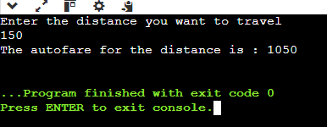OUTPUT