Find the LCM for 2 numbers given as input

REQUIREMENTS  
Enter 2 numbers

The entered number should be an integer

Calculate the hcf(gcd) using modulus operator

The output is the lcm of 2 numbers

TEST CASES:

Input-12,18

Output-36

Input-8,14

Output-56

PROGRAM

import java.util.Scanner;

public class Main

{

public static void main(String[] args) {

Scanner sc=new Scanner(System.in);

System.out.println("enter 1st number");

int num1=sc.nextInt();

System.out.println("enter 2nd number");

int num2=sc.nextInt();

int findlcm=lcm(num1,num2);

System.out.println("LCM of given number is\n"+findlcm);

}

public static int lcm(int num1,int num2){

return (num1\*num2)/gcd(num1,num2);

}

public static int gcd(int num1,int num2){

while(num2!=0){

int temp=num2;

num2=num1%num2;

num1=temp;

}

return num1;

}

}

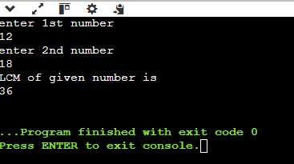OUTPUT