1. Download folder AW1_Login_UserActivityTtracking.
2. The folder contains Login_modules and ext subfolders.
3. Load unpacked extension “ext” from location on system on Chrome webpage.

**For Local Setup:**

1. Install mongodb on system.
2. Install nodejs.
3. Open Command Prompt
4. Cd to file folder Login_modules
5. Type npm install
6. Once done, type npm install datetime
7. Then, npm install xmlhttprequest
8. Open new command prompt window and cd to bin folder location of Mongodb.
9. Type the following command

mongoimport --db passport --collection users --file user_login.json --jsonArray

Screenshot of data stored in mongodb using Robo 3t GUI.  
3 users with variables:

Username  
Encrypted password

Login History

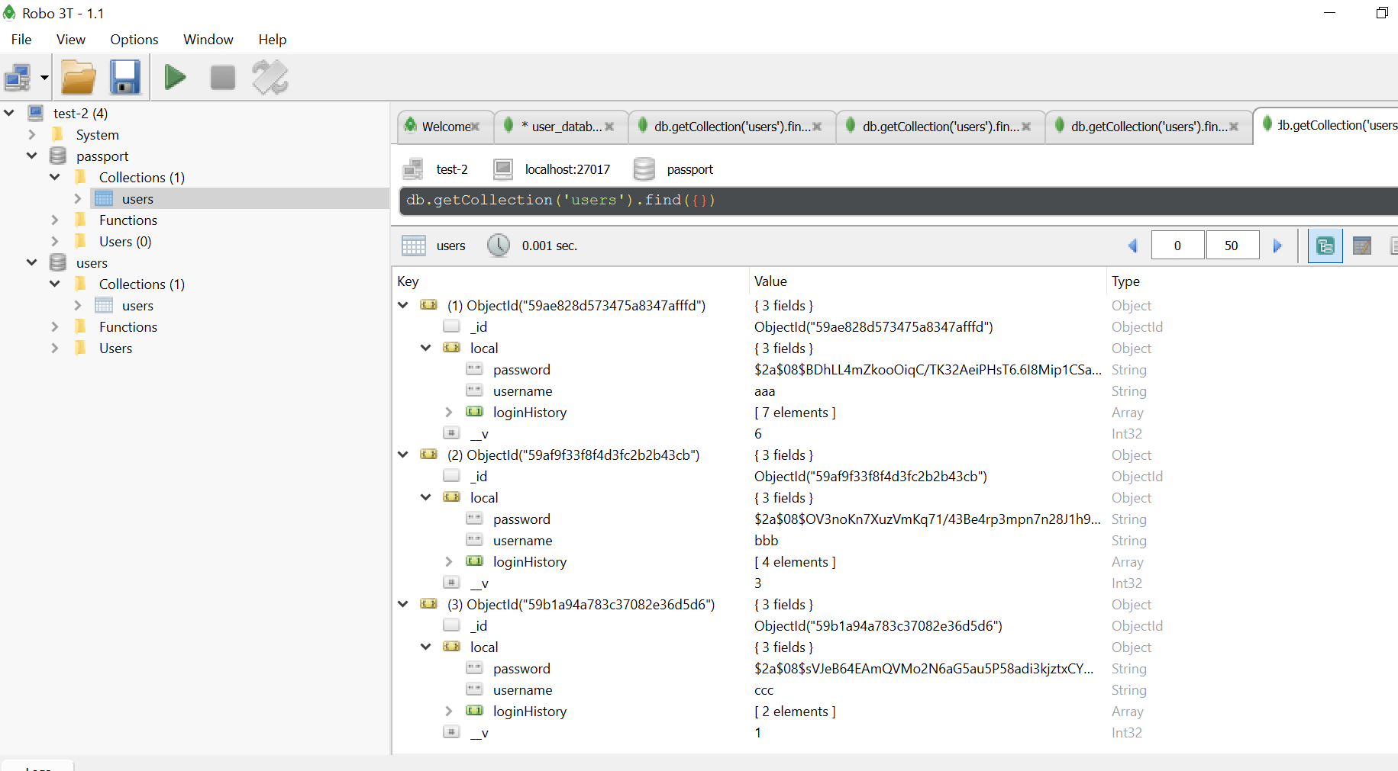

1. Type mongod in command prompt.
2. Open new command prompt window and type mongo
3. On the first (of 3) command prompt windows, execute command node server.js
4. Open <http://localhost/8080> on chrome.
5. Ensure extension is enabled.

**To access online website, navigate to:**

<http://13.56.232.157/>