**FACIAL ATTENDANCE SYSTEM**

**ABSTRACT**

In today’s world, taking student attendance in schools and colleges is a very significant duty for the faculty. If the faculty takes attendance physically, it wastes a lot of time. Hence, we have been taking the help of technology. This will play a vital role in enlightening the excellence of the educational system. Taking attendance physically takes a lot of time and effort. For the faculty to maintain and manage the attendance sheet is very boring work and it costs time from the lectures. The smart and computerized attendance system can help manage attendance. It will help to instigate using several ways of biometric. Face recognition is unique and the most famous technology nowadays. This new technology helps to replace the old traditional sheets. via this model, the problem of forged attendance and proxies can be cracked. In the old system, students just punch the card and then don’t go to class. The proposed work that monitors the realtime attendance of the students. The Proposed work defines the effective algorithm that helps to mark attendance inevitably without human involvement. The most important step in this system is to detect the faces and recognize them. When we can talk about a comparison of the traditional attendance and currently proposed system, that we have seen the current system help to monitor the student attendance more properly. This system will be actual help to maintain the attendance and help faculty to record the students.

**INTRODUCTION**

In school and university, attendance marking is a very important job for faculty. Many schools and universities follow the outdated tradition of marking the attendance of the student by calling their enrollment number. But now some universities are applying biometric devices on their campuses such as punch cards, swipe cards, RFID Cards, and Thumbprint scanners. The school and university now move on towards Biometric devices such as punch cards for attendance. but the enrollment calls out and punch card methods have some drawback because the enrollment method is done by faculty so its very time consuming and sometimes it makes human mistakes the other punch card method is not accurate because anyone can punch anyone card and sometimes there are some mistakes where present students mark absent or if a student loses their punch cards then he/she will get a new card after 3-4 working days and this is a very difficult time to student to mark attendance. So, I have proposed a new idea for a face recognition system. The face recognition system is one of the most resourceful methods for marking student attendance. If there are so many students in the class then it is a very difficult task to maintain attendance. The school and college with the total number of students have very difficult work to take attendance manually because there are some chances of student’s proxies and time-consuming by the faculty. The face recognition system helps to mark being present of the student by identifying their faces. This system will close the proxies and human error. Face recognition is one of the best methods for proof of the identity of a student. We can implement in the ground of schooling for supervision being present of students. The face recognition system is separated into multiple phases. The significant phase in face recognition is to detect the face of the student. In the first phase for marking the attendance, we have the image of class students, then we can capture the student faces by the electronic camera which is kept at the highest point in the class where the electronic camera will capture an image without leaving out any student. This camera image is the input of the system. For accurate results, we have to perform image enhancement and image acquisition by using some techniques. To identify the last bench students, we have to use the histogram equalization of photo desires to be completed. In the second phase, we get the image after the image enhancement and image acquisition, and then it will go for face detection where we can apply some famous algorithms like neural networks, ad-boost algorithms, and HAAR algorithms. After applying algorithms, we can detect the faces of the student by these famous algorithms. In the third phase, we are working to recognize the face of the student after detecting his/her face from the image. In face recognition, different techniques help to recognize the student’s image like PCA, Eigen, and some other algorithm. The best algorithm according to me is Eigen. In this technique when the student's face is cropped from the image. We have separated each student's image by using Eigen Features like every student has different facial, eyes, nose, and hairs. After performing the Eigen algorithm, we compare the generated image from the database to recognize the students. So, comparing with the database we will create the database by enrolling the student. In that database, we can keep the student information like name, class, enrollment number, his/her photo for verification.

**PROPOSED METHODOLOGY**

**Architecture**

This architecture has a better implementation of marking the student attendance in school and college. This system is also known as a smart attendance system. It's very helpful for the teacher to mark the attendance without taking extra time from the lecture. To implement this system into exertion, we essential both computer hardware and software requirements for our development. To implement this system in the school or college, we need a classroom where we will have to require a high-definition camera that we will be secure in the maximum height where it will capture all students' pictures. When the camera captures the image of all students, that image becomes input. The input image is going to be processed by image processing. First, it will do image acquisition where the image transforms Real-World Data into an array of numerical data which could be far ahead wrought on a computer, previously any image processing can originate an image must be captured by the camera and transformed into a practicable entity. Second, we will convert the image into a grayscale image because a grayscale image has intensity is kept eight-bit integer giving two hundred fifty-six possible dissimilar shades of gray from black to white. If the stages are consistently spaced out then the modification among uninterrupted gray levels is more expressive than the gray level to make up your mind for the power of the human eye. The third thing we can do is histogram equalization, which improves contrast in images. It will work like enlarging out the intensity range of the image. Then we have an output image that was generated in MATLAB after that we consider that output image as a new input image for the second process. Now take the input image for detecting the faces of every student. The detecting of the student’s face is done by some face algorithm. Then after detection of the student's face. We will recognize the student faces through each student's face and will be cropped by the output image, after the cropped faces then we will compare that image from the database of the faces. The database has stored all students' face information and that database is maintaining all information of the student images. So, we will be comparing the output student face with the database student faces one by one, after comparing the faces the system will automatically mark the attendance of that student on a server with time, date, and particular subject.

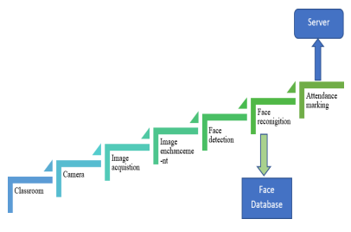

**Methodology**

We have some methodologies for implementing the system which helps to perform the process. We need some stages are as follows Stages for Face Recognition Based Attendance System:

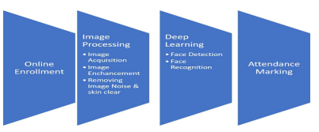

**Image processing**

We are using image processing in our project because image processing helps to get an enhanced image or to citation some useful data from the image.it helps to evaluating and manipulating the image. We have used MATLAB software because in MATLAB. We have a pre-defined algorithm and package 3.4.1 Image Acquisition: The image acquisition work is to capture the image. First, we have to install a high-definition camera in the classroom. The camera will be installed at the maximum height in the classroom. So, we can get every student's image on the camera. After capturing the image of each student that image becomes the input image for the system.

**Image Enhancement**

It is the process that helps to manipulate the image so that we have got a suitable image than the original. Grayscale Conversion: After capturing the image from the camera. Sometimes that image is not clear or high contrast. So, we have to manage that image. the grayscale conversion is very simple. It’s a color gray in which the red, green, blue colors are easily adjusted or we can say all colors have equal intensity. so, the input image will be converted into a grayscale image.

**Histogram Equalization**

Histogram equalization is a technique used to improve image quality. It helps to improve the contrast in the image and stretching out the intensity range of the image. the use of histogram equalization is removing the contrast of the image so we can see the faces of every student in the classroom. It represents the image in the graphical which helps to distribute the intensity. It will help to recognize the face of the student.it generates the histogram of the image which was capture by the camera after histogram equalization.

**Deep Learning**

Deep learning is nothing but an ordinary example of machine learning, more indeed -one of its algorithms.

**Face Detection**

It’s a technology used to discover and classify human faces in digital images. Face Detection is used algorithms and Machine learning to detect the student's faces in the input images. After the image processing part, we will get an image for face detection. The face detection will distinguish the face of each student from the output pictures. we will be applying some algorithms to detect the student's faces like Viola and Jones algorithms.

**Face Recognition**

Face Recognition is a technique of categorizing or authenticating the identity of a specific using their face. Face recognition systems use computer algorithms to preference out precise individual details about a student’s face. Face recognition is the following stage afterward face detection. Face recognition can be accomplished by gathering the face as of the images. After cropping the image, we have to compare that image from the face database. that database had been enrolled by the students. The student’s face is check one by one using Eigen Algorithms.

**Attendance Marking**

The attendance marking is the last step where students get t h e mark for their class. Completing the verification of all student faces effective recognition is completed, the attendance had been noticeable on the server.

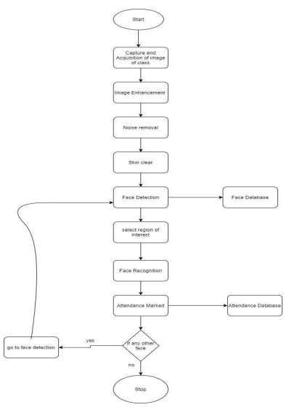

**Algorithm**

The algorithm displays the stage by stage at work of a model. For this model, we have been prerequisite to using the following algorithm.

ALGORITHM: FACE RECOGNITION FOR ATTENDANCE SYSTEM.

Start: Classroom image captured by the camera. Result: Attendance marking.

PROBLEM EXPLANATION: Identification and Verification of School and College Student.

Stage 1: Start

Stage 2: Tell the student to enroll the credential information and picture store in the face database. Stage 3: Install the camera at the quiet place where it will cover all student pictures.

Stage 4: Input the picture taken by the camera.

Stage 5: Image Processing

5.1 Acquired the input picture and perform image acquisition

5.2 Convert the input picture into a grayscale image after converting then perform histogram equalization.

5.3 Then remove the noise from the picture, after removing the noise then perform skin clear, this process a & b come under image enhancement.

Stage 6: Face Detection

6.1 Crop the student's faces from the input picture which collect from the upper stage.

6.2 Select the portion of the interest.

Stage 7: Face Recognition

7.1 Equate the cropped pictures with face database pictures. Spot the attendance-on-attendance server.

7.2 If the picture does not match or there are any new faces, then go to stage 6 again.

Stage 8: End

**Conclusion**

In this proposed system, we have developed a system for Smart Attendance System using Face Recognition. This paper presents the effective and precise method of attendance in the classroom atmosphere that can replace the old traditional manual methods. The system takings attendance of individual students by nonstop observation at the entrance and exit points. Via this model, the probabilities of fake attendance and proxies can be abridged. It protects time and effort, especially if it is a class with a massive number of students. Similarly, to implement this model, not a little specific hardware is required. A camera device & a single Personal Computer, database servers are enough aimed at making the smart attendance system. Current work is attentive to the face detection algorithms from images or video frames. We would also try to implement geolocation so that a person can mark their attendance using their mobile device, all they need to do is to scan their face using an application and if they are within the location and their faces are recognized then their attendance would be marked automatically.