ER-ASSIGNMENT -1
- database for the National Hockey League (NHL).
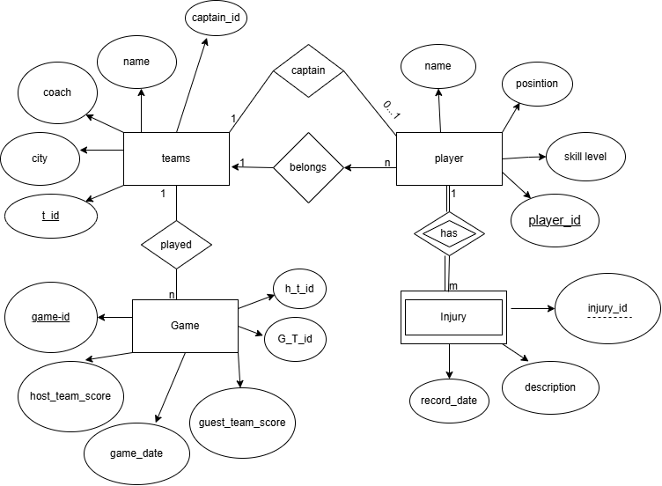

- E-R diagram for a car-insurance company
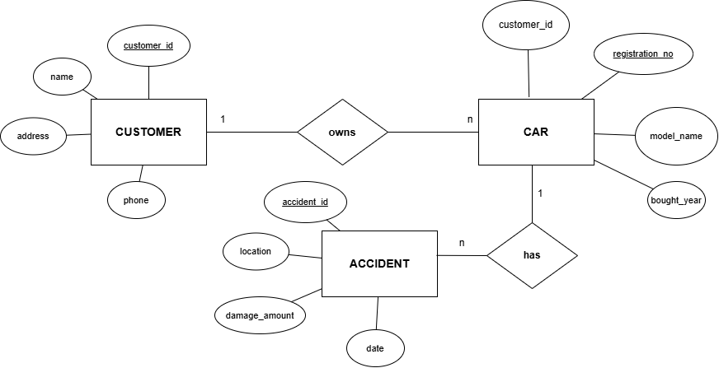
- E-R diagram for a hospital
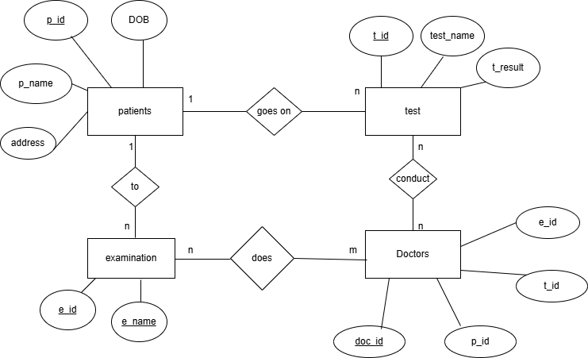
- A university registrar’s office maintains.
