ASSIGNMENT 1 (Kruthika K J)

- Select employee details of dept number 10 or 30.
SELECT * from emp WHERE depno in (10,30) ORDER by depno;
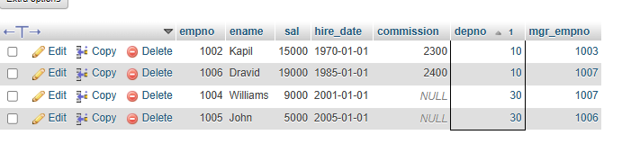
- Write a query to fetch all the dept details with more than 1 Employee.
SELECT d.depno,d.dname,d.loc, count(e.empno) as employee_count
from dept d
JOIN emp e
ON d.depno=e.depno
GROUP BY d.depno,d.dname,d.loc
HAVING count(e.empno)>1;
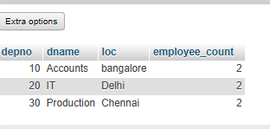
- Write a query to fetch employee details whose name starts with the letter “S”
SELECT * from emp WHERE ename LIKE "s%";
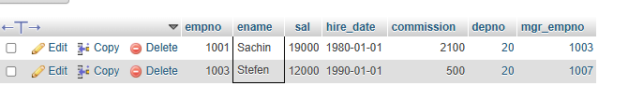
- Select Emp Details Whose experience is more than 2 years
SELECT *FROM emp WHERE TIMESTAMPDIFF(YEAR, hire_date, CURRENT_TIMESTAMP()) > 2;
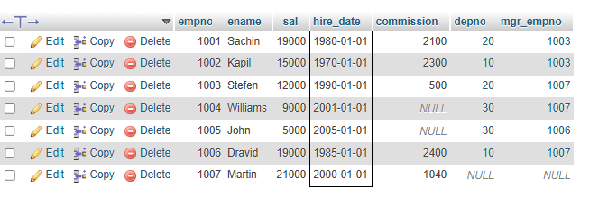

- Write a SELECT statement to replace the char “a” with “#” in Employee Name.
select ename, REPLACE (ename, ' a','#') as modifide_name from emp;

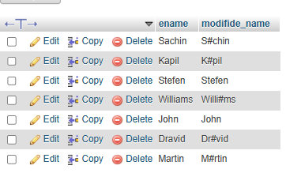

- Write a query to fetch employee name and his/her manager name.
select e.ename as employee_name ,m.ename as manager_name from emp e
left join emp m
on e.mgr_empno=m.empno;
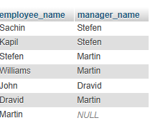
- Fetch Dept Name , Total Salry of the Dept.
select d.depno, d.dname ,sum(sal) as total_sal from dept d
join emp e on d.depno=e.depno GROUP by d.depno,d.dname;
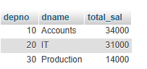
- Write a query to fetch ALL the employee details along with department name, department location, irrespective of employee existance in the department.
select e.*,d.dname,d.loc from emp e join dept d on e.depno=d.depno;

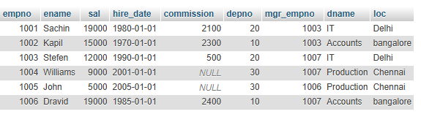
- write an update statement to increase the employee salary by 10 %
UPDATE emp SET sal=(sal+sal*0.10);
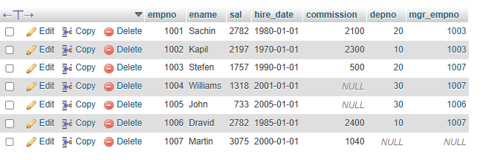
- Write a statement to delete employees belong to Chennai location.
DELETE from emp WHERE
depno in(select depno from dept WHERE Loc="chennai")
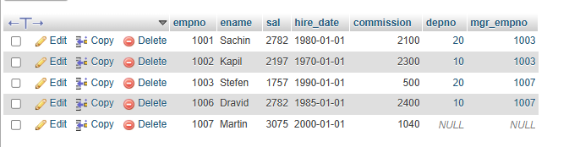
- Get Employee Name and gross salary (sal + comission)
SELECT ename, sal+commission as gross_sal from emp;
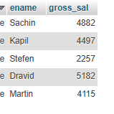
- Increase the data length of the column Ename of Emp table from 100 to 250 using ALTER statement
ALTER TABLE emp MODIFY ename varchar(250);

- Write query to get current datetime
SELECT Now() as current_datetime;

- Write a statement to create STUDENT table, with related 5 columns
CREATE TABLE student(sid int PRIMARY KEY, sname varchar(20), dob date, cource varchar(20) NOT null)
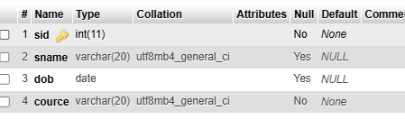

- Write a query to fetch number of employees in who is getting salary more than 1000
SELECT COUNT(empno) as emp_count FROM emp WHERE sal>1000;
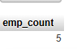
16 Write a query to fetch minimum salary, maximum salary and average salary from emp table.
SELECT min(sal) as min_sal, max(sal) as max_sal, AVG(sal) as avg_sal from emp;
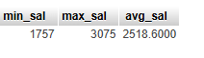
- Write a query to fetch number of employees in each location
SELECT d.loc ,count(e.empno) as emp_count from dept d left join emp e on d.depno=e.depno GROUP by d.loc;
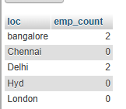

- Write a query to display emplyee names in descending order
SELECT ename from emp ORDER by ename DESC;
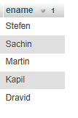
- Write a statement to create a new table(EMP_BKP) from the existing EMP table
CREATE TABLE EMP_BKP AS SELECT * FROM Emp;
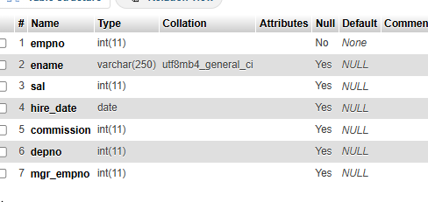
- Write a query to fetch first 3 characters from employee name appended with salary.
SELECT empno,ename ,sal, concat(LEFT(ename,3),'_',sal) as name_salary FROM emp;
