ASSIGNMENT 2 (Kruthika K J)

- Fetch all the Customer Details along with the product names that the customer has ordered.
SELECT DISTINCT c.Customer_Id,c.Customer_name,p.product_name from customer c
join orders o on c.Customer_Id =o.Customer_Idjoin order_details od
on o.Order_Id=od.order_id join product p on od.product_id=p.product_id
ORDER by c.Customer_Id;
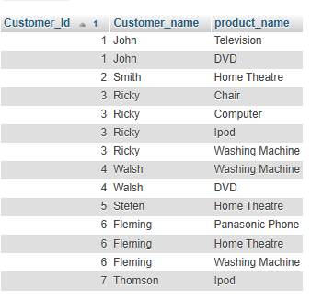
- Fetch Order_Id, Ordered_Date, Total Price of the order (product price*qty).
select o.order_Id, o.Ordered_Date,sum(p.Product_Price* od.Quantity) as total_price from orders o join order_details od on o.Order_Id=od.Order_Id join product p on od.Product_Id=p.Product_Id GROUP by o.Order_Id,o.Ordered_Date
order by o.Order_Id;
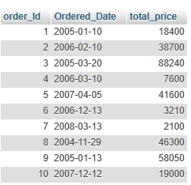
- Fetch the Customer Name, who has not placed any order
select c.customer_name,c.Customer_Id from customer c
where not EXISTS(SELECT o.customer_id FROM orders o where o.Customer_Id=c.Customer_Id)

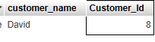
- Fetch the Product Details without any order(purchase).
select p.* from product p where not exists
select o.Product_Id from order_details o where o.Product_Id=p.Product_Id)
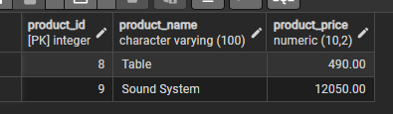

- Fetch the Customer name along with the total Purchase Amount

select c.customer_name, sum(p.Product_Price* od.Quantity) as total_purchase_amt
from customer c
join orders o on o.customer_id=c.customer_id
join order_details od on o.order_id= od.order_id
join product p on od.product_id=p.product_id
group by c.customer_id
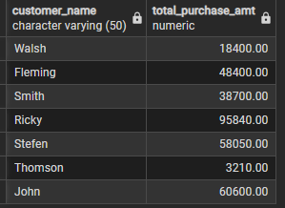

- Fetch the Customer details, who has placed the first and last order
select o.ordered_date as first_order,c.customer_name from orders o
join customer c
on o.customer_id=c.customer_id where o.ordered_date =
(select max(ordered_date) from orders) or o.ordered_date=(select min(ordered_date) from orders)
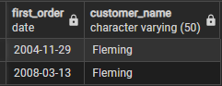

- Fetch the customer details , who has placed more number of orders

select c.customer_id,c.customer_name ,count(o.order_id) as order_count from customer c
join orders o on c.customer_id=o.customer_id
group by c.customer_id,c.customer_name
order by order_count desc limit 1


- Fetch the customer details, who has placed multiple orders in the same year
select c.* from customer c
join orders o
on c.customer_id=o.customer_id
group by c.customer_id,extract (year from o.ordered_date)
having count(o.order_id)>1 ;


- Fetch the name of the month, in which more number of orders has been placed
select to_char(o.ordered_date, 'Month') AS month_name,
extract(month from o.ordered_date) AS month_number, count(o.order_id) AS order_count from Orders o
group by to_char(o.ordered_date, 'Month'), extract(month from o.ordered_date)
order by order_count desc limit 1;

- Fetch the maximum priced Ordered Product
select p.product_name,p.product_price from product p
join order_details od on p.product_id = od.product_id
group by p.product_name,p.product_price
order by p.product_price desc limit 1
