**Batch-1: Blockchain Essentials**

**Name: Kruti Rach**

Question 1: Experiment with Ander’s blockchain.

Answer:

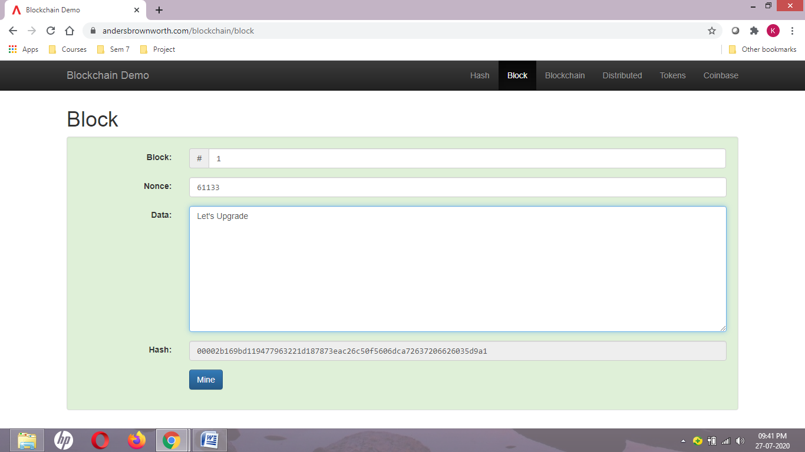

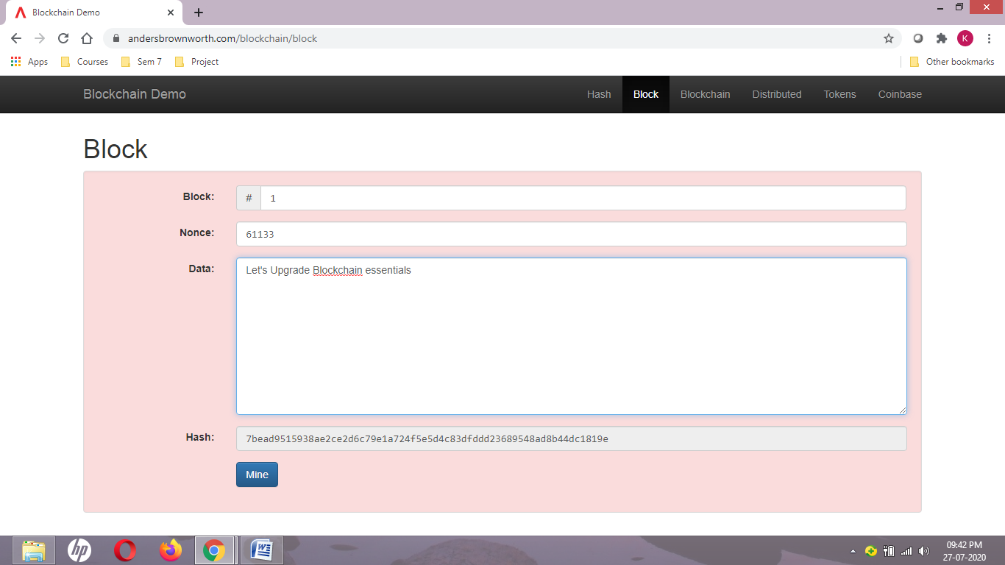

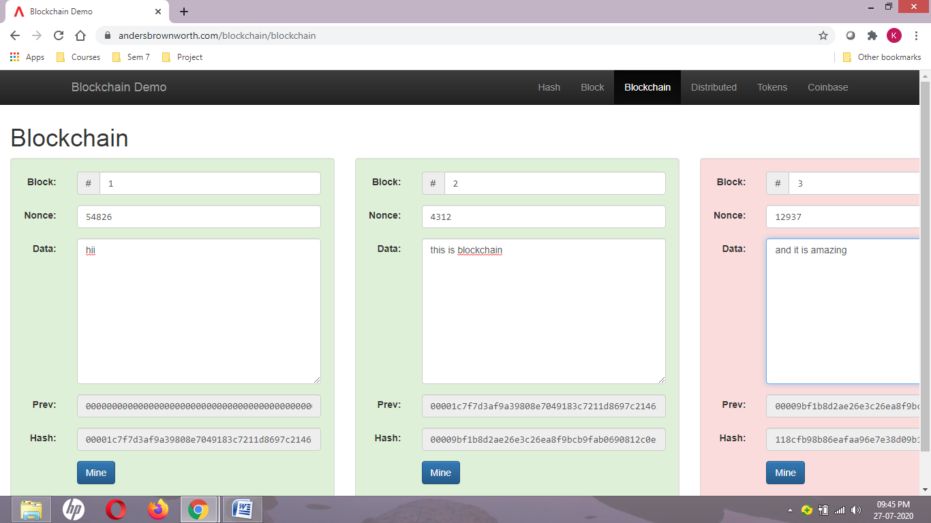

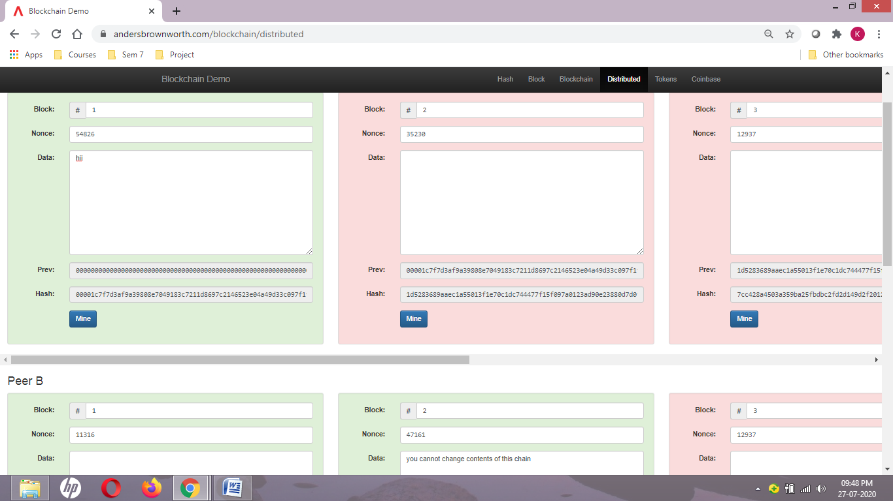

Question 2: Make a simple contract on remix.ethereum.

Answer:

