**AWT Practical - 10 Task**

**Login Script Demo with PHP**

This week we will demonstrate Login Script with the objective of learning the following concepts in the real world. Students will be required to create a report with implementation of all following concepts in any script of their choice with clear explanation-understanding of concepts.

**1.** MySql as a Database and its syntax

**2.** Database connection with my-sql

**a.** OOP way of connecting database

**b.** Procedural Way of Connecting Database

**c.** PDO(PHP Data Objects)

**3.** Session management

**4.** Use of PHP Constants in practice

**5.** MVC and Code Structuring

**6.** Form error Handling

**7.** Includes & Redirections

1. In this practical we will be performing the login script in PHP, here we have used the MySql database, the syntax is pretty common for creating the table, insert data to table and much more.

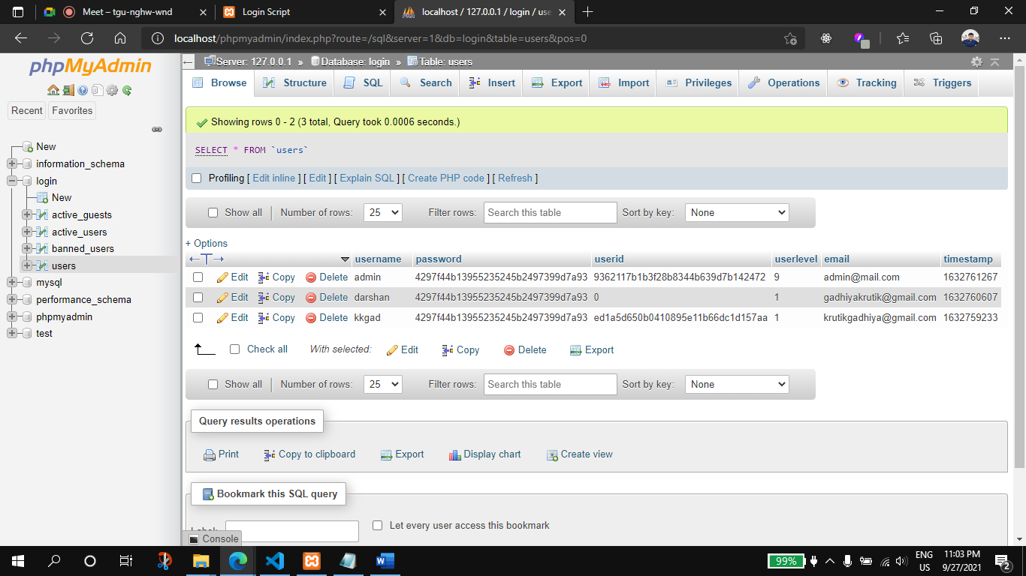

1. There are multiple ways we can connect database with the PHP as specially the MySql DB, 1st method is to use the mysqli_connect() method which is the procedural way to connecting, 2nd method is OOP way using new mysqli() and the final way is using PDO which stands for PHP data Objects

in this particular practical I have used the procedural way.

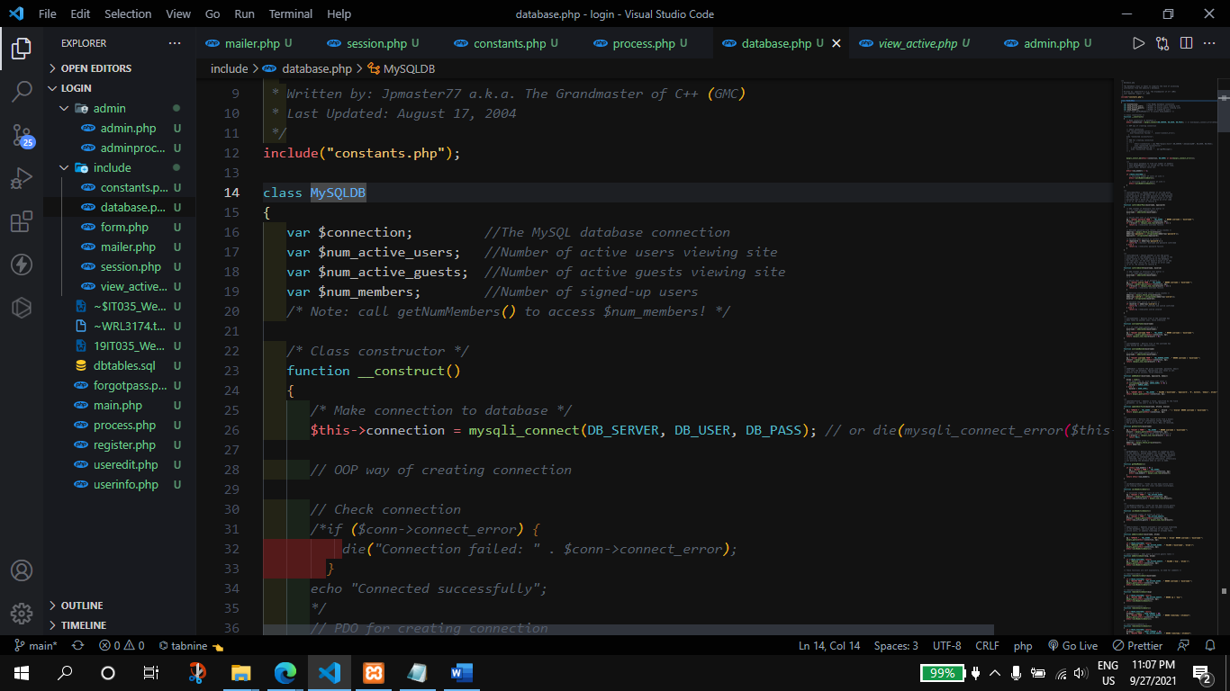

1. For the session management we have made a separate file with Session class, which contains various properties and methods which handles the different operations on the session

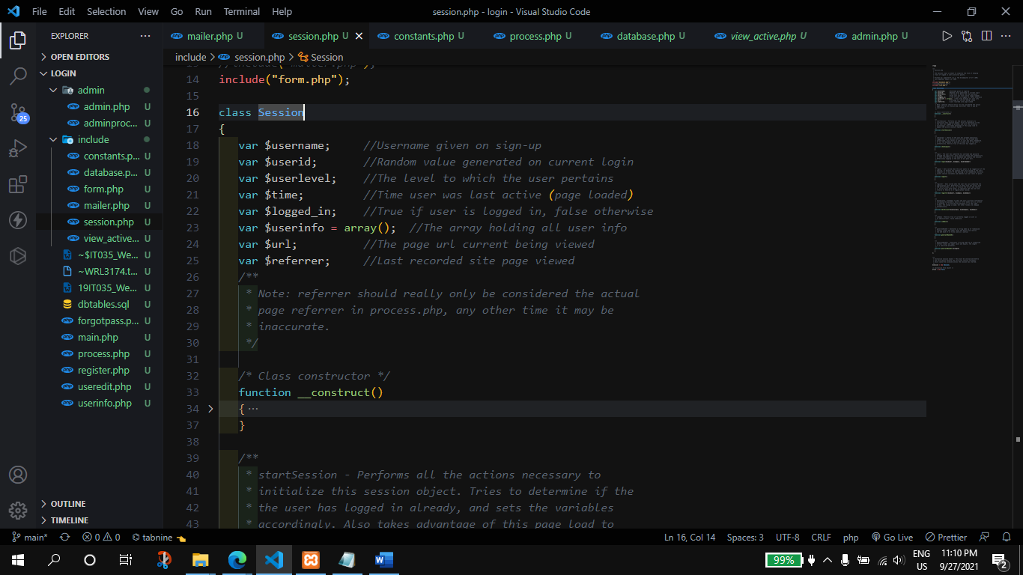

1. the there is some date which is redundant and we need to use them again and again ad various places such as the table name, user types etc. so instead of hardcoding them we can define them in other file as constants as their values are not going to change and then we can use them in other files. The same we have done here the name of the file is given as Constant.php.

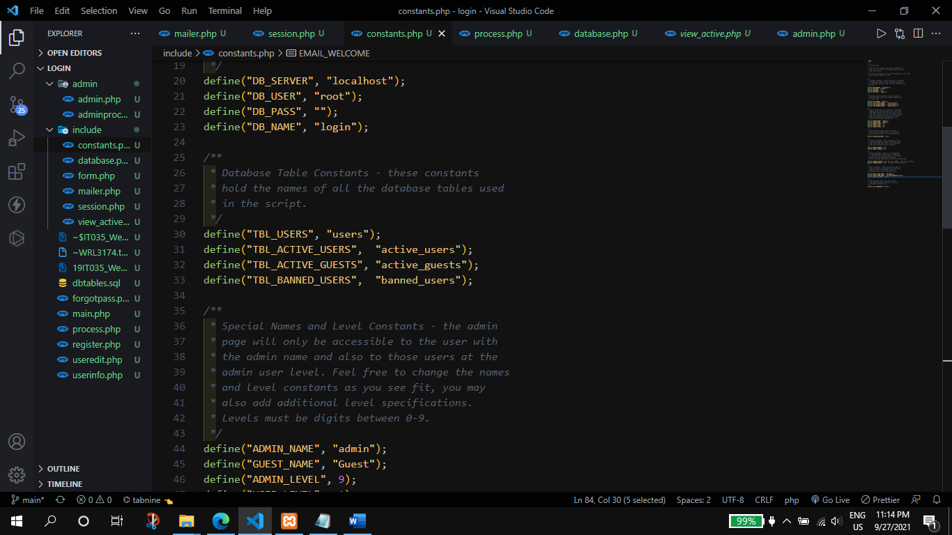

1. MVC stands for model view and controller this is the model is code that actually perform the tasks such as database update, sending email etc. the view is that the user interacts with and the controller which sits between model and view and depending on the users action, tells the model to perform the task.
2. Form handling is also an important thing to do as we have to store the correct data so the form handling ensures the correct data is being entered to the database by performing check on the data received from the user and depending upon the type of the date we can instruct the user to what to do next.

For the form we have created the separate file which contains the From class similar to the Session class which contains few properties and the method to handle the data.

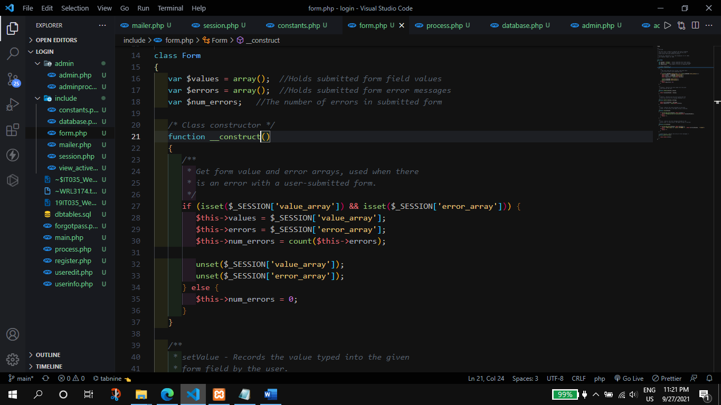

1. The separate files that we created we need to include them in to different files so that we can use sessions in that file, we can connect to database etc. that can be done using include() which takes one argument the name of the file we want to include

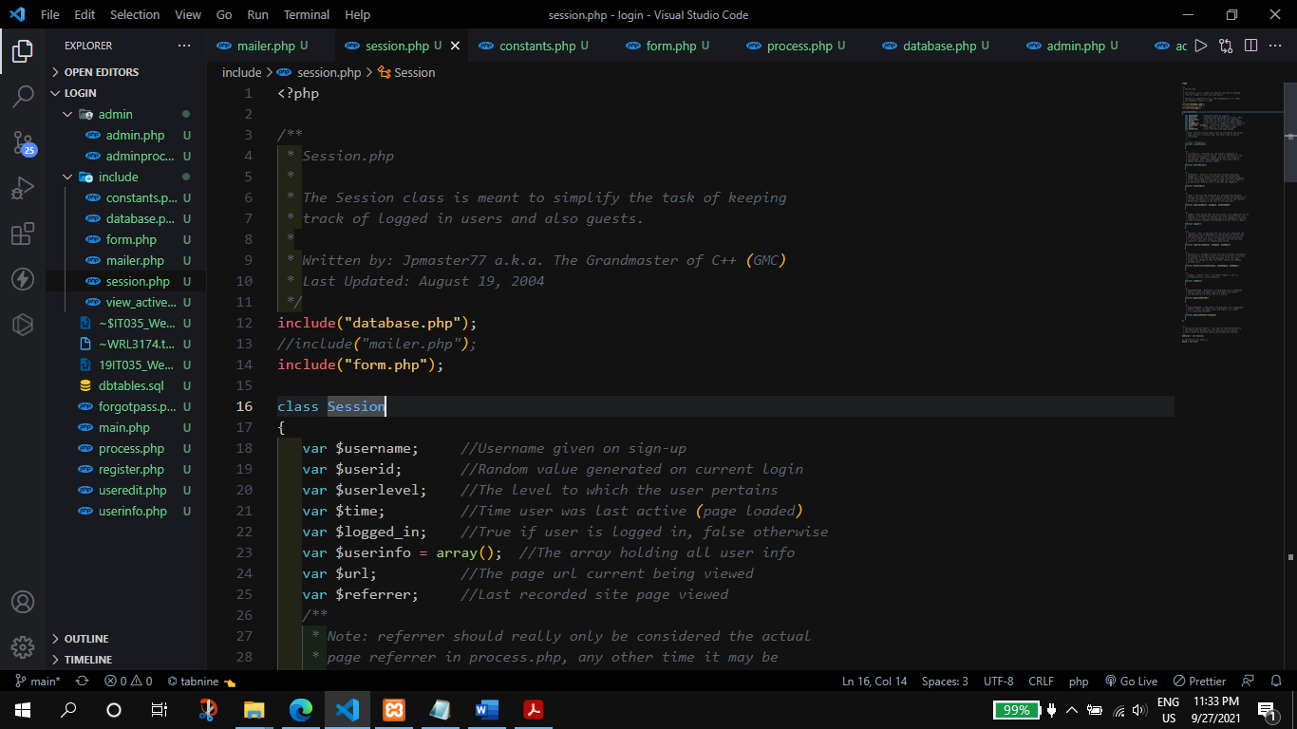

For redirection the best way is query string as we can redirect user from the backend.

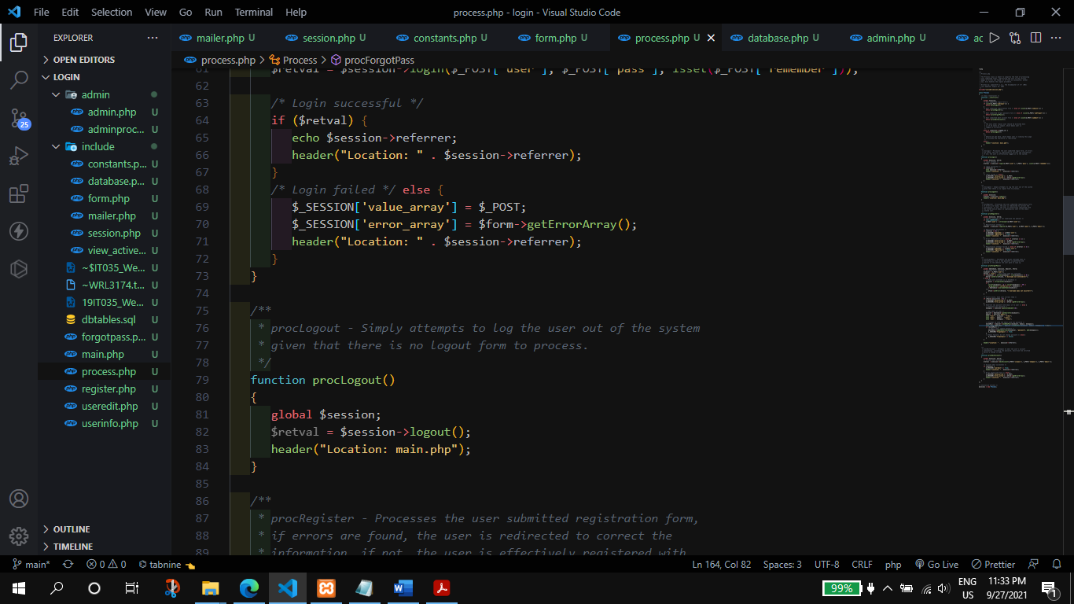

**Problems/Issues found in the projects:**

* missing php from <?php ?> at many places In **almost** all the files

in almost all the files the php from the php tag were missing and due to those incomplete tags the files are not detected as php so, most part of the system does not work

* wrong constructor name

in the classes the name of the constructors were wrong, the constructor were given the name of the class, but in the new PHP syntax the constructor is declared as __constructor()

* get_magic_quotes_gpc()

this method is deprecated and no longer supported and there is no meaning of writing/using it.

* regex expression not written correctly

the regex expression is not written correctly it was missing the starting and ending /.

* mysql_result() method is depricitated

this method was used to get the contents of multiple cells in one function call, as it is deprecated, I found some alternate to it made another function which act like the same.

* mysql_numrows wrong method name

the correct name is mysqli_num_rows()

* <?php ?> was enclosed in double inverted coma

In many places in the form the <?php ?> tag was enclosed within double inverted commas and which is not correct.

* mysqli_query() paramater were swapped

the position of the parameter were swapped, so changing it the site start working.

* when user is deleted then the entry in active_user table is still their so added implementation for the same

**Output:**

