**AWT Practical *Week - 10 Task***

**OOP Concepts using PHP**

1. Demonstrate the Concept of Class and Object with suitable example. [ constructor/destructor]

**Code:**

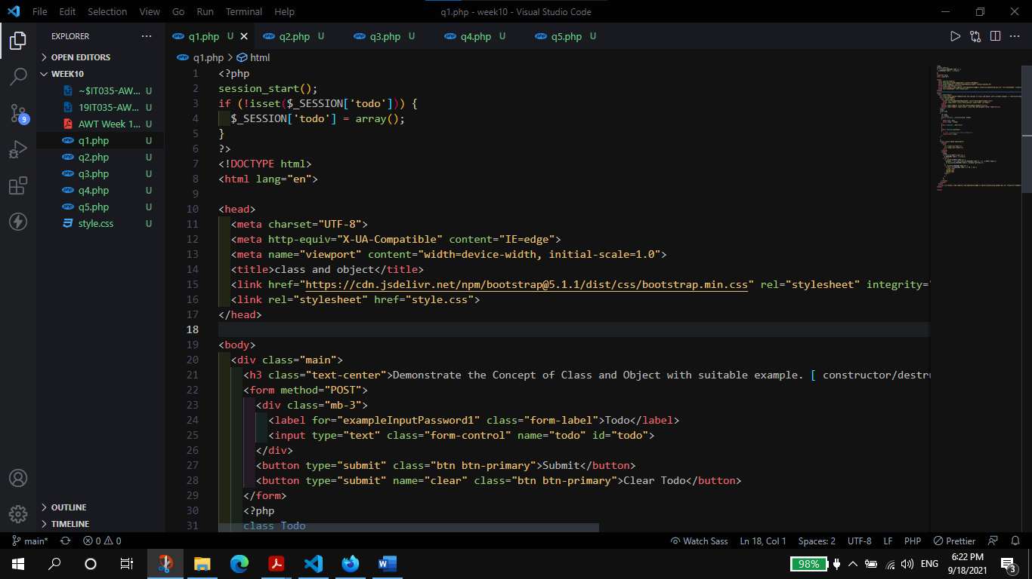

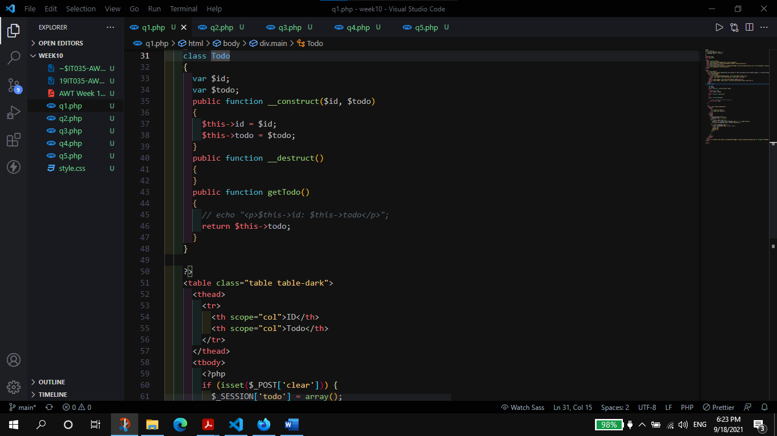

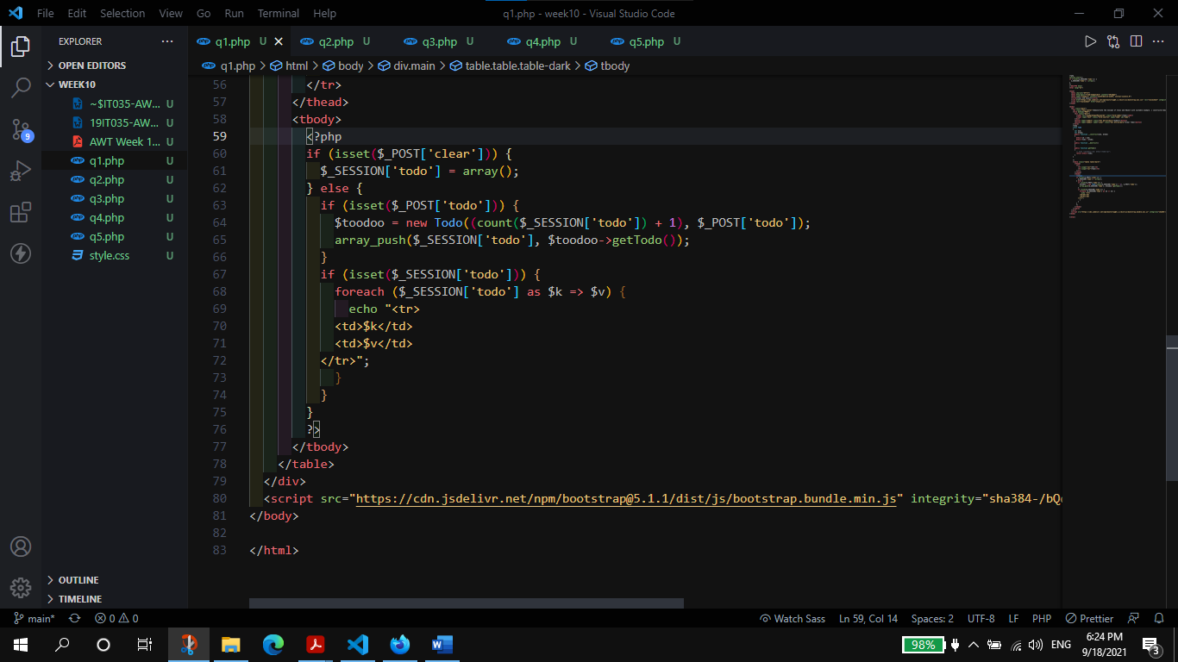

**Output:**

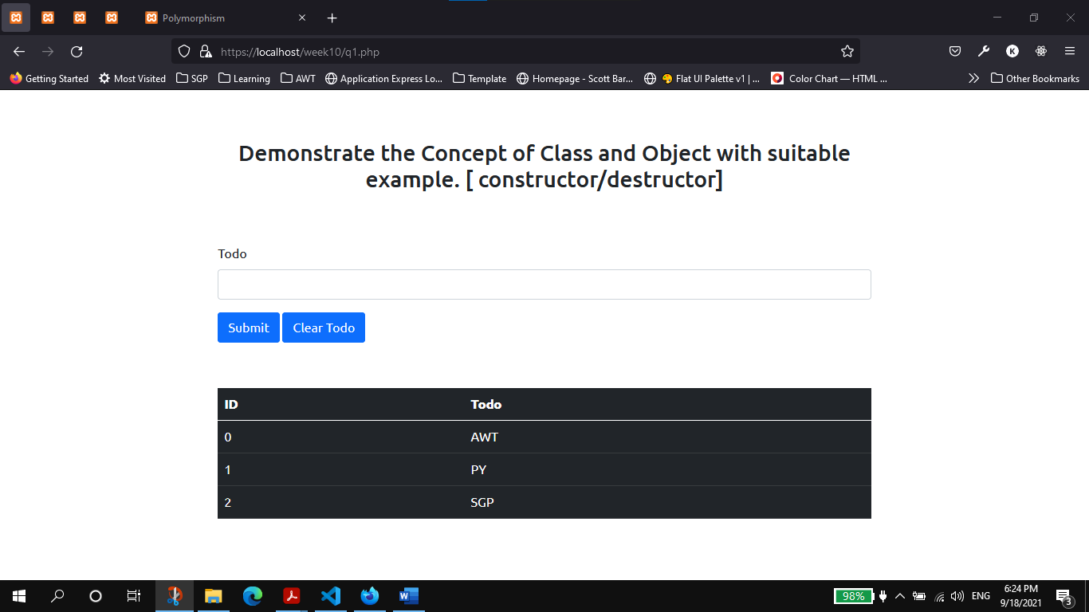

1. Demonstrate the Instance Members and Class Members (static + const) [ $this and self ]

**Code**:

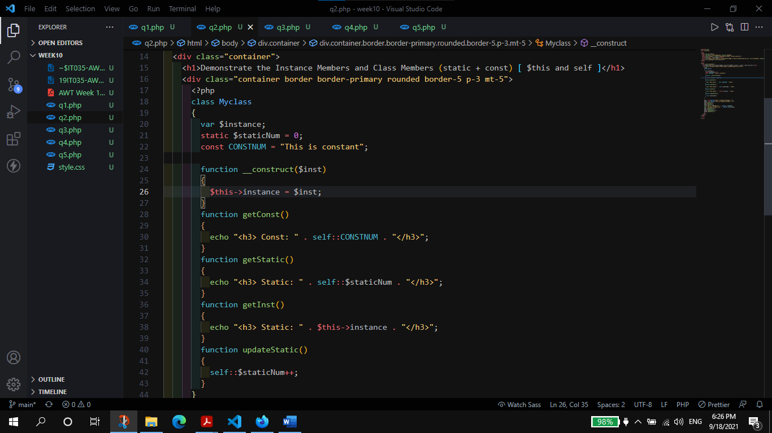

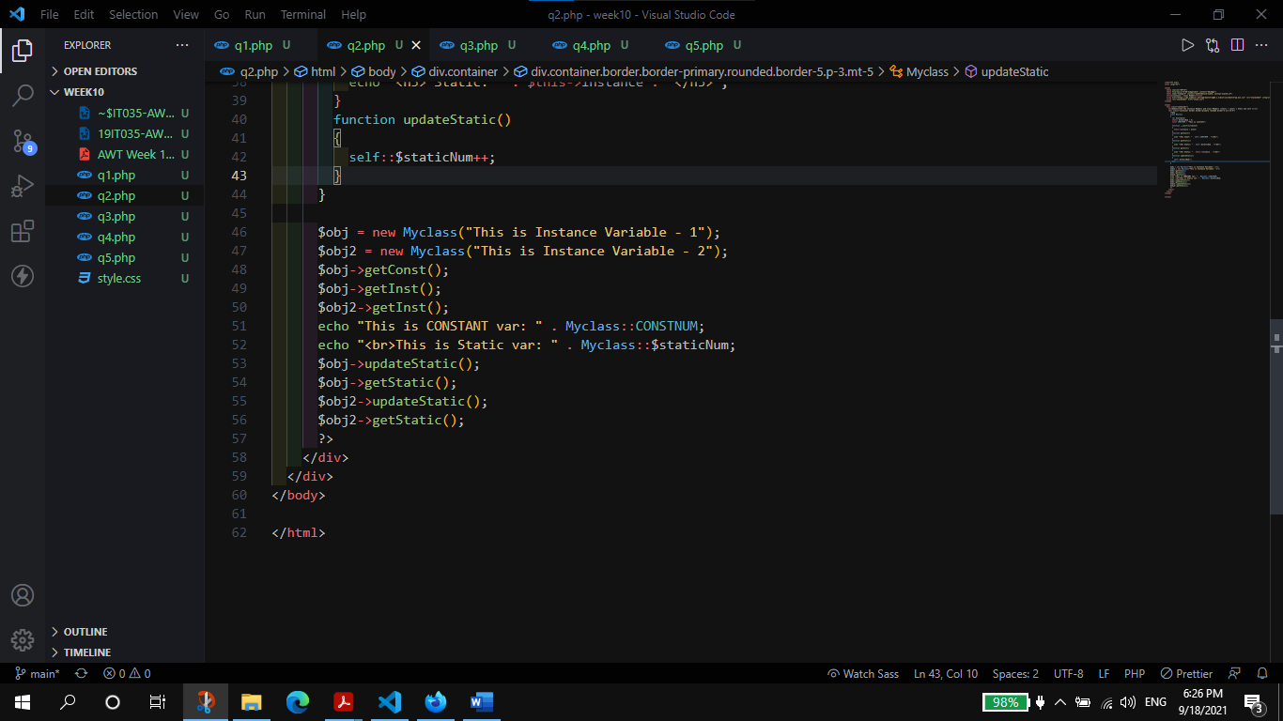

**Output:**

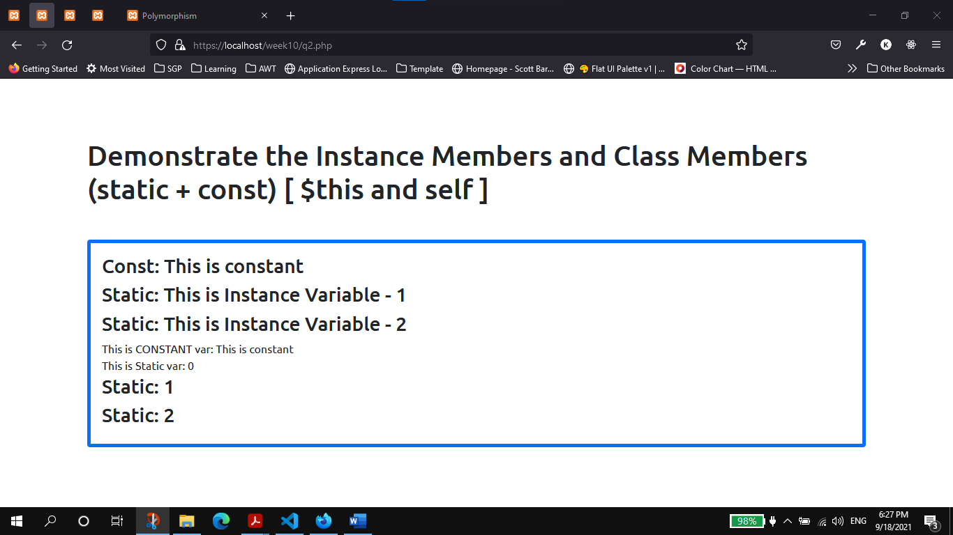

1. Demonstrate the inheritance/s [parent keyword].

**Code:**

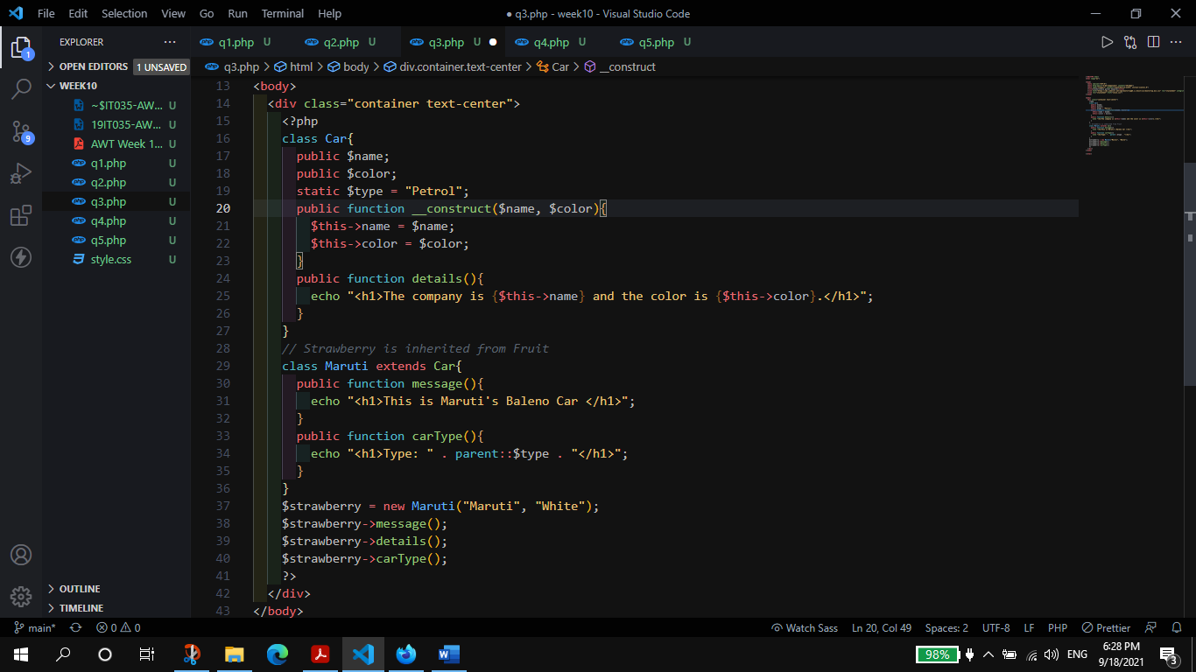

**Output:**

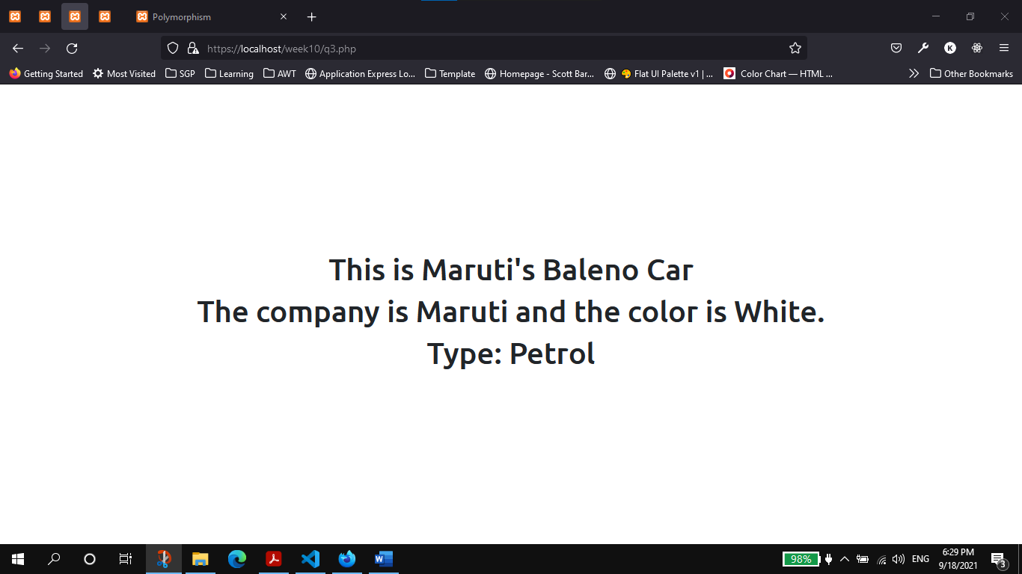

1. Demonstrate the Abstract Class and Interfaces with suitable examples.

**Code:**

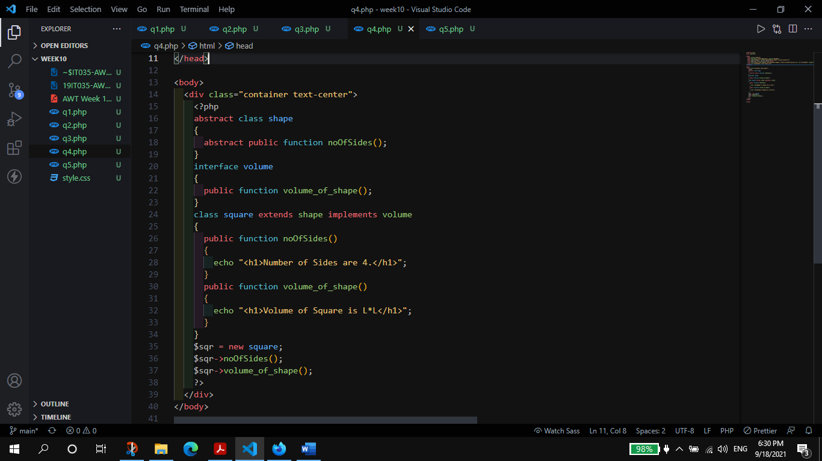

**Output:**

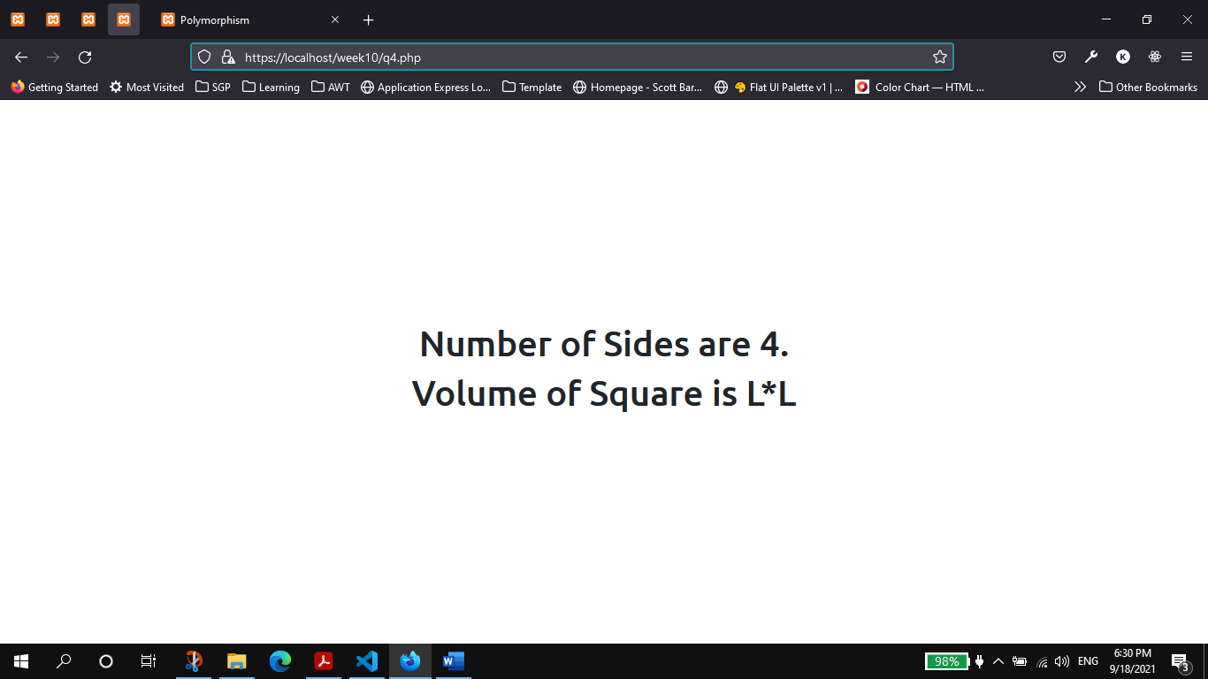

1. Demonstrate Polymorphism with suitable examples.

**Code:**

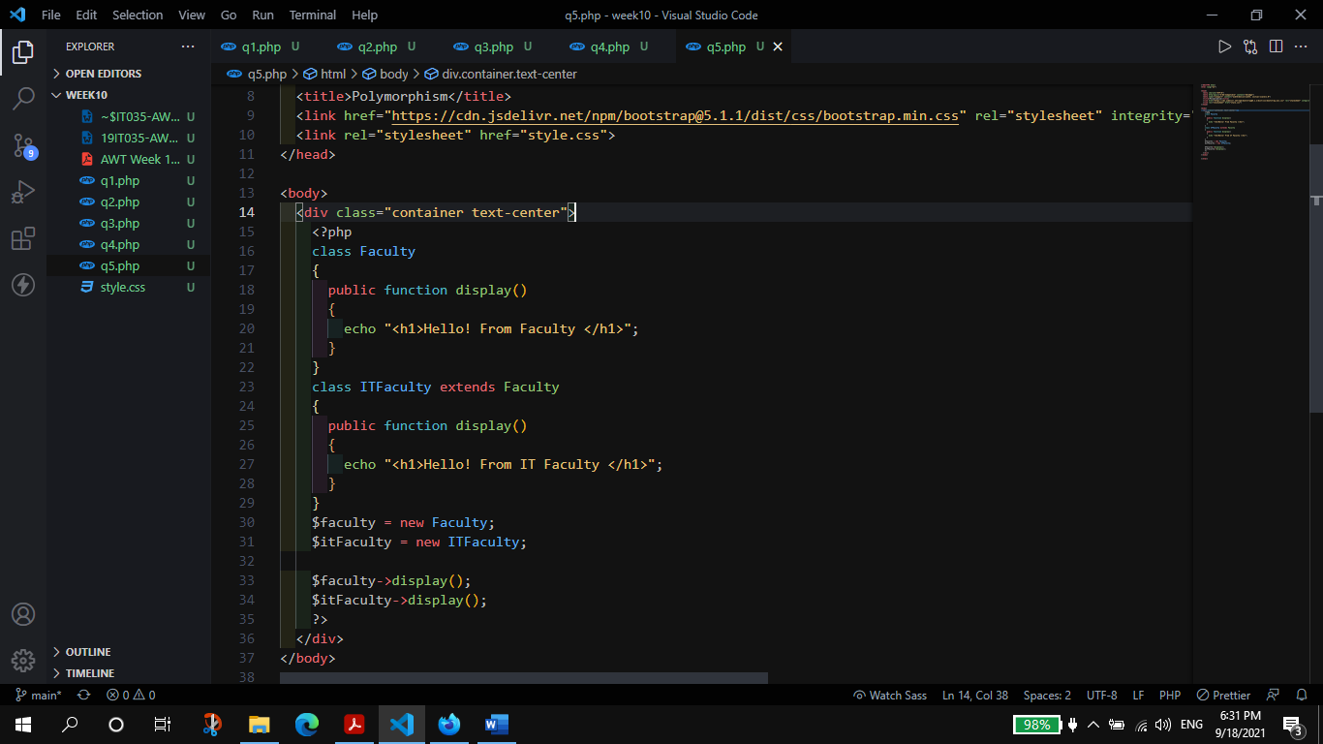

**Output:**

