**AWT Practical *Week - 13 Task***

**Web Services Using PHP**

1. Consume web-service(API) using php & display it on webpage from https://openweathermap.org/ or any other web-service.

**Code:**

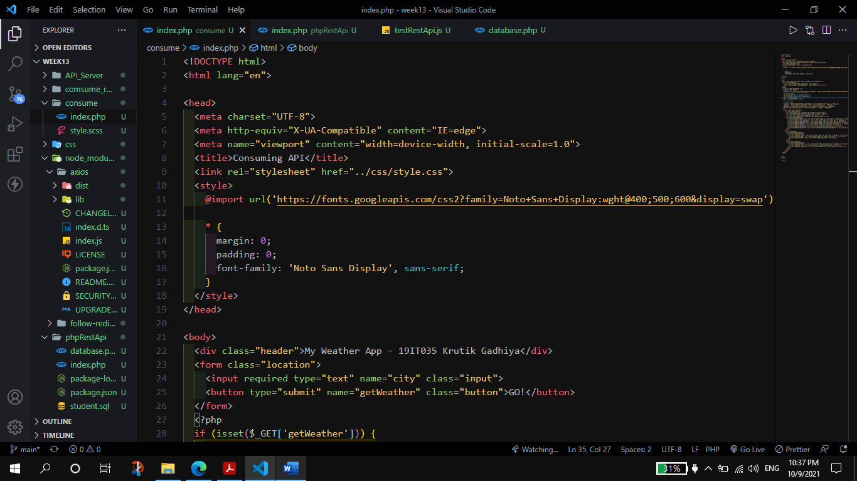

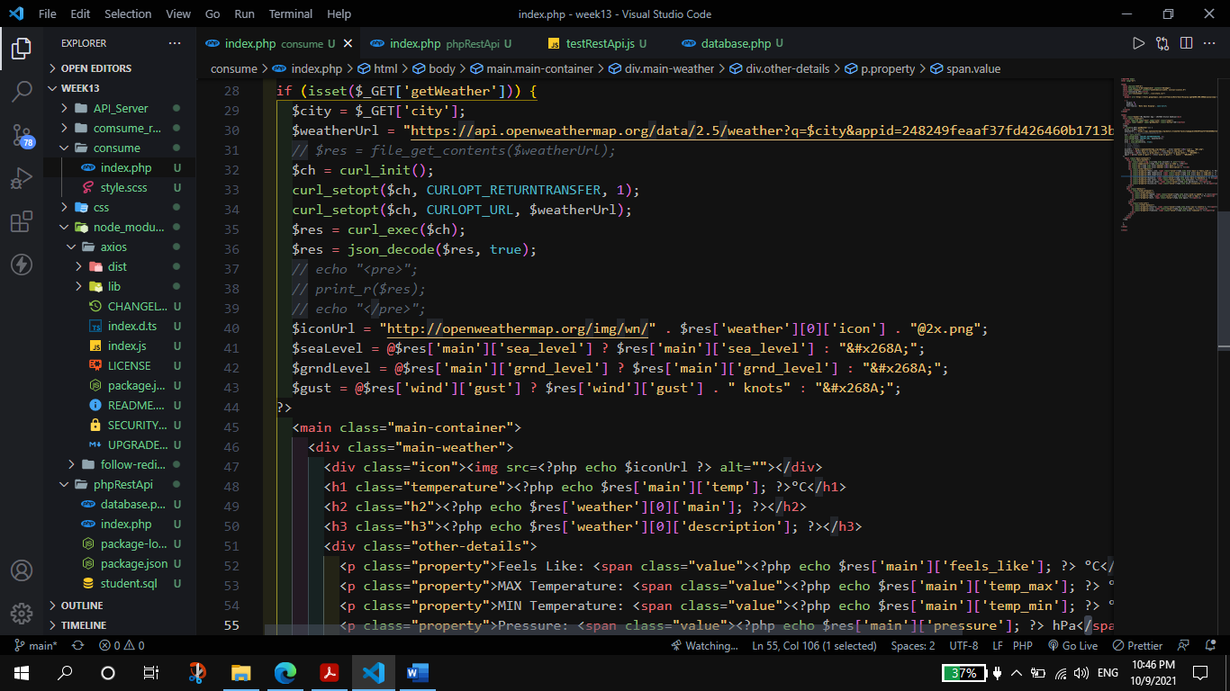

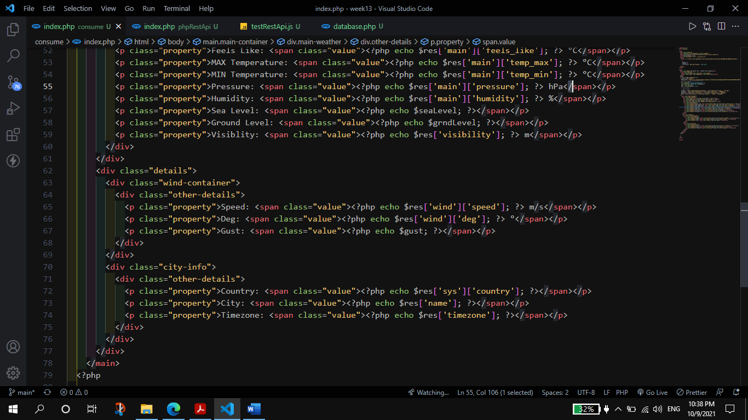

**Output:**

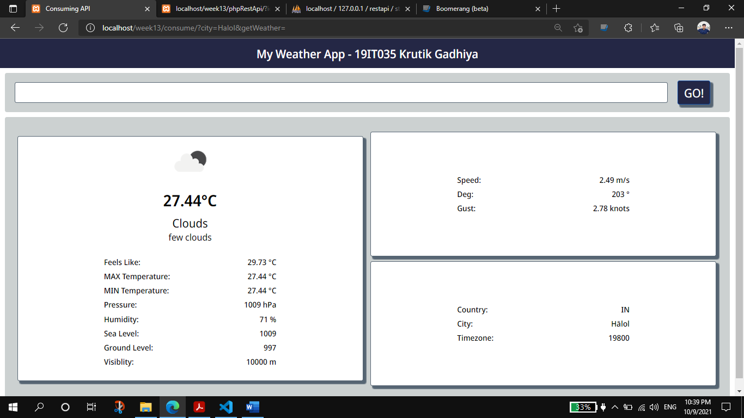

1. Create REST- API using PHP and Consume it in Python/Java/Nodejs.
2. API will receive Student Id using GET method and response with Student Details in JSON from Database.
3. API will receive student data(json) to update student details in database using POST Method]

**Code**:  **Database.php**

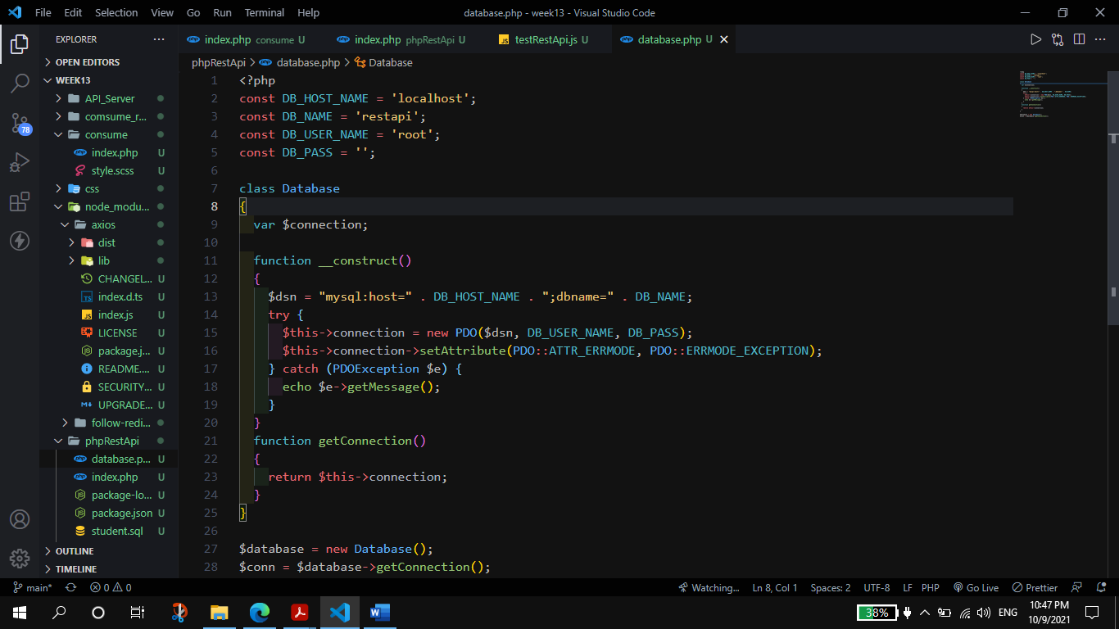

**index.php (api)**

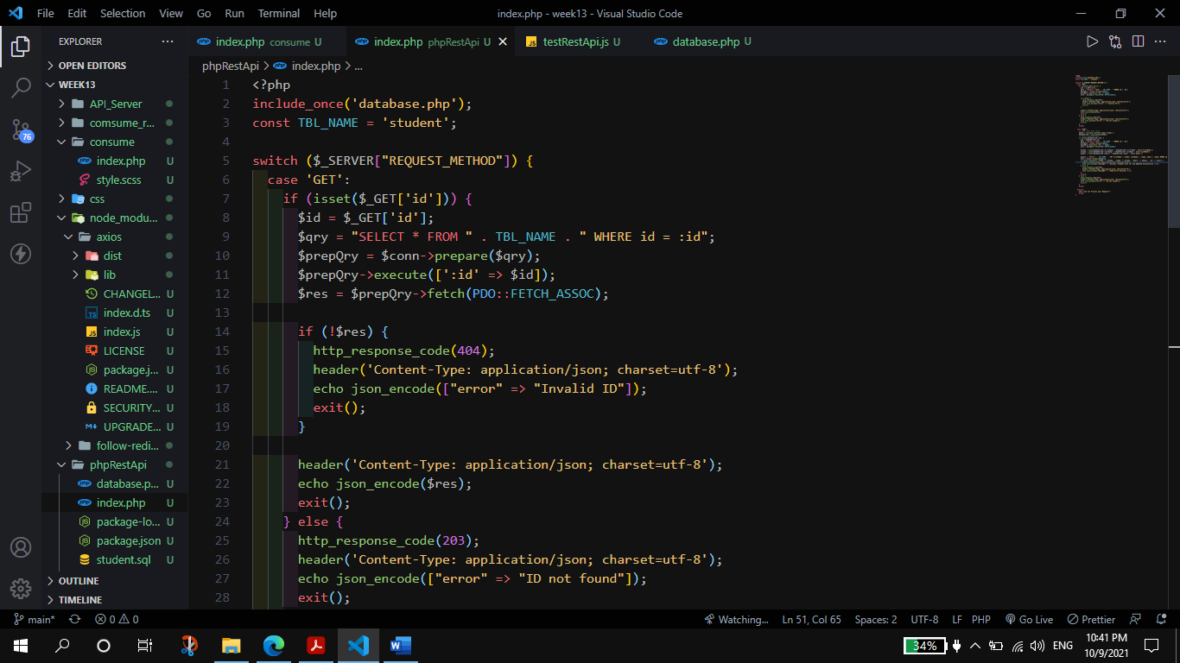

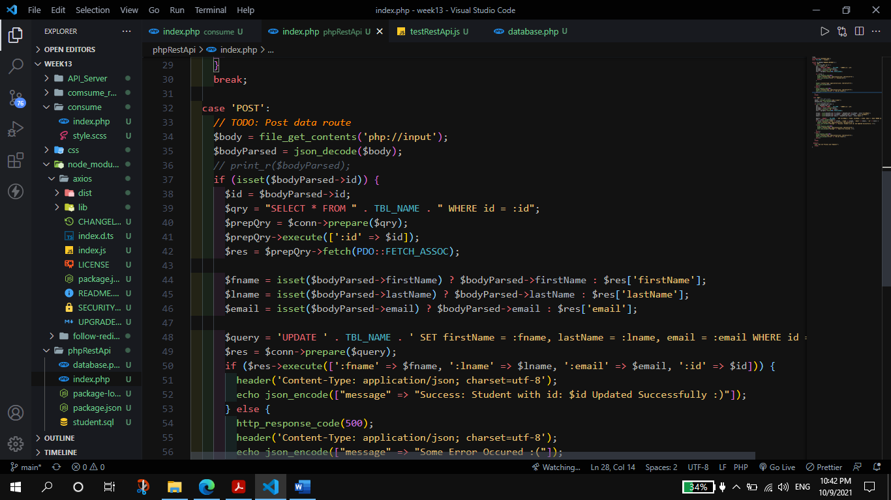

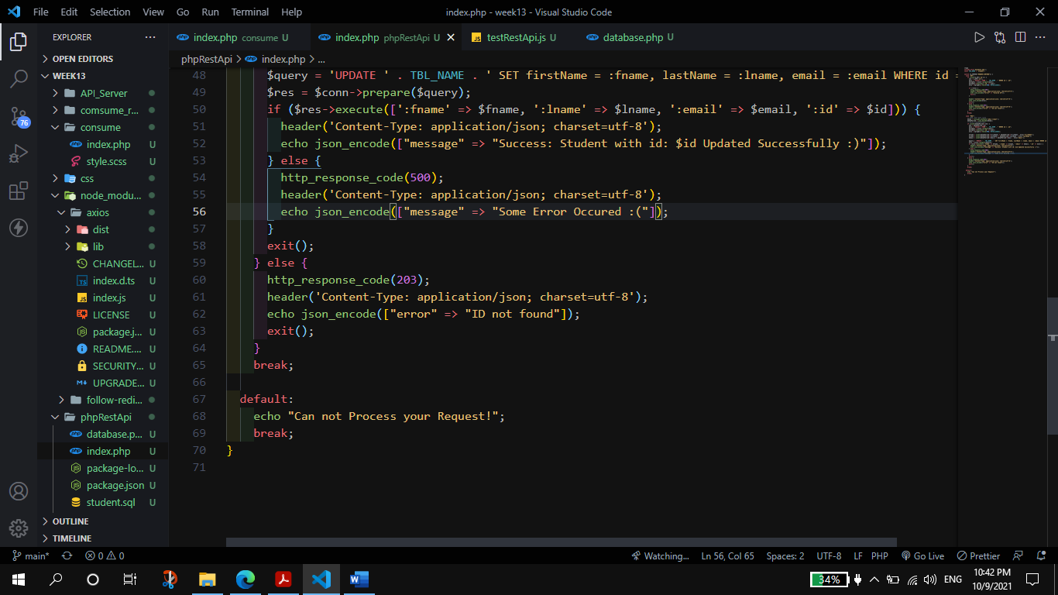

**testRestApi.js**

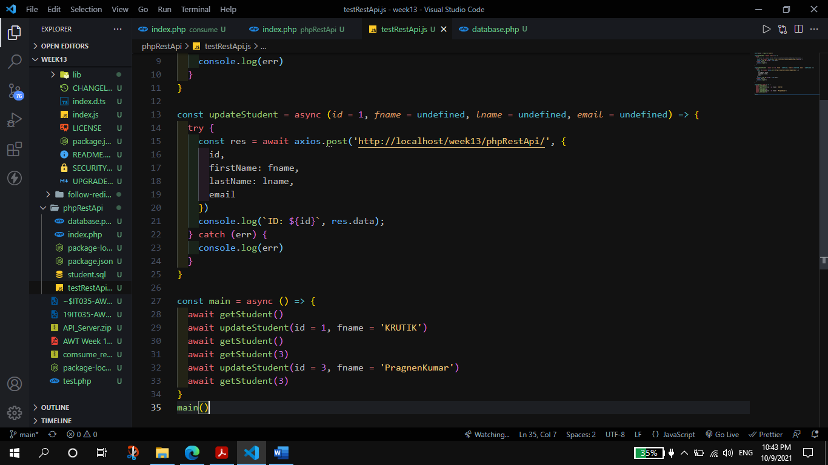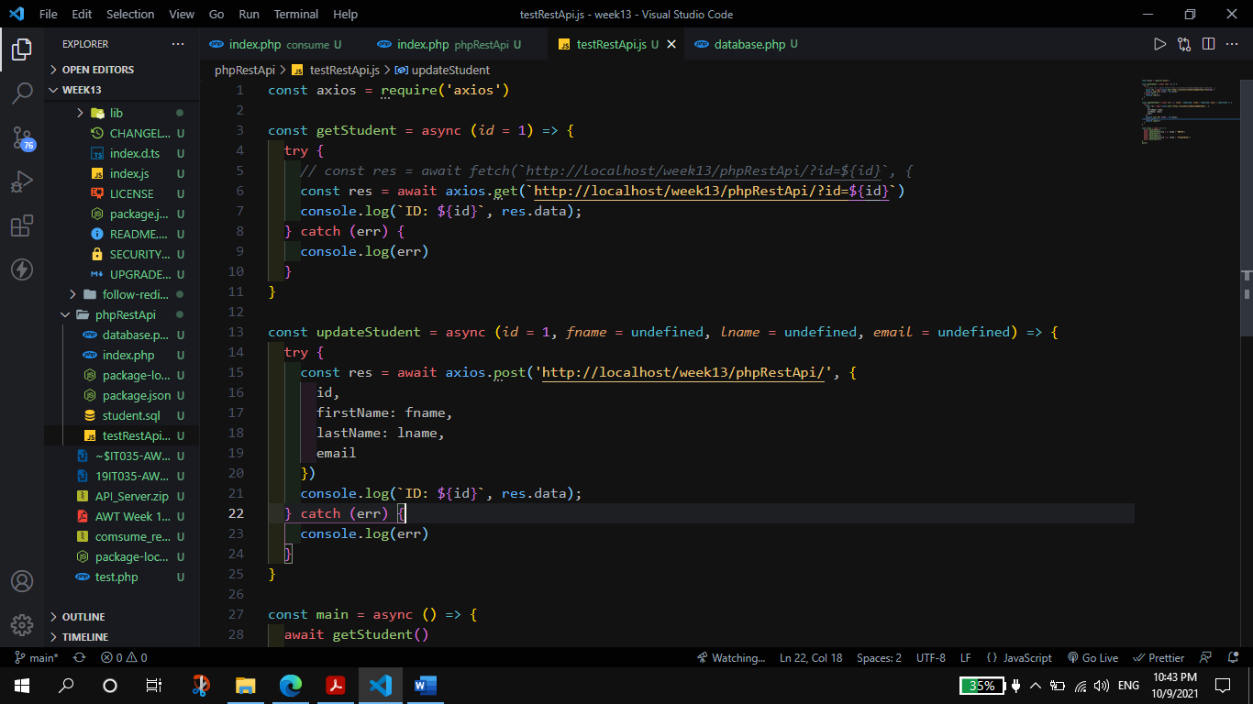

**Output:**

