**AWT Practical *Week - 15 Task***

**JQuery and Ajax PHP**

1. Experiments with Jquery:

**a.** document.ready()

**b.** jQuery Effects - Hide and Show, Fading,Sliding etc

**c.** jQuery Manipulating CSS

**d.** jQuery DOM Manipulation (val,text etc)

**Code:**

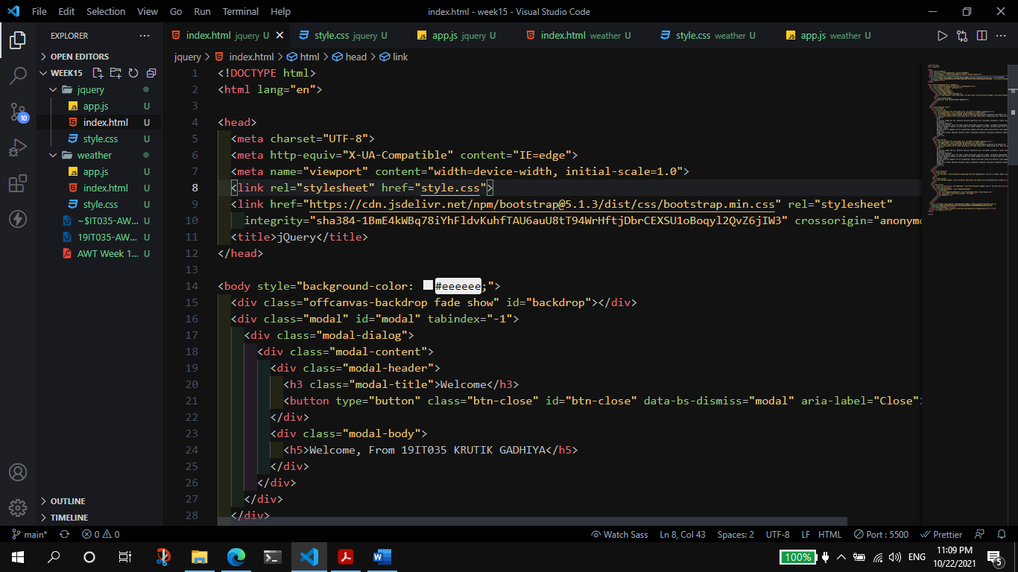

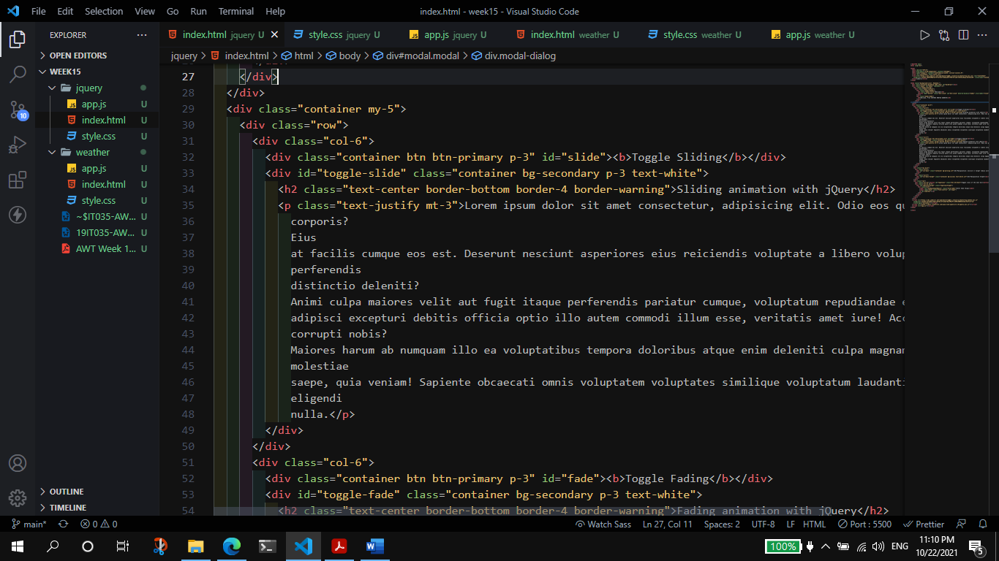

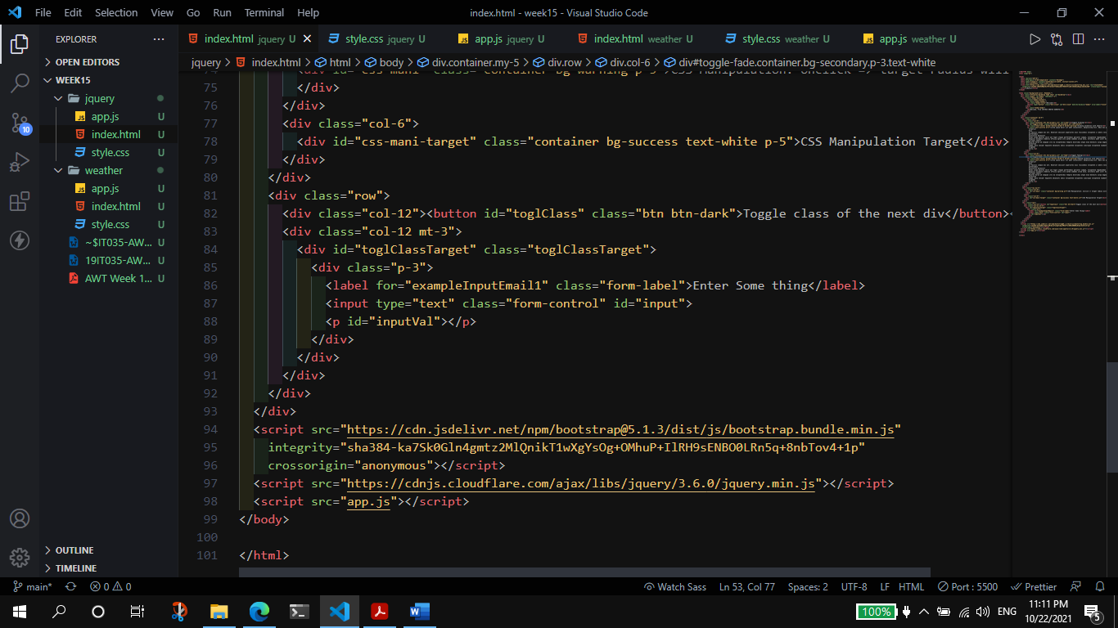

**JS (JQuery):**

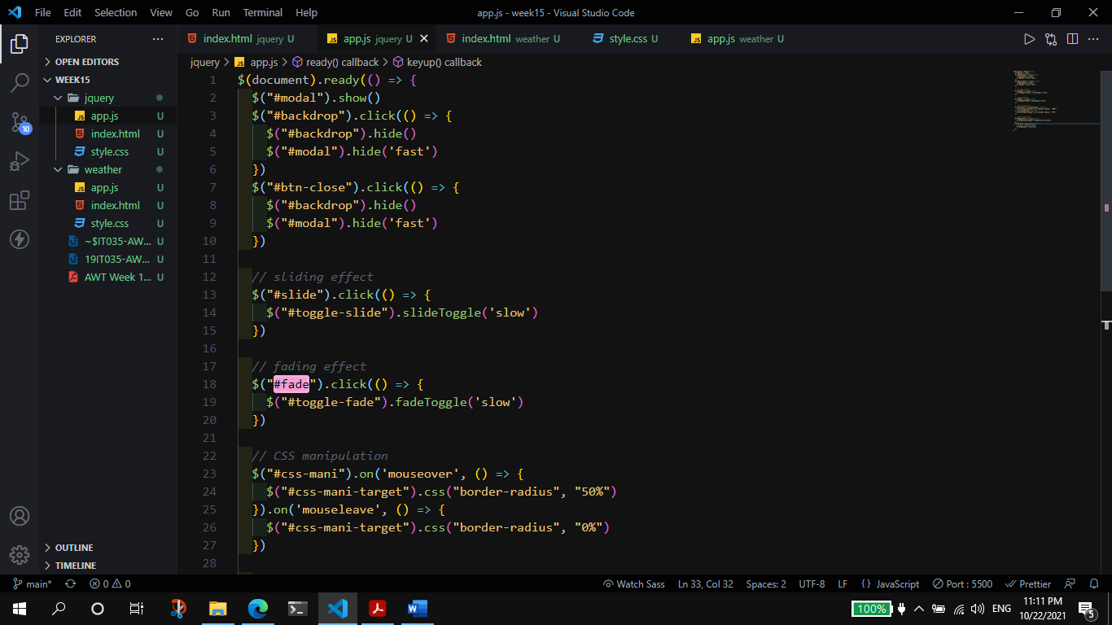

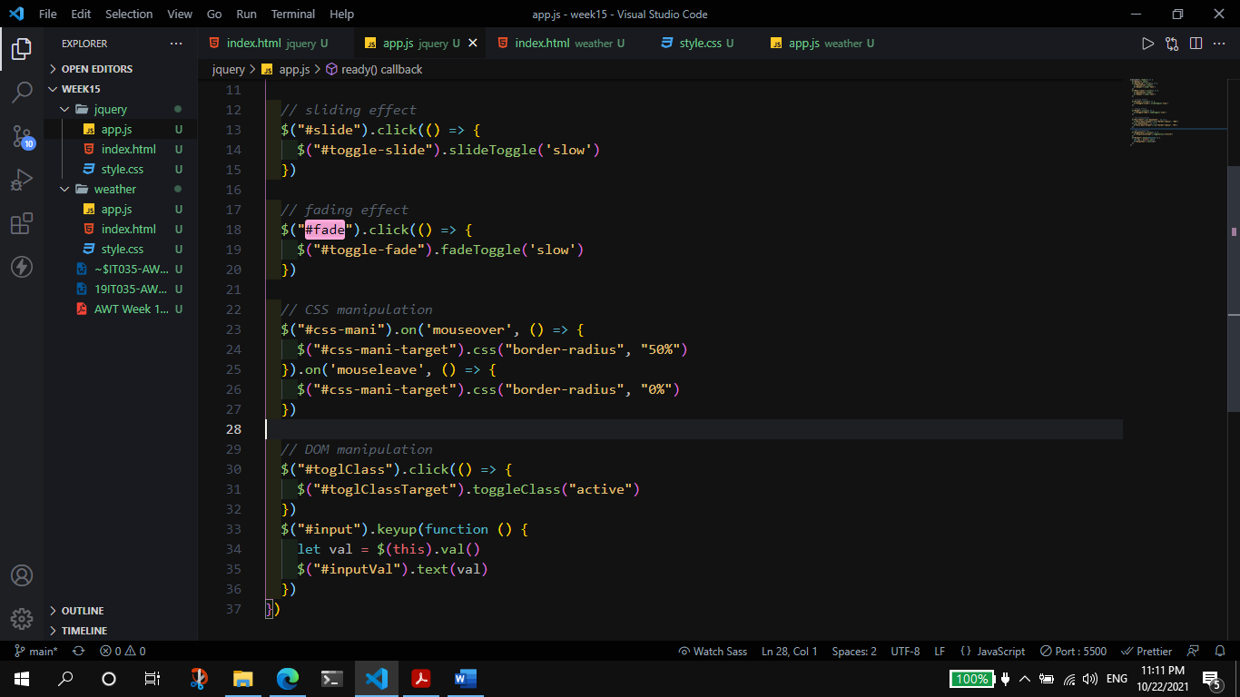

**Output:**

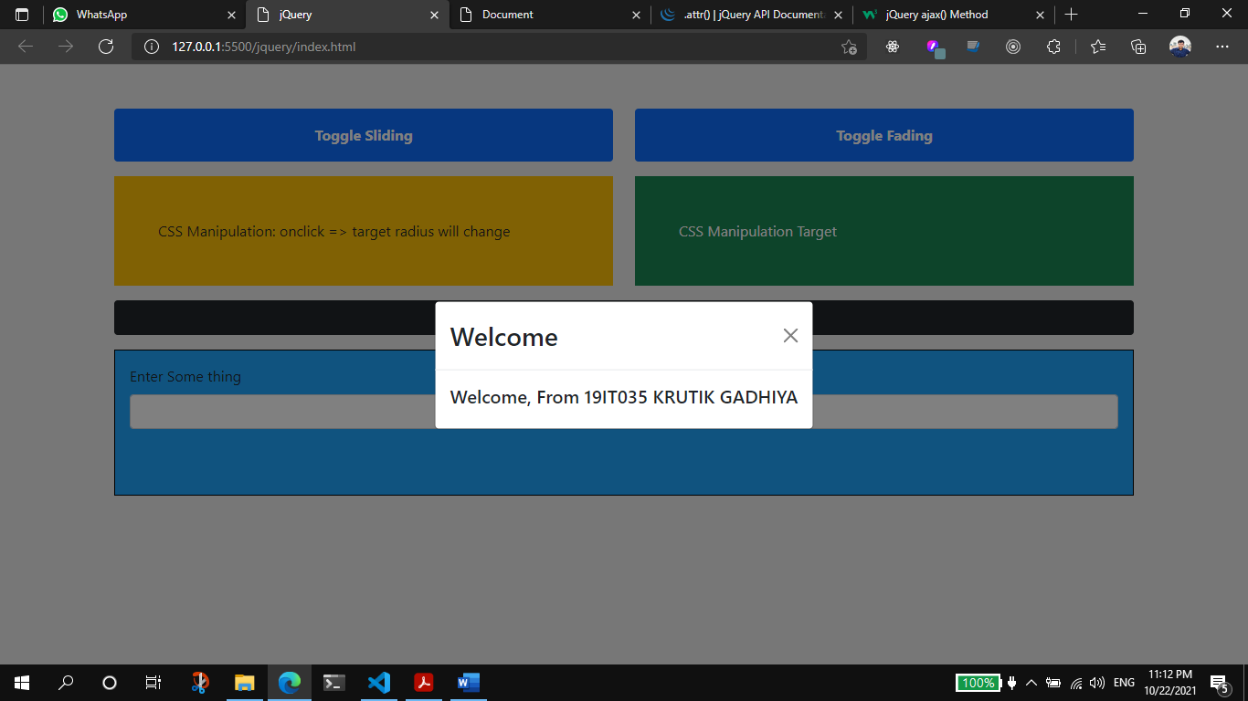

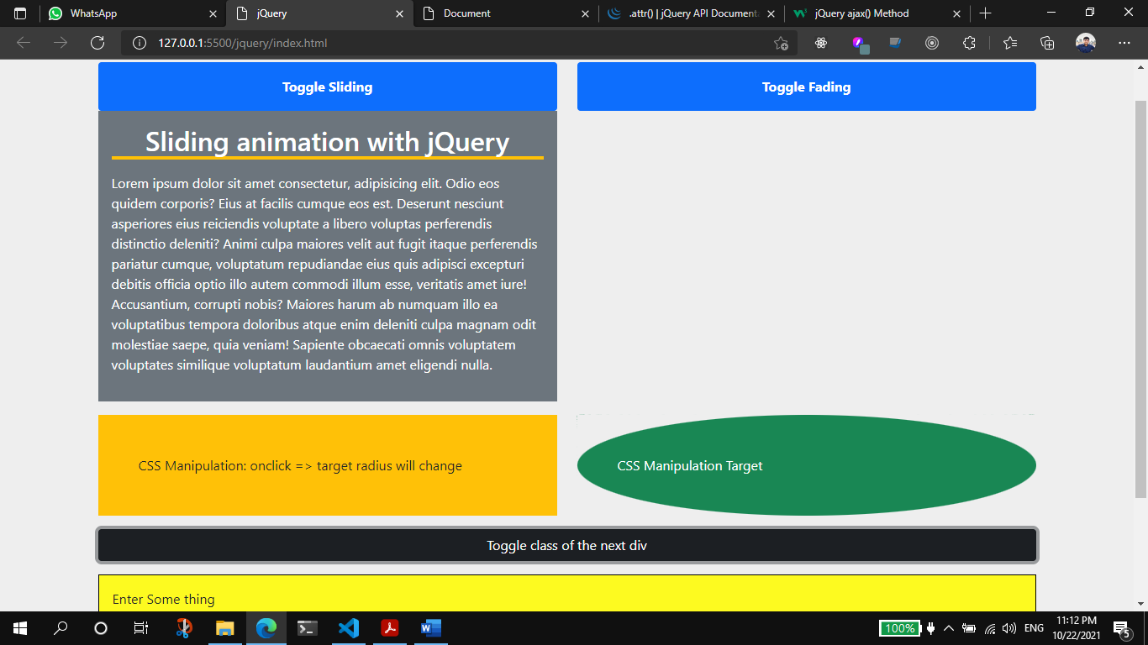

1. Show current weather information using jquery-ajax.

**a.** Enter City Name and Show weather info. on page using jquery-ajax(without page reloading)

**Code**

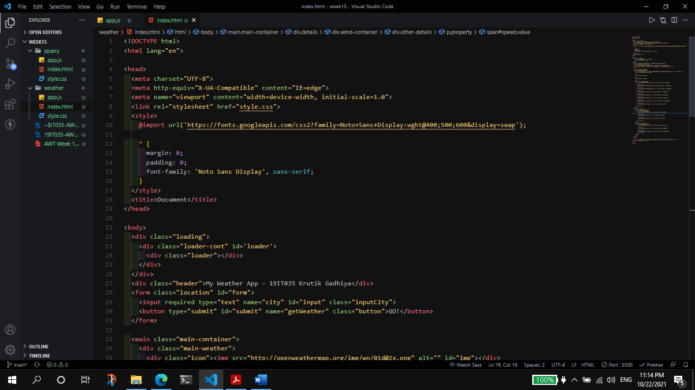

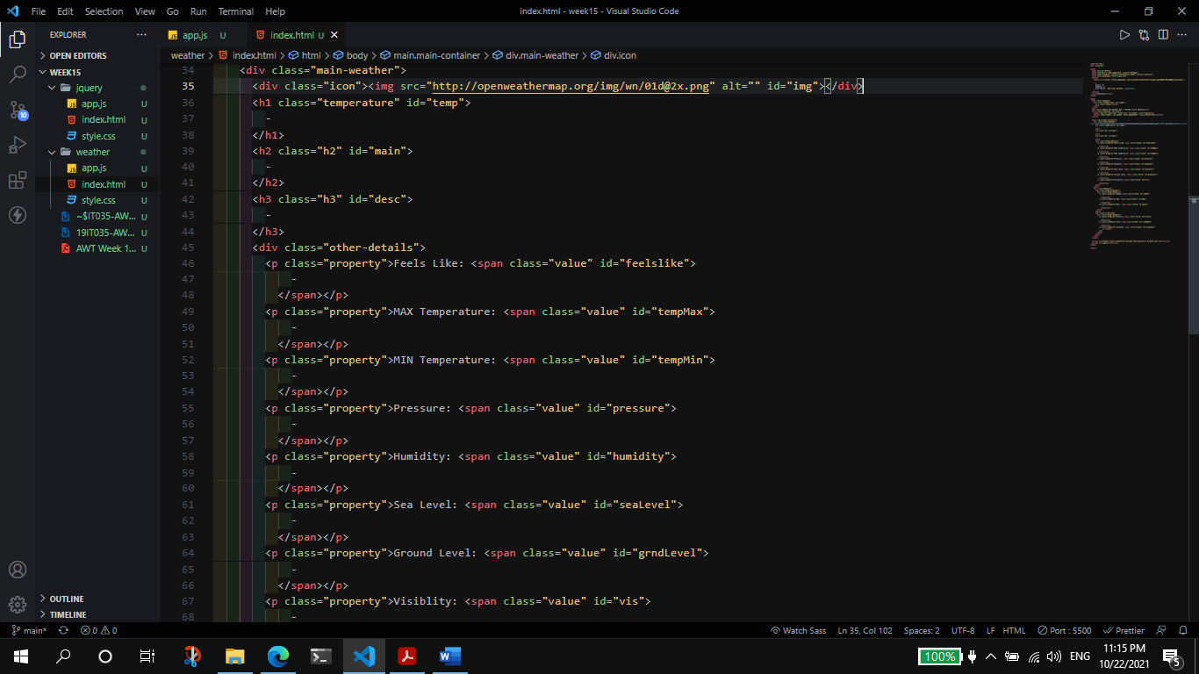

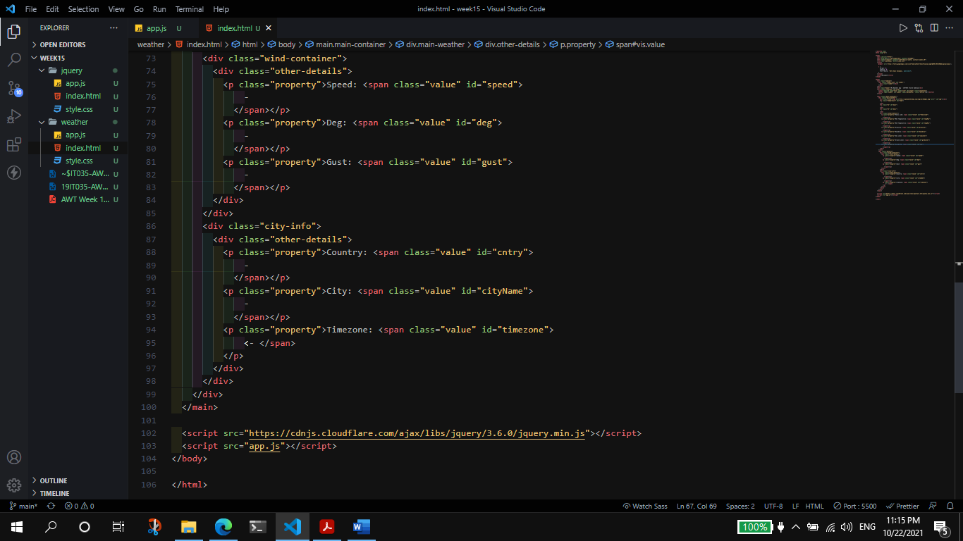

**JS (JQuery):**

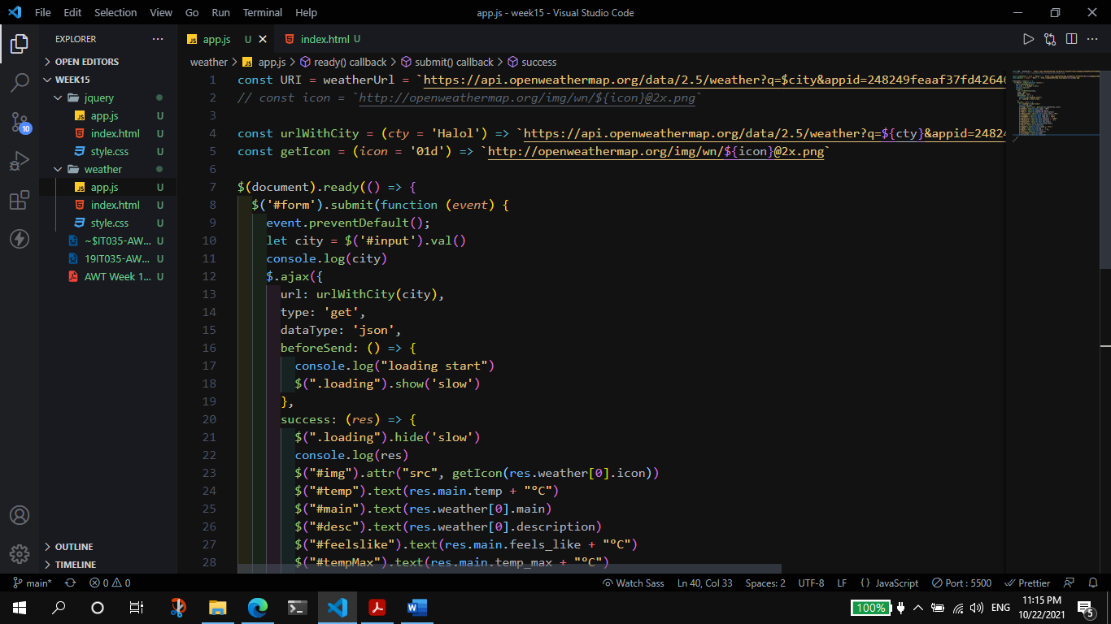

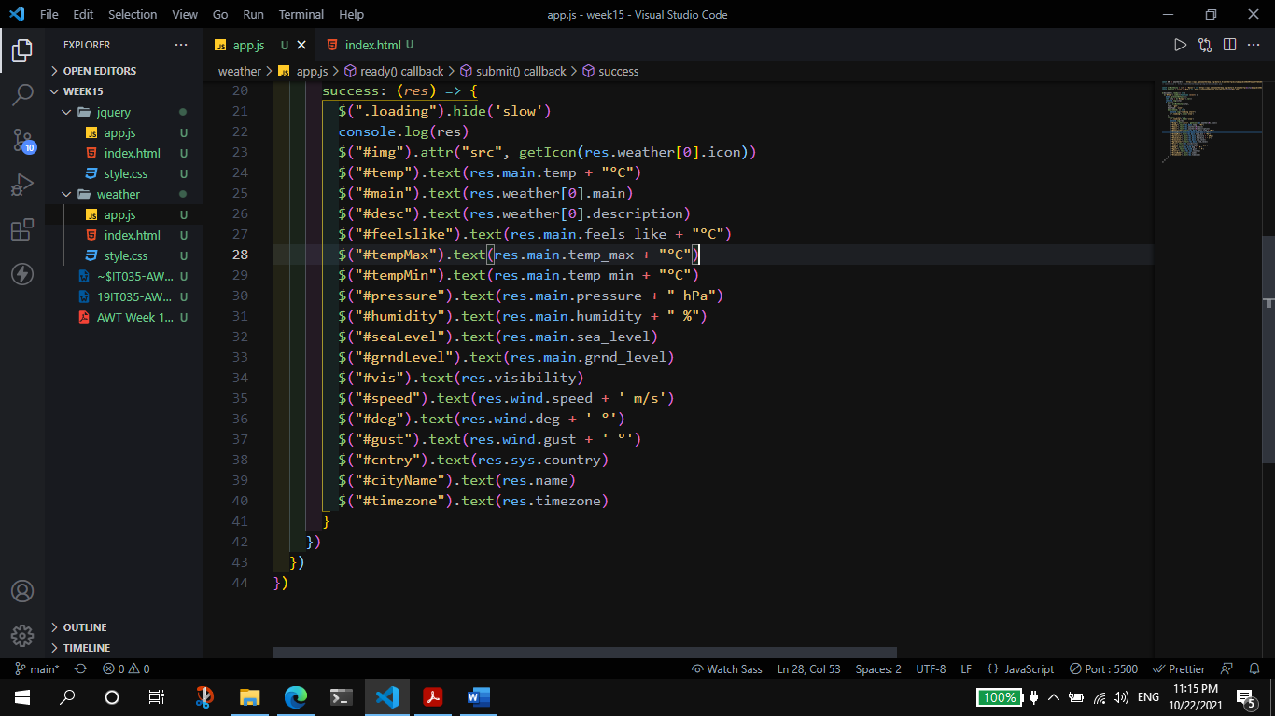

**Output:**

