**AWT Practical *Week - 4 Task***

**Date and Time**

1. Count Number of days, hours, minutes from your last birthday.

**Code:**

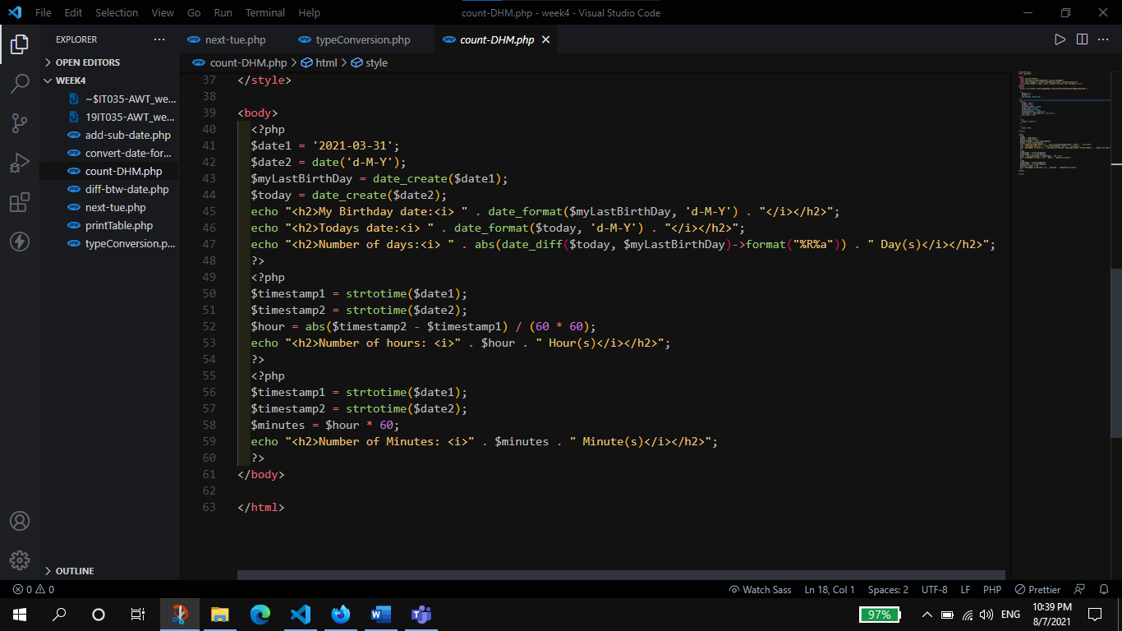

**Output:**

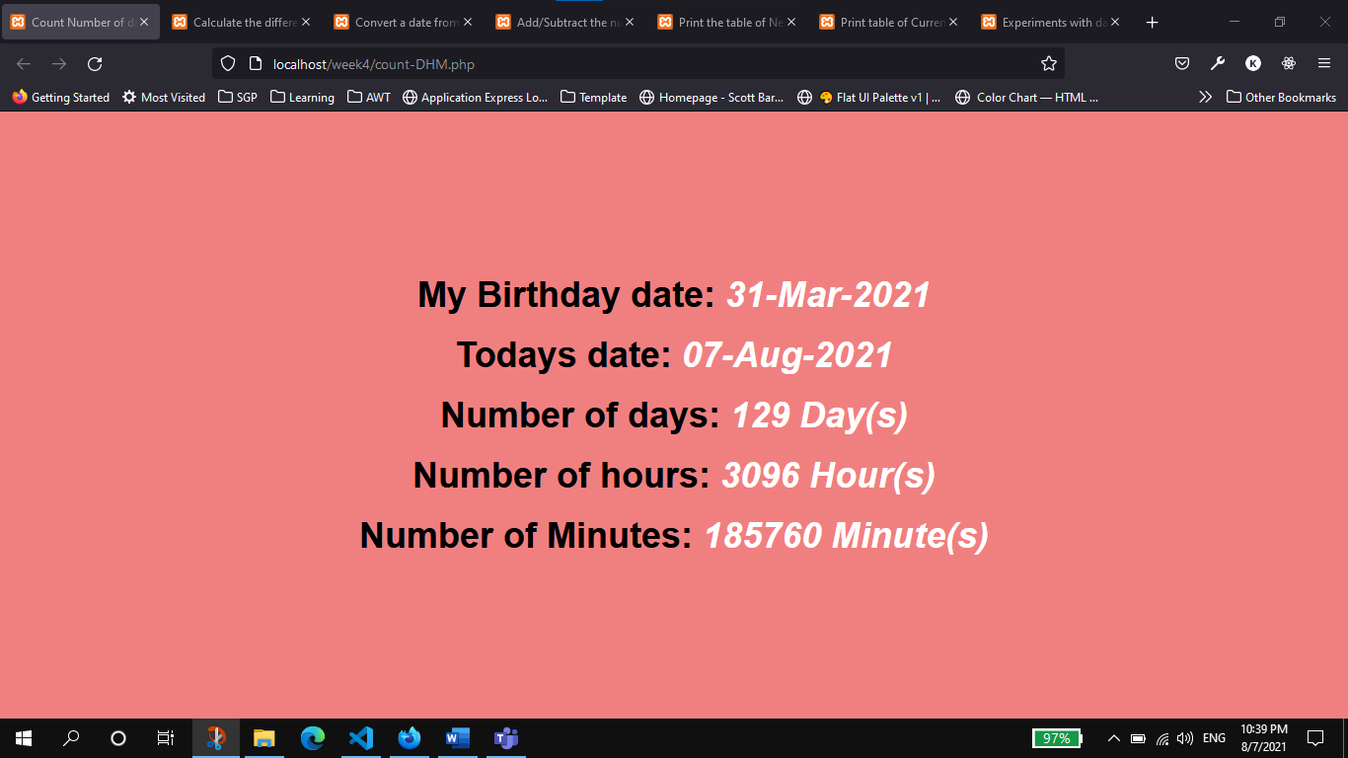

1. Calculate the difference between two dates. (date1:yyyy-mm-dd, date2:dd-mm-yyyy )

**Code:**

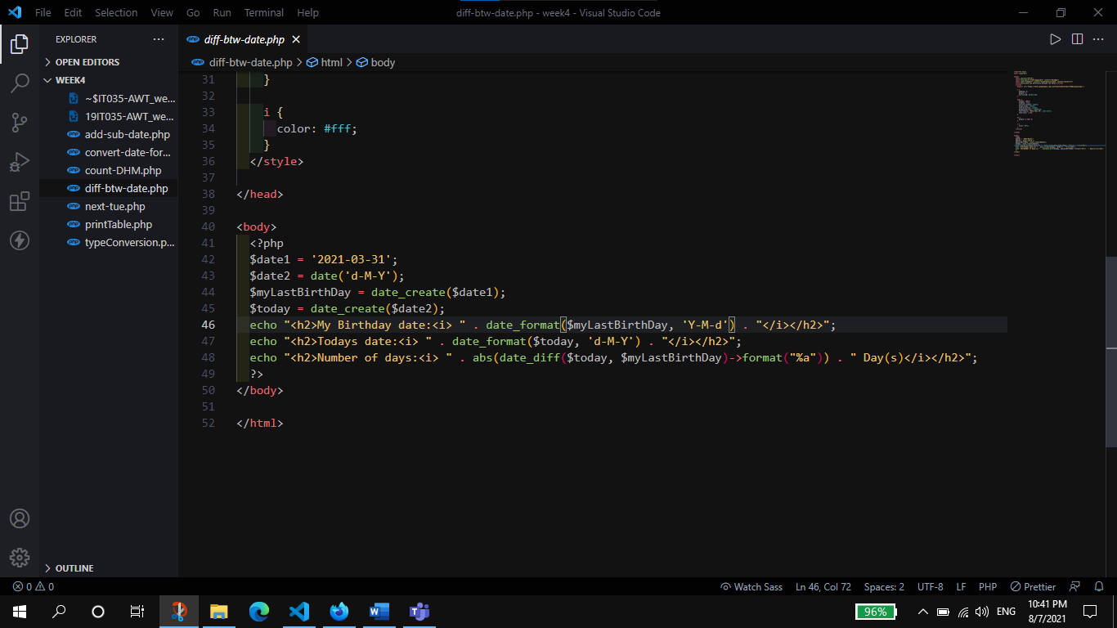

**Output:**

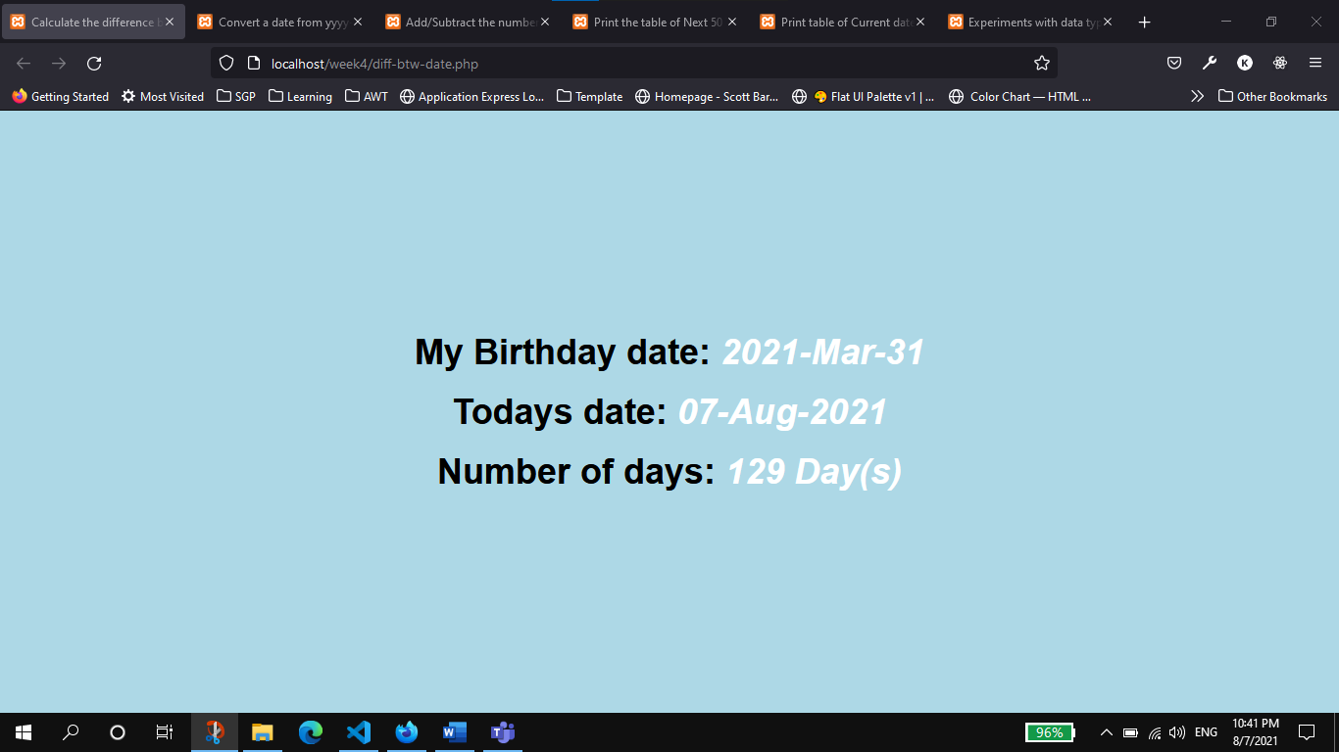

1. Convert a date from yyyy-mm-dd to dd-mm-yyyy.

**Code:**

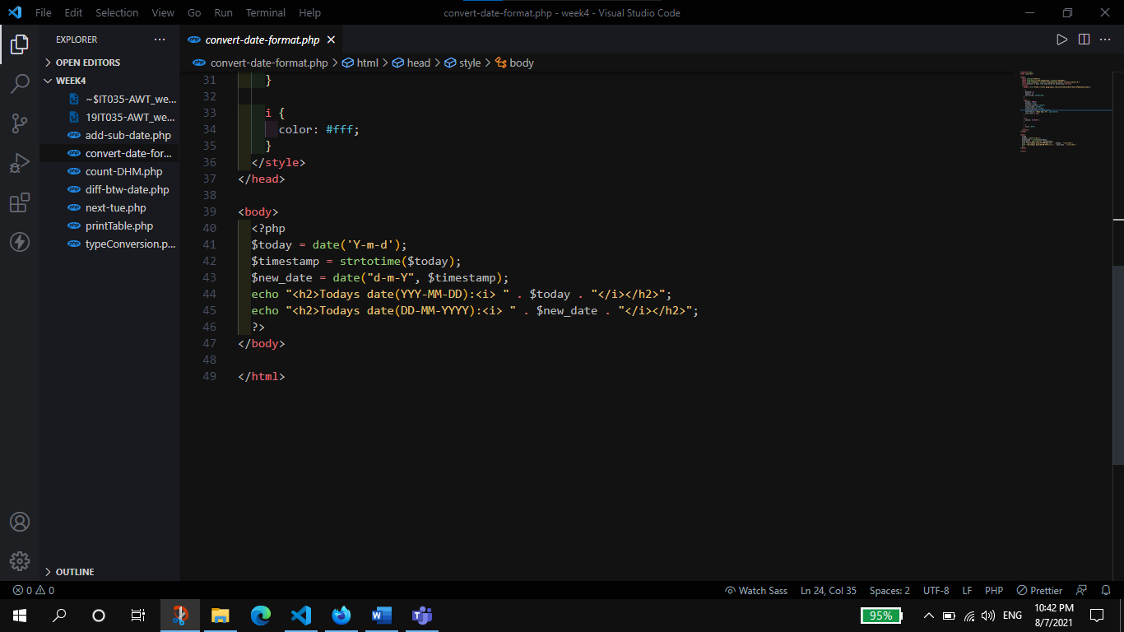

**Output:**

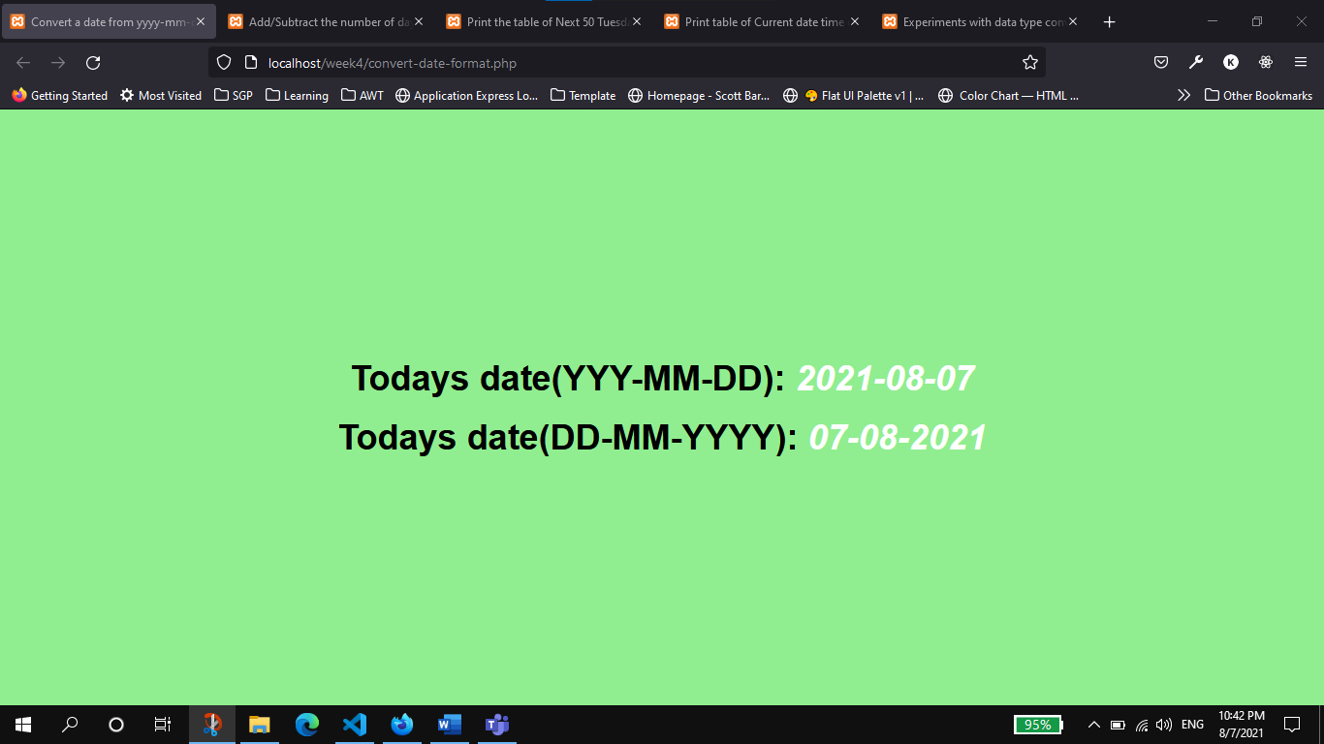

1. Add/Subtract the number of days from a given date.

**Code:**

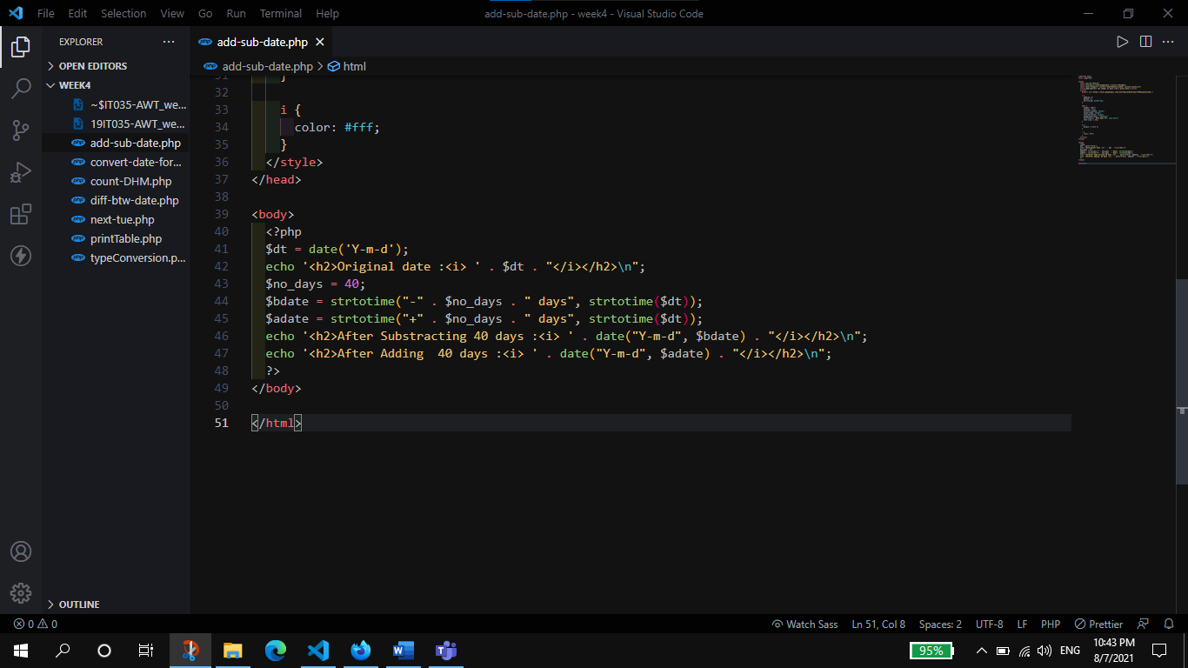

**Output:**

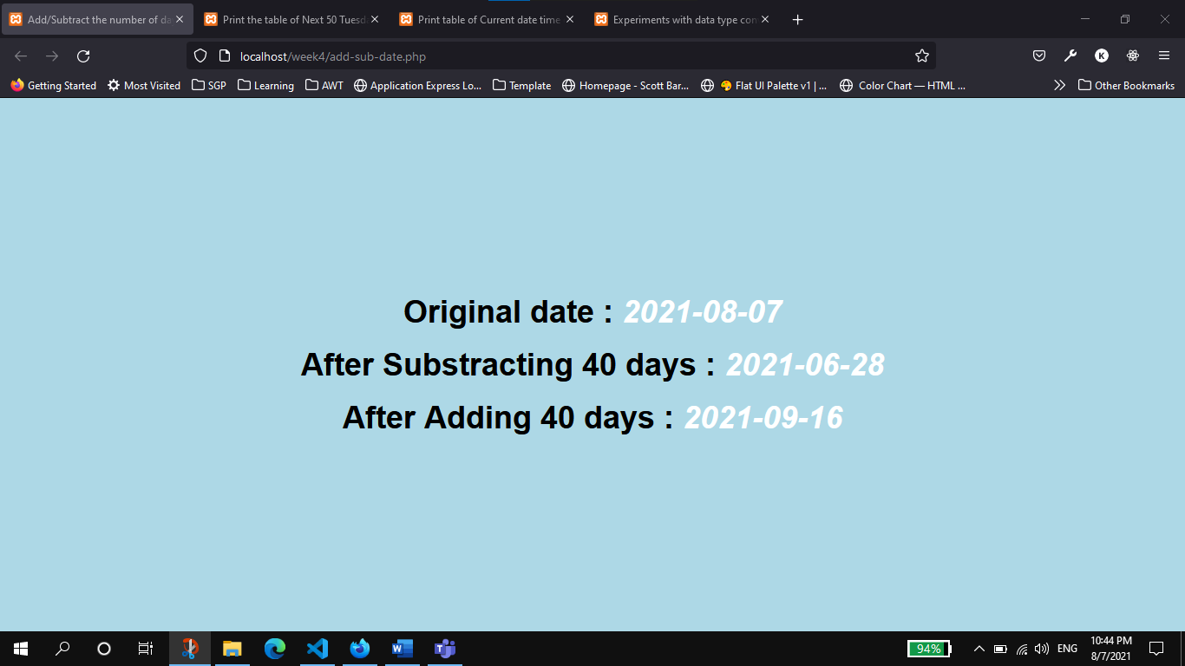

1. Print the table of Next 50 Tuesday from the given date.

**Code:**

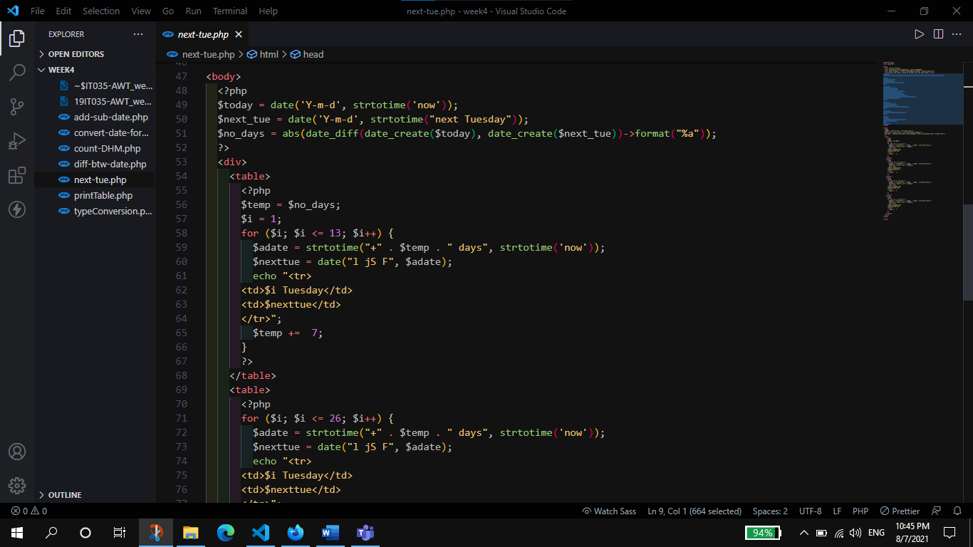

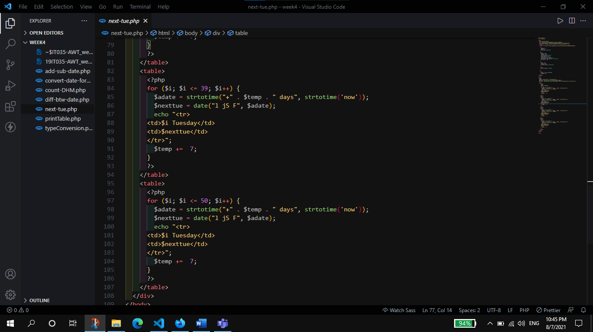

**Output:**

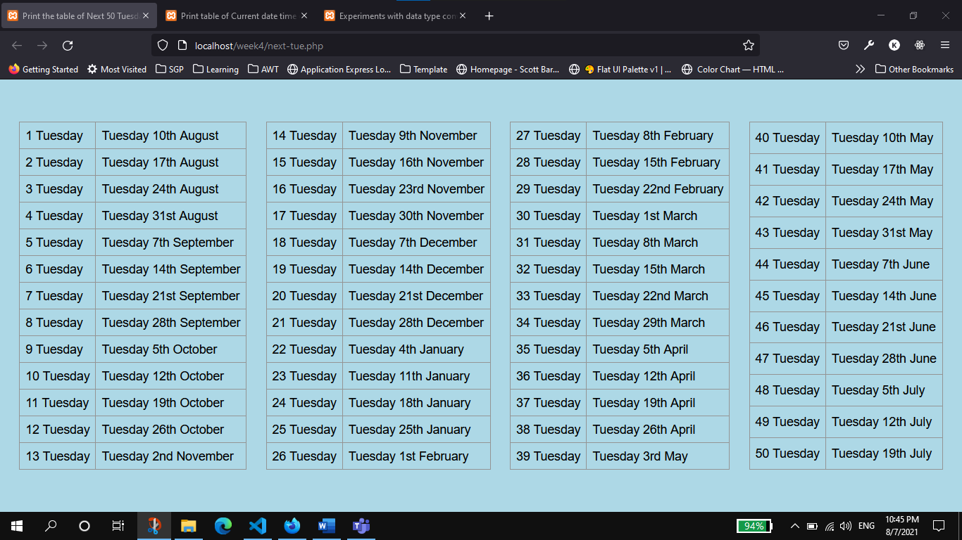

1. Print table of Current date time of UK , USA, India and Israel.

**Code:**

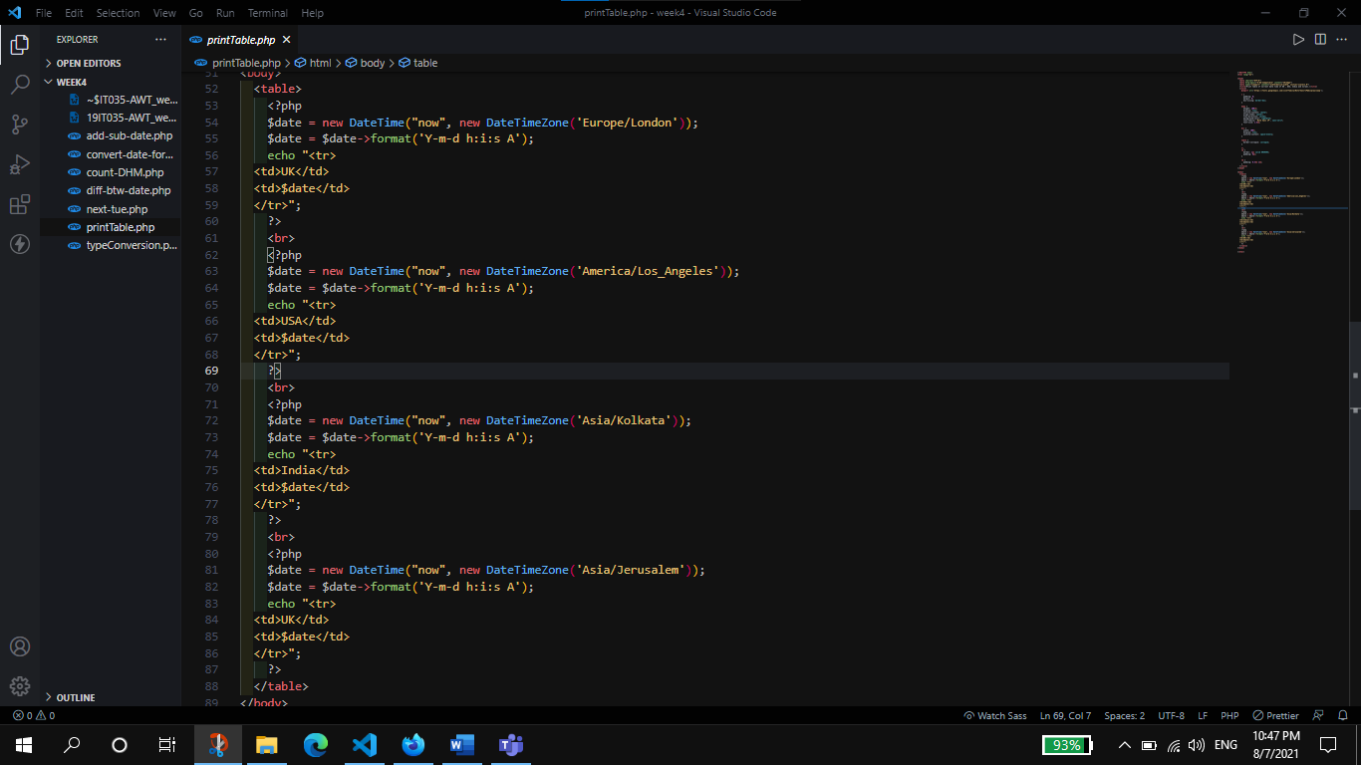

**Output:**

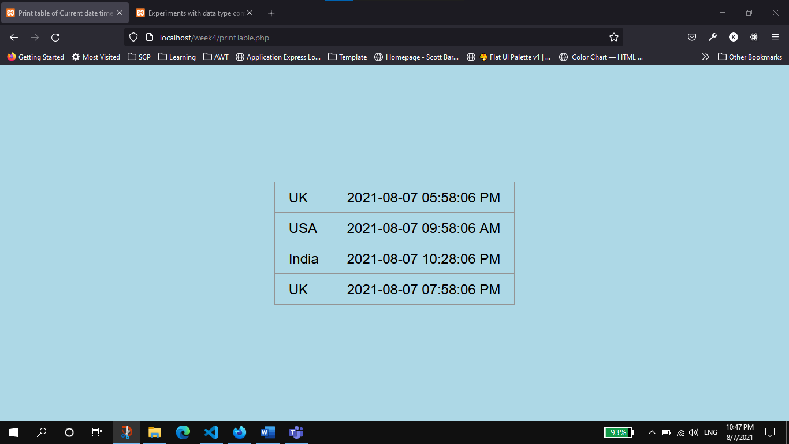

**Data Type Conversion**

1. Experiments with data type conversion in PHP.

**Code:**

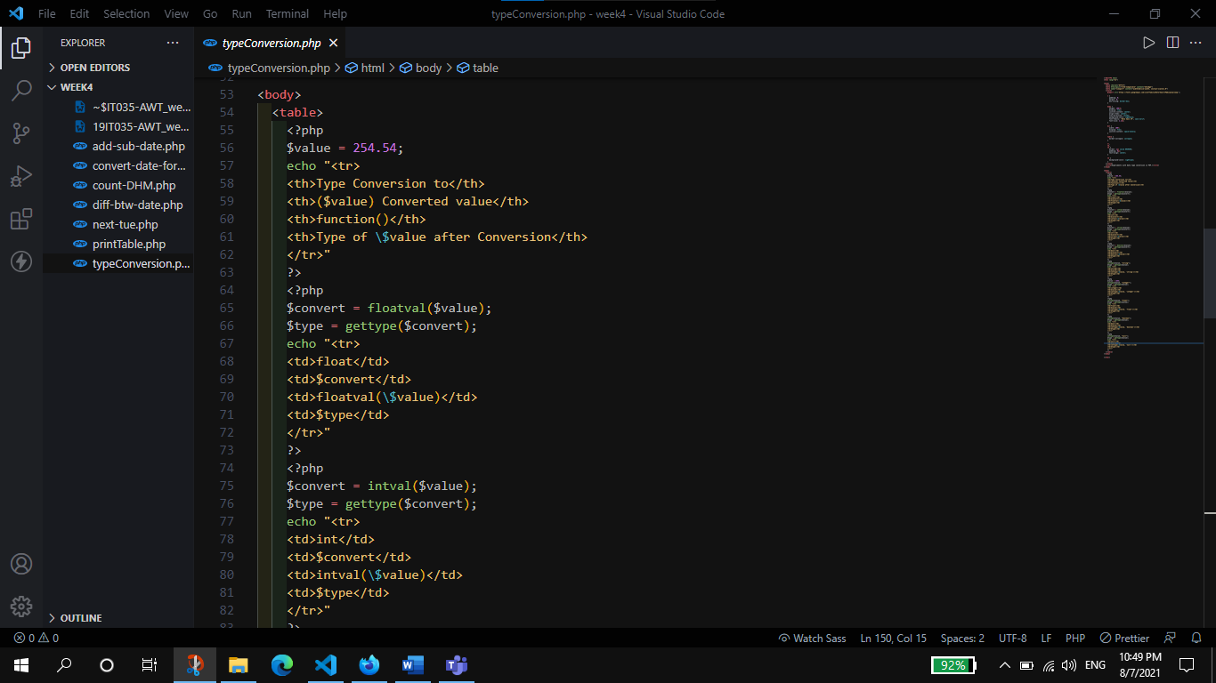

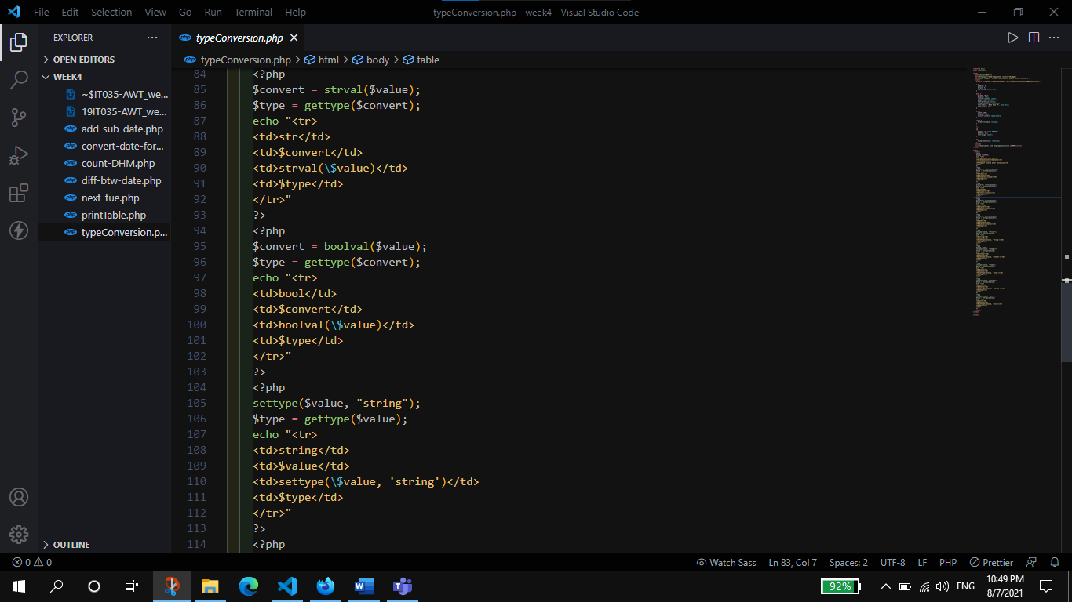

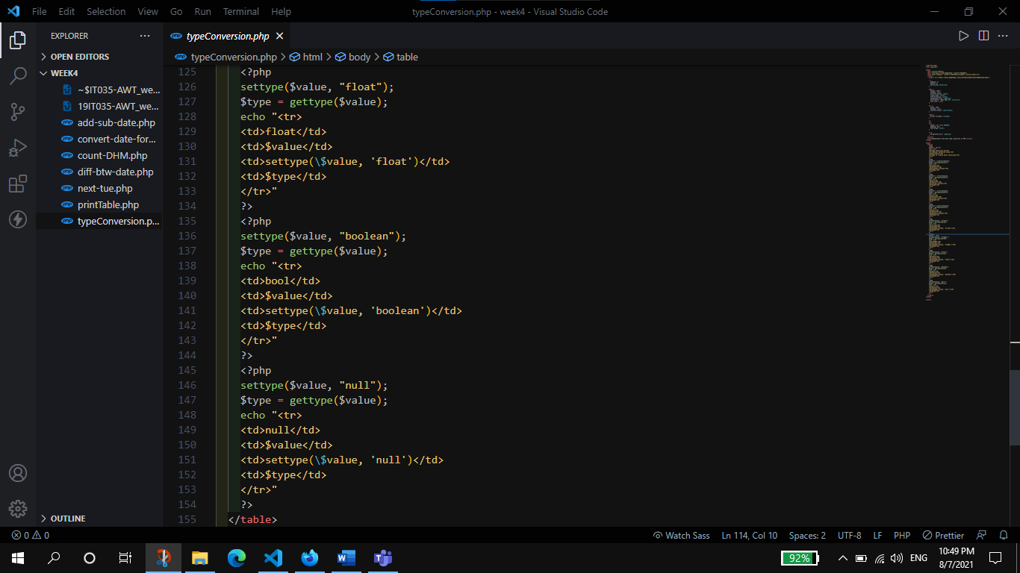

**Output:**

