**AWT Practical *Week - 6 Task***

**Array, Array methods and REGEX**

Array Operations (Numerical and Associative Both):

1. Sorting of array

**Code:**

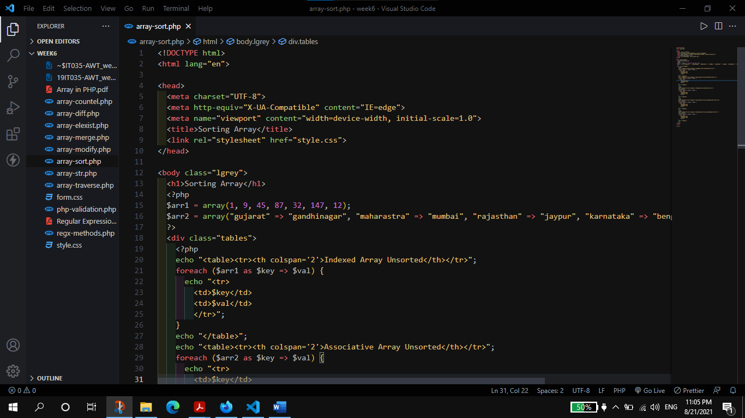

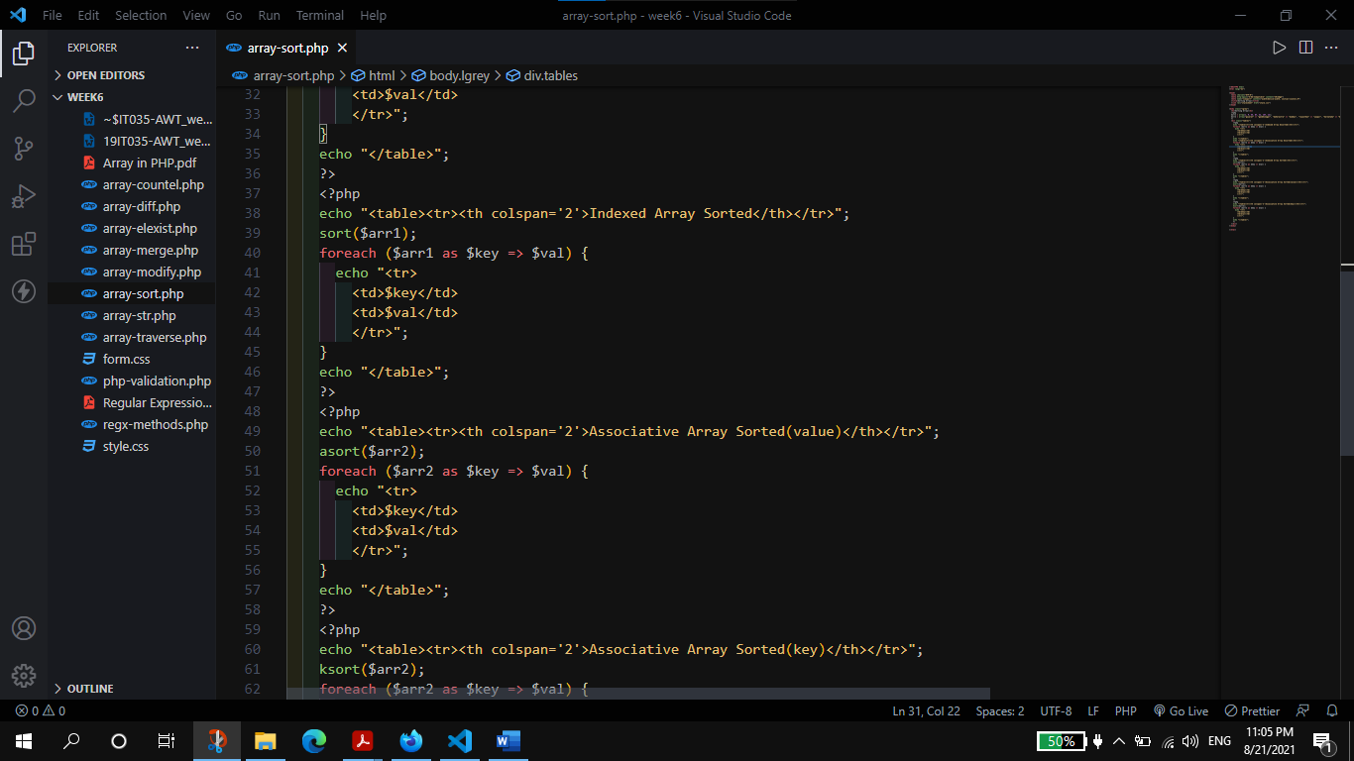

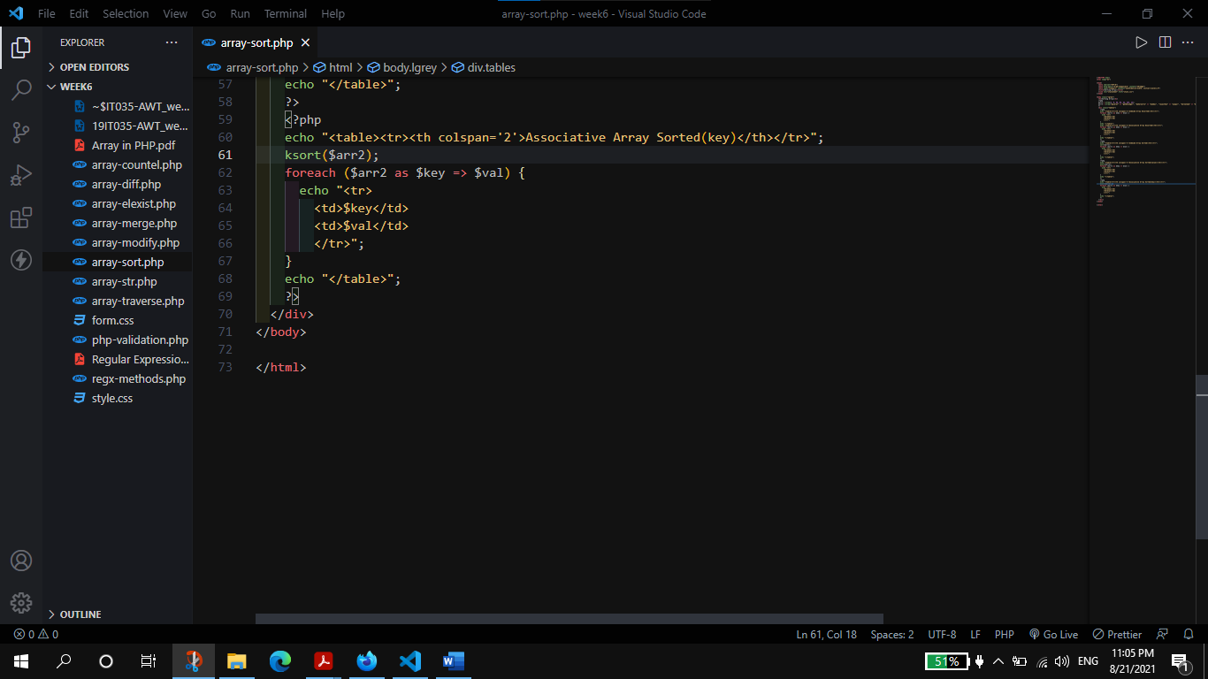

**Output:**

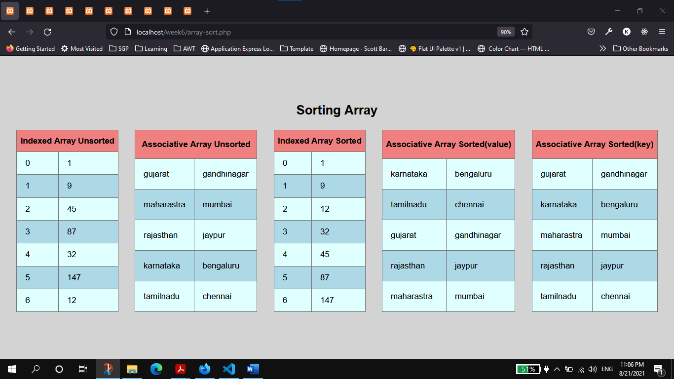

1. Modification of Array (adding / removing / updating).

**Code:**

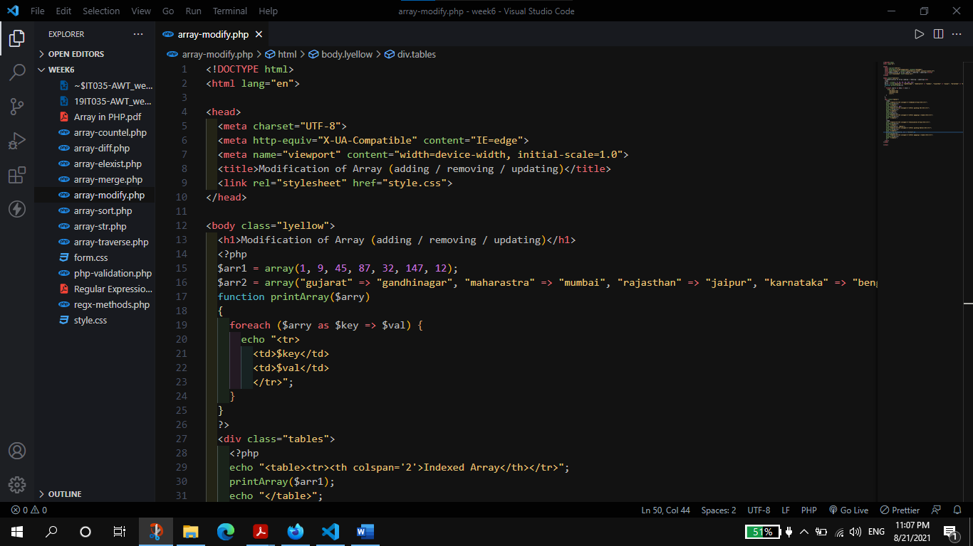

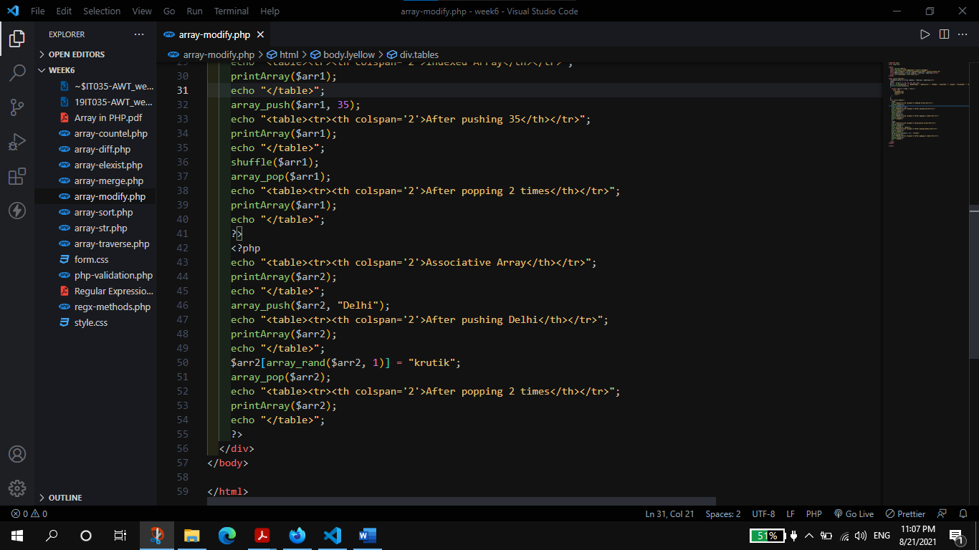

**Output:**

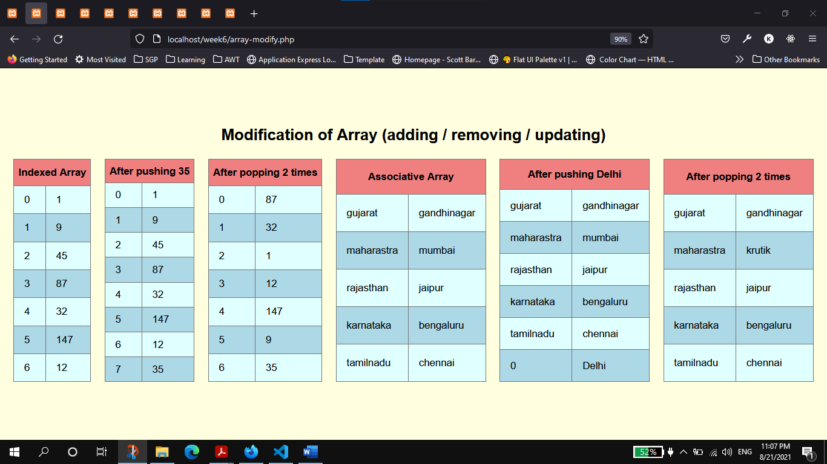

1. Traversing array

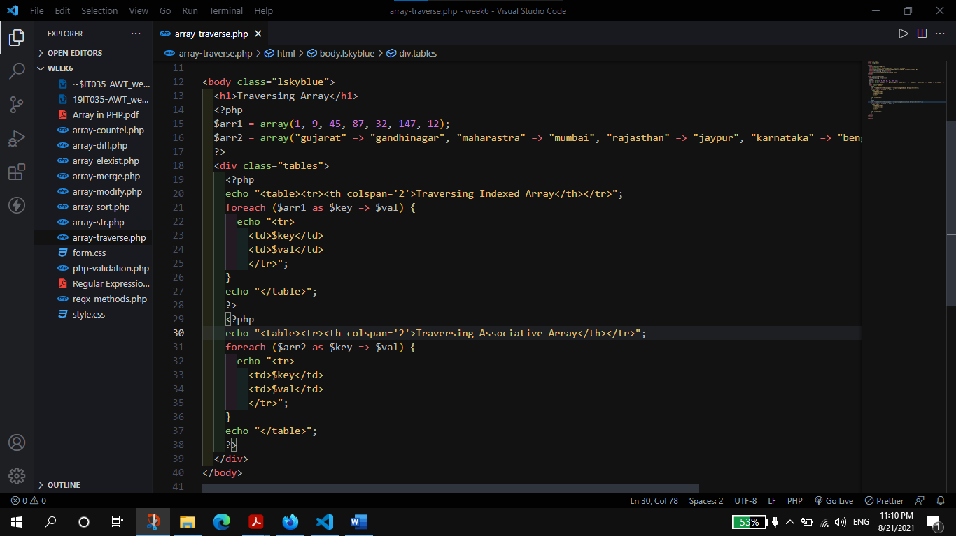

**Output:**

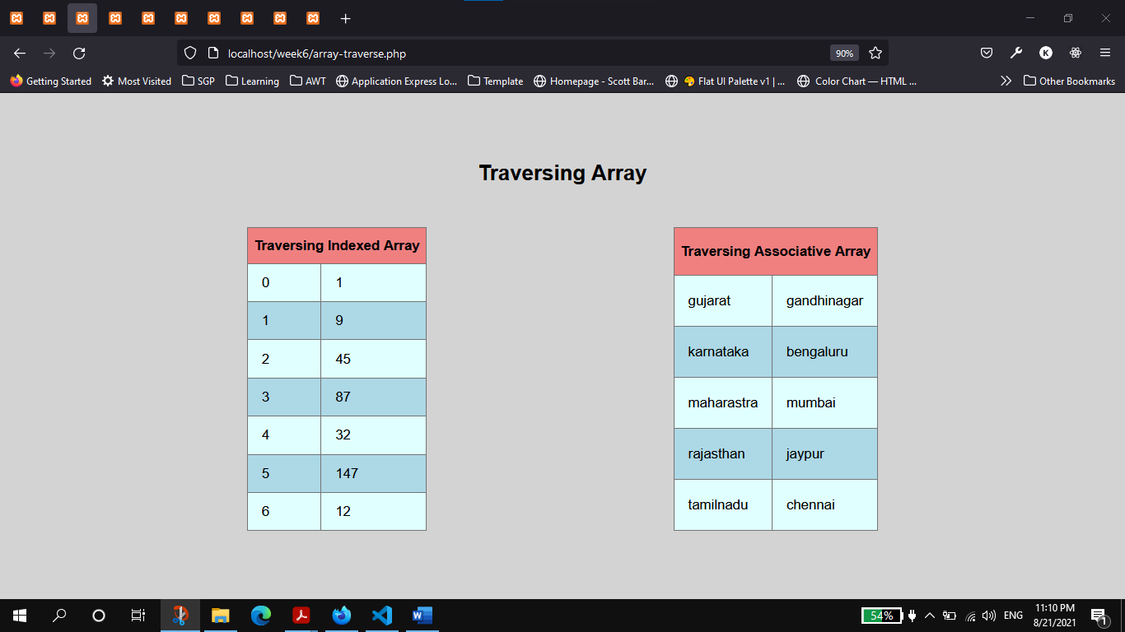

1. Merging Array

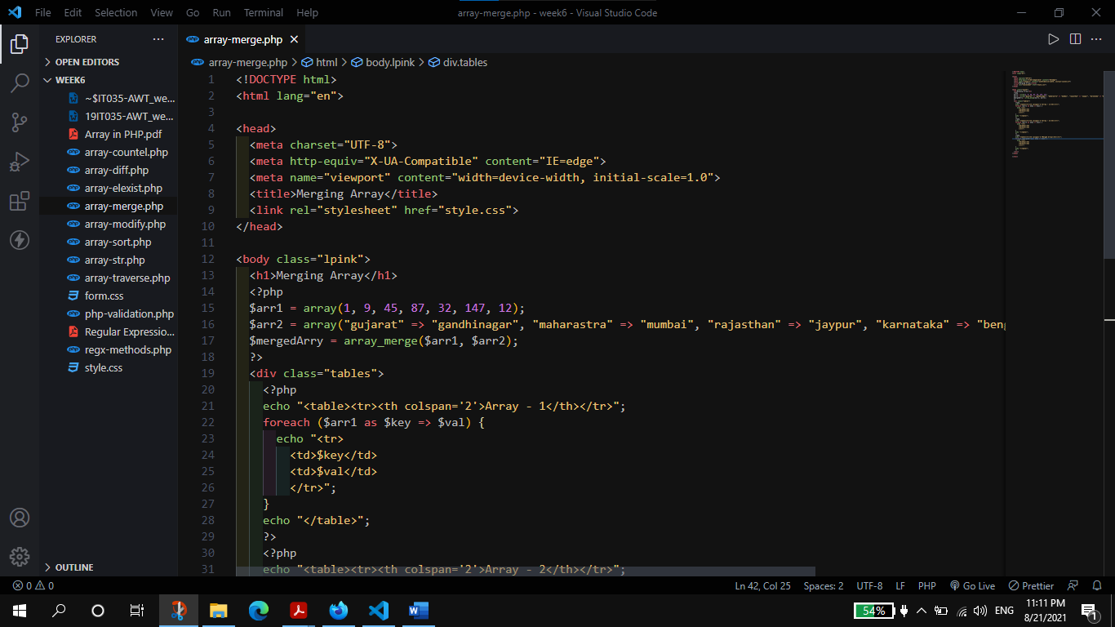

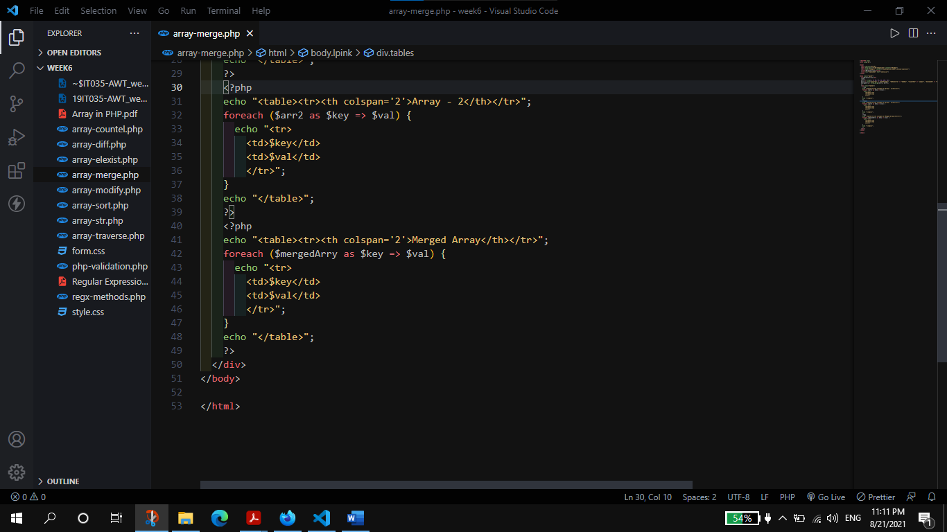

**Output:**

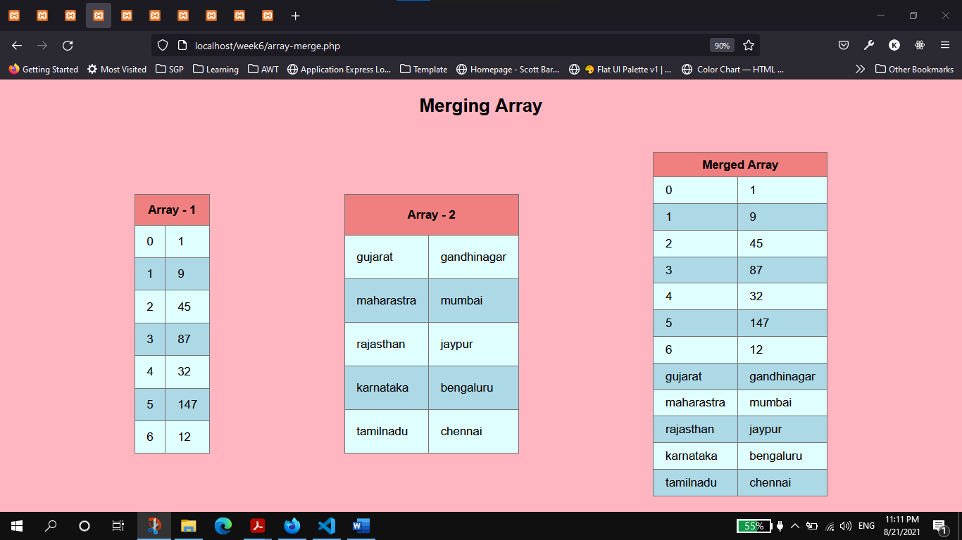

1. Counting Elements

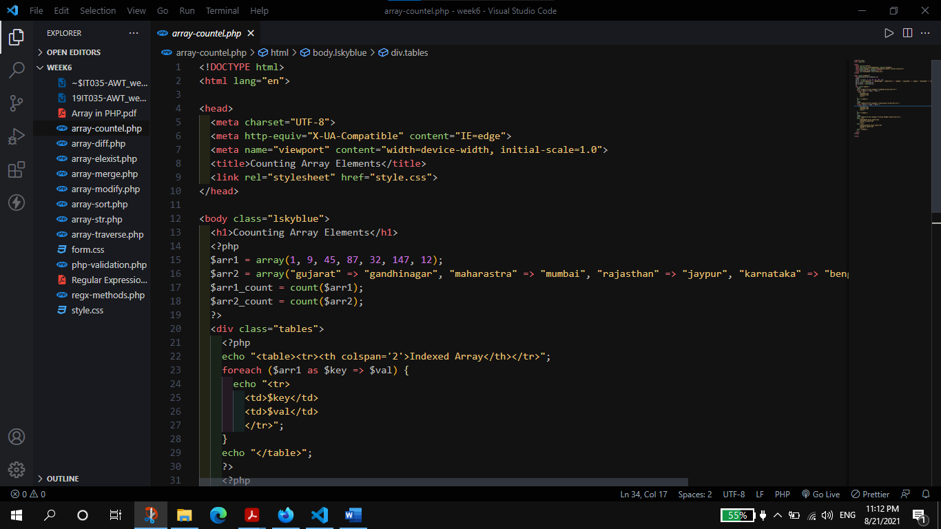

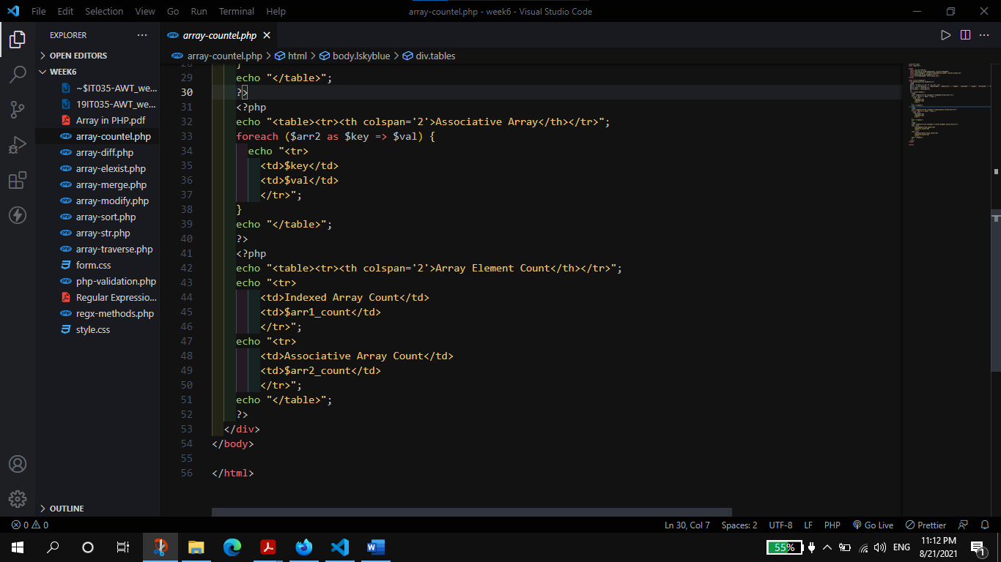

**Output:**

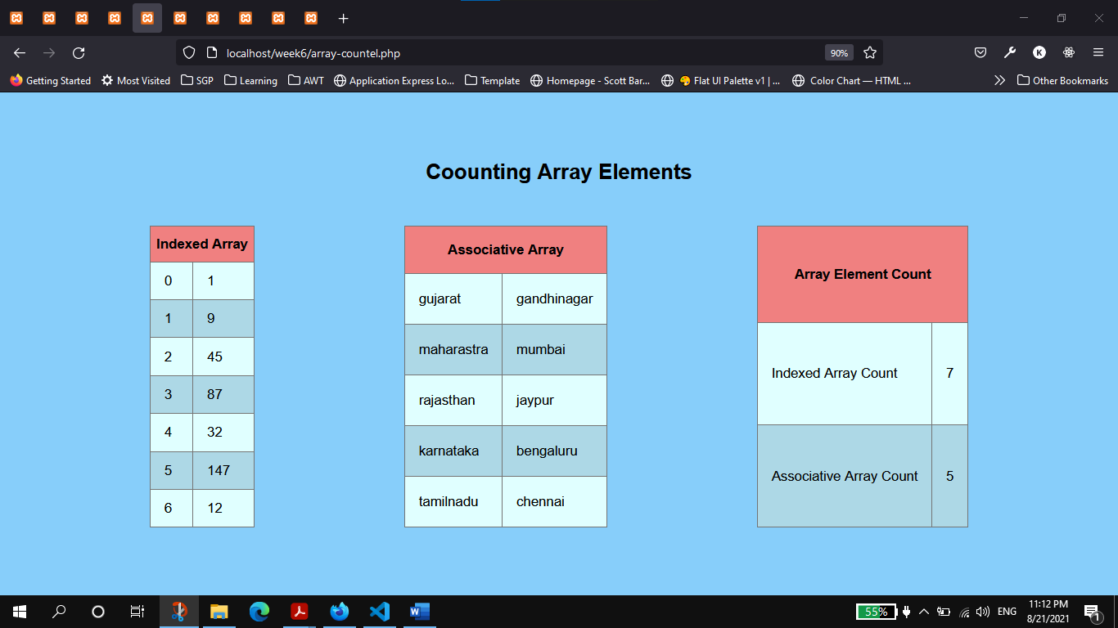

1. Diff between two Arrays

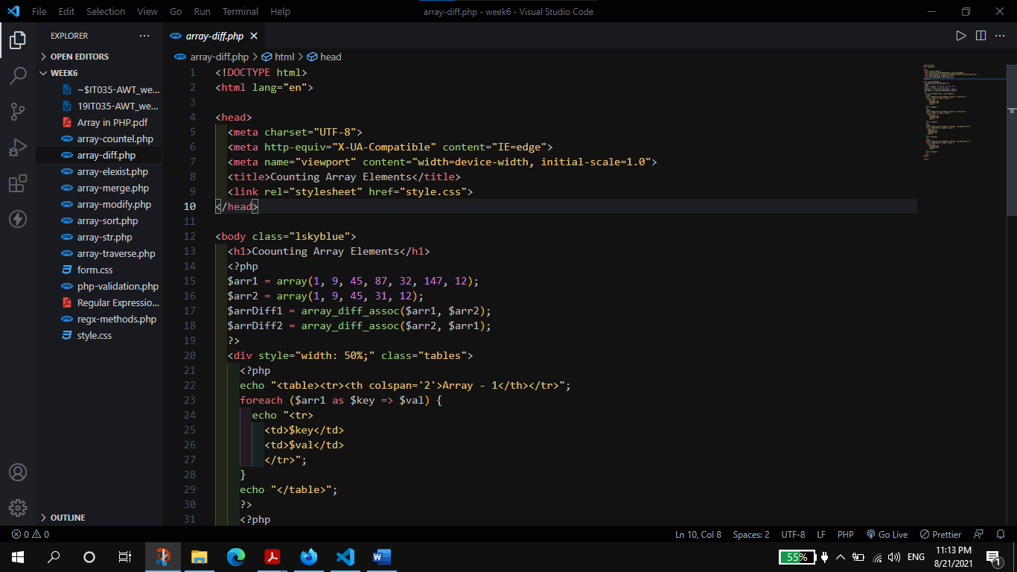

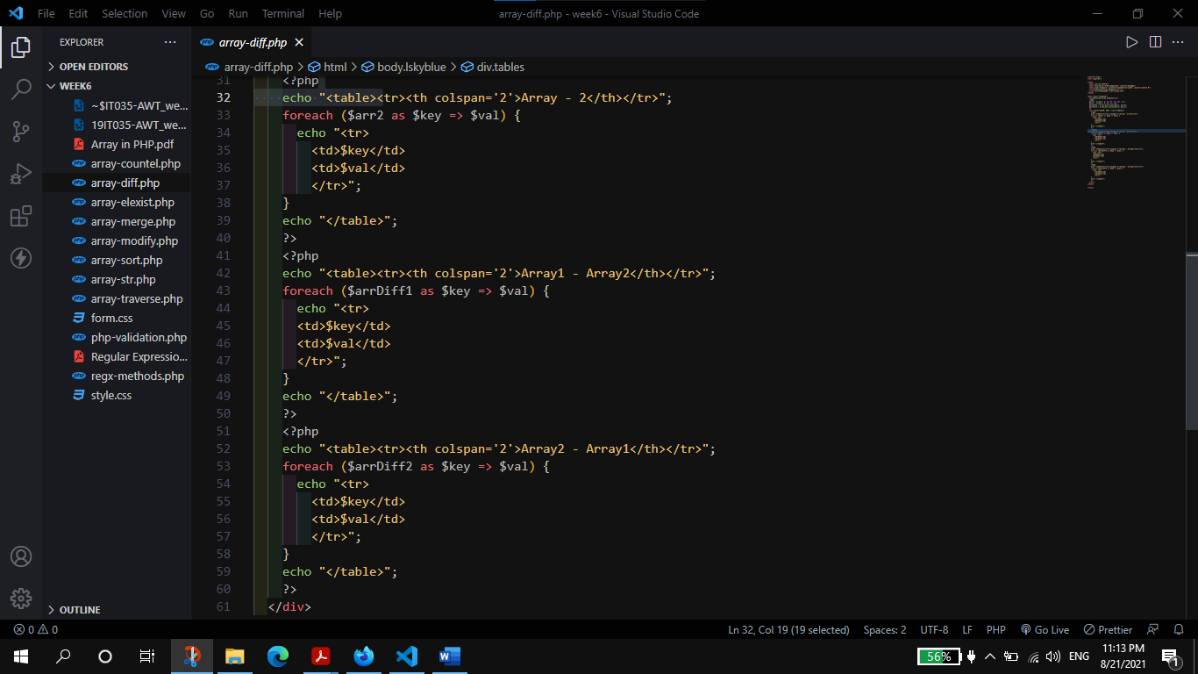

**Output:**

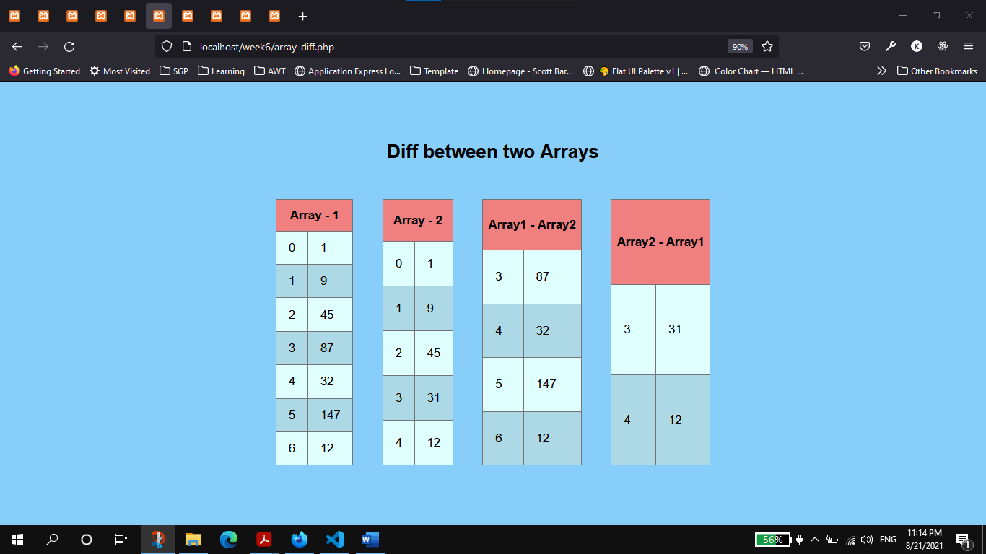

1. Check Element Exist in Array

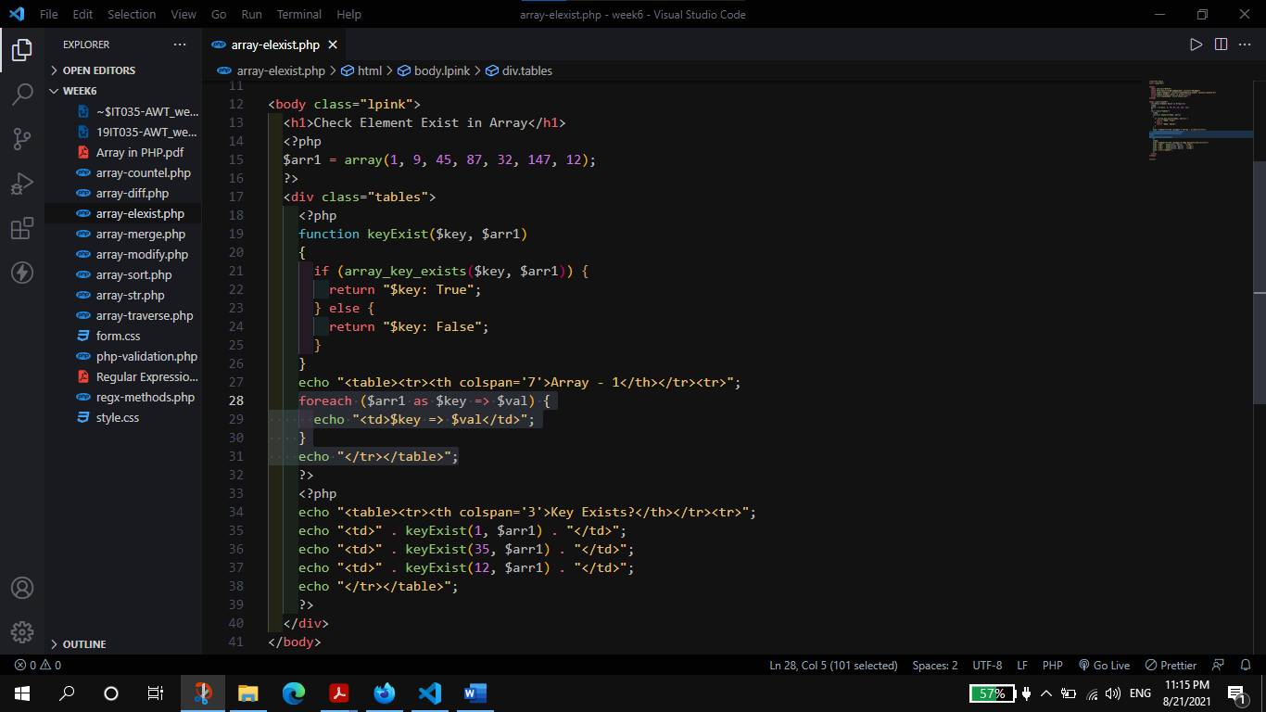

**Output:**

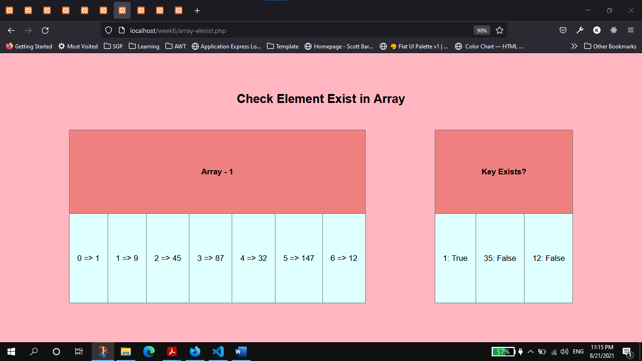

1. **S**tring to array and vice-versa

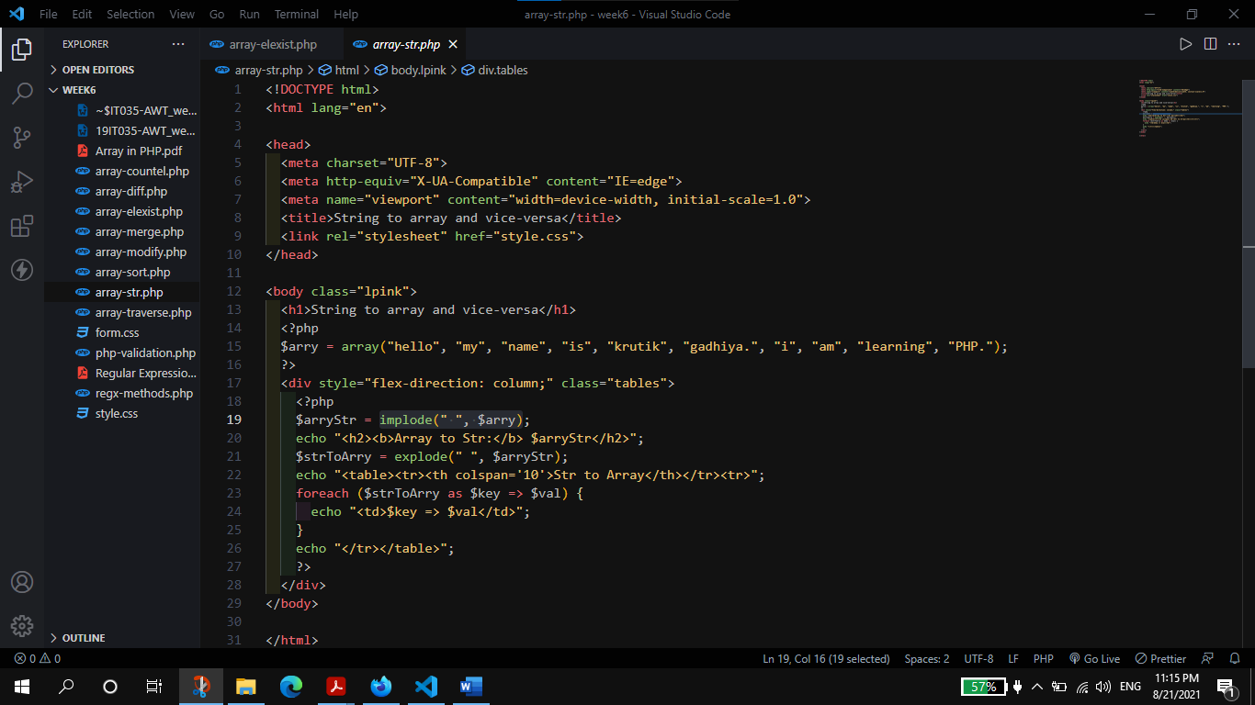

**Output:**

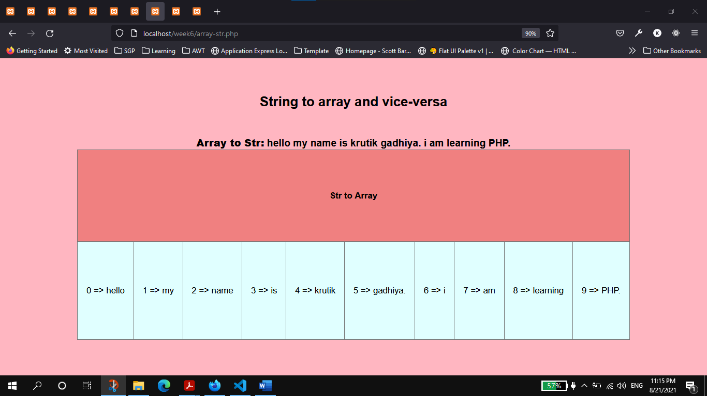

Regular expression in PHP

1. **Implement following validations in a PHP form using Regular expression in PHP.**
2. **IP Address**
3. **172.168.12.30**
4. **Domain Name**
5. **www.google.com**
6. **Email ID**
7. **A.b_abc@gmail.co.in**
8. **10 digit Mobile**
9. **Password with**
10. **8 to 16 letters, numbers, underscores, or hyphens**
11. **UserName with**
12. **3 to 16 letters, numbers, underscores, hyphens and dot**
13. **Only Start with letter**

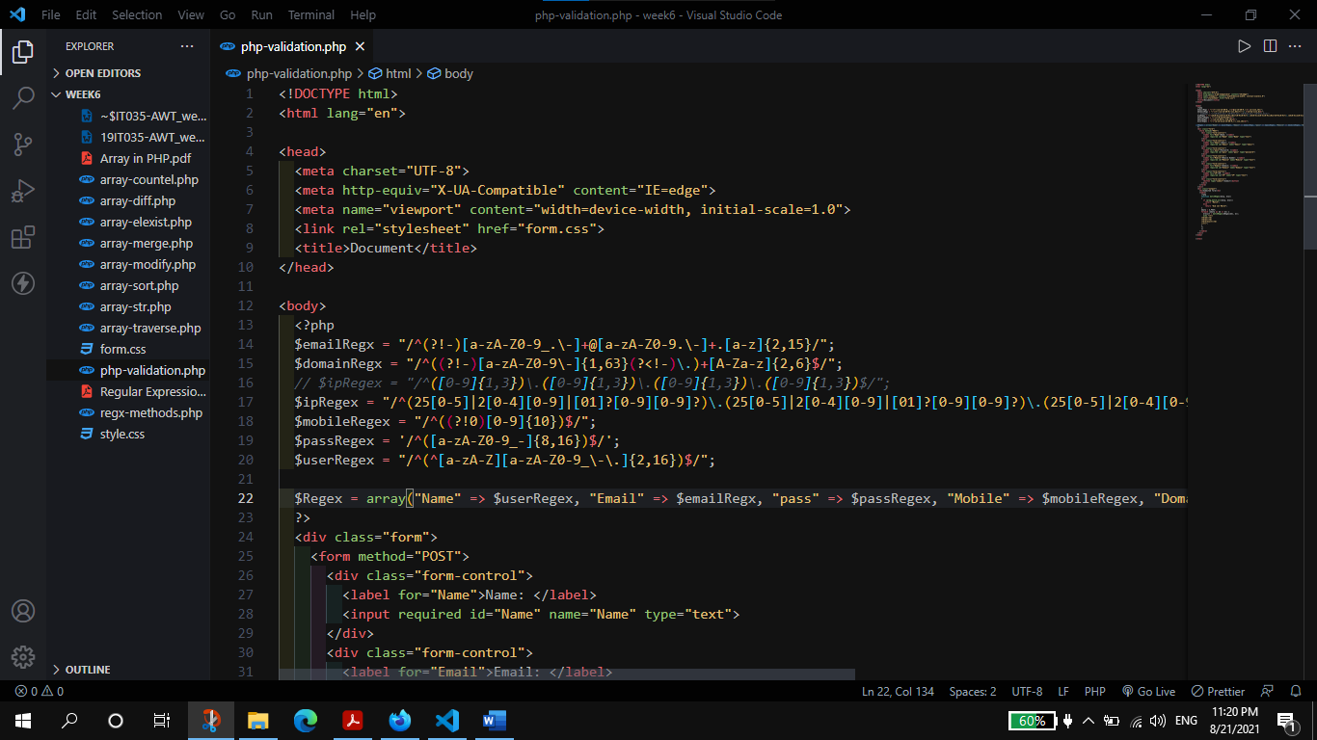

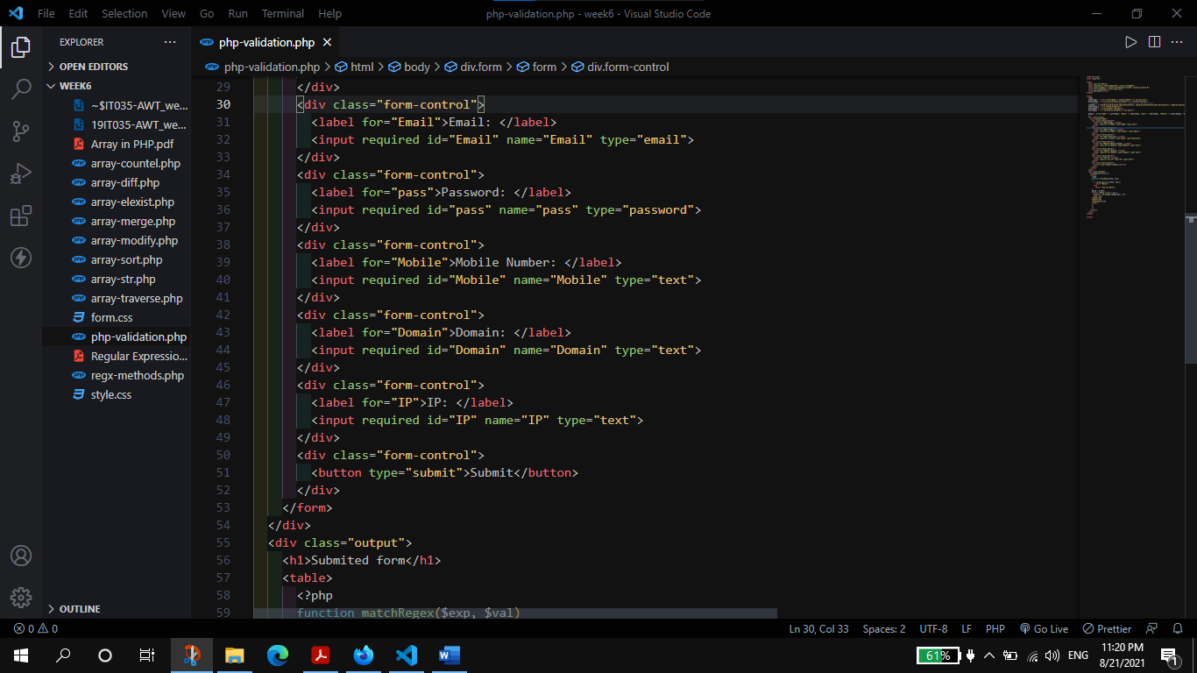

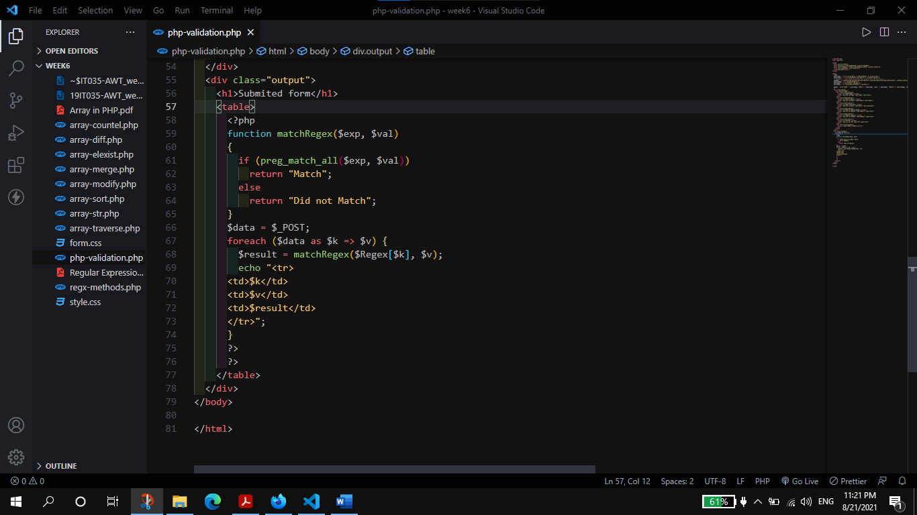

**Output:**

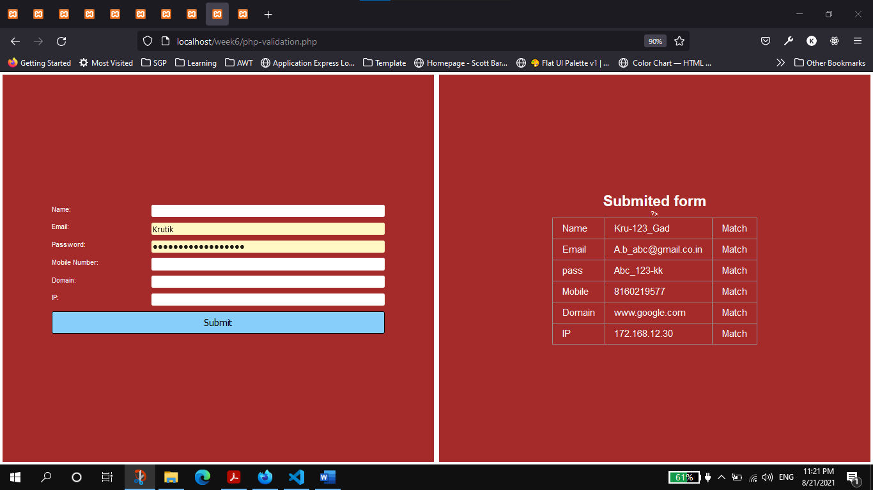

1. **Prepare code to demonstrate any five regex function from**

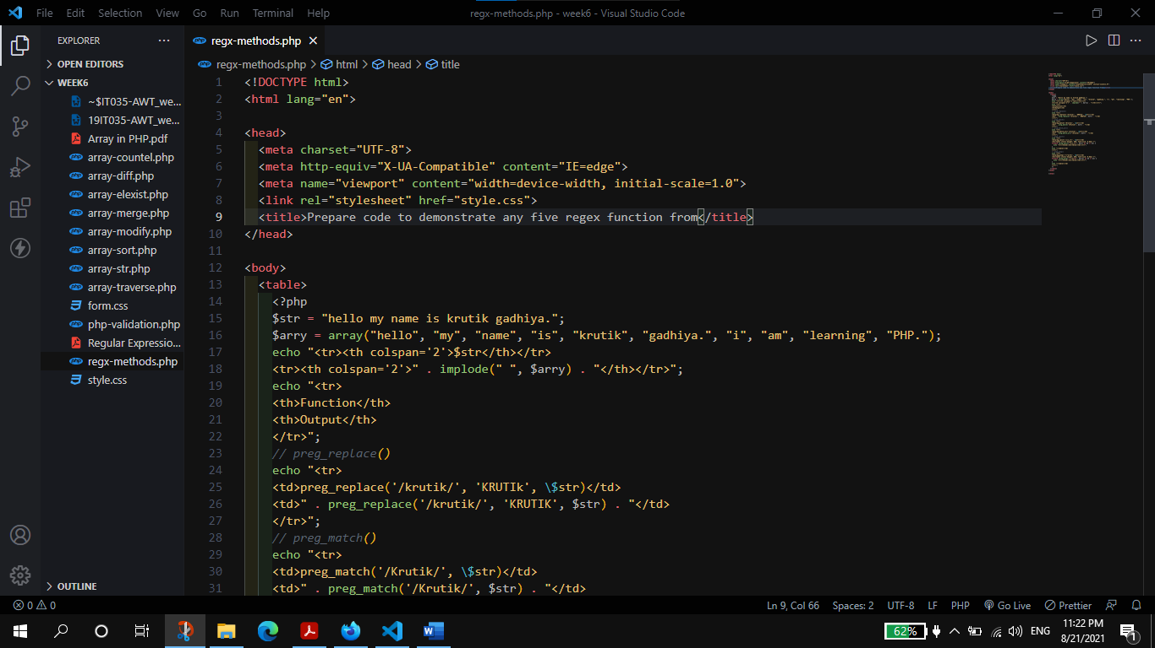

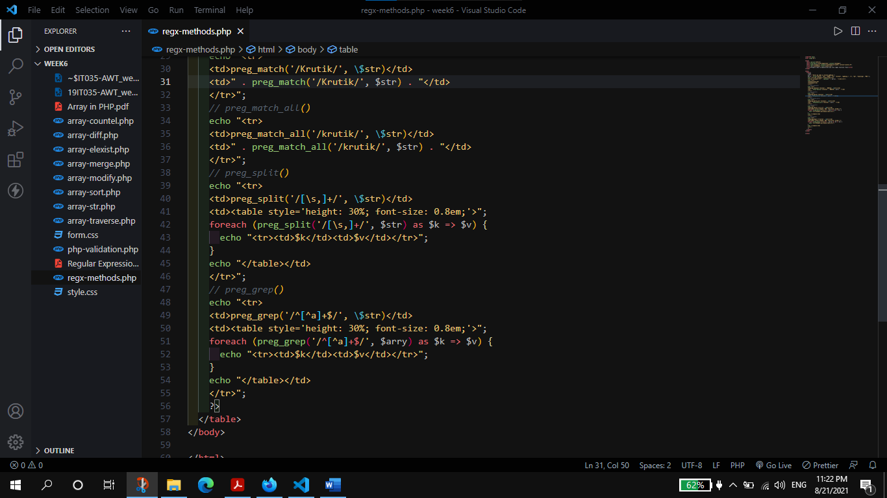

**Output:**

