**AWT Practical *Week - 7 Task***

**Functions in PHP**

1. Function with and without argument

**Code:**

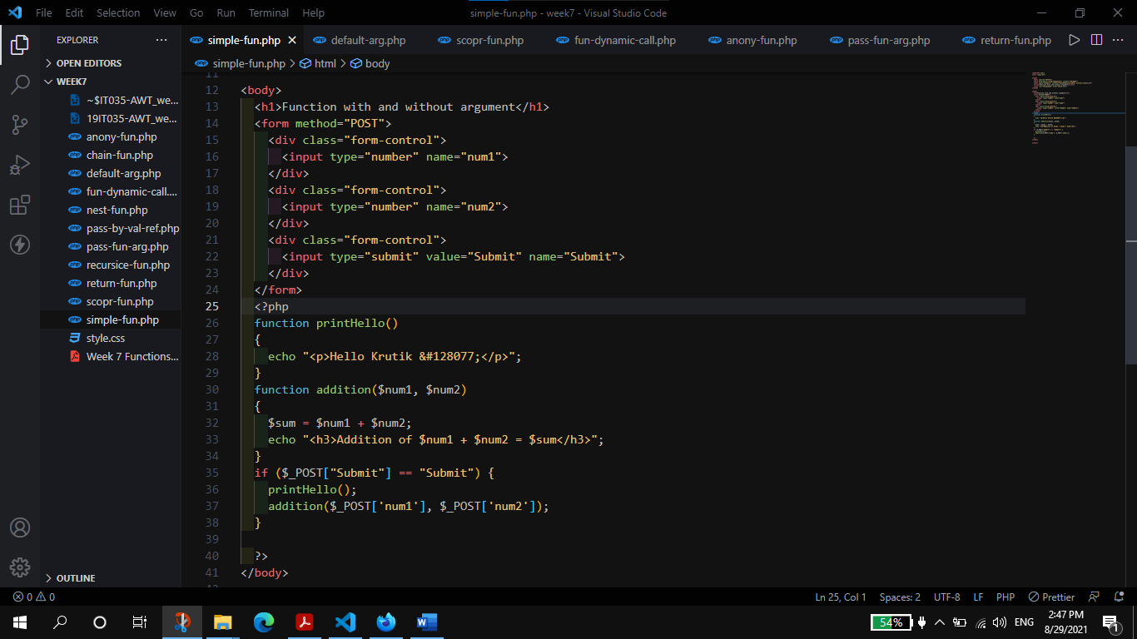

**Output:**

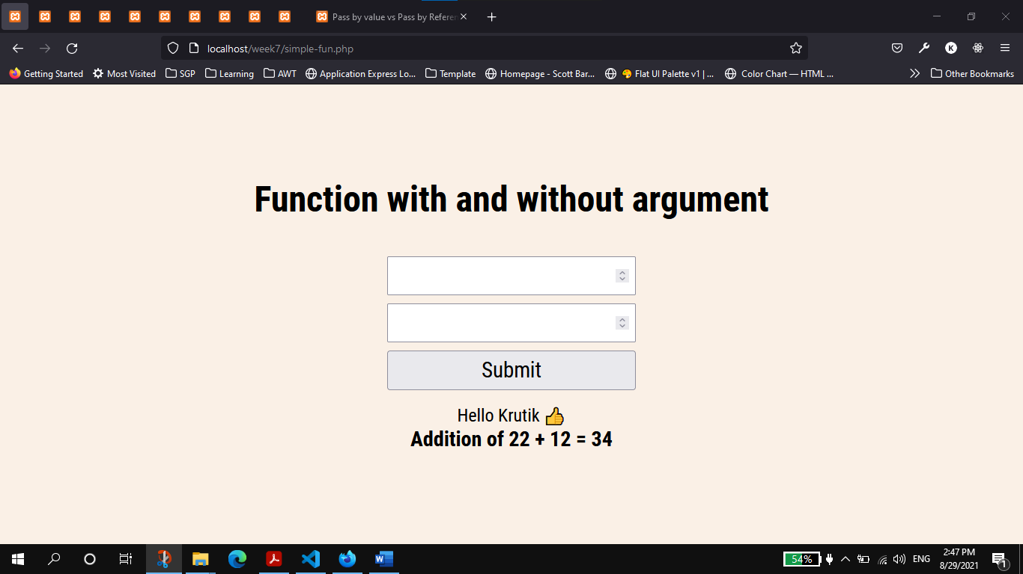

1. Function with Default argument.

**Code:**

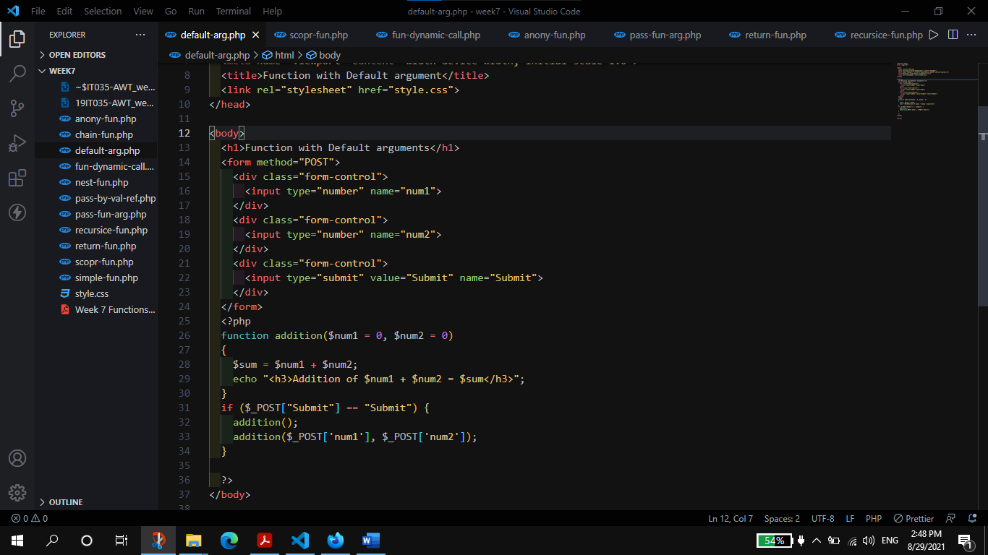

**Output:**

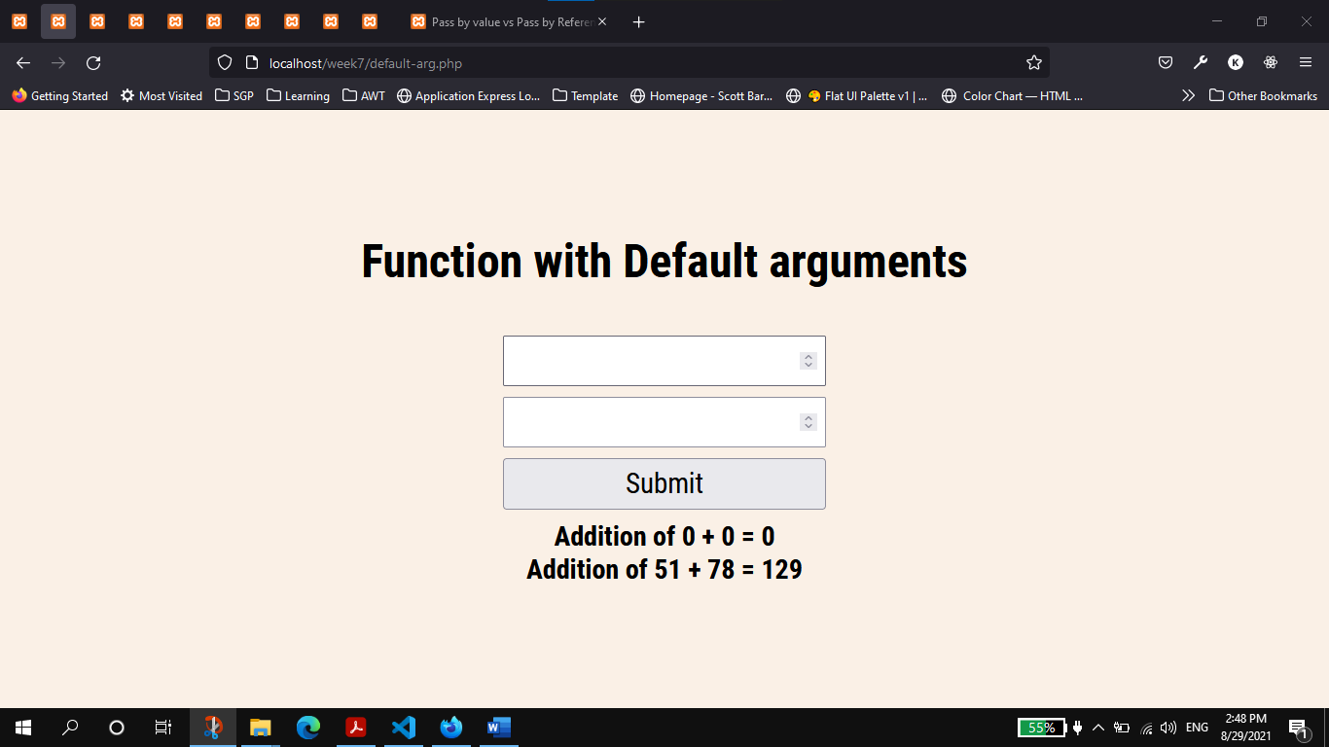

1. Scope of variable in Function (local, global, static)

**Code:**

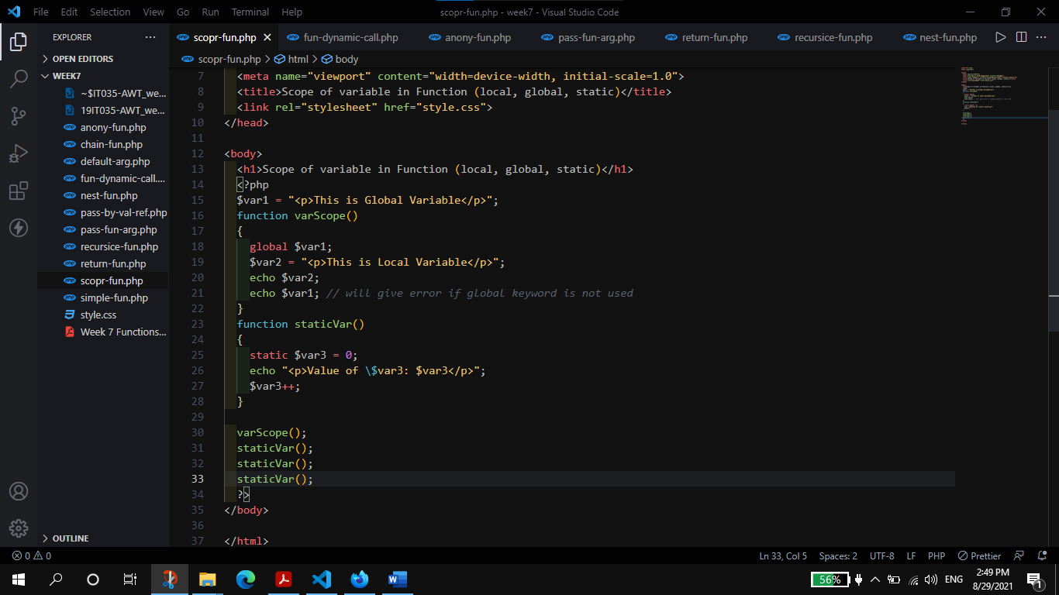

**Output:**

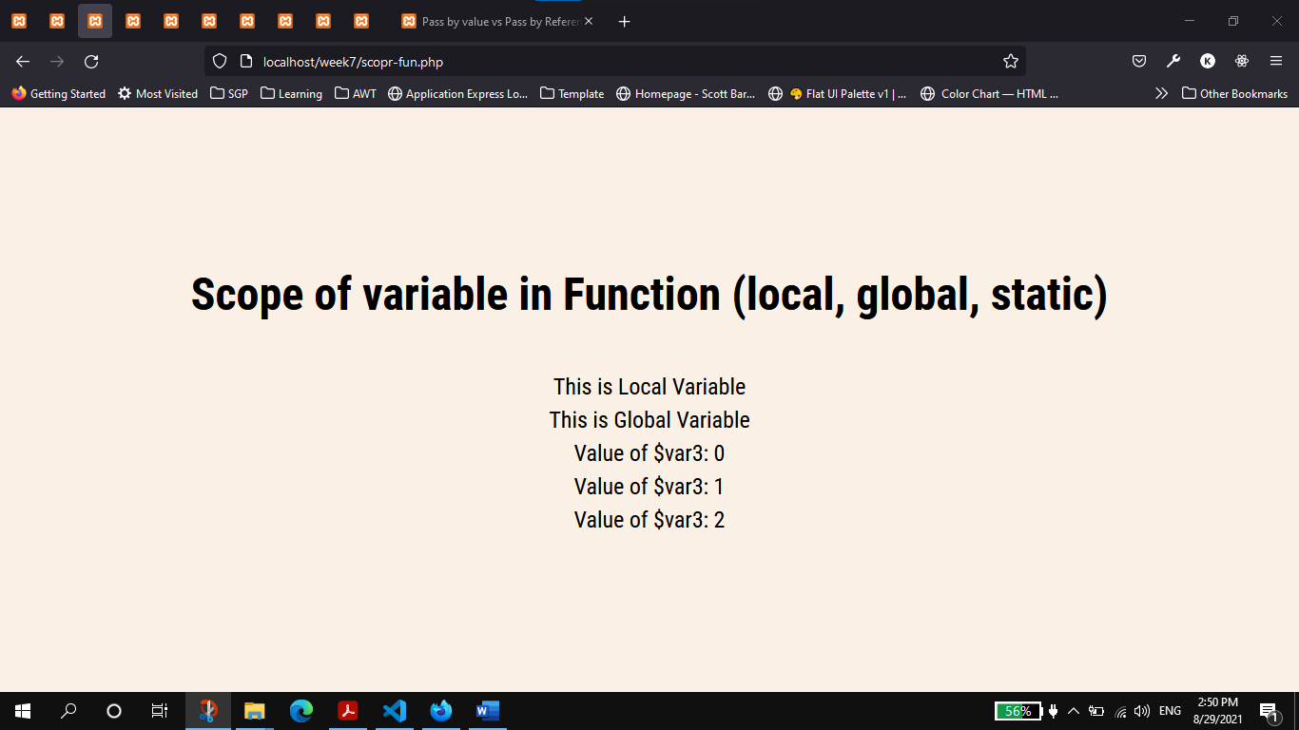

1. Dynamic Call of Function

**Code:**

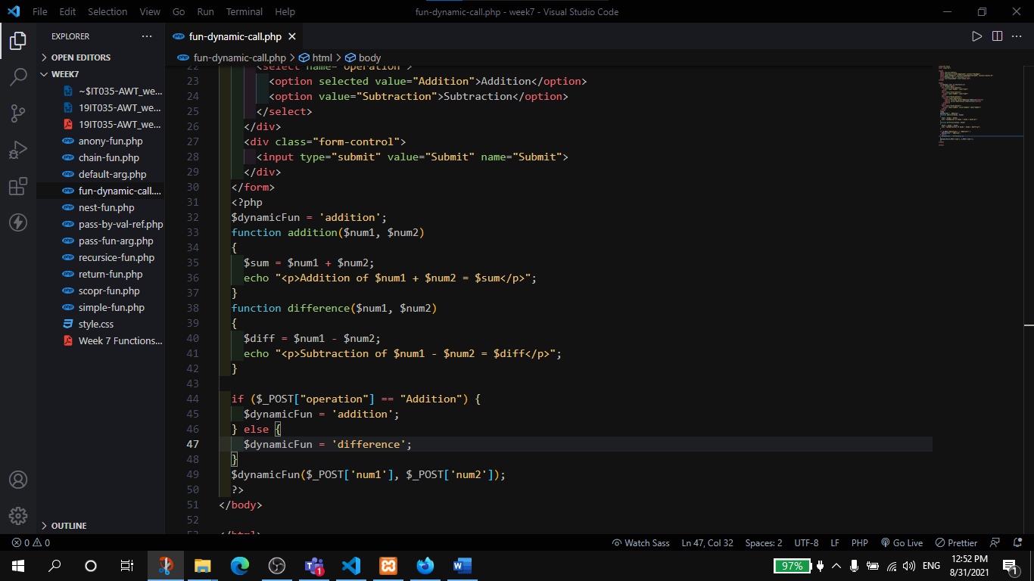

**Output:**

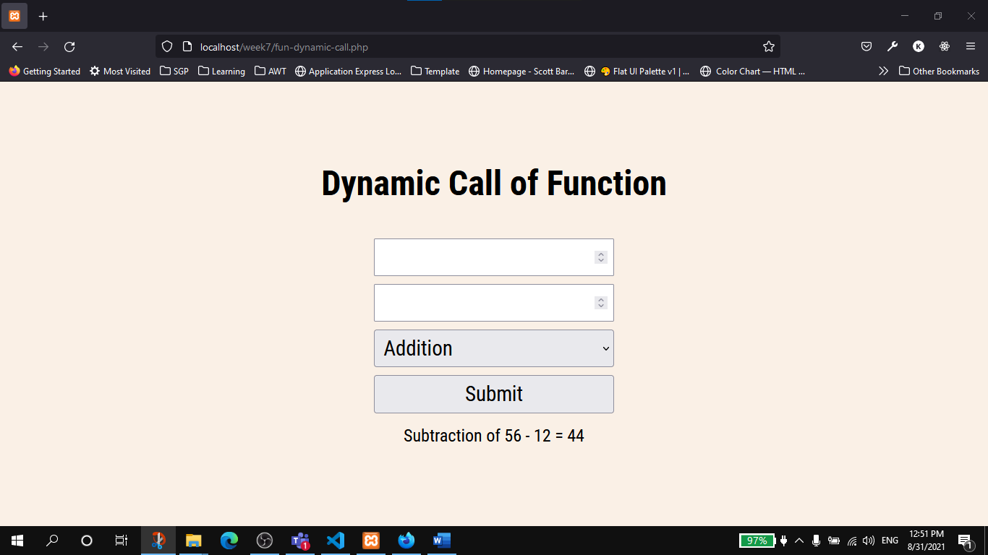

1. Anonymous Function

**Code:**

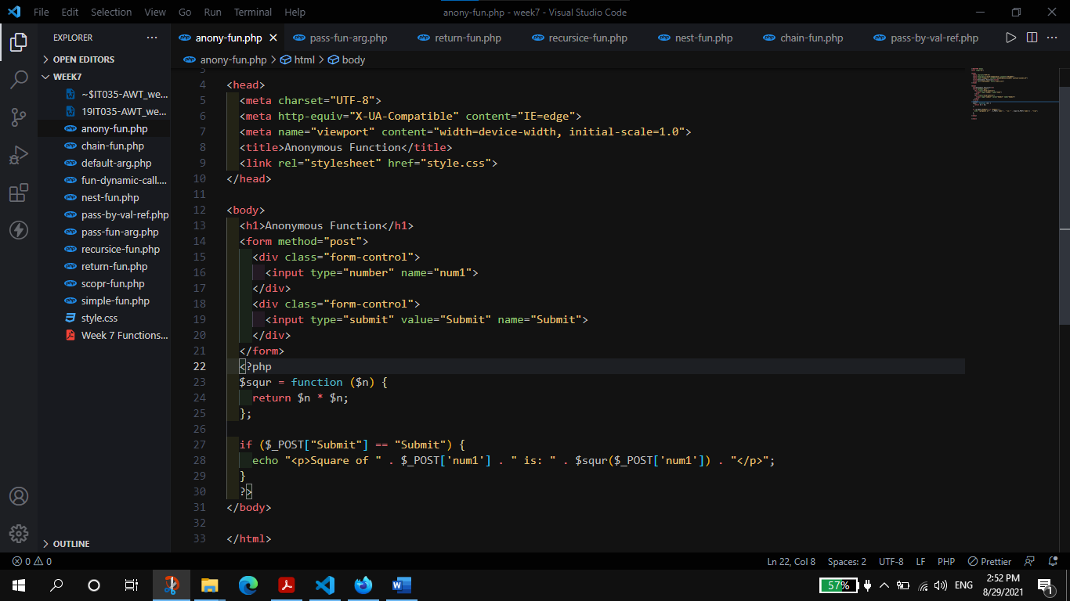

**Output:**

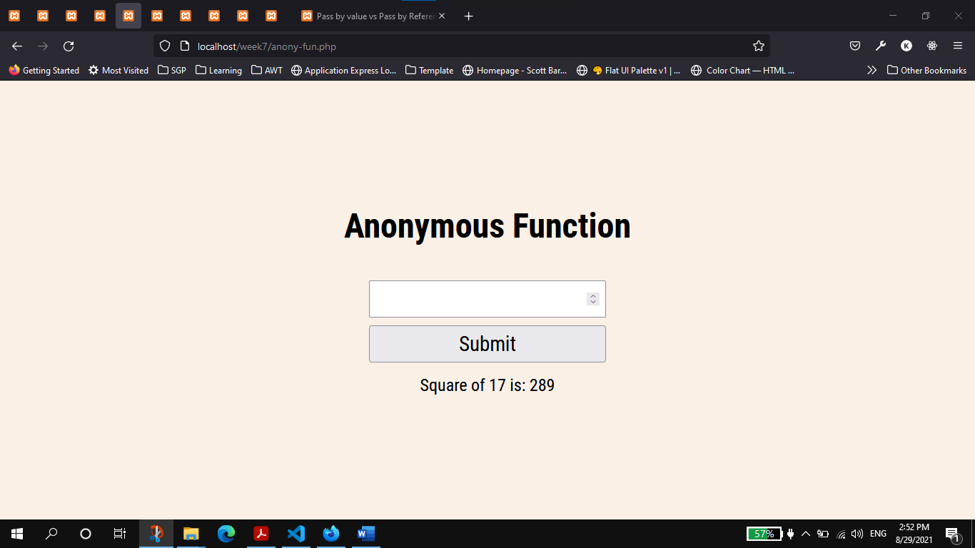

1. Passing Function as Argument to another function

**Code:**

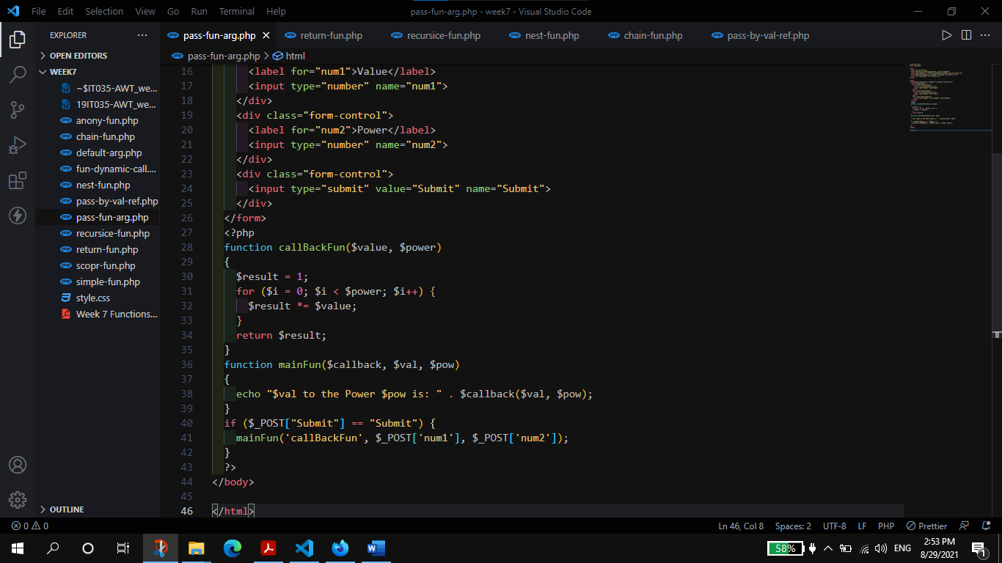

**Output:**

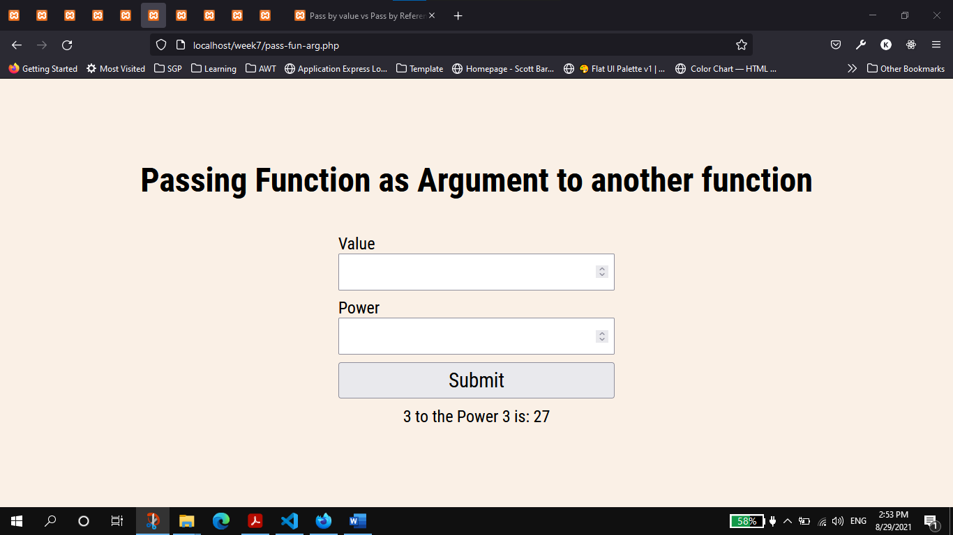

1. Returning Function from another function

**Code:**

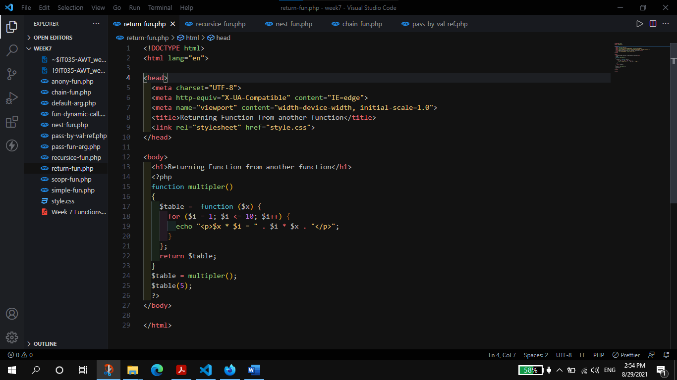

**Output:**

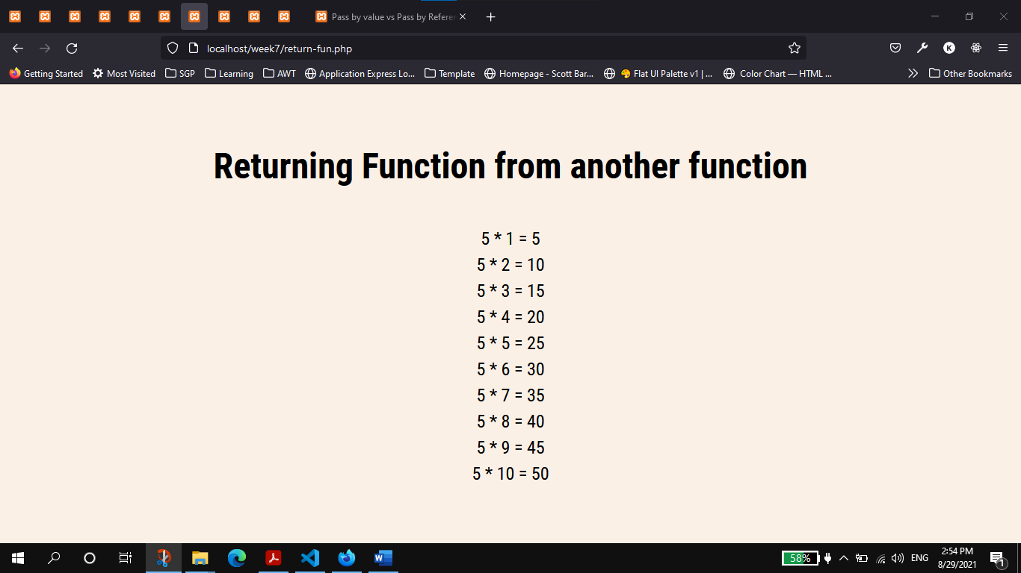

1. Recursive Function : Factorial

**Code:**

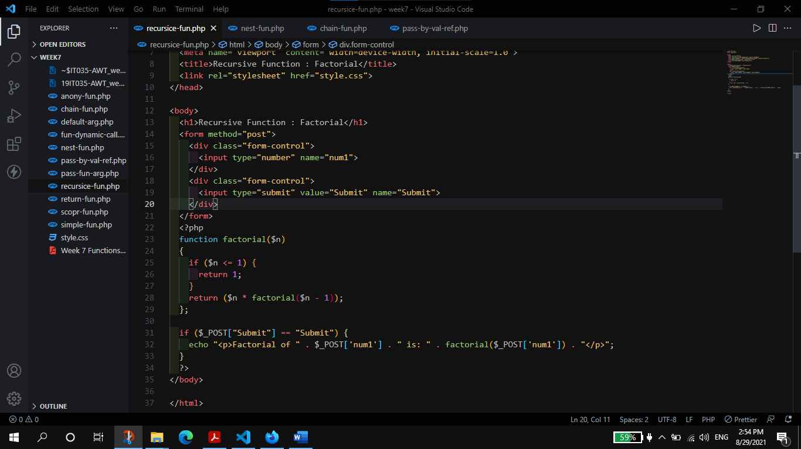

**Output:**

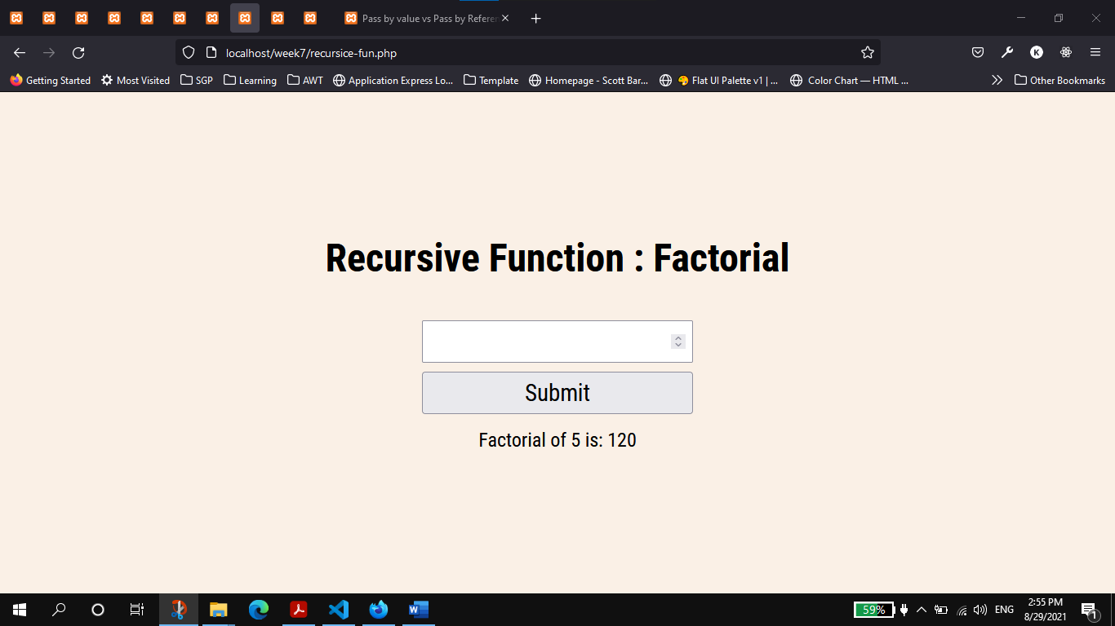

1. Nesting of Functions (Function call another function inside function body)

**Code:**

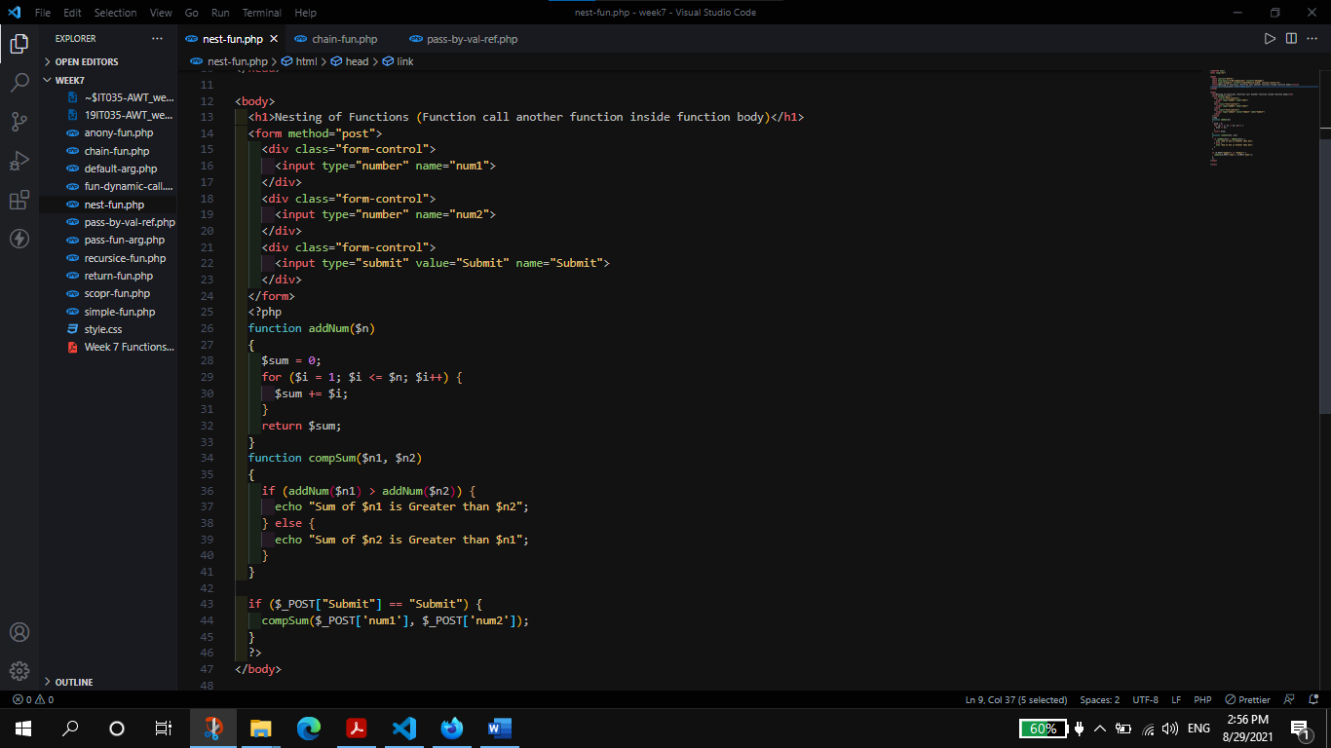

**Output:**

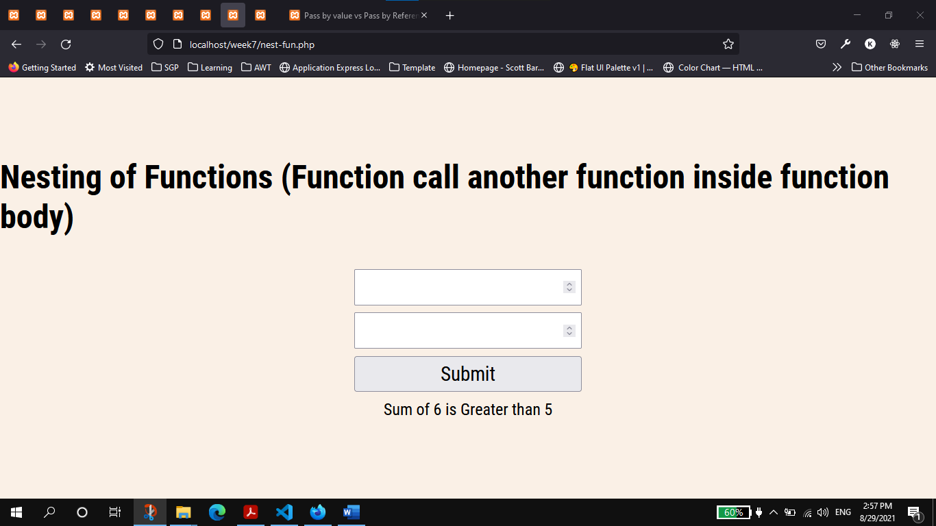

1. Function Chaining

**Code:**

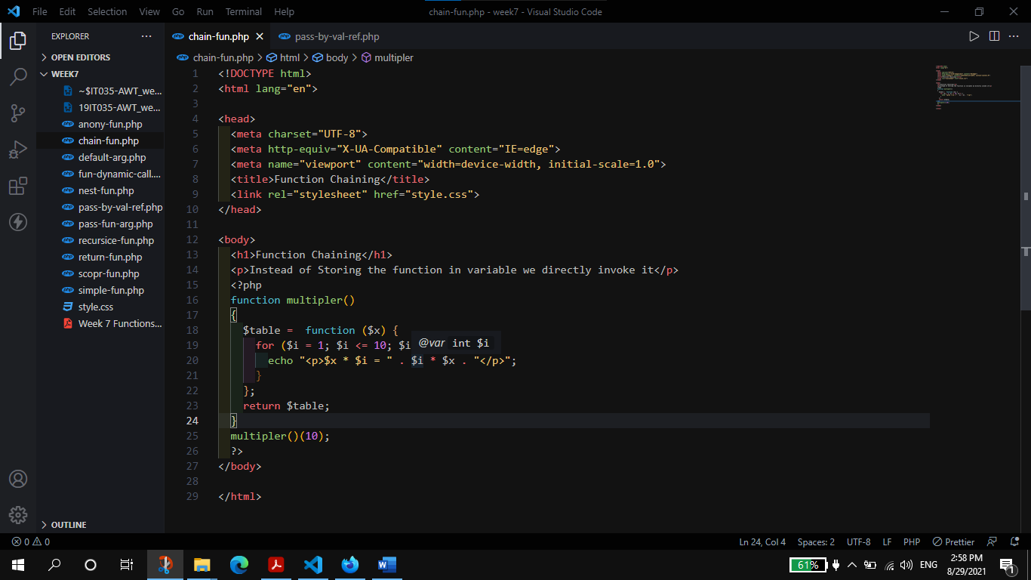

**Output:**

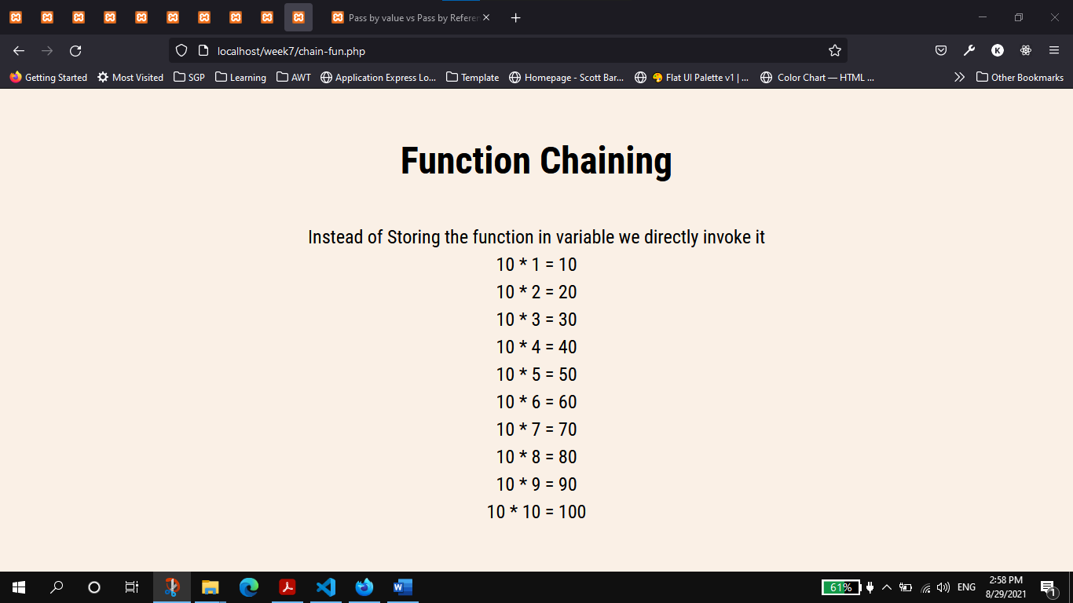

1. Pass by value vs Pass by Reference

**Code:**

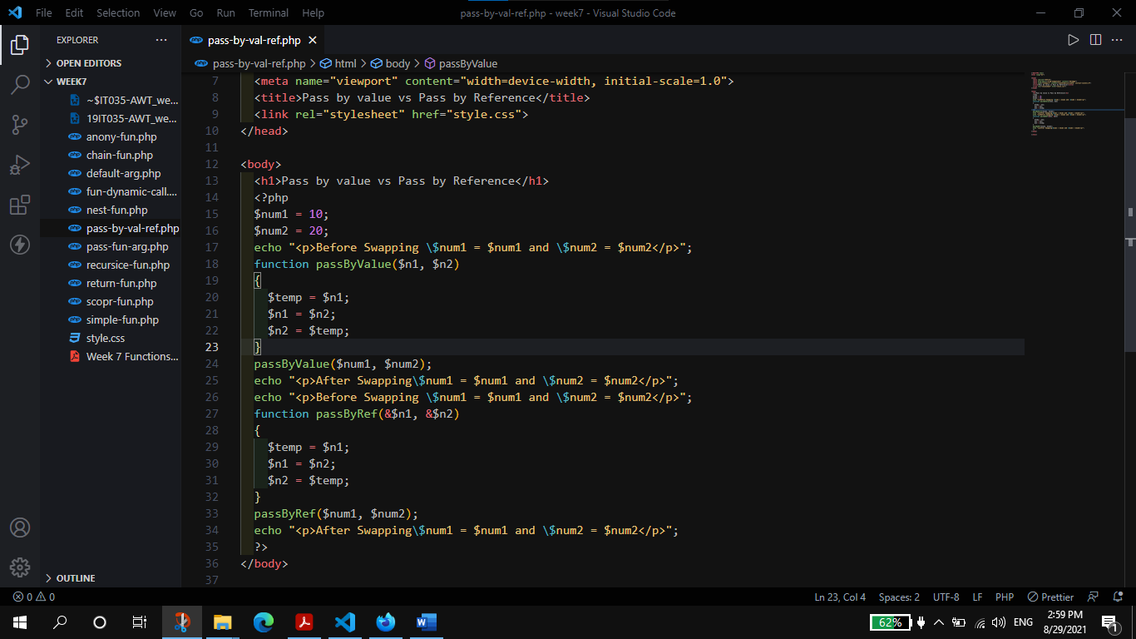

**Output:**

