**AWT Practical *Week - 9 Task***

**File Management in PHP**

1. Read File emp_records.txt file and Write even line of emp_records.txt to even_emp_records.txt and odd line of emp_records.txt to odd_emp_records.txt

**Code:**

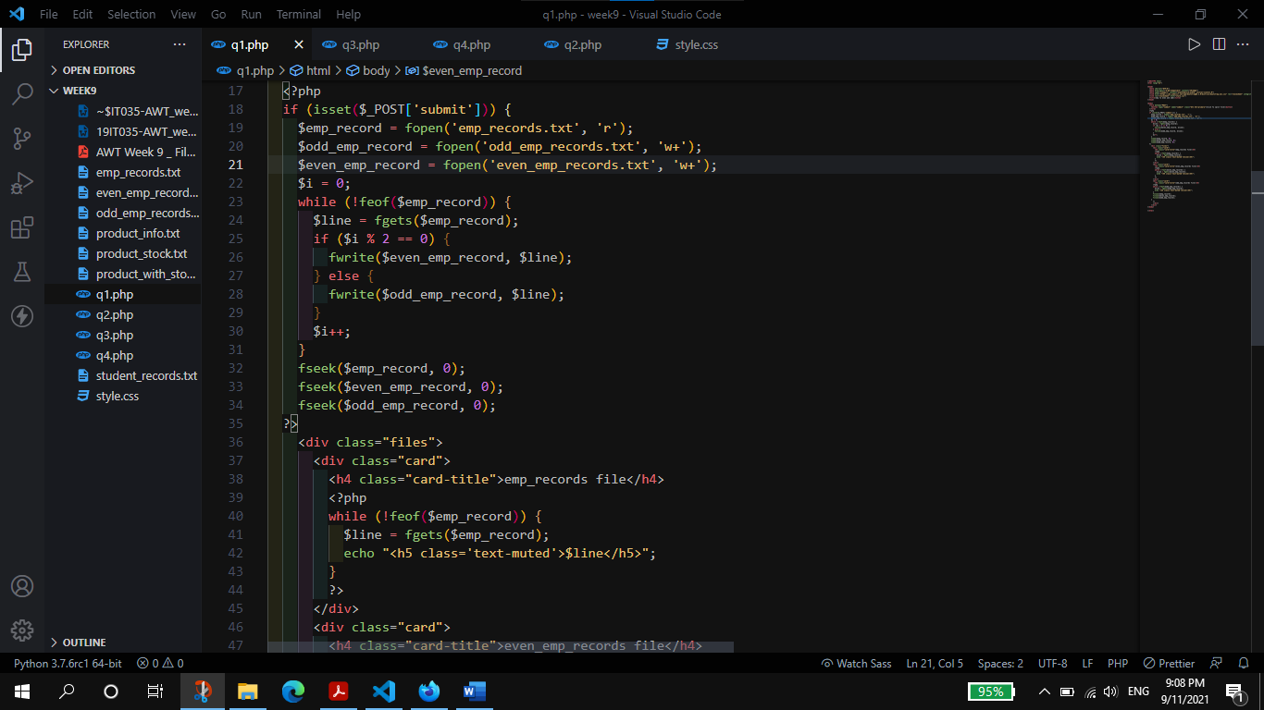

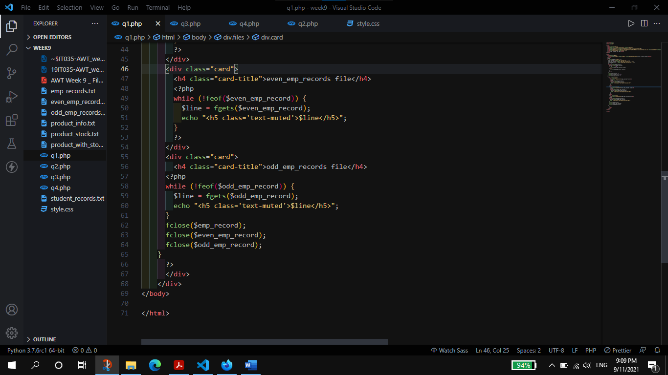

**Output:**

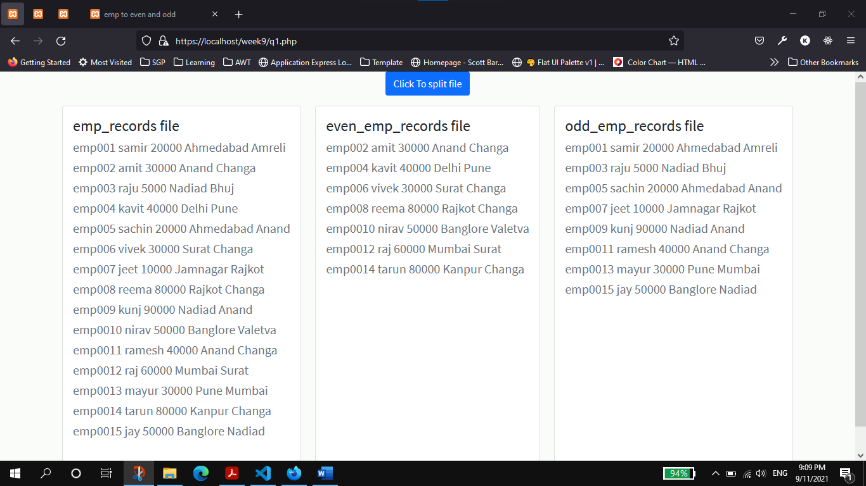

1. Get Student Record from user using console(input()) and append the record to students_records.txt file

**Code**:

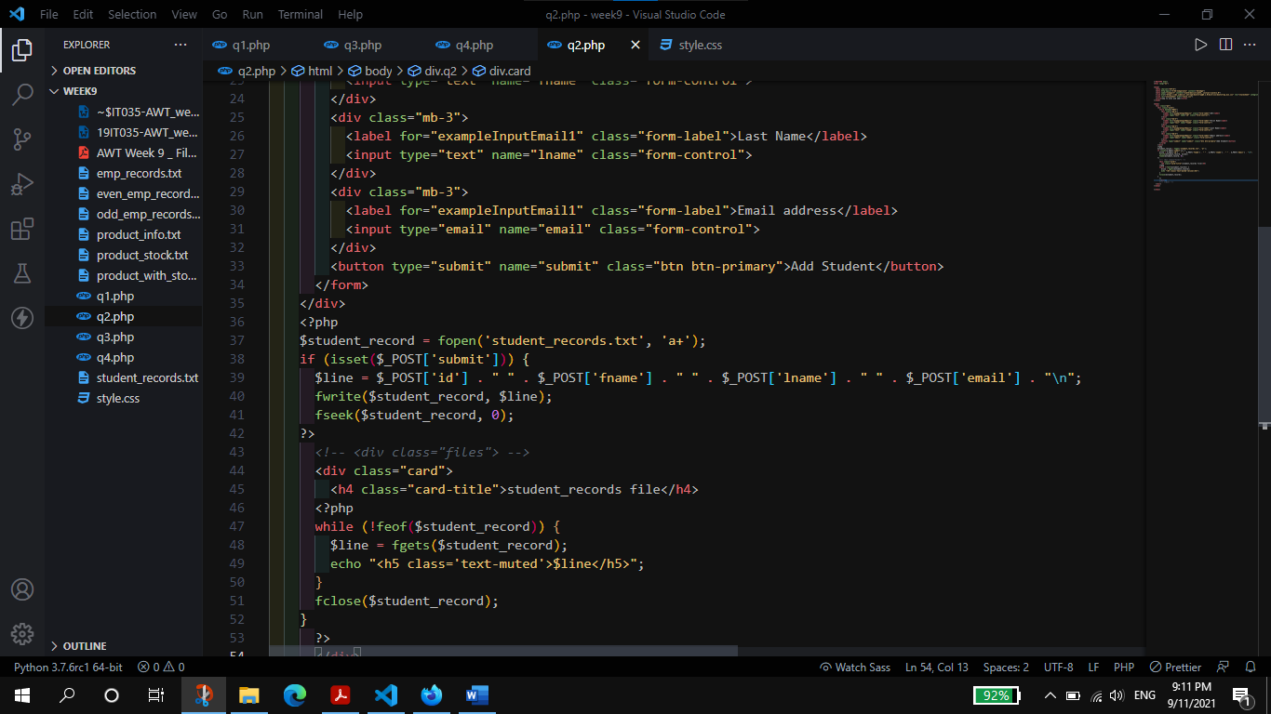

**Output:**

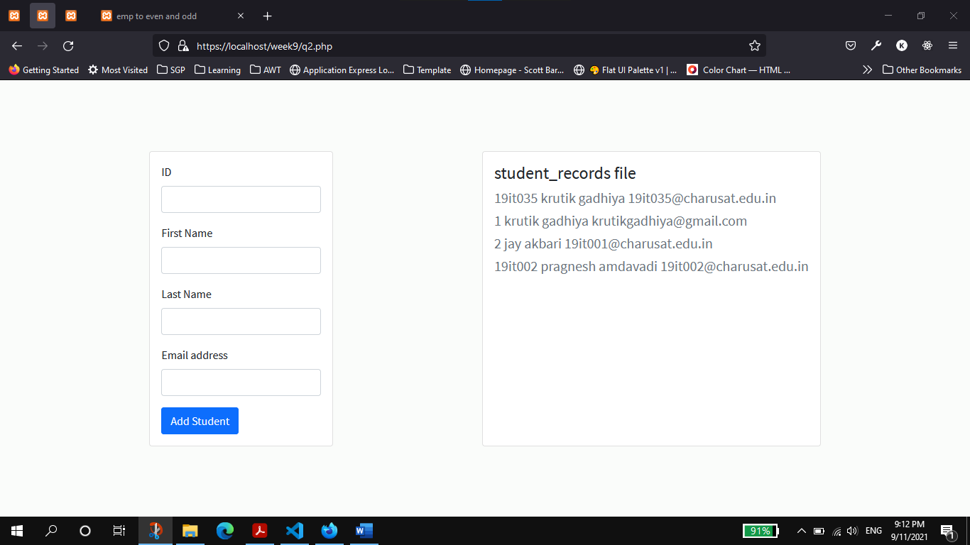

1. Read Product code and Name from product_info.txt file. Find available Stock of product from using product code from product_stock.txt. Write Details (product code, name and stock) into product_with_stock.txt file.

**Code:**

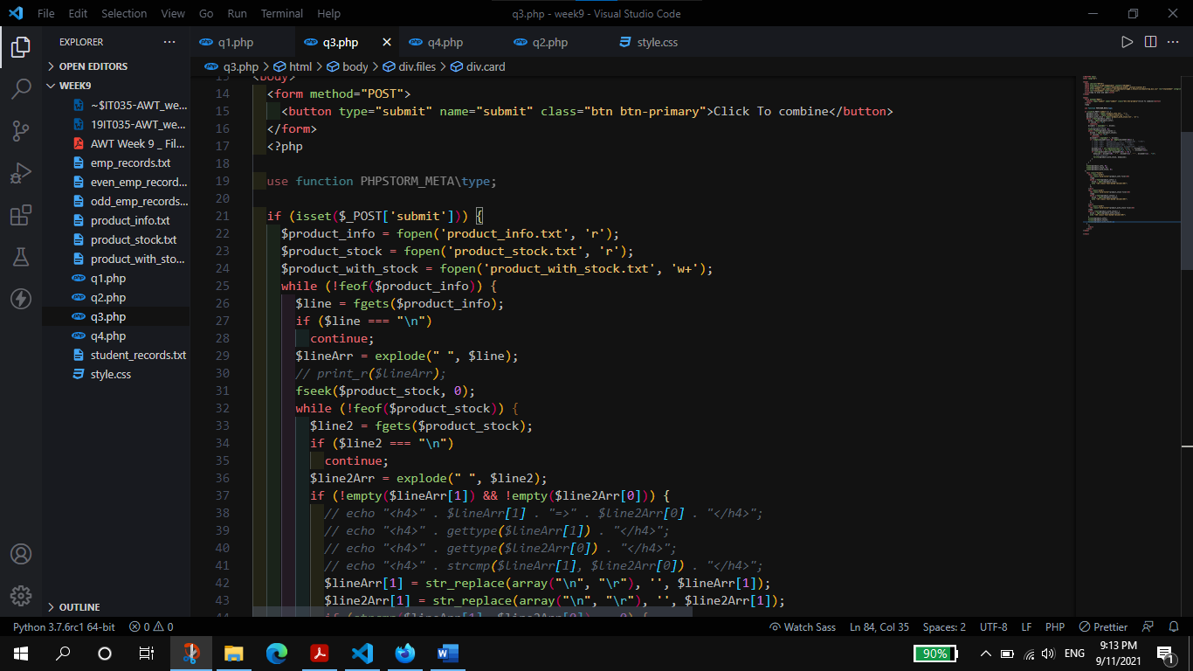

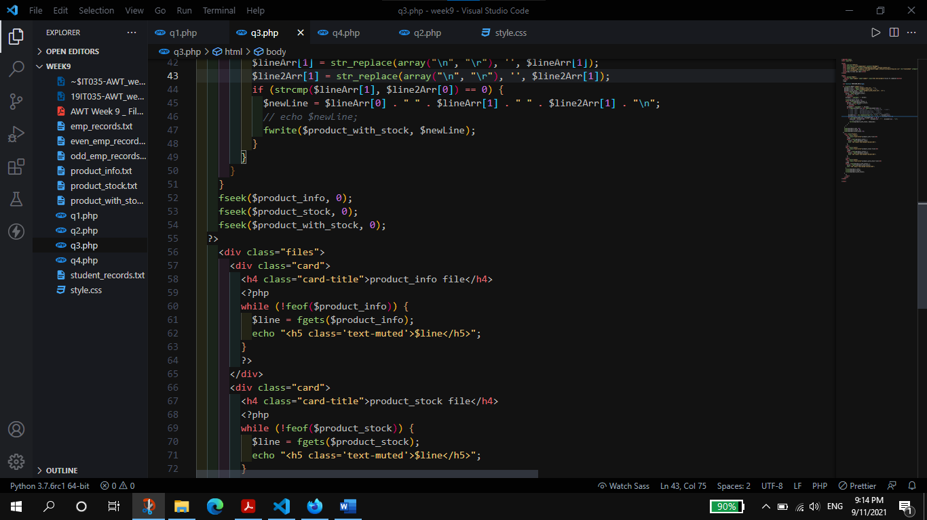

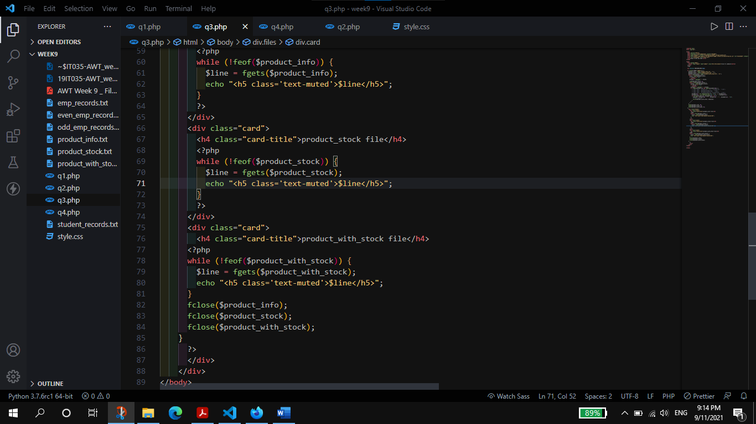

**Output:**

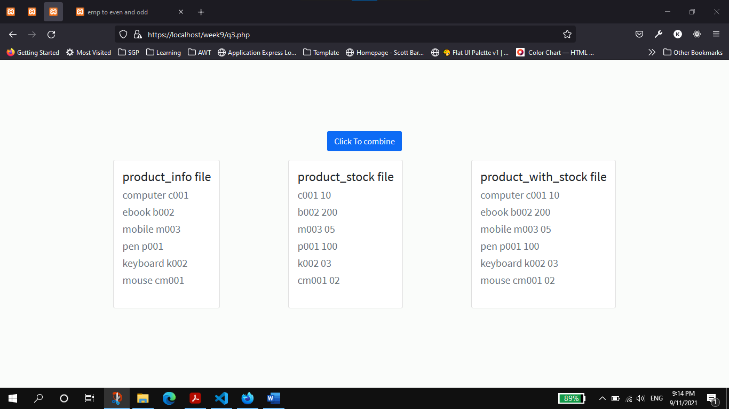

1. Get Product Code From User(input()) and Print Product Name and Stock.

**Code:**

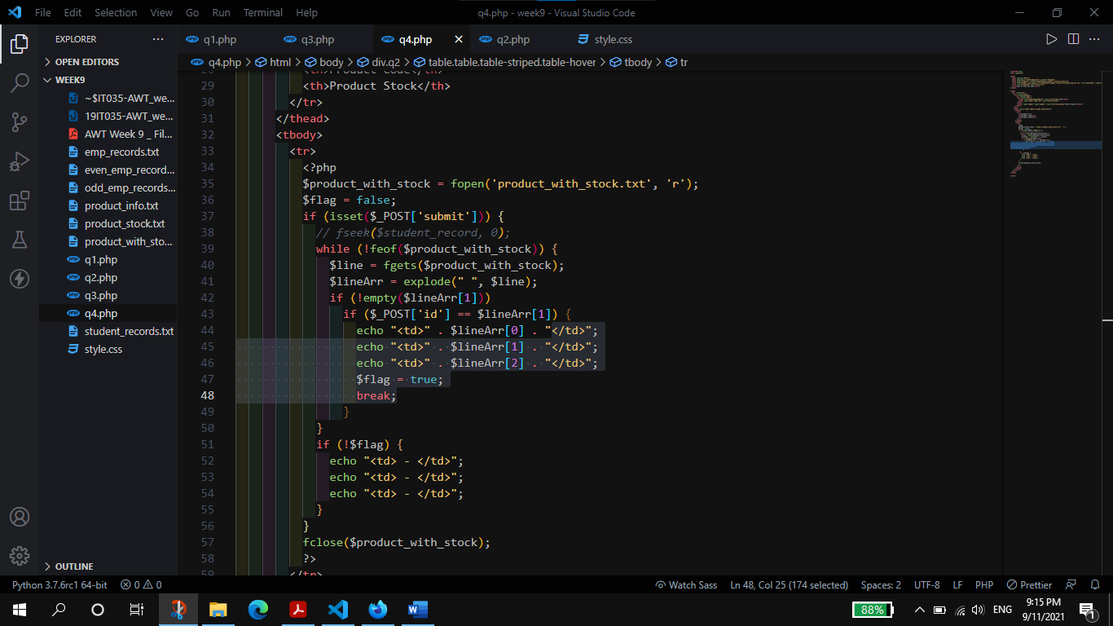

**Output:**

