Gui Application
Installation:
Currently I am using Ubuntu-16.04

A. Installing python 3.6.

sudo apt-get update
sudo apt-get install python3.6

B. Install opencv:
pip install opencv-python

C.Install tkinter
sudo apt-get update
sudo apt-get install python3-tk

D.Install pyteseract

pip install pytesseract
Get the tesseract tar.gz file from github:
https://github.com/tesseract-ocr/tesseract/releases/tag/3.05.02

Install dependencies:
sudo apt-get install g++
sudo apt-get install autoconf automake libtool
sudo apt-get install autoconf-archive
sudo apt-get install pkg-config
sudo apt-get install libpng-dev
sudo apt-get install libjpeg8-dev
sudo apt-get install libtiff5-dev
sudo apt-get install zlib1g-dev
Now,the final installation : Go to the directory where tar.gz file is downloaded
Run ./autogen.sh
$ sudo tar xf tesseract-3.05.02.tar.gz &&\
cd tesseract-3.05.02 &&\
sudo ./configure &&\
sudo make &&\
sudo make install

Working:
The Application uses tkinter to build the base GUI.Pytesserect is used to read the text in images and print the same.OpenCV enables cropping and warping
1. GUI consist of menubar on top of window,7 buttons and two dropdown menus
2. The menubar gives acces to File and help.By clicking on File,user cane open an image,Save it and exit the current GUI.Click on help menu gives access to about and instructions.It creates an text-box in text-frame and user can read them
3.Click ‘Select Image’ to select the image(*png).It is shown in Frame
4.Select the types of blur you want.Similarly,Select the respective button to get their features
5.Crop the image by ‘CLICK-DRAG’
6.You can use Auto-wrap for documents.If auto wrap is unable to detect edges.Message box will appear;in that case select the manual wrap and click on image for 4 points

Snapshots:
1. GUI :
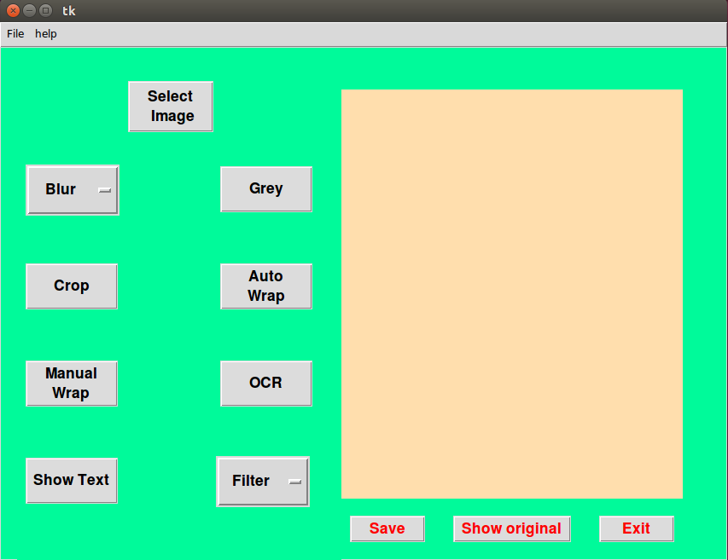

2. Select Image
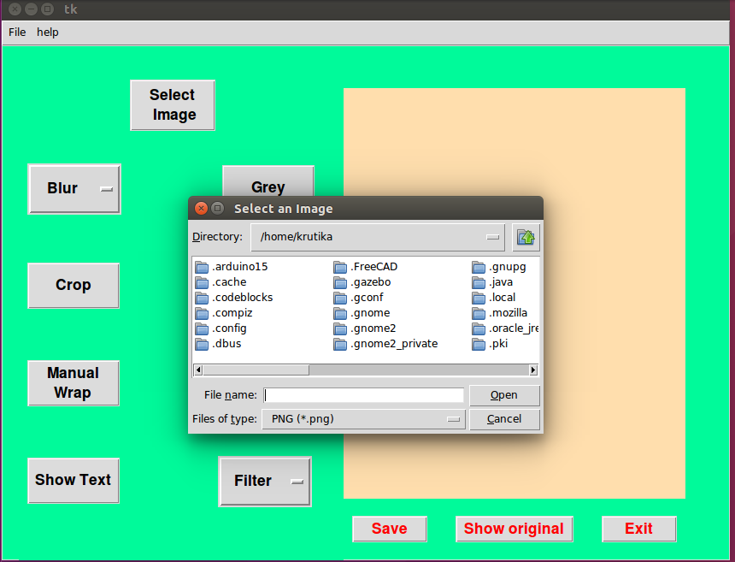
3. Selecting Mean blur in Blur Dropdown

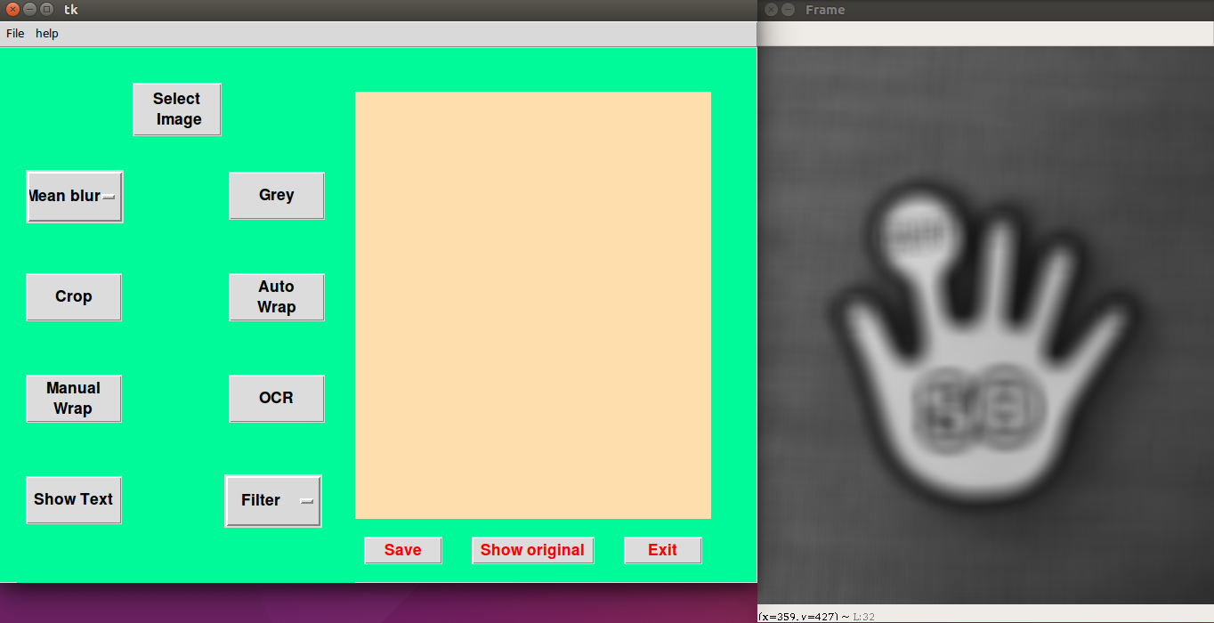

4.Grey

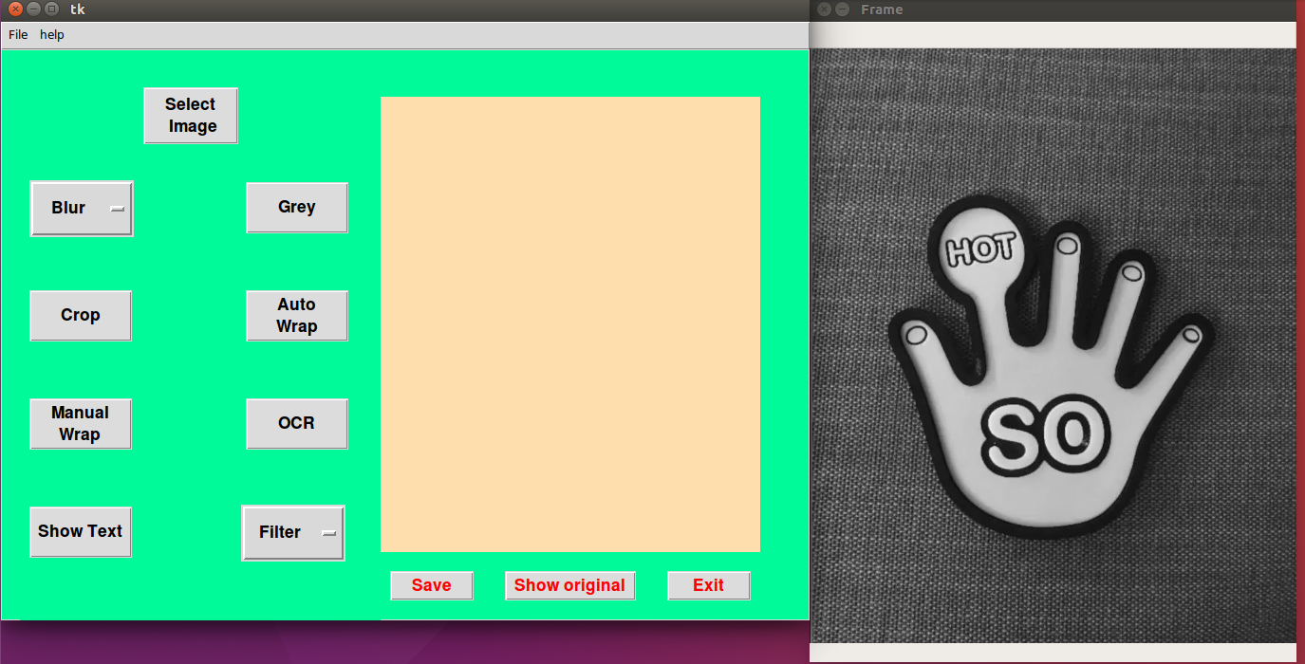
5.Crop

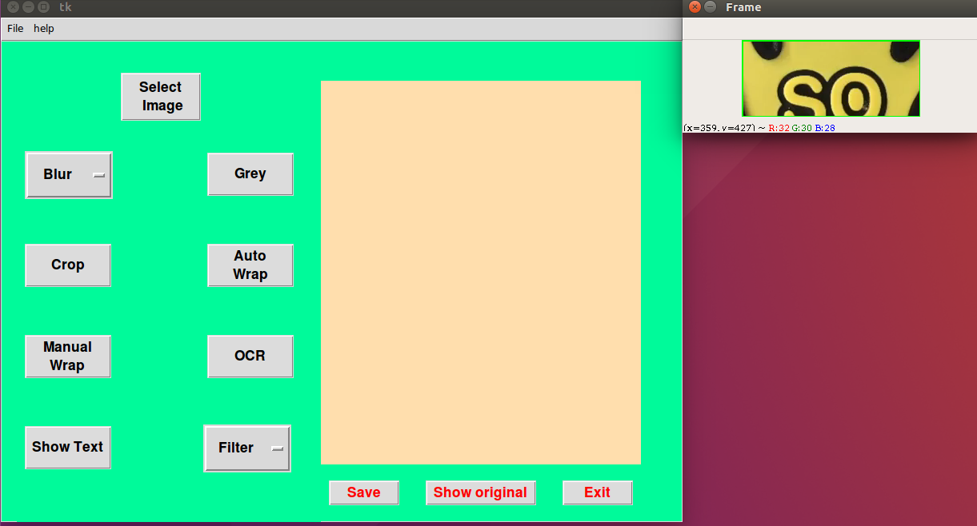

Crop image after selecting Grey:

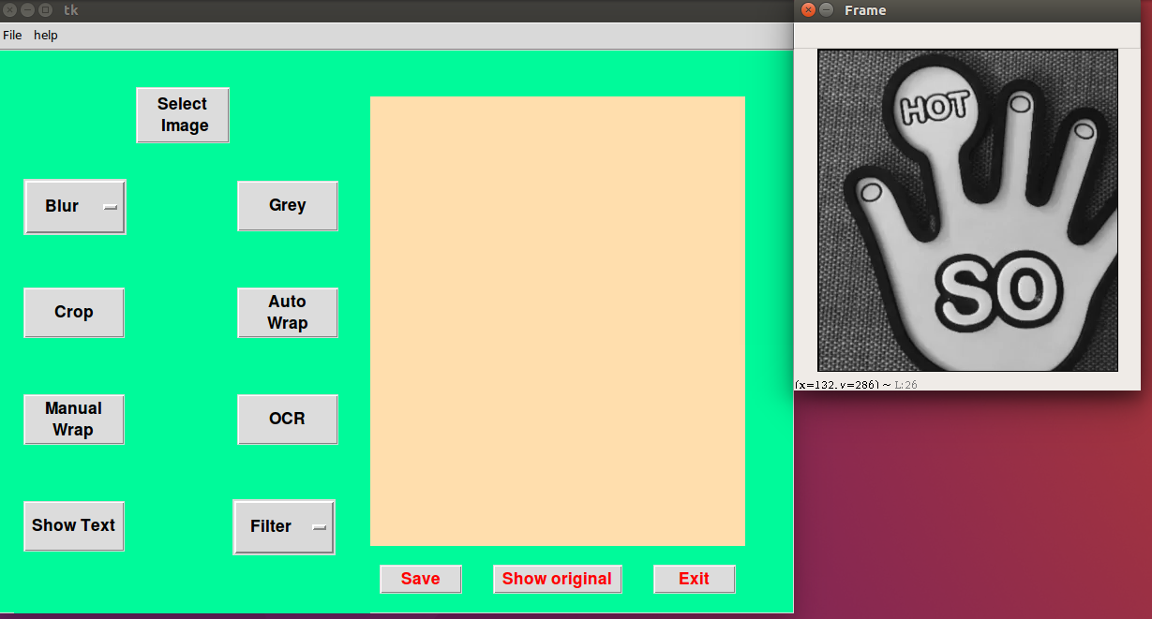

6.Auto Wrap

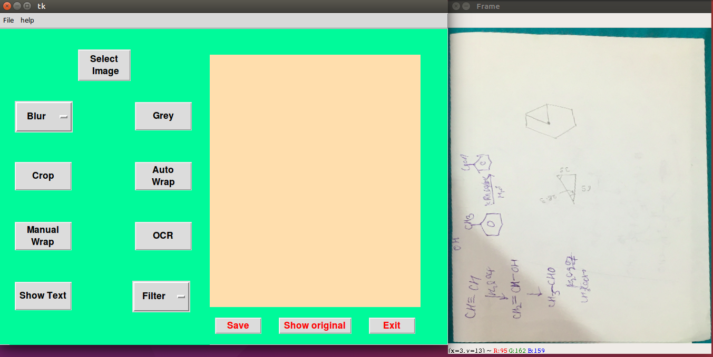
7.Manual Wrap (if Auto wrap not available)

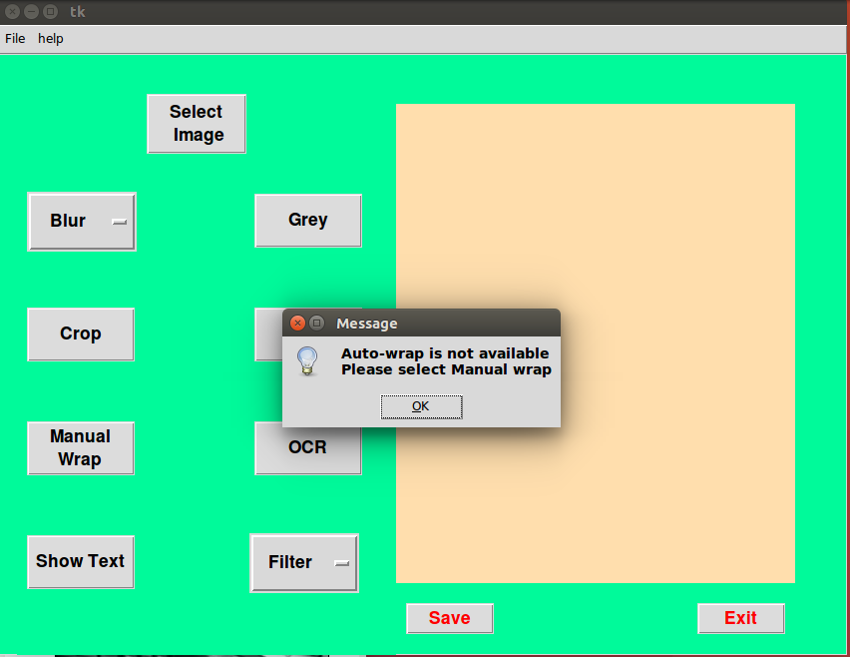
8.OCR and Show text:

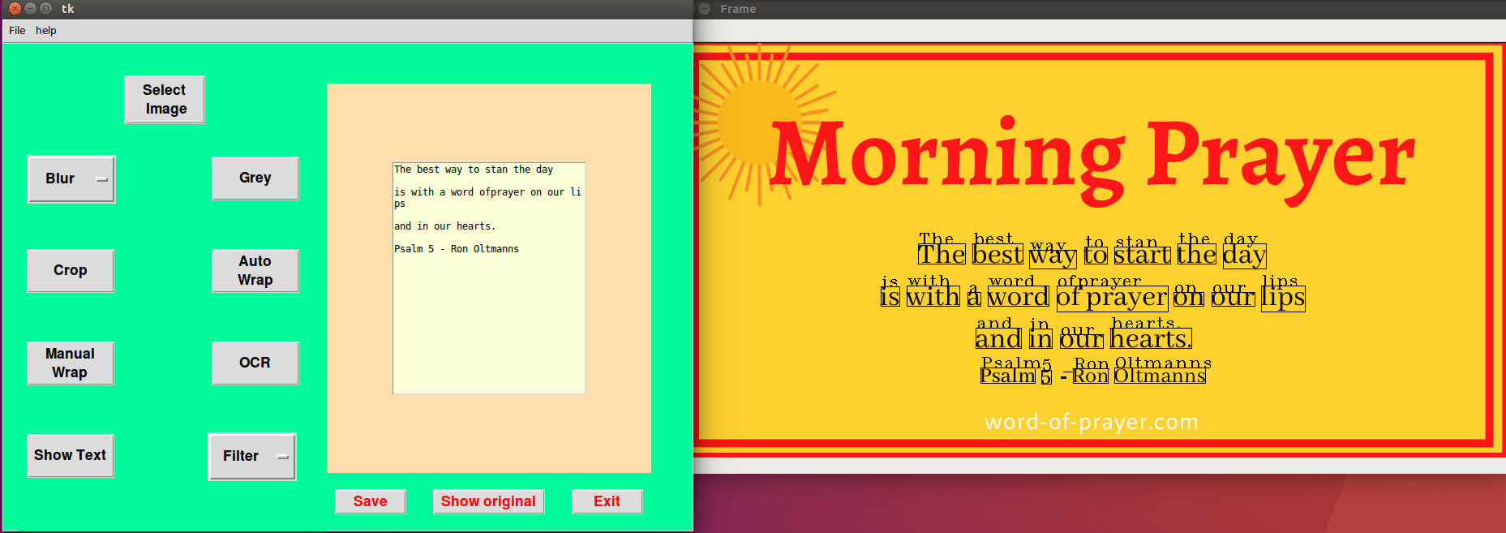

9.Filter -Selecting sobelx :
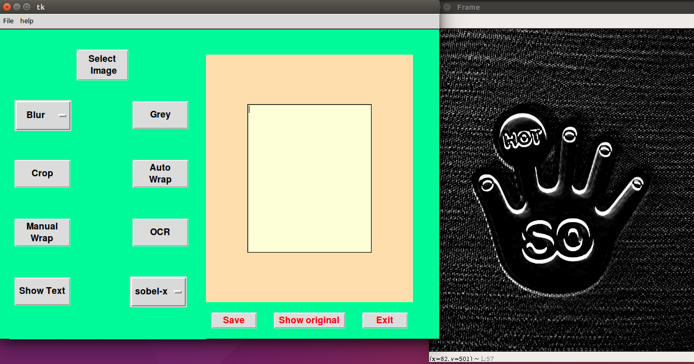
10.Saving Image (If user uses Save-as in File menu-It guides to select the name and and Save-Button saves in selected filename directory

