PHASE 1
1. Check all containers are running:
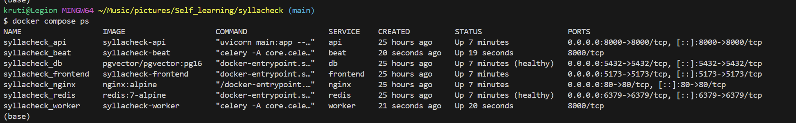
2. Check the API is responding:
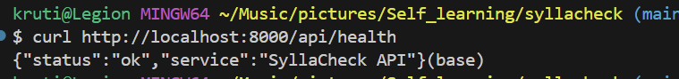
3. Check the database tables exist:
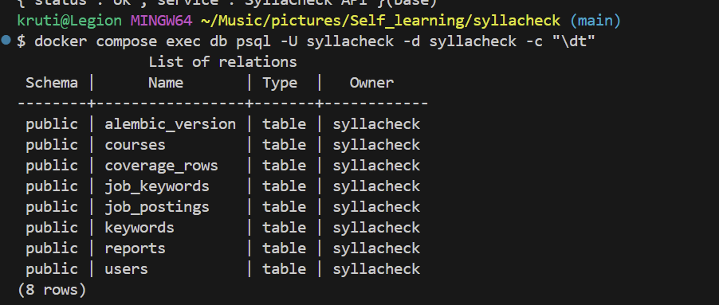
4. Check the migration status:
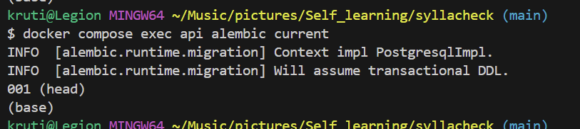
5. Check the frontend is up:
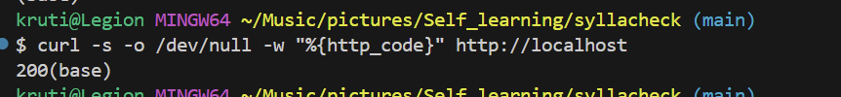
PHASE 2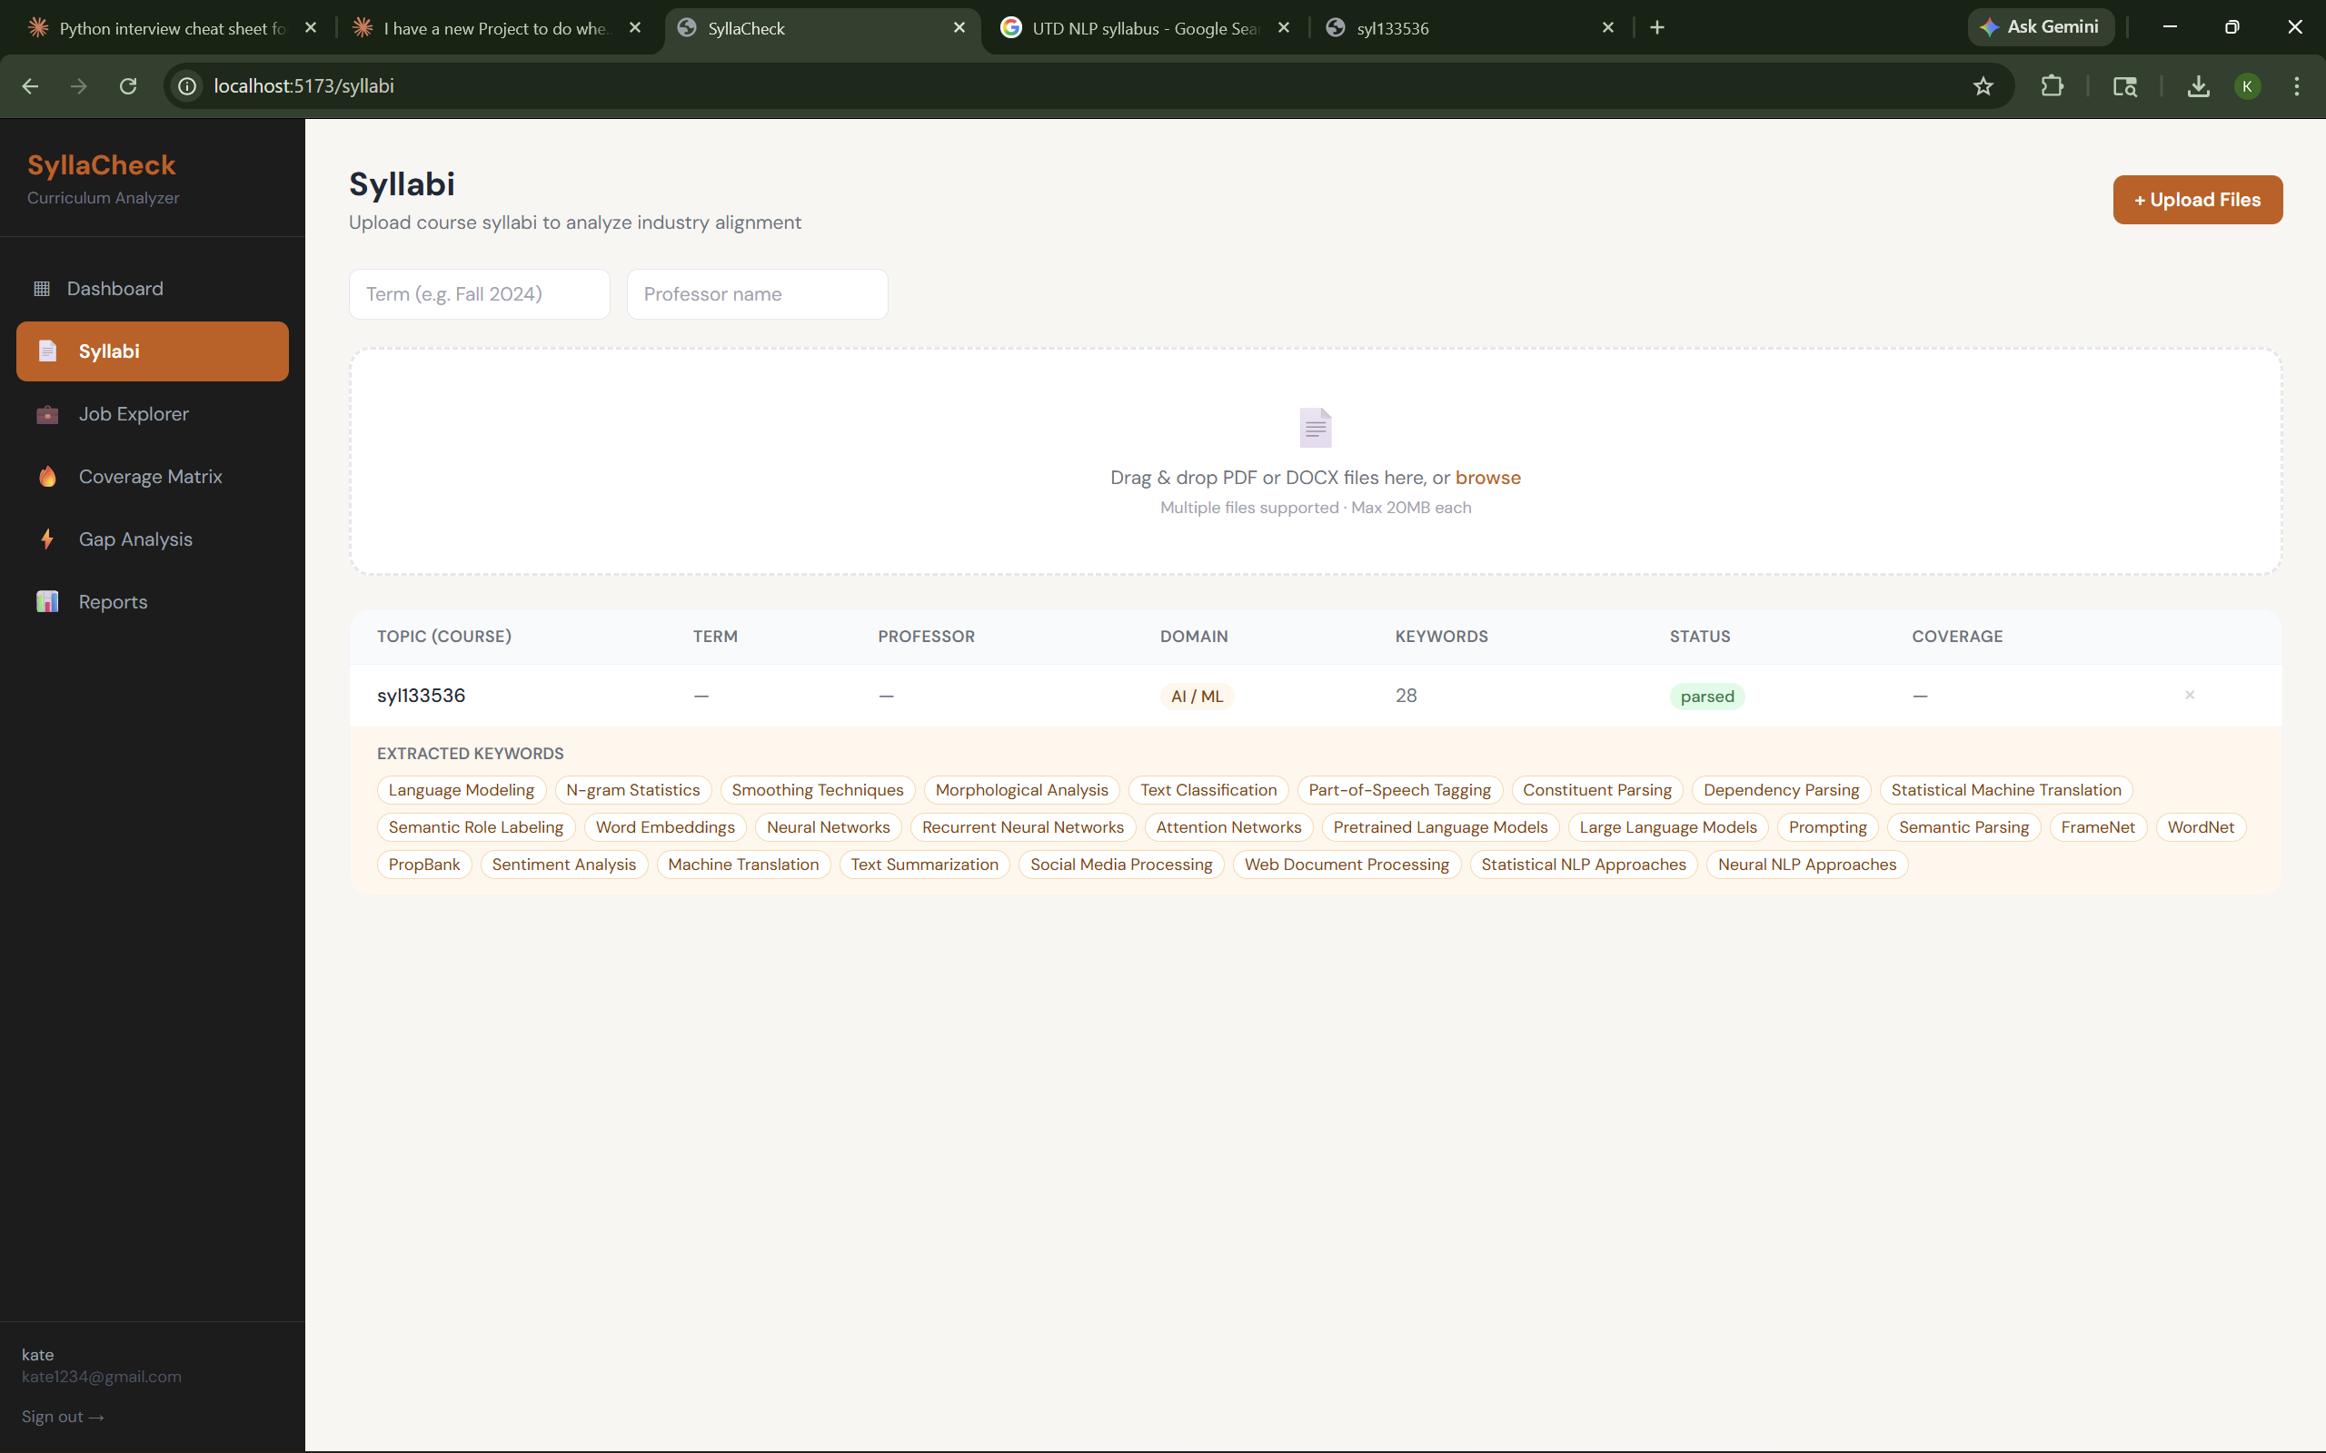Phase 3:
