# **User manual**

Guide for user to run our game:

1. Download and install Logisim;
2. Download our files game;
3. Unzip to the root of the C;
4. Open Gaev_Efimov_Masolygin_24216_Checkers_Logisim.circ in Logisim;
5. 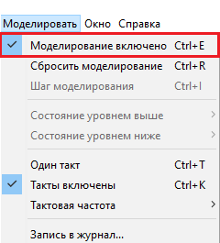
6. 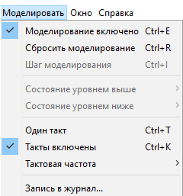
7. 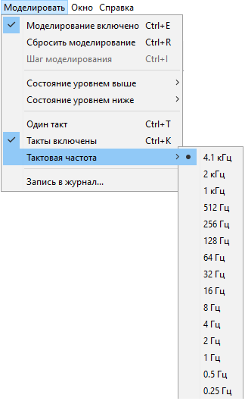
8. Choose the difficulty level;
9. Use these panels to control shapes;  
   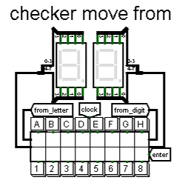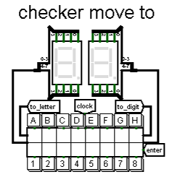

If desired, you can restart the game by clicking on the restart button. 