# Documentation

##### Name: Krystal Distribution Group

##### Author: Mykhailo Kruts

## 

## Subdomains:

* Warehouse :core
* Land Delivery :supporting
* Maritime Shipping :supporting
* Billing :supporting
* Purchasing :generic
* IAM :generic

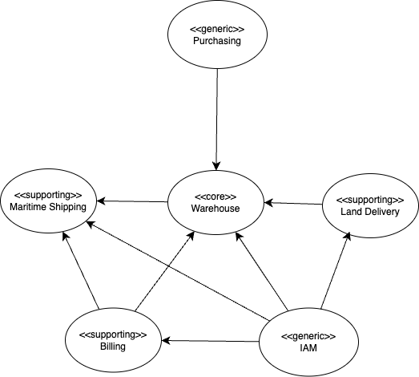

## Bounded Contexts:

1. Warehouse
2. Landside
3. Waterside
4. Invoicing

## Warehouse context:

#### Domain model:

#### Purpose:

#### Entities:

#### Value Objects:

#### Aggregates:

#### Commands:

#### Events:

## Landside context:

#### Domain model:

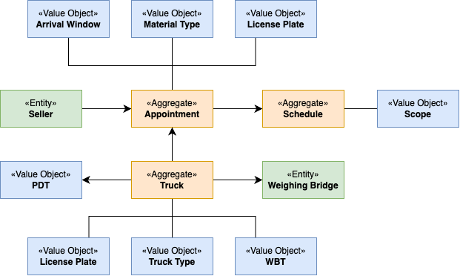

#### Purpose:

● Schedule truck arrivals to ensure efficient processing and avoid congestion.

● Maintain a log of scheduled and actual arrival times.

● Maintain a log of departures.

● Record the weight of trucks arriving and leaving the warehouse.

● Calculate the net weight of minerals delivered.

#### Entities:

* Seller
* Weighing Bridge

#### Value Objects:

* PayloadDeliveryTicket (PDT)

#### Aggregates:

* Appointment
  + Arrival Window
  + Material Type
  + License Plate
* Schedule
  + Scope
* Truck
  + Weighing Bridge Ticket (WBT)
  + License Plate
  + Truck Type

#### Commands:

* ScheduleTruckAppointmentCommand
  + Schedules a truck for delivery within a specific time window.

#### Events:

## Waterside context:

## Invoicing context:

## Context mapping plan: