Institute of Technology of Cambodia

Assignment of Mathematical Modeling

**Group: I3-AMS-A**

**Team 10: Members:**

KRY SENGHORT : e20200706

LENG MOURYHONG : e20200413

LEAT SEANGLONG : e20200971

LIM SUNHENG : e20200807

Academic Year: 2022-2023

***Exercise 1:***

In the following data, X is the Fahrenheit temperature and Y is the number of times a cricket chirp in 1 minute (see Problem 7, Section 4.1). Make a scatterplot of the data and discuss the appropriateness of using an 18th-degree polynomial that passes through the data points as an empirical model. If you have a computer available, fit a polynomial to the data and plot the results.

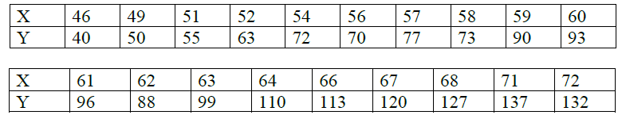

***Solution:***

By using the excel programming we get result below:

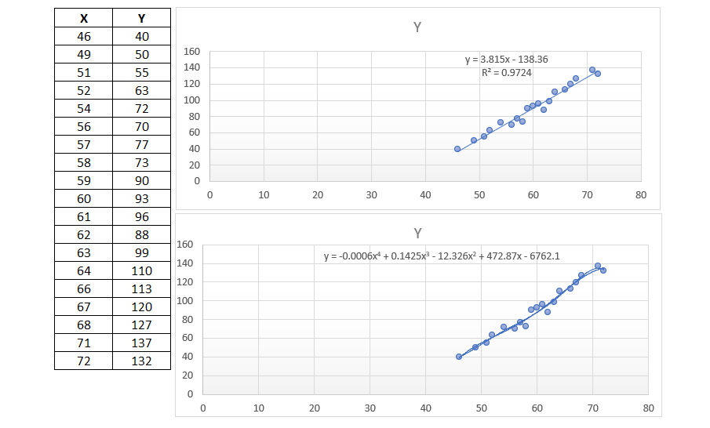

Based on the scatterplot graphs, there are two possible fit models that representing data such that is linear and polynomial.

* ***Linear Model:***

The data fit model is denoted by: Y = 3.815x – 138.36, where Y is approximately linearly related to X by using least-square method.

* ***Polynomial Model:***

The data fitting model is defined by: y = -0.0006x4 + 0.1425x3 - 12.326x2 + 472.87x - 6762.1

We cannot transform to 18th degree polynomial because the coefficient of largest degree is more infinitely.

***Exercise 2:***

For the data sets in Problems, construct a divided difference table. What conclusions can you make about the data? Would you use a low order polynomial as an empirical model? If so, what order?

|  |  |  |  |  |  |  |  |  |
| --- | --- | --- | --- | --- | --- | --- | --- | --- |
| X | 0 | 1 | 2 | 3 | 4 | 5 | 6 | 7 |
| Y | 23 | 48 | 73 | 98 | 123 | 148 | 173 | 198 |

***Solution:***

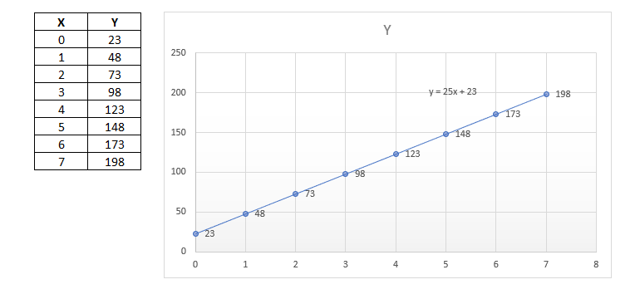

From the scatterplot graph above representing data in the table we can conclude that the model fitting of data is linear equation. We can fit this model by using linear equation satisfying below:

Y = 25x + 23

***Exercise 3:***

In the following data, X represents the diameter of a ponderosa pine measured at breast height, and Y is a measure of volume-number of board feet divided by 10 (see Problem 4, Section 4.2)



***Solution:***

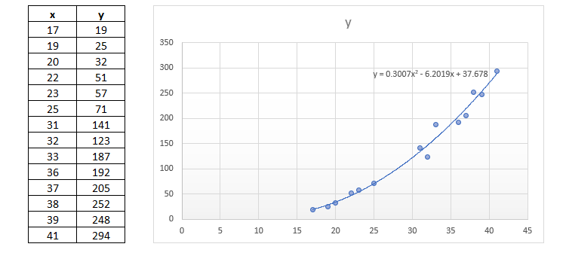

From the scatterplot graph above representing data in the table we can conclude that the model fitting of data is polynomial equation. We can fit this model by using polynomial equation satisfying below:

Y = 0.3007x2 – 6.2019x + 37.678

***Exercise 4:***

For each of the following data sets, write a system of equations to determine the coefficients of the natural cubic splines passing through the given points. If a computer program is available, solve the system of equations and graph the splines.

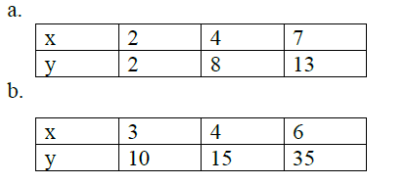

***Solution:***



The equation that can fit to this natural cubic spline is denoted by:





$\left\{\begin{aligned}2=aln\left(2\right)+b \left(1\right) \\ 8=aln\left(4\right)+b \left(2\right) \\ 13=aln\left(7\right)+b \left(3\right)\end{aligned}\right.$

After solve this system we obtain:

a = 8.7757, b = - 4.1085

Therefore, the model fitting is defined by logarithmic equation such that: 



The equation that can fit to this natural cubic spline is denoted by:



$$\left\{\begin{aligned}10=9a+3b+c (1) \\ 15=16a+4b+c \left(2\right) \\ 35=36a+6b+c \left( 3\right) \end{aligned}\right.$$

After solve this system we obtain:

  
Therefore, the model fitting is defined by polynomial equation such that: 

***Exercise 5:***

Find the natural cubic splines that pass through the given data points. Use the splines to answer the requirements.

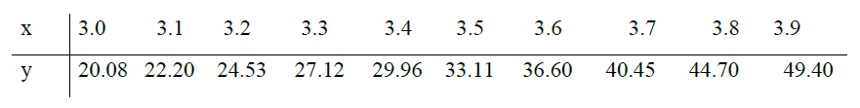

***Solution:***

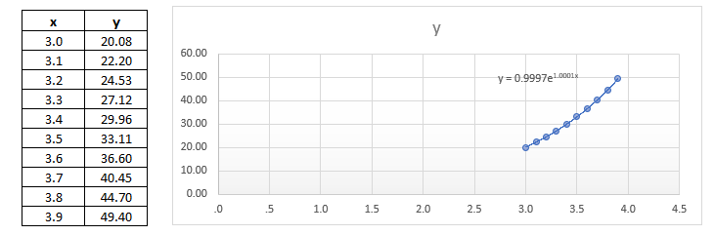

By using excel calculation we obtain the natural cubic splines that representing data table set above is exponential function equation that has the form as: 

Therefore, the model fitting is defined by polynomial equation such that: 

1. Estimate the derivative evaluated at 𝑥=3.4. Compare your estimate with the derivative of  evaluated at 𝑥 = 3.45.

***Proof****:*

We have  is the equation that represent data then derivative is denoted by:



* 
* 

We observe that: 

1. Estimate the area under the curve from 3.3 to 3.6. Compare with 

***Proof****:*

As we know that the area of curve between two points is defined by: Area = 

Then Area = 

Check: 

Therefore, 