Institute of Technology of Cambodia

Assignment of Mathematical Modeling

**Group: I3-AMS-A**

**Team 10: Members:**

KRY SENGHORT : e20200706

LENG MOURYHONG : e20200413

LEAT SEANGLONG : e20200971

LIM SUNHENG : e20200807

Academic Year: 2022-2023

***Exercise 1:***

For each of the following data sets, write a system of equations to determine the coefficients of the natural cubic splines passing through the given points. If a computer program is available, solve the system of equations and graph the splines.

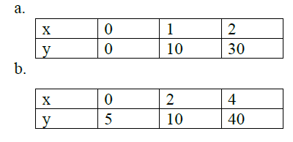

***Solution:***

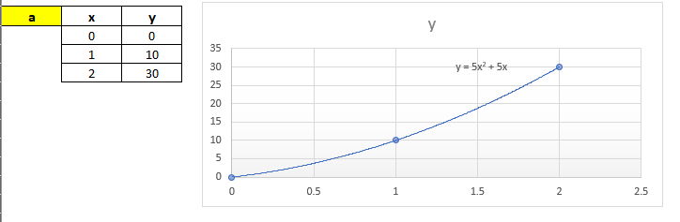

From the above graph data representation, we have the fitting model to this data set is given by 2nd degree polynomial:

 (*)

* 
* 
* 

After solving this problem, we get 

Therefore, the natural cubic splines of this data set are 2nd degree polynomial equation such that 

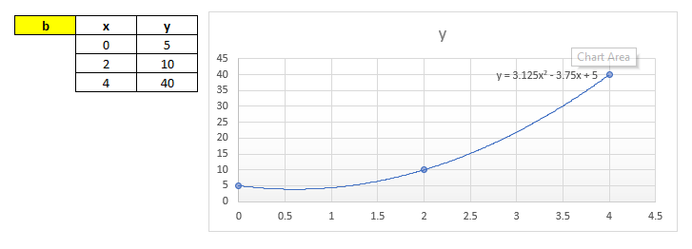

From the above graph data representation, we have the fitting model to this data set is given by 2nd degree polynomial:

 (*)

* 
* 
* 

After solving this problem, we have gotten the coefficients 

Therefore, the natural cubic splines of this data set are 2nd degree polynomial equation such that 

***Exercise 2:***

Find the natural cubic splines that pass through the given data points. Use the splines to answer the requirements.

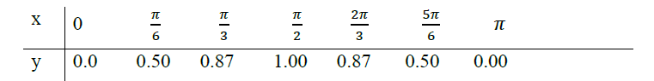

***Solution:***

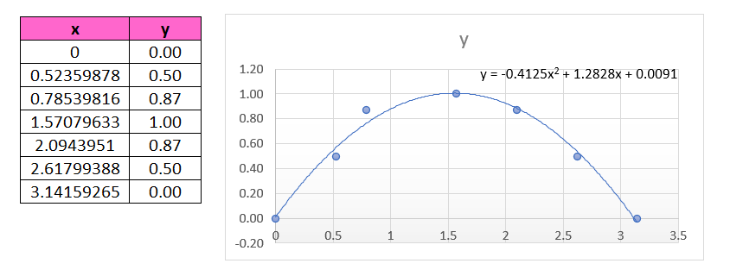

From the above graph data representation, we have the fitting model to this data set is given by 2nd degree polynomial:

 (*)

* 
* 
* 
* 
* 
* 
* 
* After solving this problem, we have gotten the coefficients 

Therefore, the natural cubic splines of this data set are 2nd degree polynomial equation such that



***Exercise 3:***

Construct a computer code for determining the coefficients of the natural splines that pass-through a given set of data points. See Burden and Fairs, cited earlier in this chapter, for an efficient algorithm.

***Solution:***

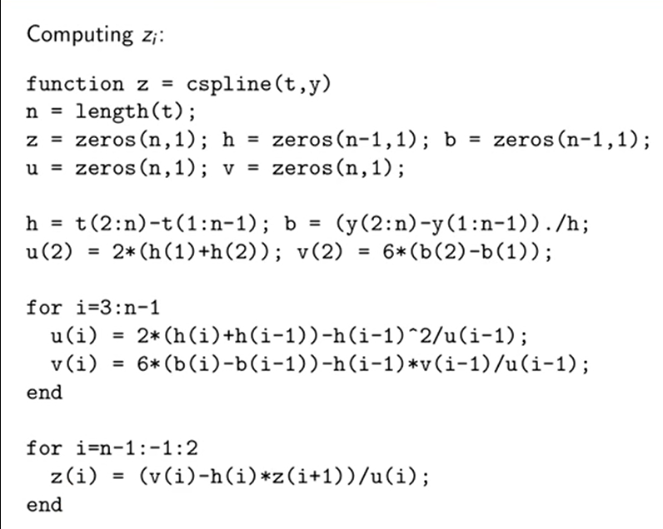 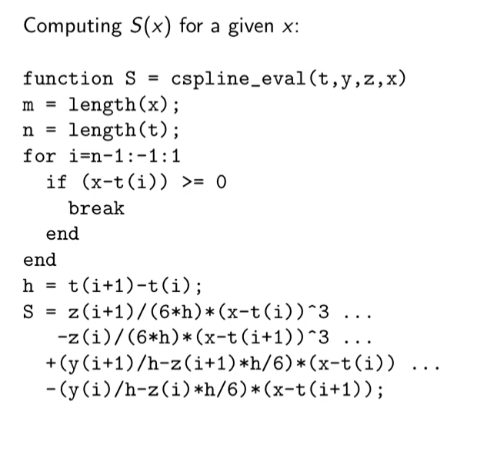

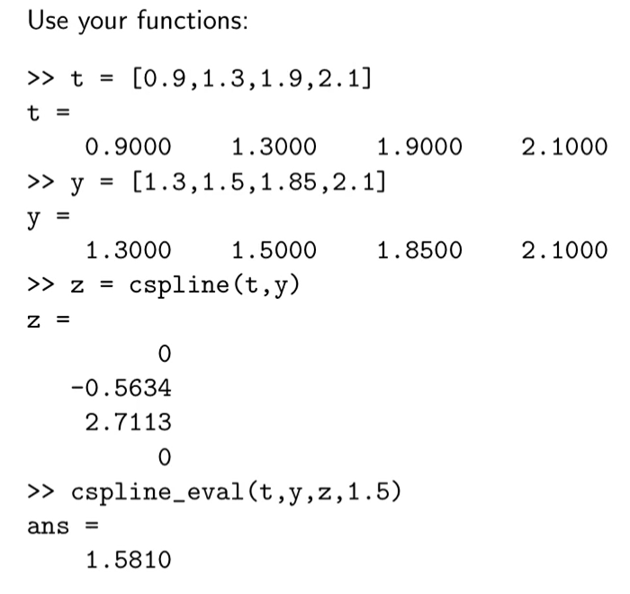

***Exercise 4:***

The following data were obtained for the growth of a sheep population introduced into a new environment on the island of Tasmania (adapted from J. Davidson, ‘‘On the Growth of the Sheep Population in Tasmania,’’ Trans. Roy. Soc. S. Australia 62(1938): 342–346). t (year) 1814 1824 1834 1844 1854 1864 P .t / 125 275 830 1200 1750 1650

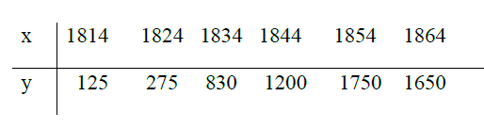

***Solution:***

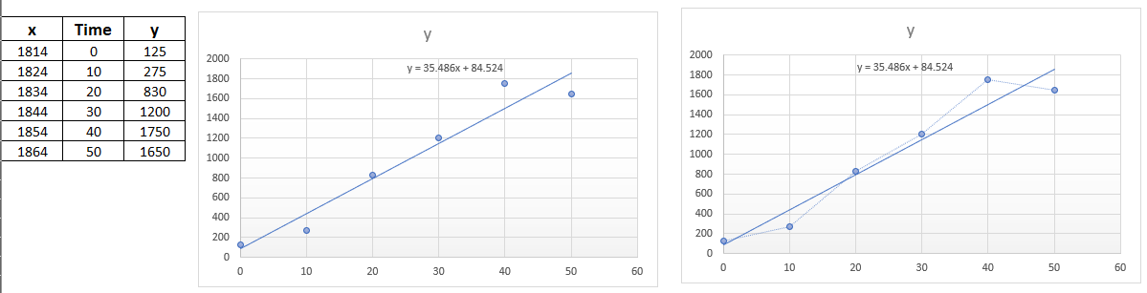

Based on the graph of data representation above we have the model fitting of cubic splines to this data set is linear equation: 

Therefore, the natural cubic splines of this data set are linear equation such that