TP01

Java Data Output

# Remark

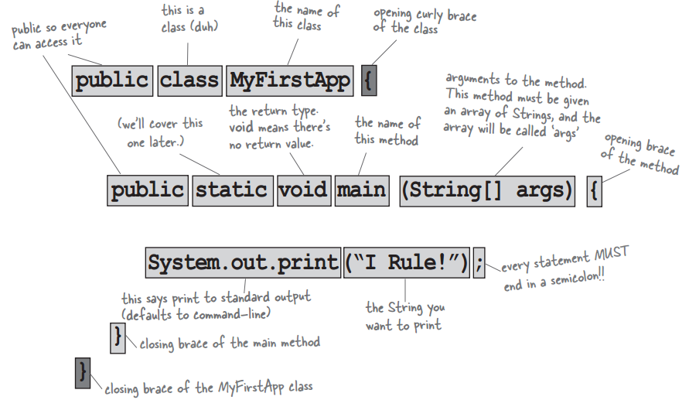

# TP01.1. Hello One’s Name

Implement an application Java that displays “Hello *<your_name>*!” where *<your_name>* represents your own name. Example, in case your name is: Visal, then:

Hello Visal!

# TP01.2. Display a Paragraph

Implement an application Java that displays the following paragraph:

\n Line break.  
\t Tabulation.  
\’ Single Quote.  
\” Double Quote.  
\\ \ Sign.  
\\\\ \\ Sign.  
// Line Comment.  
/* ... */ Block Comment.  
"""

Text block.  
"""

# TP01.3. Asterisks

Write a program in Java to display shapes as below:

A.

*************************  
 * *  
 * *  
 * *  
 * *  
 *************************

B.

*  
 ***  
 *****  
 *******  
 *********

C.

*  
 ***  
 *****  
 *******  
 *********

D.

*  
 ***  
 *****  
 *******  
 *********

E.

*  
 ***  
 *****  
 ***  
 *

F.

*  
 ***  
 *****  
 ***  
 *

G.

*****  
 ***  
 *  
 ***  
 *****

H.

*  
 * *  
 * *  
 * *  
 *

# Notes:

1. In Java, there is a class name *String* that replace *char \** in C. Example: *“Hello, it is a String”*.
2. We can concatenate 2 or more Strings using operator *+*  just like adding between 2 numbers.   
   Example: *“Kingdom” + “ of” + “ Wonder!”*   
   Example2:

String dice = “DICE students”;  
 String action = “are so”;  
 String adj = “so friendly!”;

String sentence = dice + “ “ + action + “ “ + adj;

1. To display text on the console, we use:

System.out.print(“String or Variable”);

Or:

System.out.println(“String or Variable”);

Or:

System.out.printf(“format ex: %s”, “Hello”);

**//===============================================================================================**

**import** java.util.Scanner;

**public** **class** NumberPatternPrograms{

**public** **static** **void** main(String[] args){

        Scanner sc = **new** Scanner(System.in);

        //Taking rows value from the user

        System.out.println("How many rows you want in this pattern?");

**int** rows = sc.nextInt();

        System.out.println("Here is your pattern....!!!");

**for** (**int** i = 1; i <= rows; i++){

**for** (**int** j = 1; j <= i; j++){

                System.out.print(j+" ");

            }

            System.out.println();

        }

        //Close the resources

        sc.close();

    }

}

Output:

1  
1 2  
1 2 3  
1 2 3 4  
1 2 3 4 5  
1 2 3 4 5 6  
1 2 3 4 5 6 7

**//===============================================================================================**

**import** java.util.Scanner;

**public** **class** NumberPatternPrograms{

**public** **static** **void** main(String[] args){

        Scanner sc = **new** Scanner(System.in);

        //Taking rows value from the user

        System.out.println("How many rows you want in this pattern?");

**int** rows = sc.nextInt();

        System.out.println("Here is your pattern....!!!");

**for** (**int** i = rows; i >= 1; i--){

**for** (**int** j = 1; j <= i; j++){

                System.out.print(j+" ");

            }

            System.out.println();

        }

        //Closing the resources

        sc.close();

    }

}

Output:

1 2 3 4 5 6 7  
1 2 3 4 5 6  
1 2 3 4 5  
1 2 3 4  
1 2 3  
1 2  
1

**//===============================================================================================**

**import** java.util.Scanner;

**public** **class** NumberPatternPrograms{

**public** **static** **void** main(String[] args){

        Scanner sc = **new** Scanner(System.in);

        //Taking rows value from the user

        System.out.println("How many rows you want in this pattern?");

**int** rows = sc.nextInt();

        System.out.println("Here is your pattern....!!!");

**for** (**int** i = 1; i <= rows; i++){

**for** (**int** j = 1; j <= i; j++){

                System.out.print(i+" ");

            }

            System.out.println();

        }

        //Close the resources

        sc.close();

    }

}

Output:

1  
2 2  
3 3 3  
4 4 4 4  
5 5 5 5 5  
6 6 6 6 6 6  
7 7 7 7 7 7 7

**//===============================================================================================**

**import** java.util.Scanner;

**public** **class** NumberPatternPrograms{

**public** **static** **void** main(String[] args){

        Scanner sc = **new** Scanner(System.in);

        //Taking rows value from the user

        System.out.println("How many rows you want in this pattern?");

**int** rows = sc.nextInt();

        System.out.println("Here is your pattern....!!!");

**for** (**int** i = rows; i >= 1; i--){

**for** (**int** j = 1; j <= i; j++){

                System.out.print(i+" ");

            }

            System.out.println();

        }

        //Close the resources

        sc.close();

    }

}

Output:

7 7 7 7 7 7 7  
6 6 6 6 6 6  
5 5 5 5 5  
4 4 4 4  
3 3 3  
2 2  
1

**//===============================================================================================**

**import** java.util.Scanner;

**public** **class** NumberPatternPrograms

{

**public** **static** **void** main(String[] args)

    {

        Scanner sc = **new** Scanner(System.in);

        //Taking rows value from the user

        System.out.println("How many rows you want in this pattern?");

**int** rows = sc.nextInt();

        System.out.println("Here is your pattern....!!!");

**for** (**int** i = rows; i >= 1; i--)

        {

**for** (**int** j = rows; j >= i; j--)

            {

                System.out.print(j+" ");

            }

            System.out.println();

        }

        //Closing the resources

        sc.close();

    }

}

**Output:**

7  
7 6  
7 6 5  
7 6 5 4  
7 6 5 4 3  
7 6 5 4 3 2  
7 6 5 4 3 2 1

**//===============================================================================================**

**import** java.util.Scanner;

**public** **class** NumberPatternPrograms

{

**public** **static** **void** main(String[] args)

    {

        Scanner sc = **new** Scanner(System.in);

        //Taking rows value from the user

        System.out.println("How many rows you want in this pattern?");

**int** rows = sc.nextInt();

        System.out.println("Here is your pattern....!!!");

**for** (**int** i = 1; i <= rows; i++)

        {

**for** (**int** j = rows; j >= i; j--)

            {

                System.out.print(j+" ");

            }

            System.out.println();

        }

        //Closing the resources

        sc.close();

    }

}

**Output:**

7 6 5 4 3 2 1  
7 6 5 4 3 2  
7 6 5 4 3  
7 6 5 4  
7 6 5  
7 6  
7

**//===============================================================================================**

**import** java.util.Scanner;

**public** **class** NumberPatternPrograms

{

**public** **static** **void** main(String[] args)

    {

        Scanner sc = **new** Scanner(System.in);

        //Taking rows value from the user

        System.out.println("How many rows you want in this pattern?");

**int** rows = sc.nextInt();

        System.out.println("Here is your pattern....!!!");

**for** (**int** i = rows; i >= 1; i--)

        {

**for** (**int** j = i; j >= 1; j--)

            {

                System.out.print(j+" ");

            }

            System.out.println();

        }

        //Close the resources

        sc.close();

    }

}

**Output:**

7 6 5 4 3 2 1  
6 5 4 3 2 1  
5 4 3 2 1  
4 3 2 1  
3 2 1  
2 1  
1

**//===============================================================================================**

**//===============================================================================================**

**//===============================================================================================**

**//===============================================================================================**

**//===============================================================================================**

**//===============================================================================================**