SPH2002 Outbreak Investigation
T3_Group3

No. | Student MATRIC Numbers
1 | A0192401R
2 | A2222222B
3 | A3333333C
4 | A4444444D
5 | A5555555E
6 | A6666666F

Section 1: Descriptive epidemiology (13 marks)

1. Summarize the characteristics of the population including age, sex, residency status and participant role in the conference, in a short paragraph. (5 marks)
The study population consisted of 265 participants. The median age was 37 years (IQR: 32 - 39), with a range from 27 to 49. The majority were male (104, 39.2%), while the remaining 161 (60.8%) were female. Participants were almost evenly split between overseas (129, 48.7%) and Singapore residents (136, 51.3%). Majority of the participants were delegates (200, 75.5%), while the remaining 65 (24.5%) were presenters.

2. Construct a table summarizing the frequency and percentage of symptoms reported by participants who experienced at least one symptom. Arrange the symptoms in descending order of frequency. Show your calculations in the analysis output. (5 marks)

Symptomatic participants (n = 146)
Symptom | Frequency | Percentage (%)
Diarrhoea | 132 | 90.4
Abdominal pain | 115 | 78.8
Fever | 86 | 58.9
Vomiting | 70 | 47.9
Loss of appetite | 19 | 13.0
Nausea | 4 | 2.7

3. In Singapore, the background rate of foodborne illness is typically less than 1%. Based on your analysis above, evaluate whether the observed illness among conference participants is likely to represent an outbreak. Provide justification for your conclusion. (3 marks)
The proportion of participants reporting at least one symptom was 55.1% (146 out of 265), which greatly exceeds the background rate of foodborne illness in Singapore (<1%). Therefore, this finding strongly suggests that an outbreak has occurred among conference participants.

Section 2: Developing the case definition (22 marks)

4. Propose a suitable case definition for this outbreak. (6 marks)
[To be completed]

5. What are the benefits and challenges of using a case definition that is too broad or too narrow during an outbreak investigation? How might this impact the outcome of the investigation? (4 marks)
[To be completed]

6. Describe two strategies public health investigators can implement to effectively balance between rapid outbreak response and accurate determination of the outbreak source when using a working case definition. (4 marks)
[To be completed]

7. Using the pre-determined case definition, calculate the attack rate among the conference attendees. Show your calculation and present your final answer as a percentage. (2 marks)
Number of cases = 132
Total number of attendees = 265
Attack rate = (132 / 265) × 100 = 49.8%

8. What were the minimum, median and maximum durations of illness (in days) among the cases? Show your calculations in the analysis output. (3 marks)
Minimum duration = 1.71 days
Median duration = 3.04 days
Maximum duration = 6.79 days

9. What were the minimum, maximum, and median incubation periods (in days) among cases? Show your calculations in the analysis output. (3 marks)
Minimum incubation period = 0.58 days
Median incubation period = 1.00 days
Maximum incubation period = 1.42 days

Section 3: Epidemic curve (15 marks)

10. Construct an epidemic curve using the dates and times of illness onset among the cases. Include your graph below. Ensure it has a title, labelled axes, and appropriate time intervals. Show how the graph was generated in the analysis output. (12 marks)
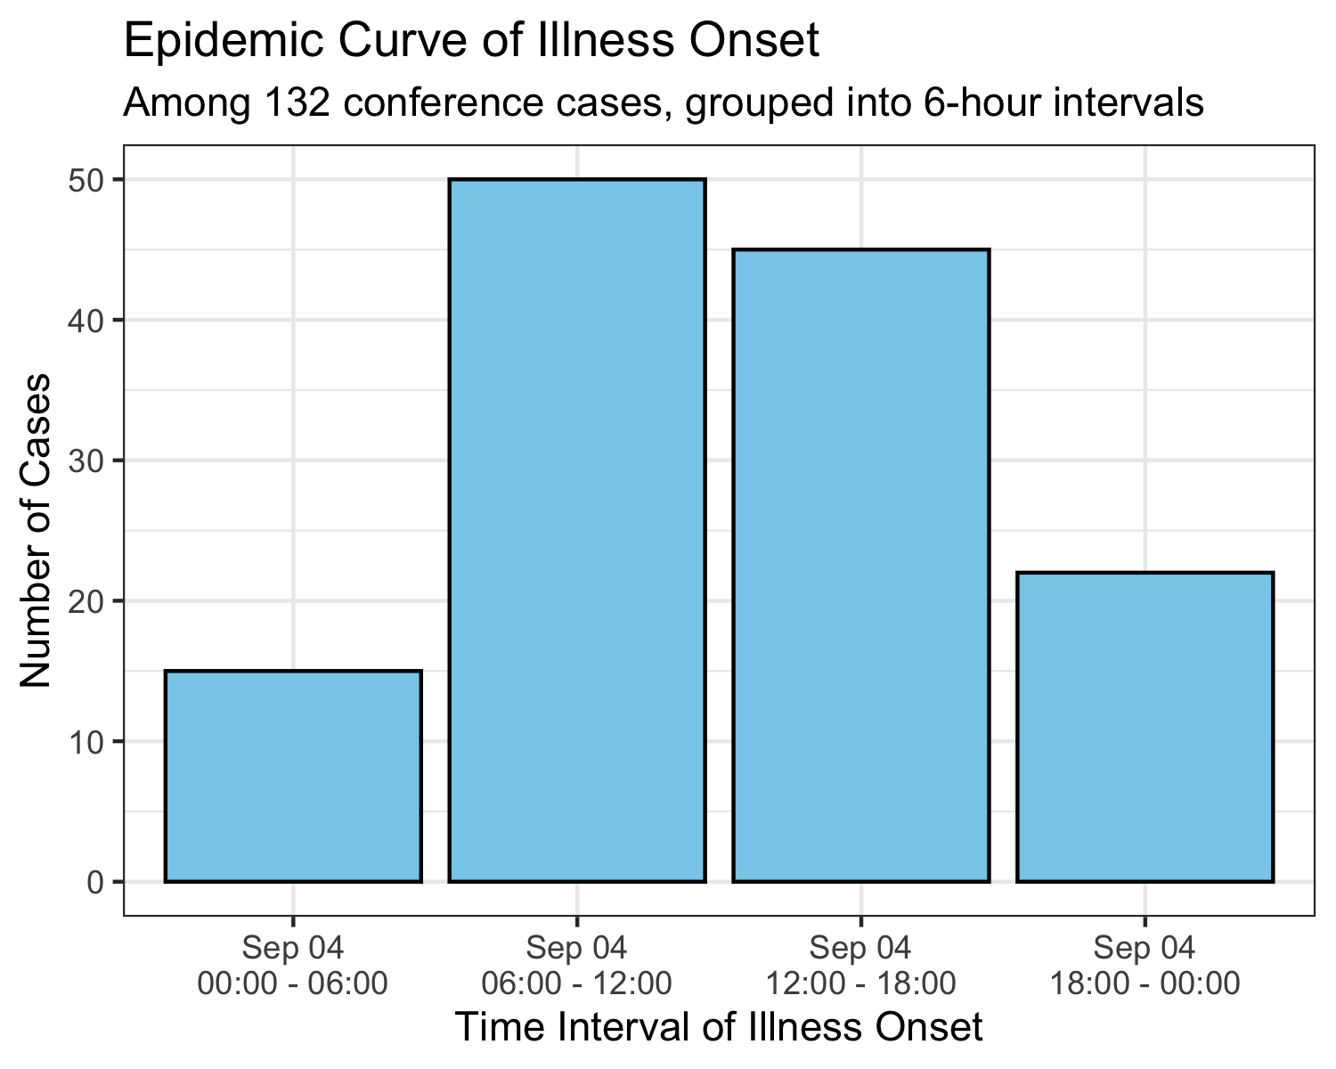

11. Based on your epidemic curve, what kind of outbreak does it suggest? Give reasons for your answer. (3 marks)
[To be completed]

Section 4: Analytical epidemiology (21 marks)

12. Construct a table summarising the frequency and attack rates among the exposed and unexposed groups for each food item served at the conference. (10 marks)

 | Exposed |  |  | Unexposed
Food | Ill | Total | Attack Rate (%) | Ill | Total | Attack Rate (%) | Unknown
Beef Tenderloin | 60 | 138 | 43.5 | 72 | 127 | 56.7 | 0
Caesar Salad | 95 | 200 | 47.5 | 37 | 65 | 56.9 | 0
Cheese Platter | 28 | 93 | 30.1 | 102 | 169 | 60.4 | 3
Chocolate Fondue | 72 | 159 | 45.3 | 60 | 104 | 57.7 | 2
Grilled Salmon | 23 | 38 | 60.5 | 109 | 226 | 48.2 | 1
Lemon Cake | 96 | 189 | 50.8 | 36 | 74 | 48.6 | 2
Mashed Potatoes | 52 | 78 | 66.7 | 80 | 187 | 42.8 | 0
Mini Quiches | 68 | 135 | 50.4 | 63 | 129 | 48.8 | 1
Orange Juice | 17 | 61 | 27.9 | 111 | 198 | 56.1 | 6
Red Wine | 102 | 190 | 53.7 | 30 | 75 | 40.0 | 0
Roast Chicken | 31 | 68 | 45.6 | 101 | 197 | 51.3 | 0
Smoked Salmon | 52 | 112 | 46.4 | 80 | 153 | 52.3 | 0
Sparkling Water | 37 | 100 | 37.0 | 95 | 165 | 57.6 | 0
Strawberry Compote | 50 | 70 | 71.4 | 82 | 195 | 42.1 | 0
Tiramisu | 104 | 138 | 75.4 | 28 | 127 | 22.0 | 0
White Wine | 19 | 34 | 55.9 | 109 | 225 | 48.4 | 6

13. Calculate an appropriate measure of association to determine which food item was most strongly linked to the illness. Construct a table summarising the measure of association and its 95% confidence interval for each food item. Include your table below with appropriate headings and labels. Show your working in the analysis output. (7 marks)

Food | Attack Rate (%)  (Exposed) | Attack Rate (%)  (Unexposed) | Relative Risk | 95% CI
Beef Tenderloin | 43.5 | 56.7 | 0.77 | 0.60 – 0.98
Caesar Salad | 47.5 | 56.9 | 0.83 | 0.65 – 1.08
Cheese Platter | 30.1 | 60.4 | 0.50 | 0.36 – 0.70
Chocolate Fondue | 45.3 | 57.7 | 0.78 | 0.62 – 1.00
Grilled Salmon | 60.5 | 48.2 | 1.25 | 0.94 – 1.68
Lemon Cake | 50.8 | 48.6 | 1.04 | 0.79 – 1.37
Mashed Potatoes | 66.7 | 42.8 | 1.56 | 1.24 – 1.96
Mini Quiches | 50.4 | 48.8 | 1.03 | 0.81 – 1.32
Orange Juice | 27.9 | 56.1 | 0.50 | 0.33 – 0.76
Red Wine | 53.7 | 40.0 | 1.34 | 0.99 – 1.82
Roast Chicken | 45.6 | 51.3 | 0.89 | 0.66 – 1.19
Smoked Salmon | 46.4 | 52.3 | 0.89 | 0.69 – 1.14
Sparkling Water | 37.0 | 57.6 | 0.64 | 0.48 – 0.86
Strawberry Compote | 71.4 | 42.1 | 1.70 | 1.36 – 2.12
Tiramisu | 75.4 | 22.0 | 3.42 | 2.43 – 4.81
White Wine | 55.9 | 48.4 | 1.15 | 0.83 – 1.60

14. Write a paragraph summarizing the results of your statistical analysis. Describe which food item was most strongly associated with illness in this outbreak, and present the statistical evidence supporting this conclusion. Your interpretation should be based on the findings from Questions 12 and 13. (4 marks)
[To be completed]

Section 5: Study bias and confounding (17 marks)

15. Describe two types of bias that could have affected the outbreak investigation. For each, explain how it might impact the results and suggest a way to minimize the impact. (6 marks)
[To be completed]

16. Identify a potential confounder in this outbreak investigation. Explain how you would assess confounding and describe methods to control for confounding during data analysis. (7 marks)
[To be completed]

17. If this outbreak had been investigated using a case-control study instead of a retrospective cohort study, how would the analysis of food exposure differ? List one advantage and one limitation of each study design in the context of this outbreak. (4 marks)
[To be completed]

Section 6: Identifying the etiologic agent and control measures (14 marks)

18. Based on the information that you have compiled from your analysis, which micro-organism do you think is most likely to be responsible for this outbreak? Give 3 reasons, with explanation for your answer. (10 marks)
[To be completed]

19. Based on your investigation findings, suggest two immediate control measures to prevent further transmission of the outbreak. Identify indicators you would monitor to assess whether the control measures are effective. (4 marks)
[To be completed]

