Corner Grocer Item-Tracking Program: Design and Functionality
The program reads a purchase log and reports how often each item was bought. For the design, I used five classes so each has one job: ItemCounter holds the data, BackupFile saves it, ReportPrinter displays it, Menu handles user input, and CornerGrocerApp coordinates them, which keeps main() to three lines. Data members are private and reached only through public methods, so other classes cannot change the counts. I chose std::map because counting is simply ++counts[item], and it keeps items sorted for display. For functionality, the log is read at startup and frequency.dat is written automatically. Option 1 returns one item’s count (case-insensitive, 0 if absent), option 2 lists every item, option 3 prints a histogram with one asterisk per purchase, and option 4 exits. Menu input is validated, so invalid entries are re-prompted instead of crashing the program. I followed best practices by commenting each class and method and using descriptive names and const methods that do not modify data. Figures 1 and 2 show options 2 and 3.
Figure 1  Menu Option 2: Item Frequencies |  | Figure 2  Menu Option 3: Histogram
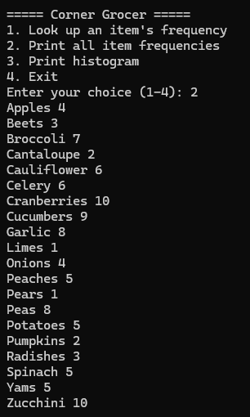 |  | 