**Calculate Floodwater**

Bididibus is an ancient two-dimensional world. The inhabitants living there are called the Bididibus people. They have two-dimensional water, two-dimensional mountains, one-dimensional televisions, and 2D film technology. One day, the wise scholars of Bididibus predicted that it was going to rain. This natural disaster would cause all the valleys in Bididibus to be filled with water. The scholars wanted to estimate how much water would be retained in these valleys.

Bididibus is made up of square blocks of equal size. Mountainography (the study of mountains) in Bididibus describes this world using a sequence of symbols from left to right, including:

* / : slope up
* \: steep down
* _: flat ground

For example, consider a 2D world like this one:

_

/ \

/ \ /\_

/\_ _/ \ _

/\/ \_/ \_/ \ /\

/ \/\/

It is represented as follows (noting each column from left to right):

//\//\_\_/_///_\\ /\_\\_/_\\/\//\

After the rain falls, water will be retained in the valleys.

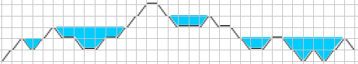

In this representation, the blue color indicates water.

A block that has a boundary formed by a / or \ holds 1/2 unit of water.

A block that is fully submerged in water holds 1 unit of water.

In the example above, the total amount of water retained in the entire world is 21 units.

Write a program to help the wise scholars of Bididibus calculate the amount of water retained, given the 2D world's representation as input.

Example:

|  |  |
| --- | --- |
| Input | Output |
| //\//\_\_/_///_\\ /\_\\_/_\\/\//\ | 21 |
| ////\\\\\\\\ | 0 |
| \/ | 1 |
| \\\\\\\\\\////////// | 100 |