Depression Detection using Two-Stream Feature Fusion Model
Final Evaluation Report
Bachelor Thesis Project
Submitted by | Jitendra Choudhary (22BEC059) and Kabir Singh Khair (22BEC061)
Supervisor | Dr. Amit Vishwakarma
Department | Electronics and Communication Engineering
Institute | PDPM Indian Institute of Information Technology, Design and Manufacturing, Jabalpur
Evaluation stage | End-semester final evaluation
Project stack | PyTorch, MediaPipe, OpenCV, FastAPI, React/Vite, ReportLab

Medical disclaimer
This report describes an AI-assisted screening prototype. It is not a clinical diagnostic system and must be validated by qualified mental-health professionals before any real clinical use.

01 Abstract
This project develops an AI-assisted depression screening prototype that analyzes video interviews using facial and body-behavior features. The final system extends the mid-semester concept into an integrated pipeline with feature extraction, temporal modeling, backend inference, a web dashboard, probability visualization, and automatic PDF report generation.
The final implementation uses MediaPipe FaceMesh to extract a 68-landmark facial representation and MediaPipe Pose to capture shoulder-level body cues. Each video is sampled to a fixed 360-frame sequence, normalized for translation and scale, projected through separate face and body streams, fused into a 160-dimensional temporal sequence, and classified with a bidirectional LSTM plus temporal attention.
Validation on 352 segments shows 57.67 percent accuracy, 0.4688 precision, 0.4255 recall, 0.4461 F1-score, and 0.6597 AUC-ROC for the selected checkpoint. A recall-oriented candidate reaches 0.8227 recall and 0.5873 F1-score but lowers accuracy and AUC. These results demonstrate a functioning end-to-end prototype while also showing the need for larger data, stronger generalization, and clinical validation.
Keywords | Depression detection, TSFFM, facial landmarks, pose landmarks, BiLSTM, temporal attention, FastAPI, React
Primary output | Binary screening prediction: depressed or not depressed
Evaluation basis | Validation split metrics, confusion matrix, ROC curve, training history, and system integration tests

02 Table of Contents
No. | Section | Page
1 | Abstract | 2
2 | Table of Contents | 3
3 | List of Figures, Tables, and Abbreviations | 4
4 | Introduction | 5
5 | Problem Statement and Motivation | 6
6 | Objectives and Scope | 7
7 | Literature Survey | 8
8 | Proposed System Overview | 9
9 | Dataset and Label Design | 10
10 | Preprocessing and Feature Extraction | 11
11 | Model Architecture | 12
12 | Training Strategy | 13
13 | Evaluation Protocol | 14
14 | Final Results | 15
15 | Confusion Matrix and ROC Analysis | 16
16 | Training Dynamics | 17
17 | Discussion and Error Analysis | 18
18 | Backend and API Implementation | 19
19 | Frontend and Report Generation | 20
20 | Testing and Deployment Readiness | 21
21 | Ethics, Privacy, and Clinical Safety | 22
22 | Limitations and Risk Mitigation | 23
23 | Future Scope | 24
24 | Conclusion and References | 25

03 List of Figures, Tables, and Abbreviations
Figure | Description
Figure 1 | Final end-to-end inference pipeline
Figure 2 | Implemented TSFFM-BiLSTM-attention architecture
Figure 3 | Validation metric comparison
Figure 4 | Confusion matrix and ROC curve
Figure 5 | Training and validation history
Figure 6 | Integrated web/backend/reporting workflow

Abbreviation | Meaning
TSFFM | Two-Stream Feature Fusion Model
BiLSTM | Bidirectional Long Short-Term Memory network
PHQ-8 | Eight-item Patient Health Questionnaire
AUC-ROC | Area under the Receiver Operating Characteristic curve
API | Application Programming Interface
ROI | Region of Interest

04 Introduction
Depression is a major public-health challenge and can remain undetected when access to mental-health professionals is limited or when patients under-report symptoms. The World Health Organization currently estimates that approximately 332 million people worldwide have depression, which reinforces the need for scalable, accessible, and early screening support.
Clinical screening normally depends on interviews, questionnaires, and professional interpretation. These remain essential, but they also require time, trained personnel, and patient willingness to disclose internal states. Video-based behavioral analysis can provide a complementary signal by observing non-verbal cues such as facial expressiveness, posture, gaze behavior, and psychomotor activity.
The project therefore explores whether a two-stream visual model can learn discriminative behavioral patterns from interview videos. The final result is not merely a model script: it is a working prototype that connects preprocessing, model inference, web interaction, visualized probabilities, and PDF report generation into one demonstrable system.
Final evaluation position
The system should be judged as an AI-assisted screening prototype with research and engineering value, not as a deployable clinical diagnostic product.

05 Problem Statement and Motivation
The central problem is to automatically classify whether a subject shows depression-related indicators from a video interview. The system must process raw or preprocessed visual evidence, extract useful behavioral features, fuse face and body information, and return a binary prediction with confidence values that can be understood by a user.
- Traditional diagnosis can be subjective, time-intensive, and difficult to access in rural or resource-constrained settings.
- Self-reporting can be affected by stigma, recall bias, and under-reporting.
- Single-modality AI systems may miss important context when they observe only face, speech, posture, or text.
- Video is non-invasive and uses commonly available hardware, making it practical for a prototype screening workflow.
The motivation carried from the mid-semester work was to combine facial expression and posture cues into a richer representation. The final work keeps this idea but upgrades the technical path from frame-level fusion toward sequence modeling, attention, and a full-stack user-facing implementation.

06 Objectives and Scope
- Build a video-based depression screening pipeline using visual behavioral features.
- Extract facial and body features in a repeatable format suitable for sequence modeling.
- Design a two-stream fusion model that keeps facial and pose information separate before fusion.
- Add temporal learning so the model can use behavior over time rather than isolated frames.
- Evaluate the system using accuracy, precision, recall, F1-score, AUC-ROC, confusion matrix, and training curves.
- Expose the trained model through a FastAPI backend and an interactive React dashboard.
- Generate a structured PDF report for each analyzed video while preserving a clear clinical disclaimer.
Scope boundary
The prototype performs binary screening using visual cues only. It does not include audio, transcript semantics, psychiatrist-facing calibration, or external clinical validation.

07 Literature Survey
Approach | Typical signal | Strength | Limitation
Speech analysis | Pitch, energy, pauses, voice quality | Captures affective and psychomotor cues | Sensitive to microphone quality and language
Facial expression | Action units, gaze, landmark motion | Directly observes affect display | Can miss posture and whole-body behavior
Body posture | Skeleton joints, movement amplitude | Observes energy, slumping, and motion | May miss subtle facial emotion
Text or transcript | Sentiment, topics, lexical patterns | Strong semantic signal | Depends on speech content and transcription quality
Multimodal fusion | Two or more behavioral channels | More complete evidence | More synchronization and data complexity

The proposed TSFFM approach is positioned as a visual multimodal method. It avoids specialized hardware and focuses on face plus body cues, making it more practical than physiological sensing while being richer than a face-only pipeline.

08 Proposed System Overview
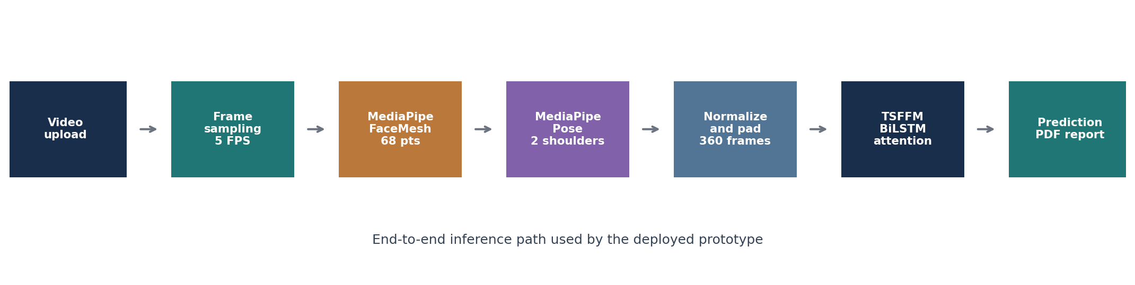
Figure 1: Final end-to-end inference pipeline.
The final system accepts a video file, samples frames at 5 FPS, extracts MediaPipe face and pose landmarks, normalizes the sequence, and pads or truncates it to 360 frames. The model then projects face and body features through separate streams, fuses them, models temporal dynamics, and emits class probabilities.
The deployed backend returns prediction, confidence, class probabilities, detection rates, frame counts, processing time, and a report URL. This transforms the model from an isolated notebook-style artifact into a usable screening workflow.

09 Dataset and Label Design
The project is organized around the DAIC-WOZ / E-DAIC style interview dataset format, where participants are recorded in semi-clinical interviews and depression labels are derived from PHQ-style scores. The training loader reads participant directories containing pre-extracted face keypoints, pose confidence features, and binary labels.
Training input | Pre-extracted NumPy arrays for face keypoints and pose confidence features
Segment structure | Each participant can contribute multiple temporal segments
Label type | Binary label: 0 for not depressed, 1 for depressed
Validation support | 352 segments in the reported evaluation: 211 not depressed and 141 depressed
Sequence design | Each segment is downsampled to 360 frames for model input

The validation distribution is moderately imbalanced, with more not-depressed samples than depressed samples. The training code addresses this using class weights, focal loss, and a weighted random sampler.

10 Preprocessing and Feature Extraction
For deployed inference, OpenCV reads the uploaded video and MediaPipe extracts visual landmarks. FaceMesh is reduced to a stable 68-landmark subset, with each landmark represented by x, y, z, and confidence. Pose extraction currently uses the left and right shoulders, each represented by x, y, z, and visibility.
Feature family | Raw shape | Flattened model input | Purpose
Face landmarks | 360 x 68 x 4 | 360 x 272 | Facial affect, gaze, mouth/eye movement proxies
Pose landmarks | 360 x 2 x 4 | 360 x 8 | Shoulder posture and upper-body orientation proxies
Metadata | Detection rates, FPS, sampled frames | API response fields | Quality visibility for users

The normalization routine subtracts the per-frame mean and divides by the maximum distance from the center. This improves translation and scale invariance so that absolute camera position contributes less to the classifier.

11 Model Architecture
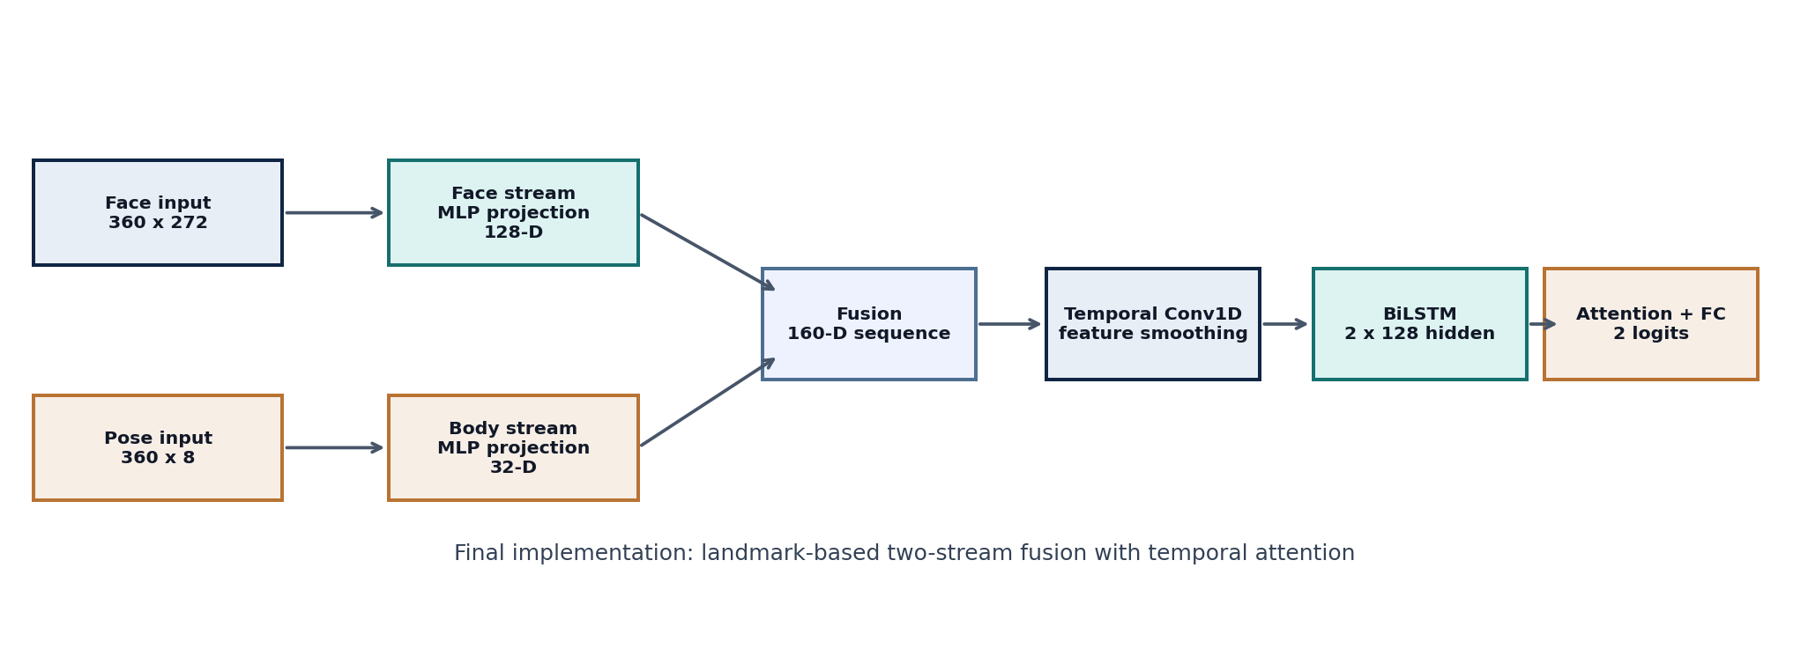
Figure 2: Implemented TSFFM-BiLSTM-attention architecture.
The implemented model differs from the earlier mid-semester diagram. Instead of using full image CNN streams, the final code uses compact landmark-feature projections. Face features are projected from 272 dimensions to 128 dimensions and pose features from 8 dimensions to 32 dimensions. The streams are concatenated into a 160-dimensional temporal sequence.
A one-dimensional convolution smooths the fused temporal sequence before it enters a bidirectional LSTM. Temporal attention then learns which frames are most informative before the final fully connected classifier outputs two logits.

12 Training Strategy
The training script uses PyTorch with Adam optimization, weight decay, class weighting, focal loss, gradient clipping, balanced sampling, learning-rate reduction on plateau, and early stopping based on validation F1. These choices are appropriate for a small, imbalanced behavioral dataset where depressed samples may be harder to classify reliably.
Training element | Final setting or behavior
Optimizer | Adam with weight decay
Loss | Focal loss with class weights
Sampling | WeightedRandomSampler for class-balanced batches
Sequence augmentation | Temporal jittering and small Gaussian landmark noise during training
Checkpointing | Best model saved using validation metric improvement
Regularization | Dropout, weight decay, gradient clipping, learning-rate scheduling

The final training history contains 19 logged epochs. Training accuracy increases strongly, while validation accuracy and AUC fluctuate, indicating that generalization remains the main research challenge.

13 Evaluation Protocol
The evaluation script runs the trained model on the validation split and records class predictions, class probabilities, and ground-truth labels. It computes standard binary-classification metrics and saves a text report, confusion matrix, ROC curve, and training-history plots.
Accuracy | Overall fraction of correct predictions
Precision | Among predicted depressed cases, how many were actually depressed
Recall | Among actual depressed cases, how many were detected
F1-score | Harmonic mean of precision and recall
AUC-ROC | Ranking quality across probability thresholds
Confusion matrix | Class-wise error pattern for false positives and false negatives

Clinical screening interpretation
Recall is especially important for a screening assistant because missed depressed cases are high-risk. However, high recall alone is insufficient if false positives become excessive.

14 Final Results
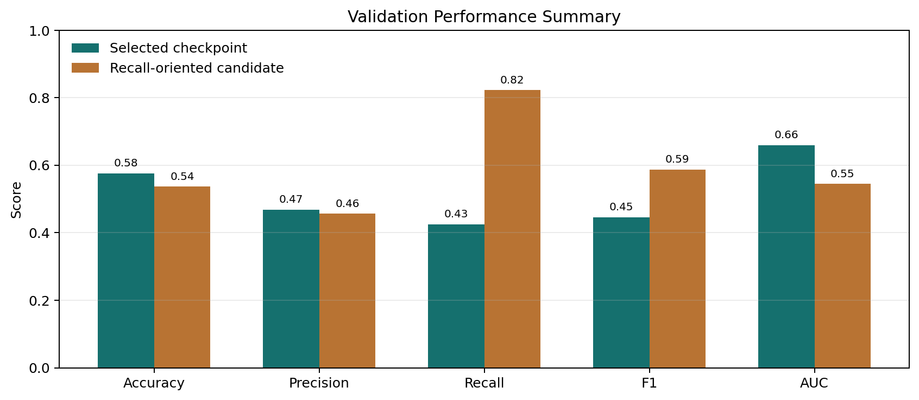
Figure 3: Validation metric comparison.
Checkpoint | Accuracy | Precision | Recall | F1 | AUC
Selected checkpoint | 57.67% | 0.4688 | 0.4255 | 0.4461 | 0.6597
Recall-oriented candidate | 53.69% | 0.4567 | 0.8227 | 0.5873 | 0.5454

The selected checkpoint has the better AUC and accuracy, while the recall-oriented candidate is more aggressive in detecting depressed cases. This trade-off is important for final evaluation because it shows the model can be tuned toward sensitivity but requires threshold calibration and better validation before practical use.

15 Confusion Matrix and ROC Analysis
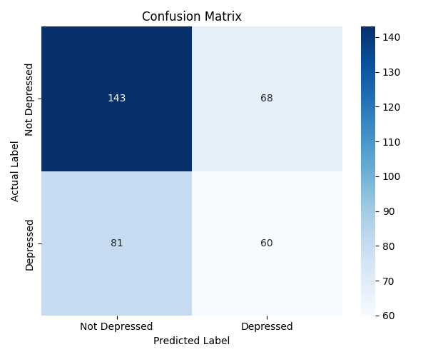 | 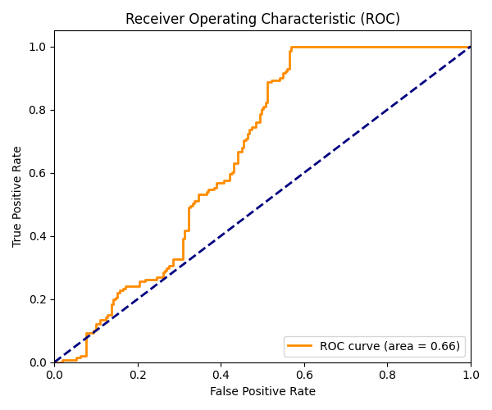
Figure 4: Confusion matrix and ROC curve from the selected evaluation.
The selected model correctly classifies more not-depressed samples than depressed samples. The AUC-ROC of 0.6597 suggests the probability scores contain useful ranking information, but the operating threshold still needs calibration to reach clinically acceptable sensitivity.
Approximate confusion-matrix interpretation from the report is 143 true negatives, 68 false positives, 81 false negatives, and 60 true positives. The false-negative count is the most important weakness for a mental-health screening context.

16 Training Dynamics
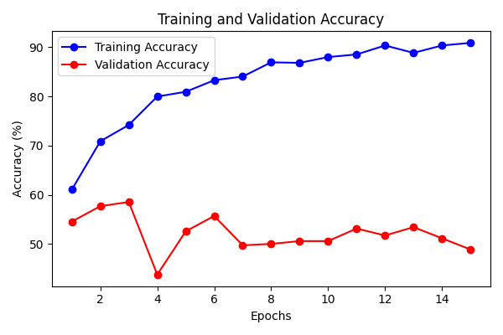 | 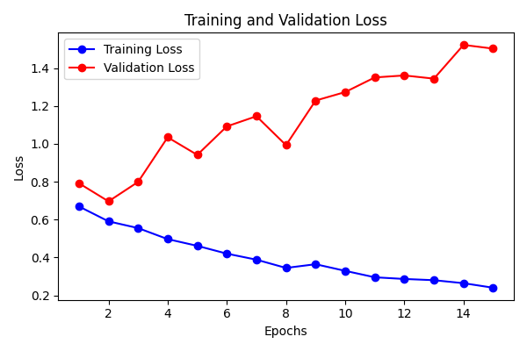
Figure 5: Training and validation history.
Final logged training accuracy | 86.19%
Best logged validation accuracy | 57.67%
Best logged validation AUC | 0.6144

The widening difference between training and validation behavior suggests overfitting. This is expected for small behavioral datasets and should guide the next iteration toward stronger regularization, participant-level split checks, and more data diversity.

17 Discussion and Error Analysis
The end-semester prototype demonstrates a complete technical path, but the current results should be interpreted cautiously. Depression-related visual behavior is subtle, heterogeneous, and influenced by culture, personality, interview setup, camera position, lighting, and co-occurring conditions.
- The selected checkpoint is conservative and misses many depressed samples.
- The recall-oriented candidate detects many more depressed samples but increases false positives.
- The deploy extractor uses a limited pose representation, so body-language evidence is under-used compared with the original design goal.
- Validation performance indicates the model has learned some discriminative signal but has not yet reached clinical-grade robustness.
Most important final insight
The project succeeds as an integrated proof of concept. The main remaining research task is not interface engineering but improving generalization and clinically meaningful sensitivity.

18 Backend and API Implementation
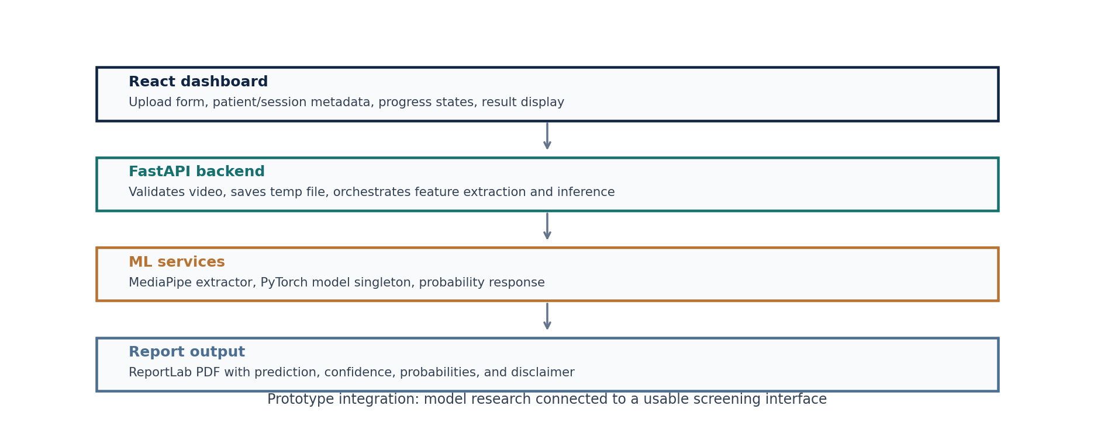
Figure 6: Integrated web/backend/reporting workflow.
The FastAPI backend exposes a `/api/predict` endpoint. It validates the uploaded file extension, saves the temporary video, extracts features, runs model inference, generates a PDF report, returns structured JSON, and cleans up temporary uploads.
Response field | Meaning
prediction | depressed or not_depressed
confidence | Probability of the predicted class
depression_probability | Softmax probability for depressed class
face/body detection rate | Extractor quality indicators
frames_processed | Effective sequence evidence used
report_url | Download path for the generated PDF report

19 Frontend and Report Generation
The React/Vite frontend turns the model into an accessible screening dashboard. It supports drag-and-drop video upload, patient reference entry, session-date entry, progress stages, result display, probability visualization, and report download.
- UploadBox validates video format and collects patient/session metadata.
- App.jsx coordinates API submission, loading states, result states, and retry behavior.
- ResultCard presents positive or negative screening with confidence and clinical recommendation text.
- ProbabilityChart visualizes depressed, not-depressed, face-detection, and body-detection confidence values.
- ReportLab generates a PDF screening report with metadata, probabilities, technical details, and a disclaimer.
This engineering layer is a major end-semester improvement over the mid-semester model-only demonstration, because it shows how a trained model can be packaged for real user interaction.

20 Testing and Deployment Readiness
The repository contains generated PDF reports, uploaded demo videos, built frontend assets, backend logs, and evaluation artifacts. These indicate that the major system paths have been exercised locally.
Area | Current readiness | Recommended final check
Backend | FastAPI app and prediction route implemented | Run local server and verify `/docs` plus `/api/predict`
Model | Weights and history available | Confirm model-layer consistency across train/evaluate/inference scripts
Frontend | Vite app and production dist present | Run upload workflow with at least one known demo video
Reports | PDF reports generated in backend/reports | Check wording, disclaimer, and file cleanup behavior
Packaging | Local project structure complete | Add Docker or documented deployment script

Before a final demo, the most important technical check is to run one end-to-end upload from the frontend and confirm that the generated probabilities, PDF report, and UI result agree.

21 Ethics, Privacy, and Clinical Safety
Mental-health AI systems require careful ethical boundaries. Video interviews are sensitive biometric and behavioral data. Any real deployment would require informed consent, secure storage, access controls, retention limits, and review by clinical and institutional ethics bodies.
- The interface and report must state clearly that the result is not a diagnosis.
- The system should not be used for employment, insurance, disciplinary, or high-stakes decisions.
- Bias testing is required across gender, age, language, skin tone, camera quality, and cultural expression patterns.
- Raw uploaded videos should be deleted after processing unless explicit consent and governance exist.
- Human clinical review must remain mandatory for any positive or negative screening result.
Safety principle
The safest role for the prototype is assistive triage and research exploration, not autonomous mental-health judgment.

22 Limitations and Risk Mitigation
Limitation | Impact | Mitigation
Small clinical datasets | Overfitting and weak generalization | Use larger, diverse, participant-separated datasets
Visual-only evidence | Misses speech and language symptoms | Add audio and transcript streams
Limited deployed pose points | Body stream under-represents movement | Use more joints and temporal motion descriptors
Threshold uncertainty | Recall/precision trade-off remains unstable | Calibrate thresholds with clinician-guided validation
Dataset bias | Potential demographic unfairness | Run subgroup evaluation and fairness audits

One implementation caveat is model-version consistency. The inference service loads the final two-layer BiLSTM configuration, while evaluation code should be reviewed to ensure it instantiates the same architecture used by the saved checkpoint. This should be aligned before final submission or deployment.

23 Future Scope
- Add an audio stream using pitch, energy, pause duration, speech rate, and voice-quality descriptors.
- Add a transcript/text stream using clinically meaningful language features and modern contextual embeddings.
- Use participant-level cross-validation and external validation on additional datasets.
- Expand pose features from shoulders to full upper-body and motion descriptors.
- Try temporal transformers or multimodal attention for richer sequence fusion.
- Calibrate probabilities and operating thresholds for screening sensitivity.
- Package the backend and frontend with Docker and add a deployment guide.
- Conduct clinical review with mental-health professionals before any real-world evaluation.
The strongest next step is a multimodal tri-stream model that combines visual behavior, vocal behavior, and transcript semantics while keeping privacy and clinical validation at the center.

24 Conclusion and References
The final project successfully advances the mid-semester TSFFM idea into a working AI-assisted depression screening prototype. It includes a reproducible feature pipeline, a two-stream temporal neural model, validation artifacts, backend inference, frontend interaction, and automated PDF reporting.
The current metrics show that the model is promising but not clinically ready. The best final evaluation framing is therefore balanced: the engineering integration is strong, the research concept is meaningful, and the results honestly identify generalization, recall, and validation as the main areas for future improvement.
Reference | Source
WHO depression fact sheet | https://www.who.int/news-room/fact-sheets/detail/depression
DAIC corpus | Gratch et al., The Distress Analysis Interview Corpus, LREC 2014
AVEC 2017 challenge | Ringeval et al., Real-life Depression and Affect Recognition Workshop and Challenge
LSTM | Hochreiter and Schmidhuber, Neural Computation, 1997
ResNet | He et al., CVPR 2016
Project source files | README, ml/models.py, ml/train.py, ml/evaluate.py, backend services, frontend components

