Course: PFP191 - Programming Fundamentals with Python

MOVIE TICKET PURCHASE MANAGEMENT

Group: 5
Group Members | Trần Trí Nghĩa - SE210786  Nguyễn Thanh Duy - SE194227  Trần Minh Phúc - SE210033  Thái Minh Khôi - SE211894
Lecturer | PhucNT40
Class | IA2101

Ho Chi Minh, Sep - 2026

Table of Contents

Table of Contents 2
1. Introduction 3
1.1. Project Description 3
1.2. Project Team 3
2. Requirement Analysis & Decomposition 3
2.1. Data 3
2.2. Functions 3
3. Algorithm Design & Flowcharts 3
4. Implementation of Basic Functions 3
5. Object-Oriented Design (OOP) 4
6. File I/O & Testing 4
7. Experimental Results 4
8. Appendix 4

1. Introduction

1.1. Project Description
The project develops a Movie Ticket Purchase Management System using the Python programming language. The system is designed to help cinema staff manage movie information and ticket purchasing activities through a simple console-based interface.
The program supports adding, searching, and deleting movies; creating and updating ticket purchases; checking seat availability; displaying ticket-sales statistics; calculating monthly revenue; and saving/loading data from text files. The project applies object-oriented programming (OOP), lists and dictionaries, file processing, exception handling, and modular programming.

1.2. Project Team
# | Student ID | Full Name | Completion Level | Tasks Performed
1 | SE210786 | Trần Trí Nghĩa | 90% | Analyze requirements and program structure
2 | SE194227 | Nguyễn Thanh Duy | 90% | Design Movie management
3 | SE210033 | Trần Minh Phúc | 90% | Design Ticket management
4 | SE211894 | Thái Minh Khôi | 90% | Design menu and prepare report

2. Requirement Analysis & Decomposition

2.1. Data
# | Name | Data type | Description
1 | movie_id | str | Unique identifier of a movie (e.g., M00001).
2 | title | str | Movie title.
3 | genre | str | Movie genre, such as Action, Drama, or Comedy.
4 | duration_minutes | int | Duration of the movie in minutes.
5 | release_year | int | Year the movie was released.
6 | showtime | str | Movie showtime in HH:MM - DD/MM/YYYY format.
7 | ticket_price | float | Ticket price for the movie in VND.
8 | status | str | Movie status: Showing or Ended.
9 | ticket_id | str | Unique identifier of a ticket purchase (e.g., T00001).
10 | seat_number | str | Seat assigned to the ticket (e.g., A05).
11 | purchase_date | str | Date the ticket was purchased in DD/MM/YYYY format.
12 | ticket_status | str | Ticket status: Booked, Cancelled, or Checked-In.
13 | movie_id | str | Identifier of the movie this ticket belongs to
14 | tickets_sold | int | Total number of tickets sold for a movie
15 | available_seats | int | Number of available seats for the movie showtime

2.2. Functions
2.2.1 Movie Management
# | Function | Description
1 | Movie Management | Manage movie information.
1.1 | addMovie | Add a new movie to the list of movies.
1.2 | searchMovie | Search for a movie by ID, title, or genre.
1.3 | deleteMovie | Delete movie information based on the movie_id entered by the user. A movie can only be deleted if it has no tickets currently booked.

2.2.2 Ticket Purchase Management
2 | Ticket Purchase Management | Manage ticket purchase records.
2.1 | createTicket | Create a new ticket purchase and add it to the list of tickets.
2.2 | updateTicket | Update the ticket purchase based on the ticket_id entered by the user.
2.3 | displayHighestSellingMovies | Display the movies with the highest number of tickets sold.
2.4 | displayTicketSales | Display the total number of tickets sold for each movie, sorted by ticket sales in descending order.
2.5 | displayMonthlyRevenue | Display the total revenue for each movie in the current month.

2.2.3 File Handling

3 | File Handling | Manage movie and ticket purchase data files.
3.1 | saveData | Save movie data and ticket purchase data to file.
3.2 | loadData | Load movie data and ticket purchase data from file.
4 | Control Menu | Provide a text-based menu for user interaction.

3. Algorithm Design & Flowcharts
This section outlines the core algorithms implemented in the system to satisfy the business rules of the cinema. Flowcharts can be generated based on these logical steps.

3.1. Algorithm for Deleting a Movie (deleteMovie)
According to the business rules, a movie can only be deleted if there are no tickets currently booked for it.
Step 1: Start.
Step 2: Prompt the user to input the movie_id to delete.
Step 3: Search for the movie_id in the movie_list.
Step 4: If the movie does not exist, display an error message ('Movie not found') and go to Step 8.
Step 5: If the movie exists, search the ticket_list to see if any ticket has this movie_id.
Step 6: If a ticket is found linked to this movie, display an error message ('Cannot delete movie. Tickets have already been booked for this movie.') and go to Step 8.
Step 7: If no tickets are found, remove the movie from the movie_list and display a success message.
Step 8: End.
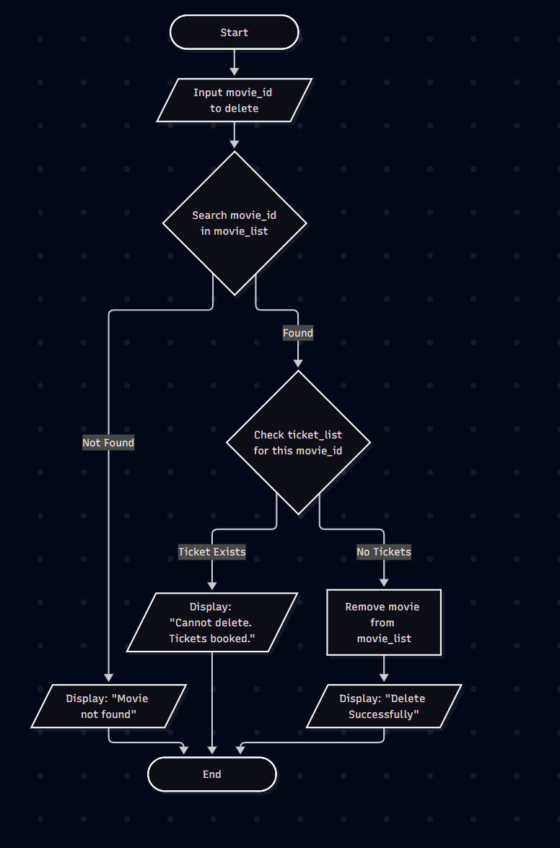

3.2. Algorithm for Creating a Ticket (createTicket)
A ticket can only be purchased if the available seats for the showtime are greater than 0, and the ticket_id must be unique.
Step 1: Start.
Step 2: Prompt the user to input ticket details (ticket_id, movie_id, seat_number, etc.).
Step 3: Check if the entered ticket_id already exists in the ticket_list. If yes, display an error message and return to Step 2.
Step 4: Check if the movie_id exists in the movie_list. If no, display an error message and return to Step 2.
Step 5: Check the capacity/available seats for the selected movie. If available seats <= 0, display an error message ('Sold out') and go to Step 8.
Step 6: Create a new Ticket object and append it to the ticket_list.
Step 7: Decrease the available seats for the movie and display a success message.
Step 8: End.
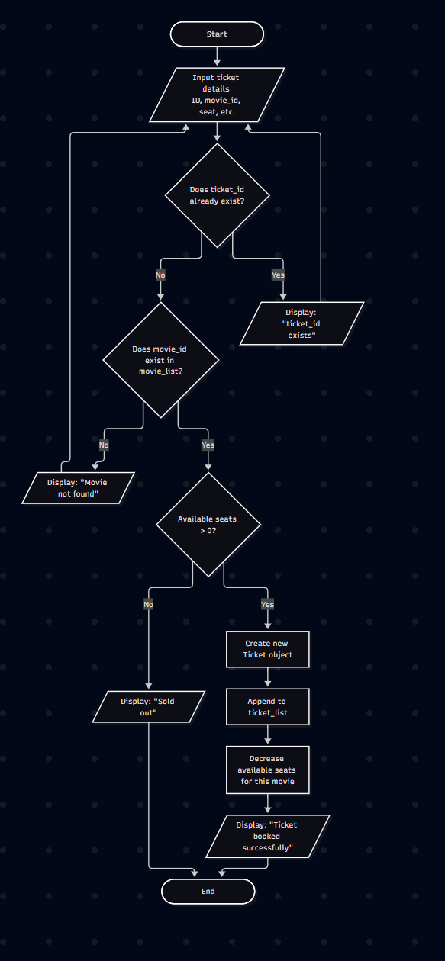

3.3. Algorithm for Calculating Monthly Revenue (displayMonthlyRevenue)
Step 1: Start.
Step 2: Get the current month and year.
Step 3: Initialize a dictionary revenue_dict to store movie_id as keys and total revenue (0) as values.
Step 4: Loop through each ticket in the ticket_list.
Step 5: For each ticket, check if the purchase_date matches the current month and the status is not cancelled.
Step 6: If it matches, find the corresponding movie in movie_list to get the ticket_price.
Step 7: Add the ticket_price to revenue_dict[movie_id].
Step 8: Sort and display the total revenue for each movie.
.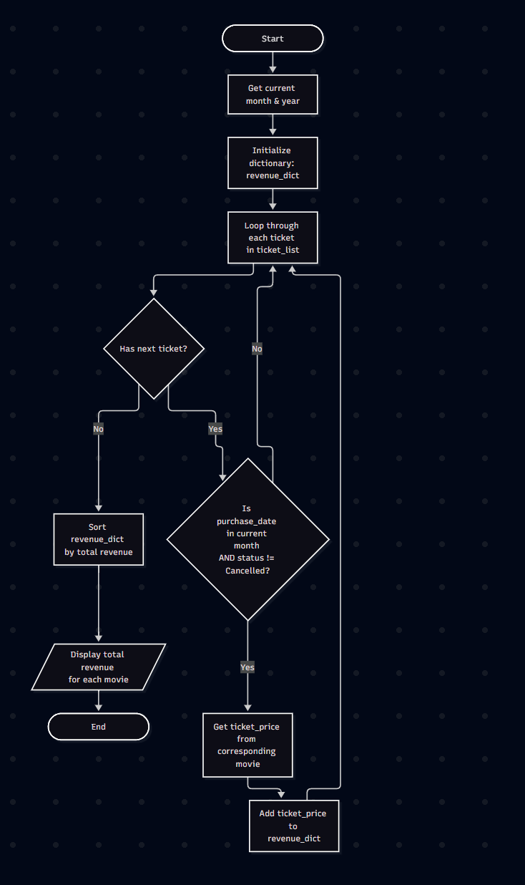

4. Implementation of Basic Functions

The program is implemented in Python. The core functionalities revolve around a Console-Based User Interface (CLI). The main functions include:
- Movie Management: Functions to add a new movie, search for a movie, and delete a movie with constraints.
- Ticket Management: Functions to create and update ticket purchases.
- Statistics: Functions to calculate and display the highest selling movies, ticket sales sorted in descending order, and monthly revenue for each movie.
- Control menu: A simple text-based menu system for user interaction.

5. Object-Oriented Design (OOP)
The program uses two main classes: Student and SystemManager.
Example UML class diagram:
[UML diagram placeholder]

6. File I/O & Testing
The system supports saving and reading data from text files (.txt).
Exception handling is applied when the file does not exist or the format is invalid.
Test cases include:
- Adding a valid student
- Searching for a non-existent student
- Handling error when opening a file fails

7. Experimental Results
The program results are demonstrated with screenshots:
[Screenshot placeholder: Main menu, add student, calculate GPA, sorting, file read/write]

8. Appendix
List of main code files (Student.py, SystemManager.py, Main.py) and sample data file (students.txt).

