**PyBer Rides Analysis**

**Analysis Overview**

The purpose of the PyBer Ride Analysis is to showcase the total weekly fares for each city type (suburban, urban, and rural). We’ll showcase said fares by creating a data frame and visualize that data frame with a multiple – line graph. Here we will further identify the differences in fares by the compiled weekly fares by city type. We’ll also identify how discovered differences can be used by PyBer Corporate.

**Results:**

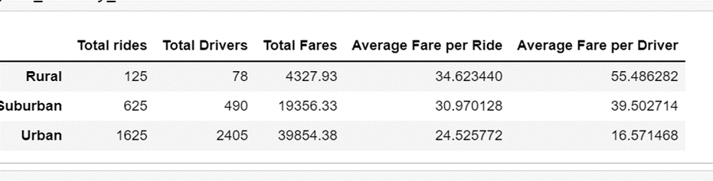

**Rural Areas**

The data frame results show an interesting fare disparity for riders in rural areas. While the total number of rides is the lowest amongst the 3 city types (rural, suburban and urban), the drivers in rural areas have the highest average fare of about $55. The average fare per ride is about $35, and the highest average fare among the city types. Though the riders and drivers in rural areas have the highest fares, the total number of fares, rides, and drivers is the lowest.

| **Total Rides** | **Total Drivers** | **Total Fares** | **Average Fare per Ride** | **Average Fare per Driver** |
| --- | --- | --- | --- | --- |
| **Rural** | 125 | 78 | $4,327.93 | $34.62 | $55.49 |

**Suburban Areas**

While the data frame results show that the fares per ride are lower than those in rural areas; at about $31 per ride, they are still close to those in rural areas when compared to the higher number of total rides, drivers and fares.

| **Total Rides** | **Total Drivers** | **Total Fares** | **Average Fare per Ride** | **Average Fare per Driver** |
| --- | --- | --- | --- | --- |
| **Suburban** | 625 | 490 | $19,356.33 | $30.97 | $39.50 |

**Urban**

Though the total number of rides, drivers and fares is the highest in the urban areas, the average fare per ride and average fare per driver is the lowest by far between the three city types. The urban areas are also the only city type whose average fare per driver is lower than the average fare per ride.

| **Total Rides** | **Total Drivers** | **Total Fares** | **Average Fare per Ride** | **Average Fare per Driver** |
| --- | --- | --- | --- | --- |
| **Urban** | 1,625 | 2,405 | $39,854.38 | $24.53 | $16.5 |

**Plot**

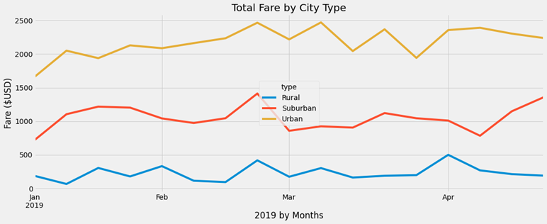

The plot results show a visualization of the total fares by city type (also reflected in the data frame results). What the line graph shows that the data frame doesn’t is the spike in fares throughout the year. There is a consistent spike in total fares for all three city types in late February. There are also similar continuous spikes within the urban areas following the first throughout March.

**Summary**

**PyBer Recommendations**

* Lower the cost per fare for rural areas and increase the number of drivers
* Lower the cost per fare for suburban areas
* Create a promotional offer for all areas during the spike in fares (if continuously occurring during February.