Overview of the School District Analysis:

Purpose of This Analysis

The purpose of the School District Analysis is to assist the school board in upholding state testing standards by describing the changes reflected when the reading and math scores are changed to NaN. The school board has been made aware of the possibility that the reading and math scores for 9th grade students at Thomas High School have been altered. The analysis will further assist the school board in knowing the probability of academic dishonesty.

Results:

How is the district summary affected?
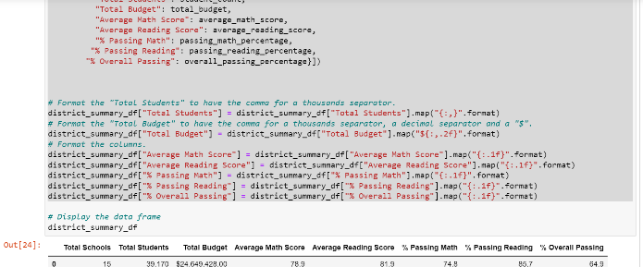

The data for the 9th grade students at Thomas High School has been changed to NaN. The new student count has a difference of about 461 students. The passing reading and math scores have been recalculated due to the NaN values for the 9th graders at THS.

How is the school summary affected?

In the first school analysis, Thomas High School began with an overall reading and math pass rate of around 91%.

Original Analysis

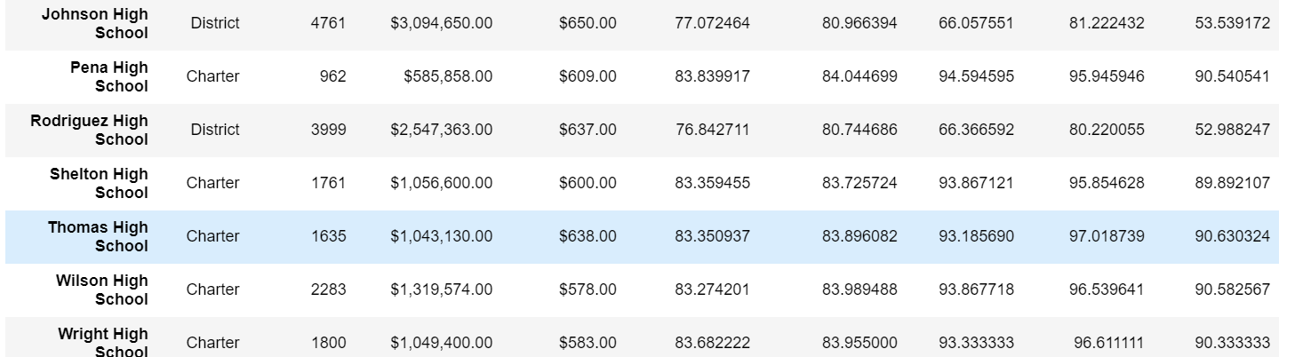

Altered Analysis

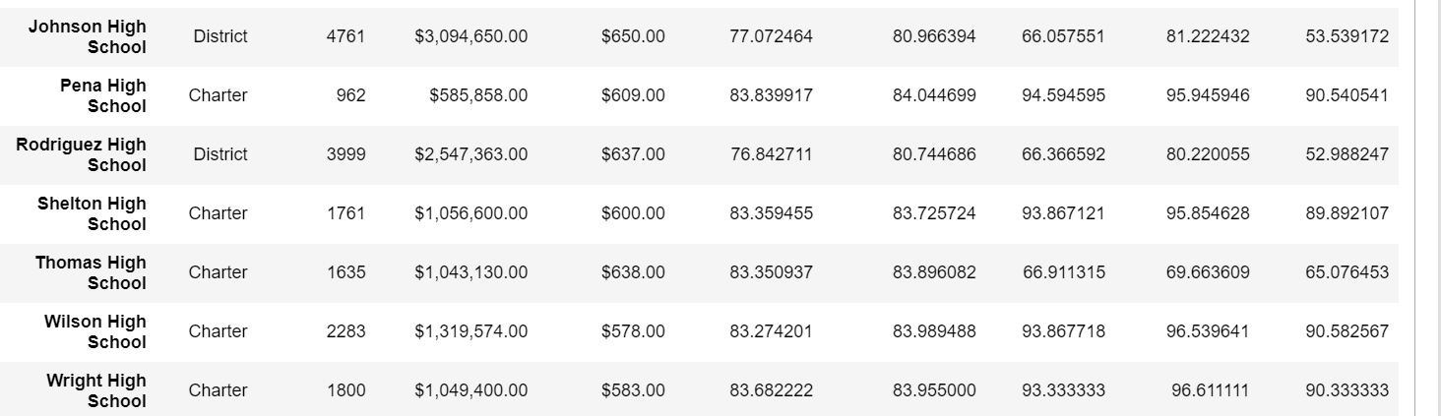

Once the 9th grade scores from Thomas High School are removed and 10-12 grade scores were adjusted the pass rate percentage for Thomas High School drastically drops to about 65%.

How replacing the ninth graders’ math and reading scores affect Thomas High School’s performance relative to the other schools:

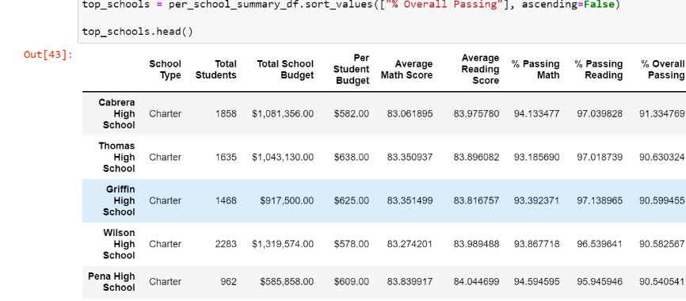
In the original analysis Thomas High School ranked 2nd in the school district.

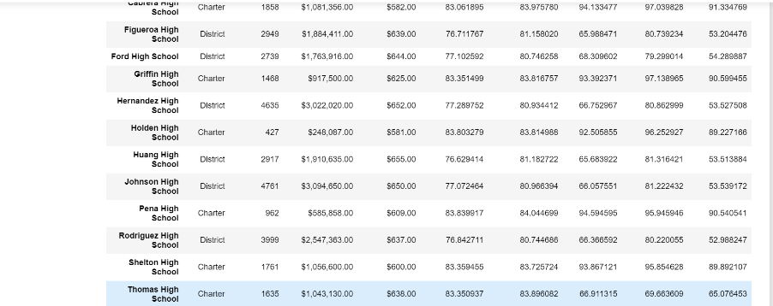
After the 9th grade scores for Thomas High School are changed to NaN values the ranking for THS drops dramatically to about 13th place in the rankings.

How replacing the ninth grade scores affect the following:

- Math and reading scores by grade

In the original school district analysis, Thomas High School had a 83.6 math average and 83.7 reading average for the 9th grade scores. The scores have now been replaced with NaN values.

Math Scores by Grade Reading Scores by Grade
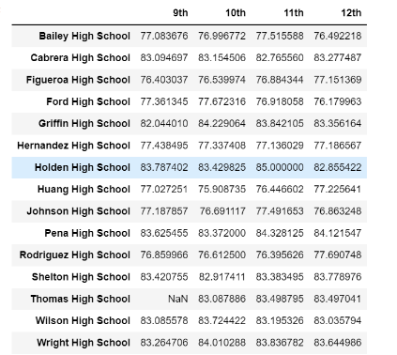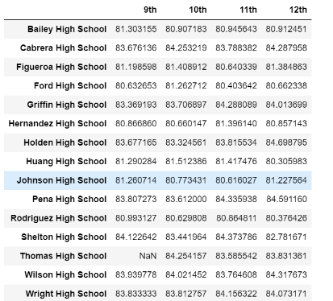

- Scores by school spending

Thomas High School is the $630-644 spending range per student in the original analysis.

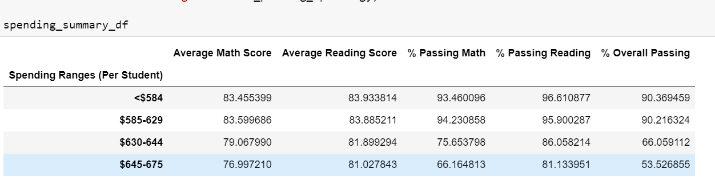

In the altered spending summary, there was not much of a change or difference in the spending ranges per student for the 9th grade scores.

- Scores by school size

The Thomas High School size falls into the medium range.

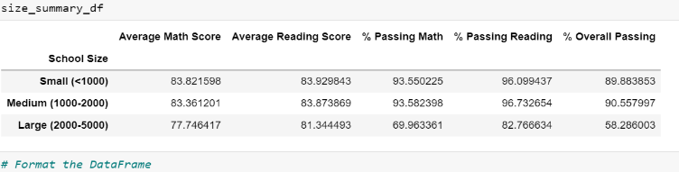

There was very little change in scores by size

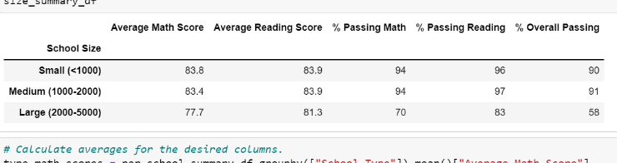

- Scores by school type

The Thomas School would be considered a Charter School.

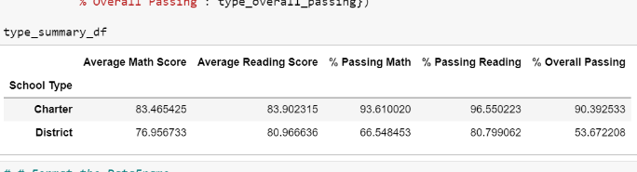

There was little to no change for the average math and reading scores per school type.
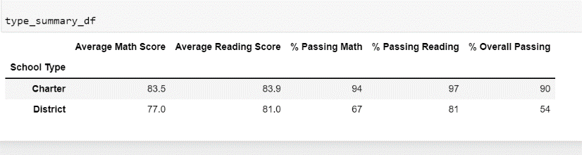

Summary

The 9th grade scores for Thomas High School now show null values in the report

The ranking for Thomas High School dropped dramatically after the school’s 9th grade scores were changed to NaNs.

The overall pass rate for Thomas High School dropped from about 90% to 65%

The school’s math and reading passing rate experienced a bit of a shift after the scores were changed to null values.

