Project 3: Unsupervised Learning
Customer Segmentation
DecodeLabs Data Science Industrial Training — 2026 Batch

1. Objective
Group an unlabeled set of retail customers into distinct, statistically justified, and business-actionable segments using unsupervised learning techniques: standardization, dimensionality reduction (PCA), and K-Means clustering.

2. Dataset
- 1,000 customers, 26 original columns: demographics, product category spend, purchase channel behavior, campaign response history, and complaints.
- No dataset was provided for this project. A synthetic dataset was generated with 4 built-in customer patterns to ensure genuine, discoverable cluster structure. This is disclosed for transparency and is not real company data.
- CustomerID dropped prior to modeling (a label, not a characteristic). Education and Marital_Status one-hot encoded, expanding the feature set to 33 columns.

3. Methodology

3.1 Standardization
All 33 encoded features were scaled using StandardScaler prior to any distance-based computation. Without this step, high-magnitude columns such as Income would dominate distance calculations used by both PCA and K-Means, rendering smaller-scale but equally meaningful behavioral features mathematically irrelevant.

3.2 Dimensionality Reduction (PCA)
Component | Variance Explained
Component 1 | 19.59%
Component 2 | 4.55%
Total Retained | 24.14%
Retaining only 24% of total variance in 2 dimensions is an expected trade-off given 33 spread-out input features, not a modeling failure. The reduction exists to make clustering and visualization tractable; final persona statistics are computed from the original, uncompressed columns, not the PCA components.

3.3 Determining K (Elbow Method + Silhouette Score)
K | WCSS | Silhouette Score
2 | 2097.2 | 0.6449
3 | 1470.3 | 0.5339
4 | 1085.3 | 0.3945
5 | 908.3 | 0.3639
6 | 786.7 | 0.3769
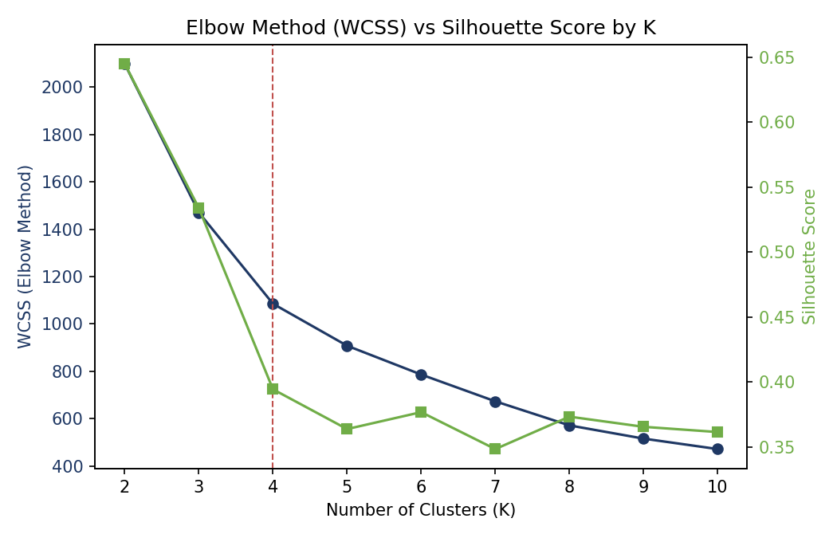
Figure 1: WCSS (Elbow Method) and Silhouette Score across K=2 to K=10
The Silhouette Score mathematically favors K=2 (0.6449), the most cleanly separated split achievable on this data. However, two segments provide insufficient granularity for differentiated marketing action. The Elbow curve's steepest gains flatten around K=4, which was selected as the final cluster count, prioritizing business actionability over the single highest silhouette value.

4. Final Clustering Result
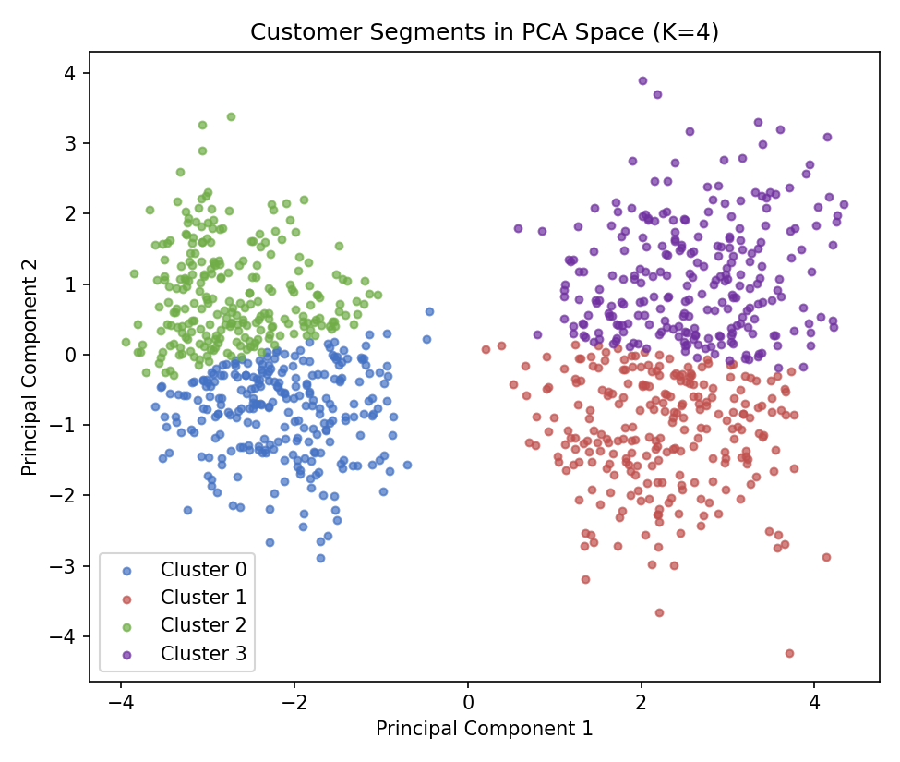
Figure 2: Final K=4 customer segments visualized in 2D PCA space
Final Silhouette Score at K=4: 0.3945, a moderate but reasonable separation, consistent with real-world customer behavior rarely falling into perfectly distinct groups.

5. Customer Personas
Persona | Age | Income | Wine Spend | Web Purch. | Store Purch. | Complaint Rate
Young Budget Shoppers | 29.7 | $26,936 | $265.70 | 2.9 | 4.4 | 0%
Young Affluent High-Engagers | 33.5 | $84,940 | $673.90 | 7.1 | 10.7 | 0%
Older Budget-Conscious | 39.8 | $26,423 | $214.00 | 2.2 | 3.4 | 10%
Established Affluent Spenders | 40.7 | $88,440 | $820.80 | 5.4 | 7.9 | 0%

- Young Budget Shoppers: youngest, lowest income, modest spending, zero complaints, prefers store over web.
- Young Affluent High-Engagers: high income, big spenders, heaviest activity across both web and store; the most valuable young segment.
- Older Budget-Conscious: lowest engagement across every metric, and the only segment with a meaningful complaint rate (10%); a retention risk worth flagging.
- Established Affluent Spenders: oldest, highest income, highest spend on wine and meat, but noticeably less web-active than the younger affluent segment; a traditional in-store shopper.

6. Discussion
The central decision point in this project was not algorithmic but interpretive: the Silhouette Score provided an unambiguous, mathematically optimal answer (K=2) that was not the most useful answer for the stated business goal. Choosing K=4 required weighing statistical cleanliness against actionable granularity, and documenting that reasoning explicitly rather than defaulting to the highest-scoring metric.
The resulting four personas differ meaningfully across income, spending category, channel preference, and complaint behavior, providing a marketing team with clear, differentiated targeting criteria that two broad segments could not have supported.

7. Conclusion
A 4-cluster K-Means solution, built on PCA-reduced, standardized data, produced four distinct and actionable customer personas. The project's key lesson mirrors a recurring theme across this training track: a statistically optimal result and a practically useful result are not always the same thing, and recognizing that distinction is part of the analytical work itself, not a deviation from it.

8. Tech Stack
Python, Pandas, Scikit-learn (StandardScaler, PCA, KMeans, silhouette_score), Matplotlib

