Clinical Trial
Results Summary

1
2

{title}

Thank you!
Thank you to the participants who took part in the clinical trial for {health_condition}. Every participant helped to learn more about the trial drug {drug_code}, also called {generic_name_of_drug}.
Novartis sponsored this trial. We believe it is important to share what was learned from the results of this trial with the participants and the public. We hope this helps the participants understand their important role in medical research.

Trial information  Trial number: {trial_number}  Novartis drug studied: {drug_code}, also called {generic_name_of_drug}  Sponsor: {sponsor_co_sponsor} |  | If you were a participant and have any questions about the results, please talk to the doctor or staff at the trial site.  This summary only shows the results of a single clinical trial. Other clinical trials may have different results.

What was the main purpose of this trial?
{purpose}
   | {health_condition_description}
 | {drug_description} | Trial drug {drug_code} also called {generic_name_of_drug}  {pronounciation}
 | {placebo}
 | {comparator_drug_description}  {adjuvant_therapies_description}

The trial’s purpose was to answer these main questions:
- {primary_endpoint}

- What medical problems, also called adverse events, happened during this trial?
Adverse events reported are any sign or symptom that participants had during this trial. Adverse events may or may not be caused by treatments in the trial.

How long was this trial?



The trial began in {trial_start_date} and ended in {trial_end_date}. {trial_duration}
{trial_parts}
{early_termination}
{planned_trial_completion}

Who was in this trial?



{total_number_of_participants} participants with {health_condition} received treatment in this trial – {total_male} and {total_female}. {age_range} {average_age}
The table below shows the number of participants by race.
{{race_table_placeholder}}

The participants could take part in this trial if they:
{inclusion_criteria}
{total_number_of_countries}
{participants_by_country}. [The map below shows the number of participants who took part in each country.]
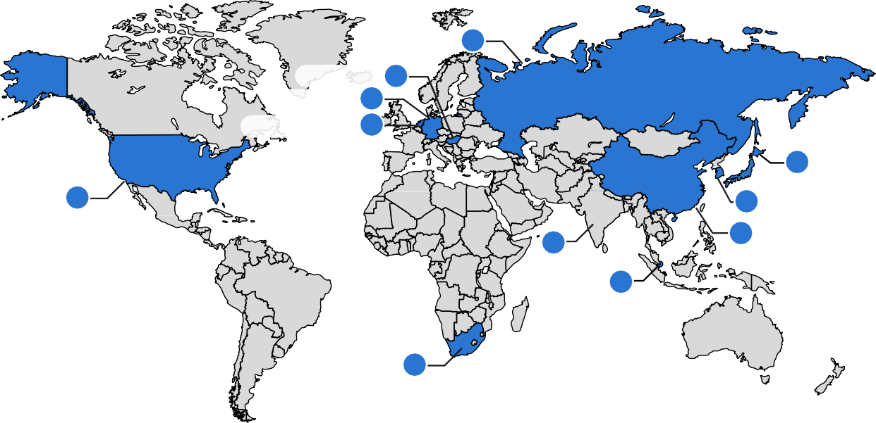
Russia X
Hungary X
Germany X
Netherlands X

X Japan

X
United States

X Republic

X
of Korea
X China

India

X
Singapore

South Africa X

What treatments did the participants receive?

The treatment[s] in this trial [were/was]:
{drug_code}, also called {generic_name_of_drug} {study_drug}
{placebo}.
{comparator_drug}
{randomization}
{blinding}
{continued_treatment_option}

What happened during the trial?

Before joining the trial | {screening_duration}

{screening}
During treatment | {treatment_duration}

{treatment}
After treatment | {follow_up_duration}

{follow_up}

What were the main results of this trial?

{efficacy_primary_endpoint_results_conclusion}

What were the other results of this trial?


{key_secondary_endpoint_results}.

What medical problems, also called adverse events, happened during this trial?

Trial doctors keep track of all medical problems, also called adverse events, that happen in trials. They do this even if they think the adverse events are not related to the trial treatments.  Researchers need results from many trials to decide if a drug or treatment causes an adverse event.  This section is a summary of the adverse events that happened from the day participants started the trial treatment until {adverse_event_tracking_duration}. | An adverse event is:  - Any sign or symptom that the participants have during a trial  - Considered serious when it is life-threatening, causes lasting problems, the participant needs hospital care, or results in death  Treatments in the trial may or  may not cause adverse events.

 | {trial_adverse_event_summary}

How many participants had adverse events?
{{adverse_events_table_placeholder}}

What serious adverse events did the participants have?
{serious_adverse_event}
{serious_adverse_event_threshold} [Additional serious adverse events happened in fewer participants.]
{{serious_ae_table_placeholder}}

What other (not including serious) adverse events did the participants have?
{other_adverse_event}
{{other_ae_table_placeholder}}

What was learned from this trial?

Researchers learned about the [effects / safety] of {drug_code} in people with {health_condition}.

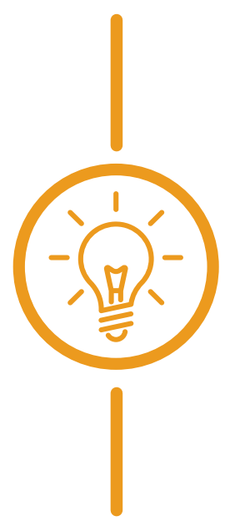     | {key_findings}
When this summary was written, [Novartis was considering next steps for [ABC123]. / the sponsor had [no] plans for future trials of [ABC123] in people with [health condition].<An extension trial [extension trial number] was ongoing for the participants who completed this trial.>

Where can I learn more about this trial?
To learn more about the results and adverse events in this trial, read the scientific summary of the results. It is available on the Novartis Clinical Trial Results website, www.novctrd.com.
Go to
www.novctrd.com
Click Clinical Trial Results
Accept the terms
Search by study number
I accept
Follow these steps to find the scientific summary:

{protocol_number}
For more information about this trial, go to any of the following websites:
- clinicaltrials.gov – search using the number {NCT_identifier}
- <clinicaltrialsregister.eu – search using the number {EudraCT_identifier}
- <euclinicaltrials.eu – search using the number {trial_registry_link}
Other trials of {drug_code} may appear on the public websites above. When there, search for {drug_code} or {generic_name_of_drug}.
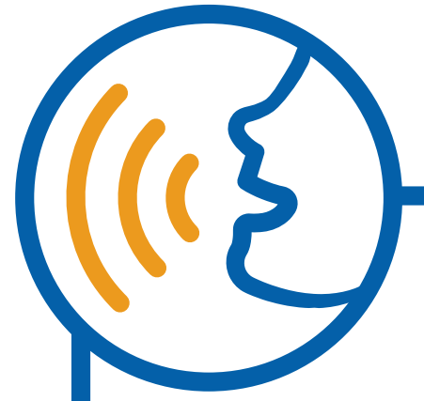

Full clinical trial title: {full_title}
11
Novartis is a global healthcare company based in Switzerland that provides solutions to address the evolving needs of patients worldwide.
1-888-669-6682 (US); +41-61-324 1111 (EU)
www.novartis.com/clinicaltrials
12
11


2

11
Novartis is a global healthcare company based in Switzerland that provides
solutions to address the evolving needs of patients worldwide.
1-888-669-6682 (US) | +41-61-324 1111 (EU)
www.novartis.com/clinicaltrials

