Queensland University of Technology, EGB242

Decoding MARS-242 Telecommunications Signal
Krystian Rozanski (n12455466)
15th of April 2026

Introduction
As part of the upcoming launch of the MARS-242 mission, our team at BASA has been tasked with developing a communications system.
This report will detail the procedures taken in removing periodic noise from the communication signals, transmitting and receiving these signals, and converting them between analogue and digital form.

Section 1: Removing Periodic Noise
  - Initial Recording and Observations
An audio waveform $s(t)$ was observed through newly installed microphones at headquarters (record242 function in MATLAB). Initial observations noted that the sound produced by the microphone exhibited audible interference and had specific segments that had been periodically attenuated and disturbed by an additional noise signal $n(t)$ (see Figure 1a), indicating an interference producing the observed noisy signal $s^{^}(t)$:
$$s(t)+n(t)=s^{^}(t)$$
After further analysis, the noise signal’s function was found to be:
$$n\left(t\right)=\{_{5e^{-3\left(t-1\right)}, 1≤t<2}^{2t+3, 0≤t<1}$$
This sample was periodic for every 2 seconds, while the audio signal lasted 10 seconds. Thus, the noise signal was defined via the following MATLAB code using linspace function. The time vector was sampled over 1/5 of the audio length, and the period is defined by these samples divided by the sampling frequency, originally equal to 192kHz:
t0 = 0;
N = length(audio) * 1/5;
T = N / fs;
t = linspace(t0, t0 + T, N);
% Initialise and create noise signal function
noise_signal = zeros(size(t)); % Create zero vector
noise_signal(t >= 0 & t < 1) = 2*t(t >= 0 & t < 1) + 3;
noise_signal(t >= 1 & t < 2) = 5*exp(-3*(t(t >= 1 & t < 2) - 1));

  - Approximating Noise Signal with Complex Fourier Signal
Now that the noise signal disturbing the function has been defined, the complex Fourier series can now be used to approximate the function such that the noise signal can be removed through the following operation:
$$s^{^}\left(t\right)- f_{c}\left(t\right)=s(t)$$
The mathematical procedure in Appendix 1 displays how the coefficients $c_{n}$ and $c_{0}$ of the complex Fourier series were calculated to produce the following approximation of $n(t)$:
$$f_{c}\left(t\right)=2+\frac{5}{6}\left(1-e^{-3}\right)+\sum_{n=1}^{∞}{\frac{1}{2}\left(\left(\frac{5e^{-jπn}-3}{-jπn}+\frac{2-2e^{-jπn}}{{(-jπn)}^{2}}\right)+5e^{3}\left(\frac{e^{-2\left(3+jπn\right)}-e^{-\left(3+jπn\right)}}{-3-jπn}\right)\right)e^{jπn}}$$
Where:
$$c_{0}=2+\frac{5}{6}\left(1-e^{-3}\right)$$
$$c_{n}=\frac{1}{2}\left(\left(\frac{5e^{-jπn}-3}{-jπn}+\frac{2-2e^{-jπn}}{{(-jπn)}^{2}}\right)+5e^{3}\left(\frac{e^{-2\left(3+jπn\right)}-e^{-\left(3+jπn\right)}}{-3-jπn}\right)\right)$$
  - Analysing how the Number of Harmonics affects Approximation and Denoising
The calculated complex Fourier series in Section 1.2 was applied to a for loop over N iterations, where N is equal to the harmonic value. This procedure was applied within a function, so that it could be efficiently reused throughout the code:
function [reconstruction] = complex_fourier_series(N, t, T)
% Initialisation
reconstruction = zeros(size(t));
ns = -N:N;
cn = zeros(1, 2*N + 1);
c0 = 2 + (5/6)*(1 - exp(-3)); % DC component calculated in Appendix 1
% Compute Fourier coefficients cn for each harmonic
for n = ns
if n == 0
% Handle n = 0 separately to avoid division by zero
cn(ns == n) = c0;
else
% General coefficient expression calculated in Appendix 1
cn(ns == n) = (1/2) * (( ...
(5*exp(-1j*pi*n) - 3) / (-1j*pi*n) + ...
(-2*exp(-1j*pi*n) + 2) / (-1j*pi*n)^2) + ...
5*exp(3) * (exp(-2*(3+1j*pi*n)) - exp(-1*(3+1j*pi*n))) / (-(3+1j*pi*n)));
end
end
% Reconstruct signal by summing complex exponentials over all harmonics
for n = ns
reconstruction = reconstruction + cn(ns == n) * exp(1j * 2 * pi * n * t / T);
end
% Only consider the real values as the noise signal is real valued
reconstruction = real(reconstruction);
end
    - Qualitative Analysis
Using 5 harmonics, the complex Fourier series was used to oppose the noise signal. The figures below display the comparison of $n\left(t\right)$ and $f_{c}\left(t\right)$ (Figure 1a), and the denoising of $n\left(t\right)$ using $f_{c}\left(t\right)$ (Figure 1b):
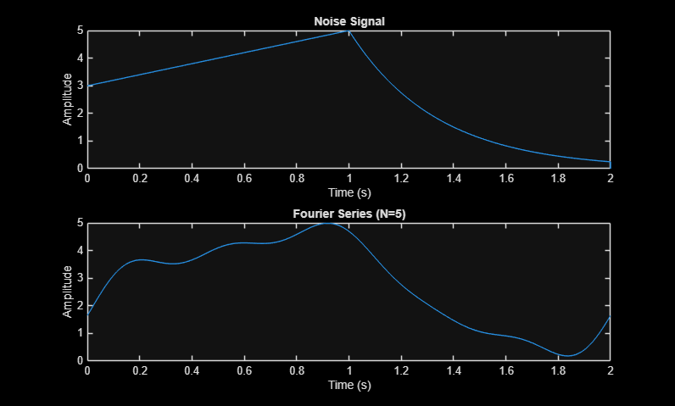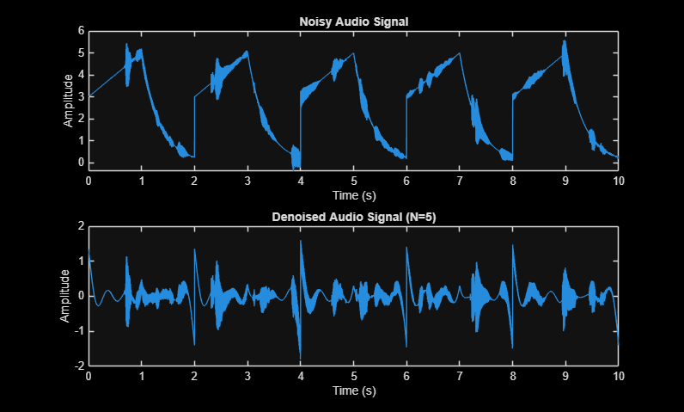
(a) (b)
Figure 1: 5 Harmonics (a) Complex Fourier Series vs Noise Signal (b) Noisy Audio Signal vs Denoised Audio Signal
As can be seen, the current number of harmonics provides a partial approximation of the noise signal and a moderate degree of denoising to the audio signal respectively; however, the denoised audio still exhibited distortion. Therefore, 100 harmonics were also tested to see whether increasing the number of harmonics increased the validity of the approximation. This was first explored qualitatively by inputting 100 harmonics and analysing the difference between graphs and audio outputted. From this, the following graphs were produced:

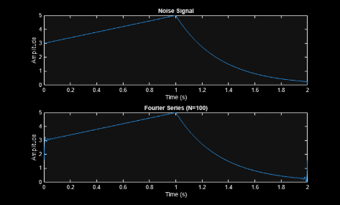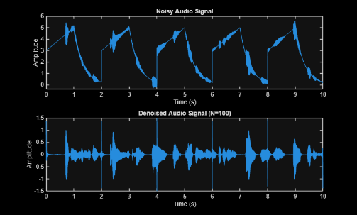
(a) (b)
Figure 2: 100 Harmonics (a) Complex Fourier Series vs Noise Signal (b) Noisy Audio Signal vs Denoised Audio Signal
These graphs display a clear improvement in the signal approximation, with the Fourier series tending towards the original function and the denoised signal tending towards a clean output. The denoised audio in this case, is identical to the original audio, however, still exhibits periodic clicking every two seconds, that can be seen in Figure 2b as additive impulses to the time domain.
This can potentially be contributed to Gibbs’ phenomenon which can be seen in Figure 2a at the end points of the graph, where for any finite number of harmonics the discontinuities imposed by the limits of the noise signal cause the approximation to overshoot or undershoot (Libretexts, 2025).
    - Quantitative Analysis
To further quantitatively analyse how changing the harmonic improves the approximation of the Fourier series, mean squared error (MSE) was calculated for a variety of harmonic values:
$$MSE= \frac{\sum_{t=0}^{T}{{(n\left(t\right)-f_{c}\left(t\right))}^{2}}}{samples}$$
The closer to 0 the MSE gets, the more $f_{c}(t)$ resembles $n\left(t\right)$ (Hodson et al., 2021). The relationship between MSE and harmonics was tabulated (Table 1) and graphed (Figure 3) below:
Table 1: Harmonic vs MSE
Harmonic | MSE
1 | 0.283135
3 | 0.115584
5 | 0.071739
10 | 0.037017
20 | 0.018773
50 | 0.007603
100 | 0.003822
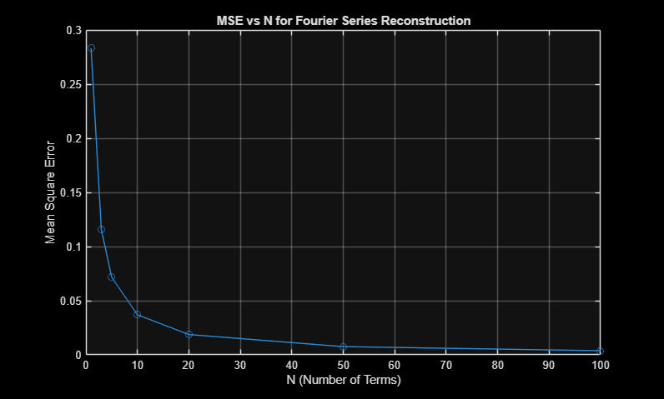
Figure 3: MSE of f_{c}(t) and n(t) over N = 1, 3, 5, 10, 20, 50, 100
This data confirms that increasing the number of harmonics improves the Fourier series approximation of the noise signal. However, the relationship follows a diminishing-returns (logarithmic) trend, whereby higher harmonics yield progressively smaller improvements while increasing computational cost. Therefore, 100 harmonics were selected for subsequent processing, as this value demonstrated an efficient and effective approximation of the noise signal.

Section 2: Transmitting and Receiving Signals
Now that the audio signal has been cleaned, it must be transmitted through BASA’s designated channel via the MATLAB channel function. To ensure that the signal does not interfere with any of the other signals in the channel, the frequency domain of both the cleaned audio and the channel must be taken into consideration.
2.1. Frequency Domain of Audio Signal and Channel
To understand the frequency domain of the audio signal (Figure 4) and the channel using channelQuiet MATLAB function (Figure 5) a magnitude spectrum was used since both time domains of the functions are aperiodic and therefore will have both real and imaginary parts, which cannot be plotted on a conventional graph:
$$F\left\{s\left(t\right)\right\}=S\left(f\right)=Re(S\left(f\right))+Im(S\left(f\right))$$
Therefore, the Fourier transform was calculated through the FFT function in MATLAB and abs function was taken to calculate magnitude:
$$\sqrt{{Re(S\left(f\right))}^{2}+{Im(S\left(f\right))}^{2}}$$
N = length(audioClean);
AudioClean = fft(audioClean); % Apply fft function to change to frequency domain
% Normalise and centre two-sided spectrum at DC = 0 Hz using fftshift to
AudioClean = fftshift(AudioClean) / N;
f = linspace(-fs/2, fs/2, N); % fftshift has a span of -fs/2 to fs/2 for two sided representations
% Compute frequency domain of quiet channel (zero input)
% Same process as audio magnitude spectrum. However, will be one sided
channelQuiet = channel(12455466, zeros(size(tt)));
ChannelQuiet = fft(channelQuiet) / N;
f = linspace(0, fs/2, N/2 + 1); % Only including positive side of the magnitude spectrum
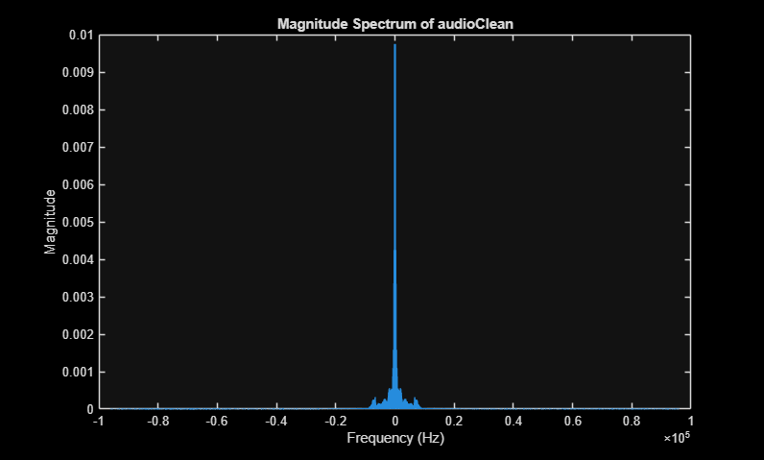
Figure 4: Two-Sided Magnitude Spectrum of Transmitted Audio Signal, with a DC value at 0Hz
The magnitude spectrum in Figure 4 was centred at 0 Hz using fftshift in MATLAB (see code above), displaying the full two-sided spectrum from $-f_{s}/2$ to $f_{s}/2$ sampled over length of audio. For a real-valued signal, the negative frequencies are the complex conjugate mirror of the positive frequencies and therefore carry no additional information; however, to ensure that the signal remains real-valued after demodulation the two-sided spectrum will be entirely modulated onto the channel, thus, it is an appropriate representation of the audio signal’s contents.
Figure 5, the channel’s magnitude spectrum, also centres the DC component at 0 Hz but displays only the single-sided spectrum from $0$ to $f_{s}/2$ sampled over half the length of audio, as the mirrored negative frequencies are not needed to understand what other signals are in the channel and where the gaps are between these signals.
2.2. Using Frequency Domains to Modulate the Audio Signal into the Channel
To modulate the audio signal into the channel the modulator property of the Fourier transform is applied to the audio signal to shift $f$by $f_{c}$, where $f=0$ as seen in Figure 4:
$$s\left(t\right)\cos\left(2πf_{c}t\right)\underset{→}{F}X\left(f\right)=\frac{1}{2}(\left(S\left(f-f_{c}\right)+S\left(f+f_{c}\right)\right)$$
$$∵f=0$$
$$∴X\left(f\right)=\frac{1}{2}(S\left(f_{c}\right)+S\left(-f_{c}\right))$$
Since the frequency domain is bounded within $f≥0$ therefore only $\frac{1}{2}S(f_{c})$ can be seen within the graph. However, it must be considered that the $\frac{1}{2}S(-f_{c})$ signal still exists outside of the graphical data. When modulated, this will be double-sideband suppressed-carrier (DSB-SC) modulation with both sidebands coexisting. In practice, this modulation uses more power and bandwidth than is required and therefore in future development, single-sided modulation should be considered, which applies a lowpass filter to $X(f)$ to attenuate the signal in the negative region (Libretexts & Steer, 2022).
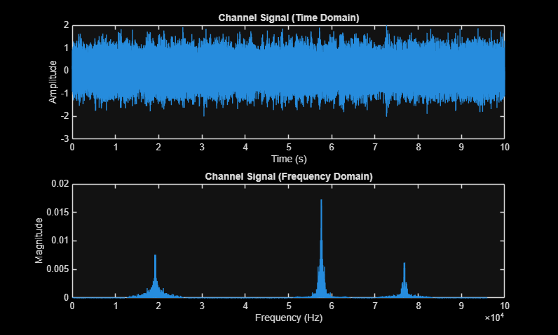
Figure 5: Time Domain (a) vs Frequency Domain (b) of Channel.
To determine $f_{c}$, a gap within the frequency domain of the channel must be identified and a frequency that does not interfere with the other signals in the channel must be selected. As can be seen in Figure 5, the largest gap sits between the left and middle signal. The edge frequencies of these signals were identified in Figure 6, and their mean was used to determine $f_{c}$:
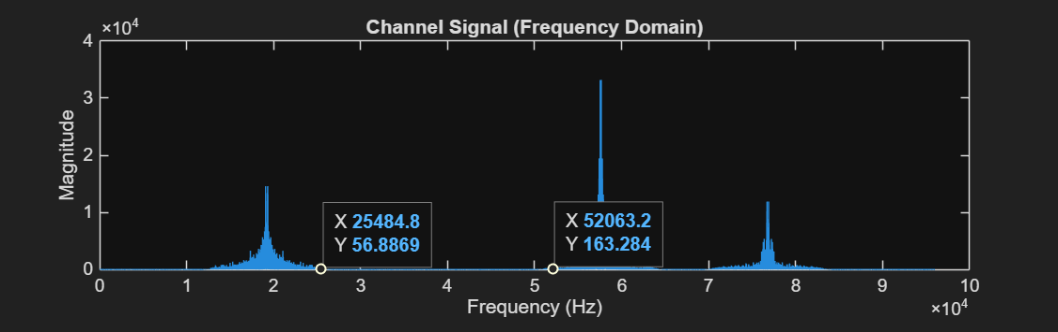
Figure 6: Edge values of adjacent peaks in the Channel
Therefore, $f_{c}$ was selected to be 38774Hz. This selection is an approximation, as it is based on a midpoint estimation from the observed frequency domain. In practice, more complex channels may present additional constraints, as certain regions of the spectrum and guard bands are typically allocated and protected for specific services. For example, within the Australian radio frequency plan, spectrum allocations are formally designated by the Australian Communications and Media Authority (Australian Communications and Media Authority, 2025). However, as can be seen in Figure 7a, this $f_{c}$ value does not interfere with the other signals and is therefore appropriate.
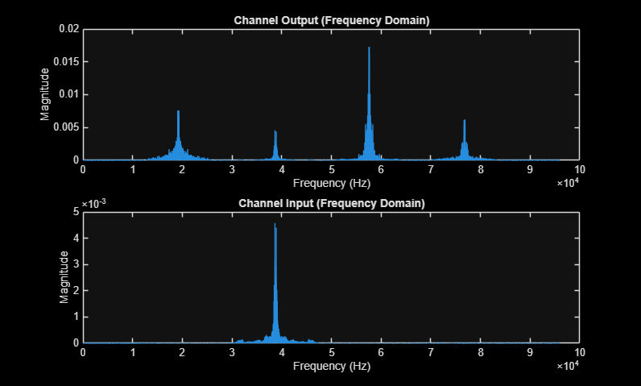
Figure 7: Output (a) and Input (b) Channels’ Frequency Domains. Comparing (a) and (b) confirms that the transmitted audio signal (input, centred at fc = 38774 Hz) occupies the gap between the left and middle signals without overlapping any existing channel occupants.
2.3. Demodulating and Receiving Audio Signal
To demodulate the audio signal from the channel a bandpass filter was applied through the bandpass function in MATLAB. This attenuates the range in which the audio signal resides through applying a linearly time invariant (LTI) transfer function:
$$H_{bp}\left(f\right)=\{_{0, otherwise}^{Ae^{-j2πft_{0}}, bpLow≤f≤bpHigh}$$
Where bpLow is $f_{0}-f_{c_{bp}}$ and bpHigh is equal to $f_{0}+f_{c_{bp}}$, this transfer function is then applied to the channel signal $X_{c}(f)$ to produce a bandpass signal $X_{b}(f)$, through the LTI relationship:
$$X_{b}\left(f\right)=X_{c}\left(f\right)H_{bp}(f)$$
This process can be simulated through the following MATLAB code:
bpLow = 32751.7;
bpHigh = 44875.35;
% Use bandpass function to apply these cut of frequencies
outputFiltered = bandpass(output, [bpLow bpHigh], fs);
Using the output in Figure 7a, the bandpass low and high values were selected based on the mean between the audio and adjacent signals’ edge frequencies to ensure signals in lower and higher frequency ranges were attenuated. From this, the following output $X_{b}(f)$ was produced (Figure 8):
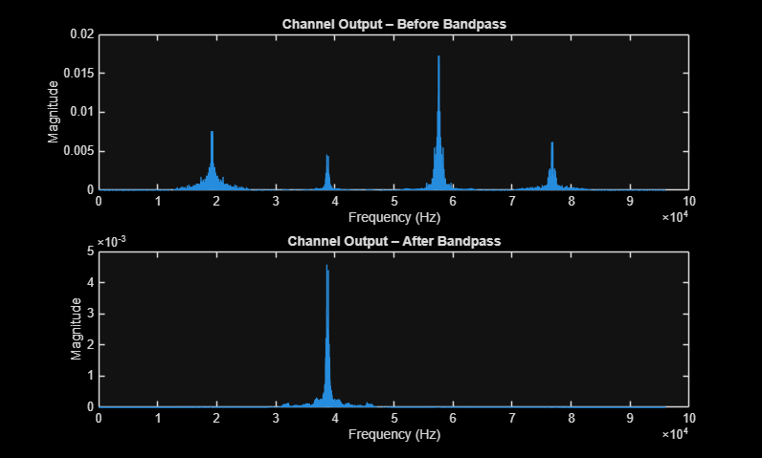
Figure 8: Frequency Domain of Channel Before (a) and After (b) Bandpass. The bandpass filter successfully isolates the audio signal centred at fc = 38774 Hz, attenuating all energy outside the selected passband [bpLow, bpHigh] and removing the other channel occupants.
The modulation process was then reversed through applying the duality property of the Fourier transform:
$$X_{b}\left(f\right)=\frac{1}{2}(S\left(f_{c}\right)+S\left(-f_{c}\right))$$
$$x_{b}\left(t\right)\cos\left(2πf_{c}t\right)\underset{→}{F}X_{d}(f)=\frac{1}{2}(X_{b}\left(f-f_{c}\right)+X_{b}\left(f+f_{c}\right))$$
$$∴X_{d}\left(f\right)= \frac{1}{4}\left(S\left(-2f_{c}\right)+S\left(2f_{c}\right)\right)+ \frac{1}{2}S(0)$$
Where $f_{c}=38774Hz$. Therefore, after demodulating $X_{d}(f)$ has three specific frequencies two mirroring $±{2f}_{c}$ = $±77545.1Hz$ and 0 (see Figure 9a). Recalling from section 2.1 the original audio signal was positioned on a baseband of zero, thus:
$$S\left(0\right)=x\left(t\right)$$
While the other two mirroring signals can be simplified to one signal on a one-sided magnitude spectrum at $2f_{c}$. To ensure that the received signal $x_{r}(t)$ has only the original audio signal $x(t)$, a lowpass filter was applied to eliminate the other to two signals, through the lowpass function in MATLAB with a cut-off frequency $f_{c_{lp}}$ of $\frac{f_{c}}{2}=\sim 19387Hz$, which is high enough to pass all the audio and low enough to reject the image frequencies.
From this, the function was scaled by 2 to rectify the scaling of ½ during modulation:
% Reversing Modulation Property
audioReceived = outputFiltered .* cos(2 * pi * fc * t);
% Lowpass to isolate audio
lpLow = fc/2;
audioReceived = lowpass(audioReceived, lpLow, fs);
% Fix Modulation losses
audioReceived = 2*audioReceived;
This MATLAB code emulates using a transfer function of:
$$H\left(f\right)=\{_{0, otherwise}^{Ae^{-j2πft_{0}, -f_{c_{lp}}≤f≤f_{c_{lp}}}}$$
Where A is the maximum of the demodulated signal $X_{d}(f)$. The LTI relationship of $H(f)$ between the demodulated signal and the received signal $X_{r}\left(f\right)$ is:
$$X_{r}\left(f\right)=X_{d}\left(f\right)H(f)$$
These processes outputted the frequency domain in Figure 9b:
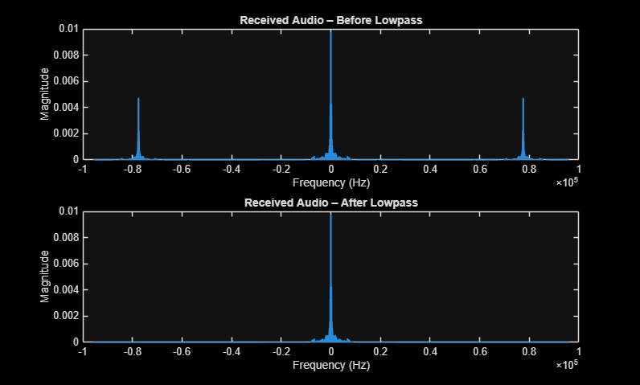
Figure 9: Magnitude Spectrum of Received Audio Signal before (a) and after (b) Lowpass. Before the lowpass filter, three spectral components are visible at 0 Hz and ±2fc = ±77548 Hz; after filtering, only the baseband audio at 0 Hz remains, confirming successful demodulation.
Throughout this demodulating process, filters attenuated completely at their cut-off frequencies; furthermore, comparing Figure 9b to Figure 4, the modulated and demodulated signals are approximately identical. These results arise because filter functions in MATLAB approximate ideal behaviour, which is not realisable in practice. Non-ideal filters do not fully attenuate at their stopbands, may exhibit ripple within their passbands, typically have a more gradual transition between the passband and stopband, and can introduce phase distortion (De Andrade Serra & Paulino, 2014).
2.4. Contents of other Signals within the Channel
As can be seen in Figure 7a, there are three additional signals present within the channel. To identify the contents of these signals, the demodulation process outlined in Section 2.3 was applied to each, with the bandpass and lowpass cut-off frequencies adjusted according to the edge frequencies and estimated carrier frequencies of each respective signal.
Upon demodulation, the content of each signal was identified. For each signal, the bandpass cut-off frequencies were set to the mean between adjacent signal edge frequencies (as per Section 2.3), and the carrier frequency was estimated as the mean of the two spectral spikes visible in the two-sided magnitude spectrum. Signal 1 was determined to contain a rock music recording. Signal contained a Harry Styles recording. Signal 3 contained the track “Never Gonna Give You Up” by Rick Astley. See Appendix 3 to gain a better understanding of the bandpass limits and carrier frequency selection for each signal.
Originally the $f_{c}$ value was selected on the perceived DC value on the frequency domain (see Figure 7a), wherein there were clear effects of phase distortion suggesting severe carrier frequency offsets. After further analysis, two distinct spikes were identified for each signal because of their representation as a two-sided magnitude spectrum, therefore the actual DC value and $f_{c}$ would be the mean of these spikes. Applying this, produced a cleaner audio with signals such as the audio signal and signal 2 that had more distinct DC spikes having less distortion than signal 1 and 3. Though, there was still a level of phase distortion which suggests offsets within this procedure.
To extend this recovery phase-locked loops could be applied, which is a control system that allows for the phase of an output signal to replicate the phase of an input signal (Dermani et al., 2022). This would provide potential improvements to the phase distortion observed.

Section 3: Analog-to-Digital Conversion
Personnel at BASA utilise headphones when operating the communication system. Therefore, to convert the analogue signal to a digital form suitable for playback, the process of pulse-code modulation (PCM) will be applied. PCM comprises two stages, sampling and quantisation.
3.1. Optimising Sampling Frequency for Audio Output
Table 2 displays the valid sample frequencies for the hardware:
Table 2: Valid Sampling Rates for Computer Systems
Valid sampling rates [Hz]
5,512 | 8,000 | 11,025 | 22,050 | 44,100 | 48,000 | 96,000 | 192,000

$$f_{s}≥2×f_{max}$$
Human hearing ranges from 20Hz to 20kHz (Rosen & Howell, 2011). Therefore, using Nyquist rate (Shannon, 1949) an appropriate frequency sample must be:
$$f_{s}≥2×20000$$
$$f_{s}≥40000Hz$$
The lowest possible sampling frequency within Table 2 that satisfies this condition is 44.1kHz. Thus, the audio signal was resampled to this frequency, to create a data efficient audio. The resample function in MATLAB was applied which takes the signal $x(t)$ and multiplicatively applies a sampling function to it. The following relationships yield:
$$x_{s}\left(t\right)=x_{r}\left(t\right)∙{δ(t)}_{train}$$
$${δ(t)}_{train}=\frac{1}{T_{s}}+\frac{1}{T_{s}}\sum_{\begin{aligned}n=-∞ \\ n≠0\end{aligned}}^{∞}{2cos⁡(2πnf_{s}t)}$$
Where:
$$f_{s}=\frac{resampled f_{s}}{original f_{s}}$$
$$T_{s}=\frac{1}{f_{s}}$$
Applying the Fourier transform:
$$x_{s}\left(t\right)\underset{→}{F}X_{s}\left(f\right)$$
$$x_{r}(t)∙(\frac{1}{T_{s}}+\frac{1}{T_{s}}\sum_{\begin{aligned}n=-∞ \\ n≠0\end{aligned}}^{∞}{2\cos\left(2πnf_{s}t\right)})\underset{→}{F}\frac{1}{T_{s}}(X\left(f\right)+X\left(f±f_{s}\right)+⋯X\left(f±{nf}_{s}\right)+⋯)$$
However, the resample function does this in three parts based on the ratio of $f_{s}$:
$$f_{s}=\frac{44100}{192000}=\frac{147}{640}$$
It first increases the samples with the numerator:
$$nf_{s}=\frac{n}{147}$$
This inserts 146 zero-valued samples between each point of $x\left(t\right)$. Then an anti-aliasing lowpass filter is applied, which mitigates the spectral overlap that would occur for frequencies past Nyquist rate of the new signal ($\frac{f_{s}}{2}$) onto the baseband and would therefore corrupt the new signal, this attenuates these frequencies and protects the resampled signal from aliasing artefacts. Finally, the function decimates by selecting every frequency with:
$$nf_{s}=640n$$
This effectively selects every 640th point of the up-sampled and filtered signal. These three stages are performed for computational efficiency and produced a resampled signal that was perceptually indistinguishable from the original, while reducing the file size by 2889 KB.
3.2. Digitising the Resampled Signal through Quantisation
The final stage in digitising the audio signal is quantisation. A mid tread quantizer ($\hat{x}\left(n\right)$) was selected, as the audio signal should be enforced to 0V to ensure that silent parts of the signals are not distorted. This is completed through considering the values of the
maximum and minimum of the audio signal, and the quantisation levels, which was initially selected as 16. The following relationships are used to model quantisation (Gray & Neuhoff, 1998):
$$Δ=\frac{{x_{s}}_{max}-{x_{s}}_{min}}{L}$$
$$\hat{x}\left(n\right)=Δ×\left\lfloor \left(\frac{x_{s}(t)}{Δ}+\frac{1}{2}\right)\right\rfloor$$
This signal was then clipped to remain within the range of the minimum and maximum of the audio signal. Both the transfer characteristic and the quantised output of the audio signal are illustrated in the MATLAB code below:
% Compute step size for 16-level quantisation
levels = 16;
delta = (x_max - x_min) / levels;
% Apply mid-tread quantiser to resampled audio
MToutput_audio = delta * floor(audioResampled / delta + 1/2);
MToutput_audio = max(x_min, min(x_max, MToutput_audio)); % Trim to remain within bounds
This code produced the following output (Figure 10):
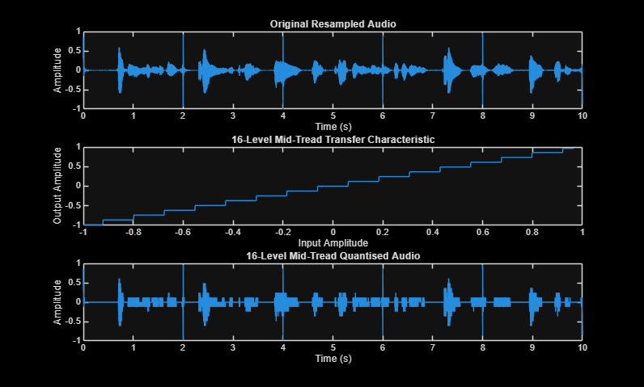
Figure 10: Time Domain Signal (a) vs Transfer Characteristic (b) vs Quantised Signal (c) (16 levels)
3.3. Quantitative and Qualitative Analysis of Quantisation Levels
While the 16-level quantisation produced a high-fidelity output, additional levels including 2, 4, 8, and 32 were evaluated to further validate this selection. Each level was assessed both qualitatively and quantitatively to provide a comprehensive justification.
3.3.1. Qualitative Comparison of different quantisation levels
The audio files and waveform plots (Appendix 2) produced for each quantisation level were qualitatively assessed. Levels 2 and 4 produced insufficient amplitude resolution, and 8 levels failed to capture specific amplitude ranges, resulting in audible degradation. These three levels were therefore deemed ineffective for the purposes of this investigation. Of the remaining levels, 16 and 32, both produced audible output; however, 16 levels provided sufficient fidelity for intelligibility, while 32 levels produced audio that was nearly indistinguishable from the analogue source.
3.3.2. Quantitative Comparison of different quantisation levels
To quantitatively compare the different levels of quantisation the Signal to Quantisation Noise Ratio (SQNR) was used:
$$SQNR=\frac{P_{s}}{P_{noise}}$$
Theoretically $P_{noise}$ is equal to $\frac{Δ^{2}}{12}$ for a pure sine wave; however, a practical representation for the audio signal would be taking the mean-square of the quantisation error ($e(n)$) which is equal to the difference the audio signal and quantised signal at n (Lathi, 1998):
$$e\left(n\right)=x_{s}\left(n\right)-\hat{x}\left(n\right)$$
For accuracy both the theoretical and practical SQNR were calculated and plotted below:
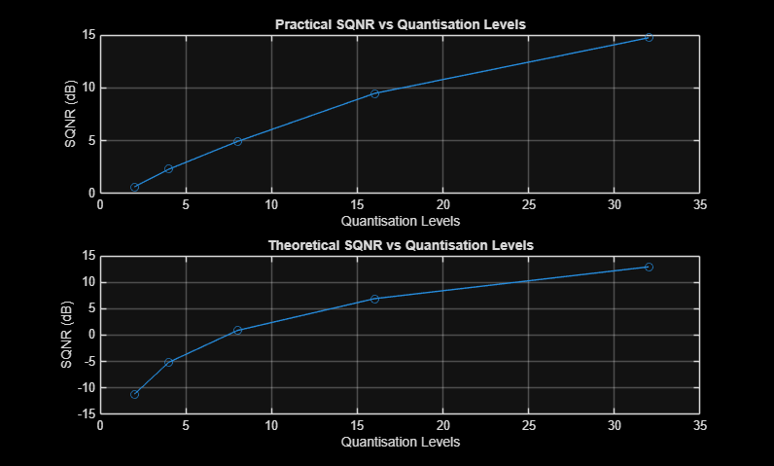
Figure 11: Theoretical (a) vs Practical (b) SQNR
This displays a clear improvement in SQNR as quantisation levels increase both theoretically (Figure 11a) and practically (Figure 11b); however, it is a logarithmic relationship meaning that increases between smaller levels are more efficient than larger levels. Thus, considering both quantitative and qualitative data, 16 levels of quantisation were selected due to the efficiency of the SQNR and the audibility of the signal. However, it must be noted that further techniques such as, dithering could be applied in future models, where distorted harmonics are removed to reduce quantisation error and power losses (Katz, 2007).
3.4. Considering Communication System’s Data Transfer Rate Restriction
Given that BASA’s internal communication system is restricted to a 90 kbits/s data transfer rate, the bit rate of each quantisation level was evaluated at the current sampling frequency. The following formula was used to determine the kbits/s for each quantisation level (see Table 3):
$$kbit rate=\frac{\log_{2}{(L)×f_{s}}}{1000}$$

Table 3: Quantisation Levels vs kbits/s
Quantisation Levels | Kbits/s
2 | 44.1
4 | 88.2
8 | 132.3
16 | 176.4
32 | 220.5

As demonstrated in Table 3, the selected 16-level quantisation scheme exceeds the 90 kbits/s limit, with only quantisation levels of 2 and 4 satisfying the constraint at 44.1 kHz, producing bit rates of 44.1 kbits/s and 88.2 kbits/s respectively. However, as established in Section 3.3, both levels produce insufficient amplitude resolution for audible reproduction of the signal — 2-level quantisation reduces the signal to a binary waveform, and 4-level quantisation fails to capture adequate amplitude detail. To resolve this conflict, a reduced sampling frequency was considered. For a 16-level quantisation scheme, the required sampling frequency is:
$$\frac{desired bit rate}{\log_{2}{L}}=\frac{90000}{4}=22500Hz$$
This produced a sufficiently audible signal, and the resulting waveforms (Figure 12) are visually consistent with those produced at 44.1 kHz (Figure 11):
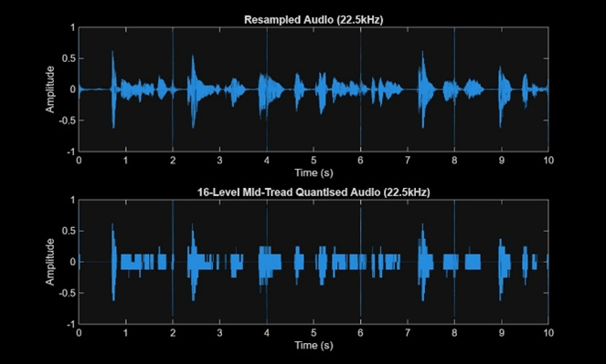
Figure 12: 22.5kHz Resampled Audio (a) and 16 Level Quantisation of Resampled Audio (b)
However, it must be considered that this action compromised the ideal sampling rate, which combined with the limited, yet audible resolution of the 16 levels of quantisation, represent key limitations to be addressed in future models.

Reflection
  - Demonstration of Concepts
Throughout this assignment I demonstrated concepts of signal analysis through correctly approximating a noise signal with the complex Fourier series and using my understanding of both interfering signals and piecewise functions to successfully remove the noise signal from my audio. This complex Fourier series was also tested with different harmonics through a MATLAB for loop and function to find which harmonic was most efficient considering mean-squared error. I was then able to transform my clean audio between frequency and time domains to successfully modulate the signal onto a MATLAB channel, requiring understanding of Fourier transform properties, specifically the modulator property and magnitude spectrums. The modulated signal was then demodulated using a combination of MATLAB filters including bandpass and lowpass, with an inverse Fourier transformation using the modulator property, from which I was able to understand how these filters affected the frequency domain of the channel with regards to their LTI system. I was then able to successfully apply the resample function in MATLAB, selecting an appropriate sampling frequency using the Nyquist rate of the human hearing spectrum. Furthermore, I applied an understanding of the Dirac pulse train function to explain how the resample function worked to resample the audio to an appropriate sampling frequency. Finally, the resampled signal was quantised with various levels using a mid-tread quantizer. These levels were compared through applying concepts of signal to quantisation noise ratio and quantisation error in both theoretical and practical scenarios and tested to see whether they aligned to the required kbit rate of the system.
  - Professional Reflection
Taking into consideration the outcomes of this report, it must be noted that this system is still entirely theoretical and lacks the complexity of an actual practical telecommunications system. The first limitation is the use of ideal filters in the demodulation and resampling stages; in practice, filters introduce losses and distortions, meaning future models should account for non-ideal behaviour and incorporate compensatory elements such as amplifier models and transition bandwidth considerations. Additionally, several MATLAB functions, including resample, channel, record242, and FFT, were treated as black boxes whose internal processes were not fully analysed, and a deeper understanding would be necessary for real-world implementation. From a professional perspective, several key lessons emerged. Estimating cut-off frequencies proved challenging due to unknown modulation parameters; however, taking the mean of the most distinct DC spectral spikes provided cleaner demodulated audio, deepening understanding of two-sided magnitude spectra. Similarly, bandpass cut-off frequencies were determined using figures and averages, highlighting the value of prior knowledge of channel signal characteristics. Finally, the required kbit rate was achieved by compromising the ideal sampling frequency, demonstrating a critical trade-off between system constraints and performance. Beyond the scope of this report, several model extensions were identified: replacing the current double-sideband scheme with single-sideband modulation would halve bandwidth requirements (Libretexts & Steer, 2022); phase-locked loops could correct the carrier phase offsets observed across recovered signals (Dermani et al., 2022); and dithering could reduce quantisation artefacts at lower levels (Katz, 2007), each representing a natural progression for future development.

References
Australian Communications and Media Authority. (2025). Band plans to allocate spectrum. https://www.acma.gov.au/band-plans-allocate-spectrum
De Andrade Serra, H. A., & Paulino, N. (2014). Non-Ideal effects. In Springer briefs in electrical and computer engineering (pp. 29–62). https://doi.org/10.1007/978-3-319-11791-1_5
Dermani, M. K., Baghaei, M. S., Colas, F., Rioual, M., Guillaud, X., & Retiere, N. (2022). Non-linear stability analysis of the electrical vehicle chargers power stage connected to the weak grid. IET Conference Proceedings., 2022(3), 955–959. https://doi.org/10.1049/icp.2022.0855
Gray, R., & Neuhoff, D. (1998). Quantization. IEEE Transactions on Information Theory, 44(6), 2325–2383. https://doi.org/10.1109/18.720541
Hodson, T. O., Over, T. M., & Foks, S. S. (2021). Mean squared error, deconstructed. Journal of Advances in Modeling Earth Systems, 13(12). https://doi.org/10.1029/2021ms002681
Katz, R. A. (2007). Mastering audio: The Art and the Science.
Lathi, B. P. (1998). Modern digital and analog communication systems. Oxford University Press, USA.
Libretexts. (2025, June 25). 6.7: Gibbs Phenomena. Engineering LibreTexts. https://eng.libretexts.org/Bookshelves/Electrical_Engineering/Signal_Processing_and_Modeling/Signals_and_Systems_(Baraniuk_et_al.)/06%3A_Continuous_Time_Fourier_Series_(CTFS)/6.07%3A_Gibbs_Phenomena
Libretexts, & Steer, M. (2022, May 22). 3.2: Single-Sideband and Double-Sideband modulation. Engineering LibreTexts. https://eng.libretexts.org/Bookshelves/Electrical_Engineering/Electronics/Microwave_and_RF_Design_I_-_Radio_Systems_(Steer)/03%3A_Transmitters_and_Receivers/3.02%3A_Single-Sideband_and_Double-Sideband_Modulation
Rosen, S., & Howell, P. (2011). Signals and systems for speech and hearing. BRILL.
Shannon, C. (1949). Communication in the presence of noise. Proceedings of the IRE, 37(1), 10–21. https://doi.org/10.1109/jrproc.1949.232969

Appendix
Appendix 1: Complex Fourier Handwritten Calculations
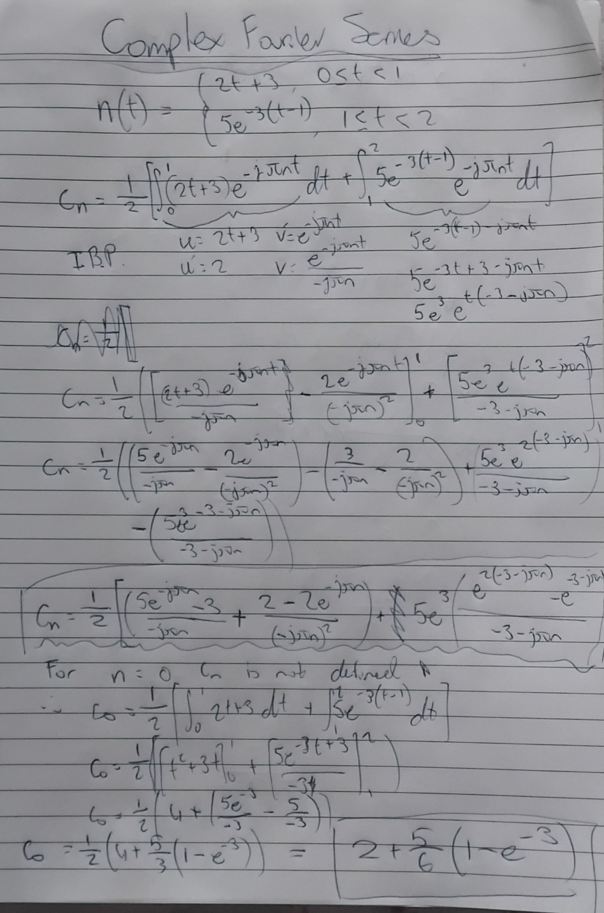
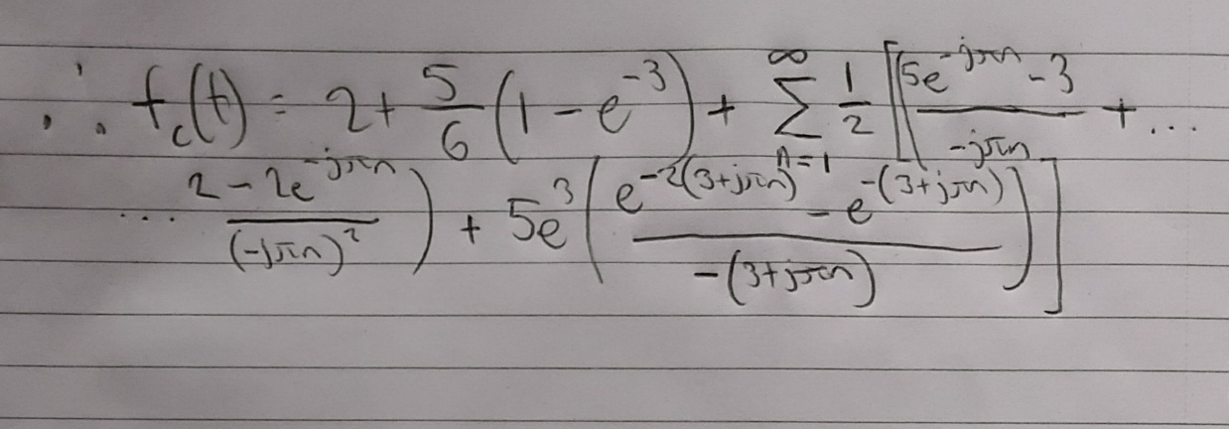

Appendix 2: Graphs of 2, 4, 8, and 32 Quantisation Levels
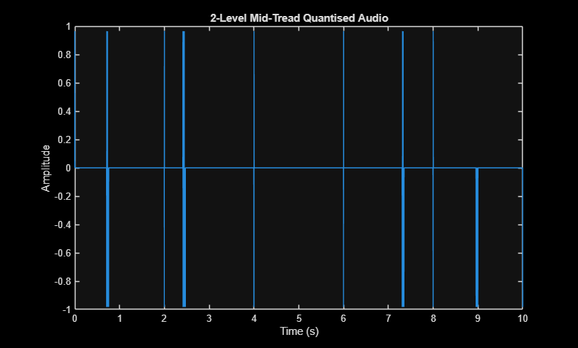
Figure 13: Amplitude vs Time 2 Quantisation Levels
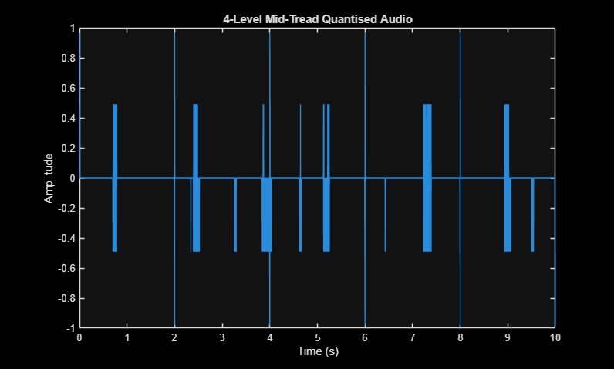
Figure 13: Amplitude vs Time 4 Quantisation Levels
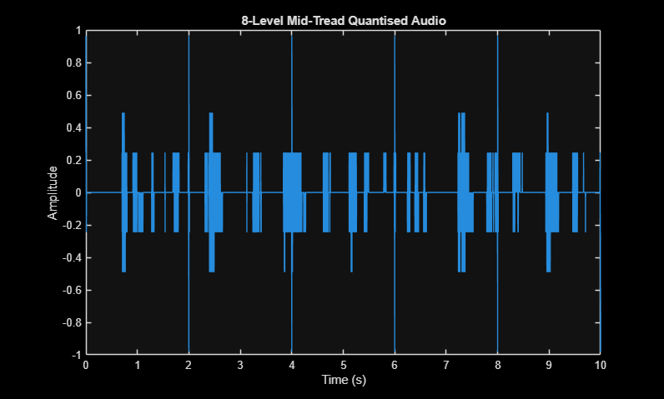
Figure 13: Amplitude vs Time 8 Quantisation Levels

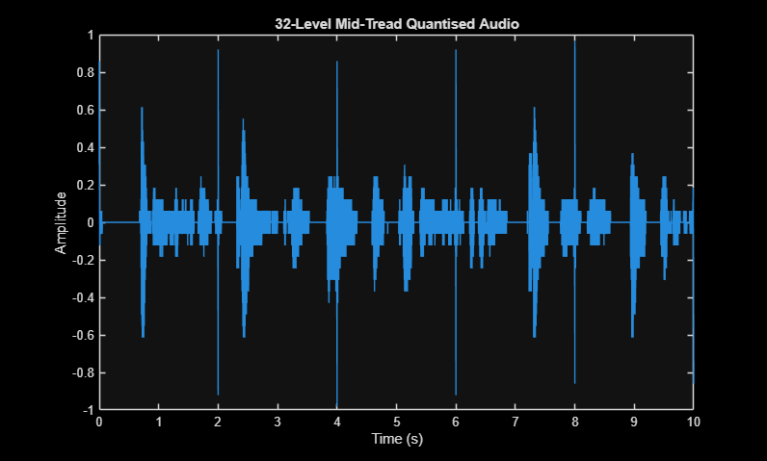
Figure 13: Amplitude vs Time 32 Quantisation Levels

Appendix 3: MATLAB Code

Load Recorded Test Audio into Workspace
clear all; close all;
load DataA1;
% Begin writing your MATLAB solution below this line.
% Listen to audio to understand qualitative aspects
audiowrite('audio.wav', audio, fs);

1.1. Understanding Noise Signal
Create time vector for noise signal — periodic over 1/5 of the audio length Since noise signal is periodic over 2 seconds in a 10 second audio
t0 = 0;
N = length(audio) * 1/5;
T = N / fs;
t = linspace(t0, t0 + T, N);
% Initialise and create noise signal function
noise_signal = zeros(size(t)); % Create zero vector
noise_signal(t >= 0 & t < 1) = 2*t(t >= 0 & t < 1) + 3;
noise_signal(t >= 1 & t < 2) = 5*exp(-3*(t(t >= 1 & t < 2) - 1));

1.2. Reconstructing Noise Signal with Complex Fourier Series
Coefficients c0 and cn derived analytically in Appendix 1. Implemented as a function for reuse in Section 1.3.2. for efficiency of the code Inputs: N (harmonics), t (time vector), T (period)
function [reconstruction] = complex_fourier_series(N, t, T)
% Initialisation
reconstruction = zeros(size(t));
ns = -N:N;
cn = zeros(1, 2*N + 1);
c0 = 2 + (5/6)*(1 - exp(-3)); % DC component calculated in Appendix 1
% Compute Fourier coefficients cn for each harmonic
for n = ns
if n == 0
% Handle n = 0 separately to avoid division by zero
cn(ns == n) = c0;
else
% General coefficient expression calculated in Appendix 1
cn(ns == n) = (1/2) * (( ...
(5*exp(-1j*pi*n) - 3) / (-1j*pi*n) + ...
(-2*exp(-1j*pi*n) + 2) / (-1j*pi*n)^2) + ...
5*exp(3) * (exp(-2*(3+1j*pi*n)) - exp(-1*(3+1j*pi*n))) / (-(3+1j*pi*n)));
end
end
% Reconstruct signal by summing complex exponentials over all harmonics
for n = ns
reconstruction = reconstruction + cn(ns == n) * exp(1j * 2 * pi * n * t / T);
end
% Only consider the real values as the noise signal is real valued
reconstruction = real(reconstruction);
end
% Apply complex_fourier_series with 5 harmonics
harmonics = 5;
nApprox = complex_fourier_series(harmonics, t, T);
figure;
subplot(2, 1, 1);
plot(t, noise_signal);
xlabel('Time (s)');
ylabel('Amplitude');
title('Noise Signal');
subplot(2, 1, 2);
plot(t, nApprox);
xlabel('Time (s)');
ylabel('Amplitude');
title(sprintf('Fourier Series (N=%d)', harmonics));
% Repeat nApprox over the full length of the audio signal since 1/5 of the
% audio this means repeat 5 times
repeat = 5;
denoise_signal = repmat(nApprox, 1, repeat);
tt = linspace(t0, t0 + repeat*T, repeat*N);
% Subtract noise approximation from audio and save. This subtraction is
% because the noise signal affected the audio additively. Therefore, it
% must be reversed
audioClean = audio - denoise_signal;
audiowrite("cleaned_audio.wav", audioClean, fs);
figure;
subplot(2, 1, 1);
plot(tt, audio);
xlabel('Time (s)');
ylabel('Amplitude');
title('Noisy Audio Signal');
subplot(2, 1, 2);
plot(tt, audioClean);
xlabel('Time (s)');
ylabel('Amplitude');
title(sprintf('Denoised Audio Signal (N=%d)', harmonics));
% Repeat process for 100 harmonics, to analyse how increasing harmonics
% affects effectiveness of the fourier series qualitatively (i.e. through
% graphs)
% Apply complex_fourier_series with 100 harmonics
harmonics = 100;
nApprox = complex_fourier_series(harmonics, t, T);
figure;
subplot(2, 1, 1);
plot(t, noise_signal);
xlabel('Time (s)');
ylabel('Amplitude');
title('Noise Signal');
subplot(2, 1, 2);
plot(t, nApprox);
xlabel('Time (s)');
ylabel('Amplitude');
title(sprintf('Fourier Series (N=%d)', harmonics));
% Repeat nApprox over the full length of the audio signal (5 periods)
repeat = 5;
denoise_signal = repmat(nApprox, 1, repeat);
tt = linspace(t0, t0 + repeat*T, repeat*N);
% Subtract noise approximation from audio and save
audioClean = audio - denoise_signal;
audiowrite("cleaned_audio.wav", audioClean, fs);
figure;
subplot(2, 1, 1);
plot(tt, audio);
xlabel('Time (s)');
ylabel('Amplitude');
title('Noisy Audio Signal');
subplot(2, 1, 2);
plot(tt, audioClean);
xlabel('Time (s)');
ylabel('Amplitude');
title(sprintf('Denoised Audio Signal (N=%d)', harmonics));

1.3.2. Analysing Different Harmonics in Complex Fourier Series
Quantitative analysis of harmonic count using Mean Squared Error (MSE)
N_values = [1, 3, 5, 10, 20, 50, 100]; % Create vector of different harmonics
MSE = zeros(size(N_values)); % Create zero vector for MSE
% Use for loop to calculate MSE for each of the harmonics
for k = 1:length(N_values)
N = N_values(k);
k_approx = complex_fourier_series(N, t, T);
MSE(k) = mean((noise_signal - k_approx).^2); % formula for MSE
end
figure;
plot(N_values, MSE, '-o');
xlabel('N (Number of Terms)');
ylabel('Mean Square Error');
title('MSE vs N for Fourier Series Reconstruction');
grid on;
% Print results table
fprintf('N\t\tMSE\n');
for k = 1:length(N_values)
fprintf('%d\t\t%.6f\n', N_values(k), MSE(k));
end

2.1. Frequency Domain of audioClean and Channel
Apply FFT to cleaned audio signal choosing 100 harmonics (i.e. leave audioClean unchanged), since this was decided as both efficient and effective at approximating noise signal
N = length(audioClean);
AudioClean = fft(audioClean); % Apply fft function to change to frequency domain
% Normalise and centre two-sided spectrum at DC = 0 Hz using fftshift to
% simplify the analysis of the frequency domain and allow for appropriate
% graphing values
AudioClean = fftshift(AudioClean) / N;
f = linspace(-fs/2, fs/2, N); % fftshift has a span of -fs/2 to fs/2 for two sided representations
% Use two sided representation since modulation process will transfer a two
% sided spectrum onto the channel and thus this representation is
% appropriate for understanding the bandwidth
figure;
plot(f, abs(AudioClean)); % abs function for magnitude spectrum, since audio is real valued.
xlabel('Frequency (Hz)');
ylabel('Magnitude');
title('Magnitude Spectrum of audioClean');
% Compute frequency domain of quiet channel (zero input)
% Same process as audio magnitude spectrum. However, will be one sided,
% since the negative region is redudant towards understanding the required
% information of band gaps and bandwidths of other signals
channelQuiet = channel(12455466, zeros(size(tt)));
ChannelQuiet = fft(channelQuiet) / N;
f = linspace(0, fs/2, N/2 + 1); % Only including positive side of the magnitude spectrum
figure;
subplot(2, 1, 1);
plot(tt, channelQuiet);
xlabel('Time (s)');
ylabel('Amplitude');
title('Channel Signal (Time Domain)');
subplot(2, 1, 2);
plot(f, abs(ChannelQuiet(1:N/2+1))); % Use abs for magnitude over the positive side of ChannelQuiet
xlabel('Frequency (Hz)');
ylabel('Magnitude');
title('Channel Signal (Frequency Domain)');

2.2. Modulation
Modulate cleaned audio onto carrier frequency fc using modulator property of fourier transform
fc = 38774;
N = length(audioClean);
t = linspace(0, N/fs, N); % Use N/fs to define period
message = audioClean;
% Apply modulator property using a cosine of frequency fc
carrier = cos(2 * pi * fc * t);
% Modulator property is multiplicative
signal = message .* carrier;
% Pass modulated signal through channel using channel function
output = channel(12455466, signal);
% Compute single-sided magnitude spectrum of channel input (signal) and output
N = length(output);
% Apply same mathematical procedures as before for single sided magnitude
% spectrum
Output = fft(output) / N;
Signal = fft(signal) / N;
f = linspace(0, fs/2, N/2 + 1);
figure;
subplot(2, 1, 1);
plot(f, abs(Output(1:N/2+1)));
xlabel('Frequency (Hz)');
ylabel('Magnitude');
title('Channel Output (Frequency Domain)');
subplot(2, 1, 2);
plot(f, abs(Signal(1:N/2+1)));
xlabel('Frequency (Hz)');
ylabel('Magnitude');
title('Channel Input (Frequency Domain)');

2.3. Demodulation
Apply bandpass filter to isolate the audio signal within the channel Cut-off frequencies selected as the mean between adjacent signal edges to effectively filter out the signals in lower and higher frequencies
bpLow = 32751.7;
bpHigh = 44875.35;
% Use bandpass function to apply these cut of frequencies
outputFiltered = bandpass(output, [bpLow bpHigh], fs);
% Compare channel output before and after bandpass filter with singled
% sided magnitude spectrum
N = length(output);
f = linspace(0, fs/2, N/2 + 1);
output_FFT = fft(output) / N;
bandpass_FFT = fft(outputFiltered) / N;
figure;
subplot(2, 1, 1);
plot(f, abs(output_FFT(1:N/2+1)));
xlabel('Frequency (Hz)');
ylabel('Magnitude');
title('Channel Output – Before Bandpass');
subplot(2, 1, 2);
plot(f, abs(bandpass_FFT(1:N/2+1)));
xlabel('Frequency (Hz)');
ylabel('Magnitude');
title('Channel Output – After Bandpass');
% Reverse modulation using the inverse fourier transform property with
% regards to modulation process in previous section
audioReceived = outputFiltered .* cos(2 * pi * fc * t);
% Compute two-sided spectrum before lowpass (for comparison)
% Multiply by two to reverse the scaling of 1/2 due to the modulator
% property and then calculate two sided magnitude spectrum
audioReceived_unfiltered = 2 * audioReceived;
AudioReceived_unfiltered = fft(audioReceived_unfiltered);
AudioReceived_unfiltered = fftshift(AudioReceived_unfiltered) / N;
f = linspace(-fs/2, fs/2, N);
figure;
subplot(2, 1, 1);
plot(f, abs(AudioReceived_unfiltered));
xlabel('Frequency (Hz)');
ylabel('Magnitude');
title('Received Audio – Before Lowpass');
% Apply lowpass filter to isolate baseband audio and correct modulation scaling
lpLow = fc / 2; % This cut off frequency passes audio and rejects image copies
audioReceived = lowpass(audioReceived, lpLow, fs);
% Apply same process as unfiltered to represent signals frequency domain
audioReceived = 2 * audioReceived;
audiowrite('AudioReceived.wav', audioReceived, fs); % save audio for qualitative analysis
% Compute two-sided spectrum of final received audio
AudioReceived = fft(audioReceived);
AudioReceived = fftshift(AudioReceived) / N;
subplot(2, 1, 2);
plot(f, abs(AudioReceived));
xlabel('Frequency (Hz)');
ylabel('Magnitude');
title('Received Audio – After Lowpass');

2.4. Other Signals in Channel
Demodulate each remaining signal using the same process as Section 2.3, with bandpass and lowpass cut-off frequencies adjusted per signal tailoring bandpass to edge frequencies, carrier frequencies to mean of two significant spikes to represent DC value, and applying that carrier frequency to low pass lpLow relationship fc/2
% Signal 1 — Rock
bpLow = 7085.9;
bpHigh = 31082.3;
Signal_1 = bandpass(output, [bpLow, bpHigh], fs);
fc = 19200;
Signal_1 = Signal_1 .* cos(2 * pi * fc * t);
lpLow = fc / 2;
Signal_1 = lowpass(Signal_1, lpLow, fs);
Signal_1 = 2 * Signal_1;
audiowrite('signal1.wav', Signal_1, fs);
% Signal 2 — Harry Styles
bpLow = 44875.35;
bpHigh = 67200;
Signal_2 = bandpass(output, [bpLow, bpHigh], fs);
fc = 57600;
Signal_2 = Signal_2 .* cos(2 * pi * fc * t);
lpLow = fc / 2;
Signal_2 = lowpass(Signal_2, lpLow, fs);
Signal_2 = 2 * Signal_2;
audiowrite('signal2.wav', Signal_2, fs);
% Signal 3 — Rick Roll
bpLow = 67700;
bpHigh = 87000;
Signal_3 = bandpass(output, [bpLow, bpHigh], fs);
fc = 76800;
Signal_3 = Signal_3 .* cos(2 * pi * fc * t);
lpLow = fc / 2;
Signal_3 = lowpass(Signal_3, lpLow, fs);
Signal_3 = 2 * Signal_3;
audiowrite('signal3.wav', Signal_3, fs);

3.1. Resampling Audio Signal
Resample received audio to 44.1 kHz — lowest valid rate satisfying Nyquist for the human hearing range (20 Hz – 20 kHz)
fs2 = 44100;
% Use resample function to conduct this
audioResampled = resample(audioReceived, fs2, fs);

3.2. Quantisation
Normalise audioResampled to [-1, 1] before quantisation to ensure uniformity within the magnitudes
audioResampled = audioResampled / max(abs(audioResampled));
% Signal parameters
x_max = max(audioResampled);
x_min = min(audioResampled);
samples = length(audioResampled);
t = linspace(0, samples/fs2, samples);
% Compute step size for 16-level quantisation
levels = 16;
delta = (x_max - x_min) / levels; % Formula for delta
% Transfer characteristic — output amplitude vs input amplitude
input = linspace(x_min, x_max, samples);
% Using formula for mid tread and then trimming
MToutput_transfer = delta * floor(input / delta + 1/2);
MToutput_transfer = max(x_min, min(x_max, MToutput_transfer));
% Apply mid-tread quantiser to resampled audio
% repeat formulation and trimming with input = audioResampled
MToutput_audio = delta * floor(audioResampled / delta + 1/2);
MToutput_audio = max(x_min, min(x_max, MToutput_audio));
figure;
subplot(3, 1, 1);
plot(t, audioResampled);
xlabel('Time (s)');
ylabel('Amplitude');
title('Original Resampled Audio');
subplot(3, 1, 2);
plot(input, MToutput_transfer);
xlabel('Input Amplitude');
ylabel('Output Amplitude');
title('16-Level Mid-Tread Transfer Characteristic');
subplot(3, 1, 3);
plot(t, MToutput_audio);
xlabel('Time (s)');
ylabel('Amplitude');
title('16-Level Mid-Tread Quantised Audio');
audiowrite('16_level.wav', MToutput_audio, fs2);

3.3. Comparison of Quantisation Levels
Compare levels 2, 4, 8, 16, and 32 using practical and theoretical SQNR to compare and make further justifications of validity and reliability
Quantisation_levels = [2, 4, 8, 16, 32]; % Quantisation vector
% Zero vectors for SQNR practical and theoretical
SQNR_dB_practical = zeros(1, length(Quantisation_levels));
SQNR_dB_theoretical = zeros(1, length(Quantisation_levels));
% For loop to calculate mid tread of each quantisation, quantisation error
% and practical and theoretical SQNR
for k = 1:length(Quantisation_levels)
levels = Quantisation_levels(k);
delta = (x_max - x_min) / levels;
% Apply mid-tread quantiser
MToutput_audio = delta * floor(audioResampled / delta + 1/2);
MToutput_audio = max(x_min, min(x_max, MToutput_audio));
% Compute quantisation error and signal/noise powers
qError = audioResampled - MToutput_audio; % Using formula for quanisation error
P_noise_theoretical = (delta^2) / 12; % Using formula for theoretical quantisation noise
P_noise_practical = mean(qError.^2); % Using formula for practical quantisation noise
P_signal = mean(audioResampled.^2); % Using formula for signal power
% Compute SQNR in dB (most appopriate representation for context)
SQNR_dB_practical(k) = 10 * log10(P_signal / P_noise_practical);
SQNR_dB_theoretical(k) = 10 * log10(P_signal / P_noise_theoretical);
% Plot and save quantised audio for each level
figure;
plot(t, MToutput_audio);
xlabel('Time (s)');
ylabel('Amplitude');
title(sprintf('%d-Level Mid-Tread Quantised Audio', levels));
audiowrite(sprintf('%d_level.wav', levels), MToutput_audio, fs2);
end
% Plot practical and theoretical SQNR vs quantisation level
figure;
subplot(2, 1, 1);
plot(Quantisation_levels, SQNR_dB_practical, '-o');
xlabel('Quantisation Levels');
ylabel('SQNR (dB)');
title('Practical SQNR vs Quantisation Levels');
grid on;
subplot(2, 1, 2);
plot(Quantisation_levels, SQNR_dB_theoretical, '-o');
xlabel('Quantisation Levels');
ylabel('SQNR (dB)');
title('Theoretical SQNR vs Quantisation Levels');
grid on;

3.4. Evaluating 90 kbits/s Data Transfer Rate Restriction
Compute bit rate for each quantisation level at fs2 = 44.1 kHz
fprintf('Level\t\tBit Rate (kbits/s)\n');
fprintf('-----------------------------\n');
levels = [2, 4, 8, 16, 32]; % Quantisation vector
kbit_rate = zeros(1, length(levels)); % Zero vector for kbit rate
% For loop to calculate kbit for each quantisation level at sampled rate
for k = 1:length(levels)
bits = log2(levels(k));
kbit_rate(k) = (bits * fs2) / 1000;
fprintf('%d\t\t%.1f\n', levels(k), kbit_rate(k));
end

Extra - Testing a new Sampling Frequency to meet kbit rate requirement
Repeat resampling and quantisation section to understand how a new sampling rate could rectify the issues observed in the previous section
fs3 = 22500;
AudioResampled = resample(audioResampled, fs3, fs2);
AudioResampled = AudioResampled / max(abs(AudioResampled));
% Signal parameters
x_max = max(AudioResampled);
x_min = min(AudioResampled);
samples = length(AudioResampled);
t = linspace(0, samples/fs3, samples);
% Compute step size for 16-level quantisation
levels = 16;
delta = (x_max - x_min) / levels;
% Apply mid-tread quantiser to resampled audio
MToutput_audio = delta * floor(AudioResampled / delta + 1/2);
MToutput_audio = max(x_min, min(x_max, MToutput_audio));
figure;
subplot(2, 1, 1);
plot(t, AudioResampled);
xlabel('Time (s)');
ylabel('Amplitude');
title('Resampled Audio (22.5kHz)');
subplot(2, 1, 2);
plot(t, MToutput_audio);
xlabel('Time (s)');
ylabel('Amplitude');
title('16-Level Mid-Tread Quantised Audio (22.5kHz)');
audiowrite('16_level_90kbit_rate.wav', MToutput_audio, fs3);

Published with MATLAB® R2025b

