Queensland University of Technology, EGB242

MARS-242 Telecommunications System
  - Group 11
  - Krystian Rozanski (n12455466)
  - Dylan Suhr (n12362646)
  - Jamie Fowler (n12363618)
  - 25th of April 2026

Introduction
BASA’s Mars mission requires a rigid communications system to receive, control, and process transmitted signals from BASA’s HQ. To ensure this, the engineering team focused on three specific subsystems: demodulation of multiplexed signals, control of the yaw angles in machinery, and the digital analysis and processing images.
This report will detail the initial solutions to these subsystems and whether they are appropriate for determining an initial landing site for BASA’s astronauts.

Section 1 – Equalising, Denoising, and Demodulating Multiplexed Audio Signal
Due to the success of the communications system implemented within the MARS-242 project, it has been integrated entirely throughout BASA’s HQs and spacecrafts.
However, the transmission is now happening within space, and the signals are being multiplexed to ensure efficiency. This introduces two new concerns, cosmic noise and demodulation.
Section 1.1. Receiving Multiplexed Signal
BASA’s spacecraft’s radio receiving system received a multiplexed audio signal through the communication channel. This signal was composed of five significant spikes in the positive region, representing five different audio signals, while there were five smaller spikes that were later found to be additive noise. The negative region reflects the positive region and is thus redundant (see Figure 1):

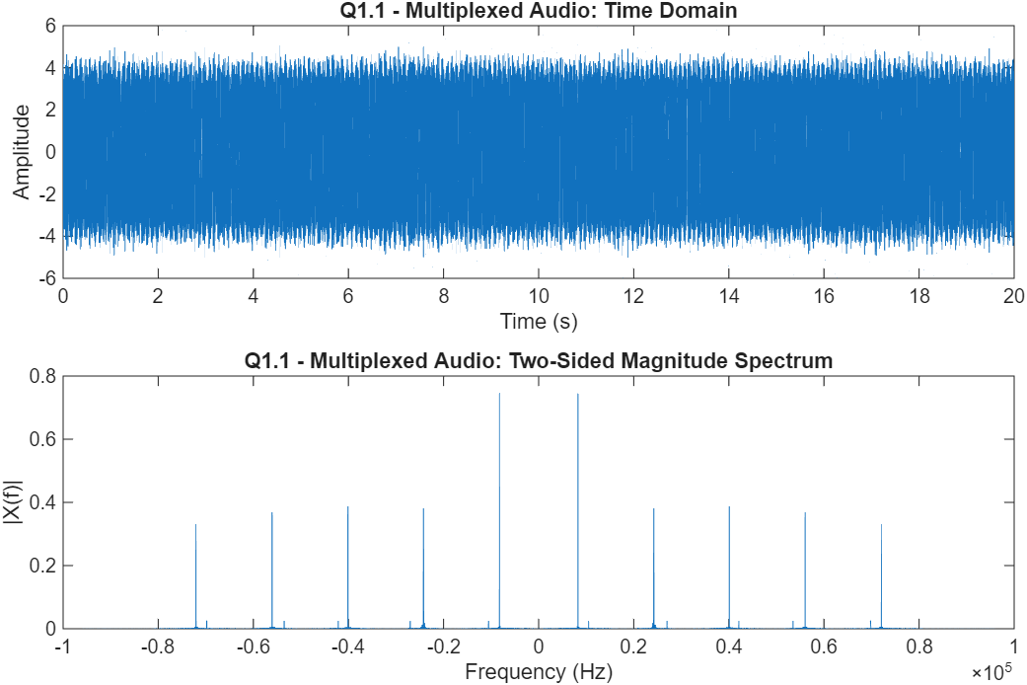
Figure 1: Multiplexed Audio Signal Time and Frequency Domains

Section 1.2. Initial Demodulation to De-multiplex the Signal
Using the demodulation system developed in MARS-242, through applying both a bandpass and lowpass filter in conjunction with the inverse modulator property of the Fourier transform (see code segment below), the five audio signals were demodulated with a for loop to ensure computational efficiency. The lowpass and bandpass cut off frequencies were determined by the position of the signal’s spike and the width of the signal respectively which were found via Figure 1.
for k = 1:5
fc_k = carriers(k);
bandwidth = (bp_edges(k,2) - bp_edges(k,1)) / 2;
bp = bandpass(audioMultiplexNoisy, bp_edges(k,:), fs);
demod = bp .* cos(2*pi*fc_k*t);
sig = lowpass(demod, bandwidth, fs) * 2;
signals{k} = sig;
audiowrite(sprintf('signal%d.wav', k), sig, fs);
end

Each signal was then plotted (see Appendix 2) and listened to. Each of the audios were inaudible with parts of the signal being completely attenuated and a consistent tonal noise occurring throughout. These single tonal noises align to the smaller spikes seen adjacent to the audio signals.
Section 1.3. Analysing the Frequency-Dependent Distortion of the Channel
The biggest concern from the initial demodulation, were the parts of the audio signals that were identified as completely attenuated. This suggests that the channel is responding as a filter in certain regions. To further explore this, the impulse response of the channel was found through creating a Dirac Delta function and modulating it onto the channel using the channel function, from which the Fourier transform was applied to find the transfer function, since:
$$F\{h\left(t\right)\}=\int_{-∞}^{∞}{h\left(t\right)e^{-j2πft}dt=H(f)}$$
This procedure is highlighted within the code section below:
x_imp = [1, zeros(1, samples-1)]; % Dirac Function

h = channel(sid, x_imp, fs); % Modulation of Dirac Function onto Channel (impulse response)
H_f = abs(fft(h)/fs); % FFT of Impulse Response (Transfer Function)

This was then plotted with the frequency domain of the multiplexed signal to gain an insight into how the response impacted the audio signals (see Figure 2):

Figure 2: Transfer Function of Channel plotted with Multiplexed Audio Magnitude Spectrum

As can be seen, there are clear points across Figure 2 where the channel’s response displays immense interference with the multiplexed signal’s frequency domain causing frequency-dependent distortion and confirming that the channel’s response is the source of the attenuation observed in Section 1.2.
Section 1.4. Equalising the Channel to Reverse Response Effects
To reverse the effects of the channel’s transfer function and additive noise, it is necessary to understand how the input is mathematically related to the output:
Let the multiplexed audio on the channel be $y(t)$. The following relationships can be defined:
$$y\left(t\right)=x\left(t\right)*h\left(t\right)+n\left(t\right)= \int_{-∞}^{∞}{x\left(t\right)h\left(t-τ\right)dτ}+n(t)$$
Where $h(t)$ is the impulse response of the channel, $x\left(t\right)$ is the multiplex audio’s input signal, and $n(t)$ is additive noise that will be discussed further in Section 1.5. Taking the Fourier transform:
$$Y\left(f\right)=X\left(f\right)×H\left(f\right)+N(f)$$
To reverse the effects of the transfer function we can divide the multiplexed audio signal by the transfer function found in Section 1.3. Though, this can be catastrophic for the system if $H\left(f\right)$ tends towards 0, as the additive noise will tend towards infinity:
$$\frac{Y(f)}{H(f)}=X\left(f\right)+\frac{N(f)}{H(f)}$$
Furthermore, $H(f)$ is a complex number. Therefore, when dividing it introduces a phase distortion. Thus, a regularised zero-forcing equaliser is applied:
$$Y\left(f\right)×\frac{H^{*}(f)}{{\left|H(f)\right|}^{2}+ε^{2}}=X\left(f\right)+N(f)×\frac{H^{*}(f)}{{\left|H(f)\right|}^{2}+ε^{2}}$$
Where $ε$ is related to the maximum of $H(f)$ and ensures that as $H\left(f\right)$ tends to 0 so does the noise. The other component:
$$\frac{H^{*}(f)}{{\left|H(f)\right|}^{2}}=\frac{H^{*}(f)}{H(f)H^{*}(f)}=\frac{1}{H(f)}$$
Acts the same as the previous algebra; however, it can also be interpreted as:
$$\frac{H^{*}(f)}{{\left|H(f)\right|}^{2}}=\frac{Ae^{-jθ}}{A^{2}}=\frac{1}{A}e^{-jθ}$$
Where the exponential component reverses phase distortion and the $\frac{1}{A}$ component maintains amplitude. Therefore, the regularised zero-forcing equaliser maintains amplitude, phase, and ensures that the additive noise remains stable (Salehi & Proakis, 2007). These processes can be seen in the MATLAB code below, where the inverse Fourier transform of $X\left(f\right)$ and the normalisation of $x(t)$ finishes the equalisation:
Y_f = fft(audioMultiplexNoisy);
epsilon = 0.01 * max(abs(H_f));
X_eq_f = Y_f .* conj(H_f) ./ (abs(H_f).^2 + epsilon^2);
audio_eq = real(ifft(X_eq_f));
audio_eq = audio_eq / max(abs(audio_eq)) * 0.9;
Demodulating the audio signals, plotting, and listening to the contents, revealed apparent improvements, with the time domain of the channel appearing less noisy (see Figure 3). However, it also highlighted the remaining additive single tonal noises in each signal with some of the additive noise being amplified by the equalisation as can be seen in the frequency domain below:
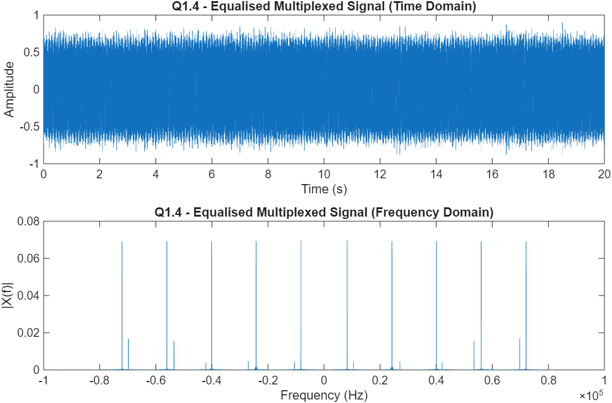
Figure 3: Time and Frequency Domains of the Equalised Channel
An alternative to the regularised zero-forcing equaliser is a Wiener filter, which applies SQNR rather than a fixed constant $ε$. The Wiener filter is optimal when considering mean-square error; however, the regularised zero-forcing equaliser was simpler to integrate within this investigation, as the Wiener filtering requires an estimate of the noise power spectral density. The Wiener filter is therefore considered an improvement towards this current model (Waliullah et al., 2020).
Section 1.5. Denoising the Audio Signals
The remaining additive noise was now the target of improvement. From the algebra in Section 1.4, the following can be derived:
$$X\left(f\right)=Y\left(f\right)×\frac{H^{*}\left(f\right)}{{\left|H\left(f\right)\right|}^{2}+ε^{2}}-N(f)×\frac{H^{*}(f)}{{\left|H(f)\right|}^{2}+ε^{2}}$$
The second term of the right-hand side displays that to evaluate the true input audio signals we must first subtract the additive noise from the equalised channel. As mentioned in section 1.1, the smaller signals were determined as the single tonal frequencies that were interfering with the audio signals, as plotting each audio signal revealed two equally positioned Dirac Delta functions. This suggests that the smaller spikes on the channel represent additive sinusoidal noise as:
$$F\{\cos{(2πf_{c}t)\}=\frac{1}{2}[δ\left(f-f_{c}\right)+δ(f+f_{c})] }$$
Thus:
$$n\left(t\right)=\cos{(2πf_{n}t)}$$
Where $f_{n}$ is the frequency of the noise determined from Figure 1. However, when subtracting we must reverse the effect of the transfer function factor caused by equalisation that may have impacted the amplitude and phase of the noise. To rectify this, a new model of $n(t)$ is used:
$$n\left(t\right)=A*cos{(2πf_{n}t+Φ)}$$
Where $A$and $Φ$ are variables determined through the final equalised audio signal’s amplitude and phase at the point of the additive noise. This is done through the following code below:
for i = 1:length(tone_list)
f_tone = tone_list(i);
noisy_bin = round(f_tone * samples / fs) + 1;
A = 2 * abs(FFT_eq(noisy_bin));
phi = angle(FFT_eq(noisy_bin));
audio_eq_clean = audio_eq_clean - A * cos(2*pi*f_tone*t(:) + phi);
end

Since the signal is not continuous the FFT stores the frequencies in different valued bin, to construct a rigid model of the additive noise, this code determines the bin through the product of the identified frequency of the additive noise and the frequency resolution. This is then used to calculate the amplitude and angle of the noise through evaluating the FFT at the bin to construct a thorough model of the additive noise.
The audio signals were then plotted and listened to and were successfully audible. Hence, concluding the demultiplexing part of this system (see Appendix 2). This method of time-domain subtraction was chosen over filtration in the frequency domain as it eliminates the exact additive noise without impacting nearby frequency bins.

Section 2 – Rover Camera Control
When the spacecraft arrives on Mars, the astronauts will send a rover down to the surface which will travel to numerous landing sites to capture images and transmit them back to the spacecraft for the astronauts to determine a suitable landing location.
This section of the report will cover how the control system for the servo motor controlling the yaw angle $ψ\left(t\right)$ in radians of the camera is modelled.

Section 2.1. Open Loop Step Response of the Motor
The motor that drives the camera’s yaw angle is modelled as an LTI system in the Laplace domain. With $K_{m}=1$ and $α=0.5$, its transfer function is:
$$G_{m}\left(s\right)=\frac{ψ_{out}\left(s\right)}{V_{in}\left(s\right)}=\frac{K_{m}}{\left(s\left(s+α\right)\right)}=\frac{1}{\left(s\left(s+0.5\right)\right)}$$
To find the step response analytically, the Laplace transform of a unit input $V_{in}\left(s\right)=\frac{1}{s}$ is multiplied by, $G_{m}\left(s\right)$ and then partial fractions are applied:
$ψ_{out}\left(s\right)=G_{m}\left(s\right) ∙ \left(\frac{1}{s}\right) = \frac{1}{\left(s^{2}\left(s+0.5\right)\right)}$,
$$Partial Fractions → \frac{A}{s}+ \frac{B}{s^{2}}+\frac{C}{\left(s+0.5\right)}$$
The open loop poles of $G_{m}(s)$ are located at $s=0 and s=-0.5$. Multiplying by the unit step ($\frac{1}{s}$) introduces a double pole at the origin, which maps to the linear term $2t$ in the time domain response, while the pole at $s=-0.5$ produces the decaying exponential $4e^{-0.5t}$. Since the term $2t$ grows without bound as $t→∞$, the open loop system is unstable under a step input (2.1: System Poles and Zeros, 2020). It was found that, therefore:
$$ψ_{out}\left(t\right)=-4+2t+4e^{\left(-0.5t\right)}, t≥0$$
The code below creates the time vector with 10,000 samples and evaluates the analytical step response.
t = linspace(0, 25, 10000); % 10^4 samples
% Define transfer function Gm(s)
s = tf('s');
Km = 1;
alpha = 0.5;
Gm = Km / (s * (s + alpha));
vin_step = ones(size(t)); % Unit step input
psi_out = (-4) + (2*t) + (4*exp(-0.5*t)); % Step Response
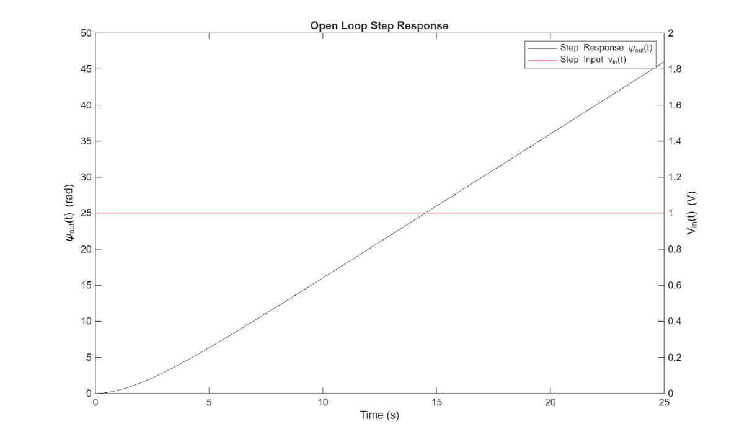

Figure 4: Open-loop step response ψ_out (t) against the step input V_in (t).
The open loop step response grows linearly with time, creating a ramp function. As visible in Figure 4, the response initially curves due to the decaying exponential $4e^{-0.5t}$ before the linear ramp $2t$ dominates at larger values of $t$. Since $G_{m}\left(s\right)$ contains a pure integrator ($\frac{1}{s}$), the output $ψ_{out}(t)$ is the time integral of the input voltage. Integrating a non-zero constant produces a value that grows without bound, so a constant input drives the motor to spin continuously rather than settle at a fixed yaw angle.

Section 2.2. Justification of Potentiometer Feedback Suggestion
The open loop system cannot hold a fixed angle because there is no mechanism that knows where the camera currently points. The supervisor proposes coupling a potentiometer to the motor shaft.
As the motor shaft rotates, it drives the wiper of the potentiometer along its resistive element. This changed the effective resistance and therefore the voltage at the wiper tap. Since wiper displacement is directly proportional to shaft angle, the device produces an output voltage $V_{pot}=K_{pot}∙ ψ_{out}$, where $k_{pot}$ is the potentiometer gain in $V/{rad}$. In Laplace domain this relationship is modelled as a constant gain block:
$$H_{p}\left(s\right)=\frac{V_{pot}\left(s\right)}{ψ_{out}\left(s\right)}=K_{pot}$$
The motor is then driven by the error signal which is the difference between the commanded input voltage and the potentiometer feedback voltage. This forms a negative feedback loop:
$$V_{diff}\left(s\right)=V_{in}\left(s\right)-V_{pot}\left(s\right)=V_{in}\left(s\right)-V_{pot}\left(s\right) ∙ ψ_{out}\left(s\right)$$
This negative feedback converts the integrating open loop system into one with a finite, bounded steady-state output. When the camera reaches the desired angle the error signal collapses to zero, removing the drive signal and halting rotation, the supervisor’s suggestion is therefore justified.

Section 2.3. Close-Loop Transfer Function and Step Response
With $K_{pot}=1$, the closed loop transfer function is derived using the standard feedback formula:
$$F\left(s\right)=\frac{G_{m}\left(s\right)}{\left(1+G_{M}\left(s\right) ∙ H_{p}\left(s\right)\right)}=\frac{\left(\frac{1}{s\left(s+0.5\right)}\right)}{\left(1+\frac{1}{s\left(s+0.5\right)}\right)}=\frac{1}{\left(s^{2}+0.5s+1\right)}$$
This is a second order system. Its poles are the roots of $s^{2}+0.5s+1=0$, given a conjugate complex pair:
$$s=-0.25±j\sqrt{\left(1-0.0625\right)}=-0.25±j0.968$$
The negative real part $σ=-0.25$ guarantees that the transient response decays exponentially with the time constant $τ=\frac{1}{0.25}=4s$. The non-zero imaginary part $ω_{d}=0.968 rad/s$ produces damped oscillation at the damped natural frequency. The poles lie in the left half of the complex plane, confirming a stable but underdamped transient response.
The code below builds the tf object, uses MATLAB’s feedback function, and simulates with lsim function:
K_pot = 1;
Hp = K_pot; % New transfer function
F = feedback(Gm, Hp); % F(s) feedback loop
disp('Poles of F(s):');
disp(pole(F));
disp('Order of F(s):');
disp(order(F));
psi_out_closed = lsim(F, vin_step, t);

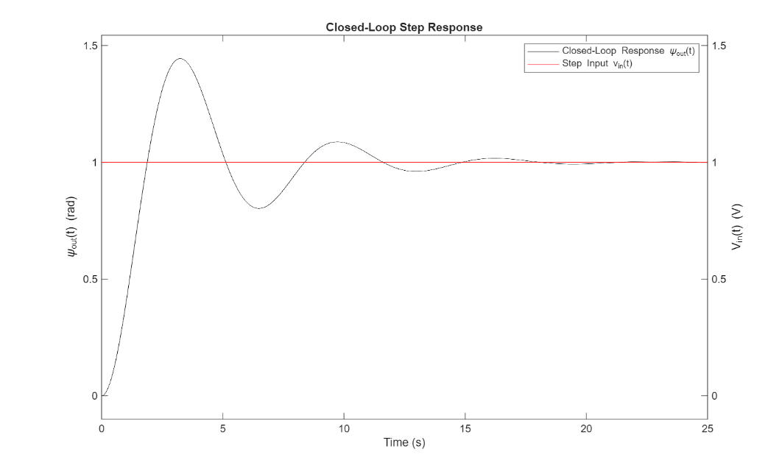

Figure 5: Closed loop step response ψ_out (t) against step input V_in (t).
Figure 5 shows that the closed loop system converges to a steady state angle of 1 rad in response to a 1V step input unlike in Figure 3 how the open loop output grew without bound. However, noticeable oscillation is visible before settling which indicates underdamped behaviour, still making this unsuitable for smooth camera operation. An underdamped system gives a faster response time, approaching the commanded value quickly. However, this results in a large overshoot and oscillations around the commanded position. These oscillations are known as ringing and decrease over time until the target value is reached within the specified error (Collins, 2016).

Section 2.4. Second-Order System Parameters and Performance Metrics
Every second order system is characterised by two parameters, the natural frequency $ω_{n}$, which is the frequency at which the system would oscillate without damping, and the damping ratio $ζ$, which describes how quickly oscillations decay (Zywno, 2019).
Comparing the closed loop denominator $s^{2}+0.5s+1$ with the standard second order form $s^{2}+2ζω_{n}+ω_{n}^{2}$.
$$ω_{n}^{2}=1 → ω_{n}=1 \frac{rad}{s}$$
$$2ζω_{n}=0.5 → ζ=0.25$$
Since $0<ζ<1$, the system is underdamped. The standard performance metrics are:
$$T_{P}=\frac{π}{\left(ω_{n\sqrt{\left(1-ζ^{2}\right)}}\right)}=3.24 s$$
This is the time elapsed before the response first reaches its peak value.
$$T_{S}=\frac{4}{\left(ζω_{n}\right)}=16 s$$
This is the time before the output remains permanently within a certain percentage of its final value.
$$\%OS=e^{(\frac{-πζ}{\sqrt{\left(1-ζ^{2}\right)}})}×100≈44\%$$
The percent overshoot is how far above the target angle the first peak reaches.
A settling time of 16s means the camera takes over 16 seconds to hold a stable angle after each move, which is unacceptably slow for a rover surveying multiple sites. The 44% overshoot means the camera swings 44% past its target angle before correcting, causing blur when the frame should be captured. Additionally, with $K_{pot}=1$ $2π≈6.28 rad/s$.
While the current underdamped parameters $\left(ζ=0.25\right)$ produce an unacceptably slow settling time of 16s and 44% overshoot, an underdamped design remains preferable to an overdamped or critically damped on, provided the gains are properly tuned. An overdamped system would eliminate oscillation but at the cost of an even slower rise time, worsening the settling time further. Critical damping minimised settling time without overshoot in theory but leaves no design margin if load inertia or back EMF coefficient varies from the nominal model. The goal therefore is not to abandon the underdamped approach, but to tune the gains appropriately.

Table 1 – Summary of second-order parameters and performance metrics for the unity-gain feedback system (K_{pot} = 1).
Parameter | Value | Source equation
Natural frequency $ω_{n}$ | 1 rad/s | ${ω_{n}}^{2}$ = 1 (from denominator)
Damping ratio $ζ$ | 0.25 | 2$ζω_{n}$ = 0.5
Damping case | Underdamped | 0 < $ζ$< 1
Time to peak $T_{p}$ | 3.24 s | $$\frac{π}{ω_{n}\sqrt{1-ζ^{2}}}$$
Settling time $T_{a}$ | 16 s | $$\frac{4}{ζω_{n}}$$
Percentage overshoot %OS | ≈ 44% | $$e^{(-\frac{πζ}{\sqrt{1-ζ^{2}}})}×100\%$$

Section 2.5. Effect of Forward and Feedback Gain on Step Response
The gain blocks $G_{g}\left(s\right)=K_{fwd }$(forward path) and $H_{g}\left(s\right)=K_{fb }$(feedback path) are added. The augmented closed loop transfer function then becomes:
$$F\left(S\right)=K_{fwd} ∙ \frac{G_{m}\left(s\right)}{\left(1+K_{fwd} ∙ K_{fb} ∙ G_{m}\left(s\right)\right)}=\frac{K_{fwd}}{\left(s^{2}+0.5s+K_{fwd} ∙ K_{fb}\right)}$$
Two sweeps are simulated, first one varying $K_{fb}$ with $K_{fwd}=1$, then varying $K_{fwd}$ with $K_{fb}=1$:
% Gain arrays
K_fb_vals = [0.1, 0.2, 0.5, 1, 2];
K_fwd_vals = [0.1, 0.2, 0.5, 1, 2];
% Vary K_fb while K_fwd = 1
for K_fb = K_fb_vals
fb_varied = feedback(1 * Gm, K_fb * Hp);
y1 = lsim(fb_varied, vin_step, t);
end
% Vary K_fwd while K_fb = 1
for K_fwd = K_fwd_vals
fwd_varied = feedback(K_fwd * Gm, 1 * Hp);
y2 = lsim(fwd_varied, vin_step, t);
end
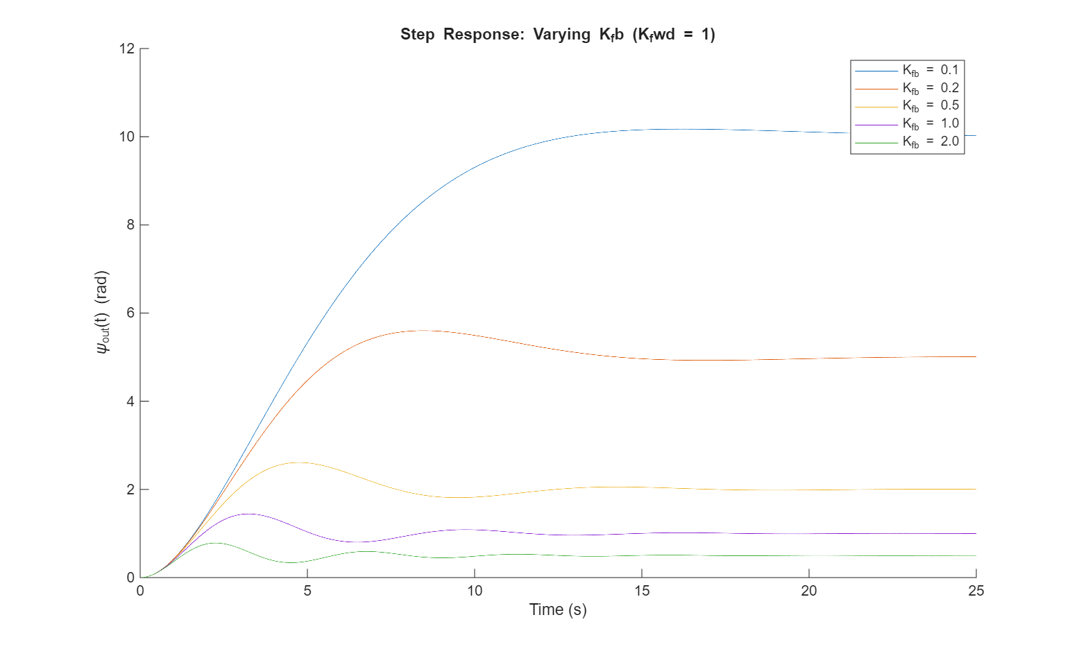
Figure 6: Varying K_fb (K_fwd=1).
As seen in Figure 6, increasing the feedback gain lowers the steady state output angle and reduces oscillatory overshoot. This follows directly from the closed loop transfer function $F\left(s\right)=\frac{K_{fwd}}{(s^{2}+0.5s+K_{fwd} ∙ K_{fb}}$. Evaluating at $s=0$ gives DC gain equal to $\frac{1}{K_{fb}}$, so larger $K_{fb}$ compresses the output range. Increasing $K_{fb}$ also raises $ω_{n}^{2}=K_{fwd} ∙ K_{fb}$, which increases $ζ=\frac{0.25}{ω_{n}}$, reducing overshoot (Ogata et al., n.d.).

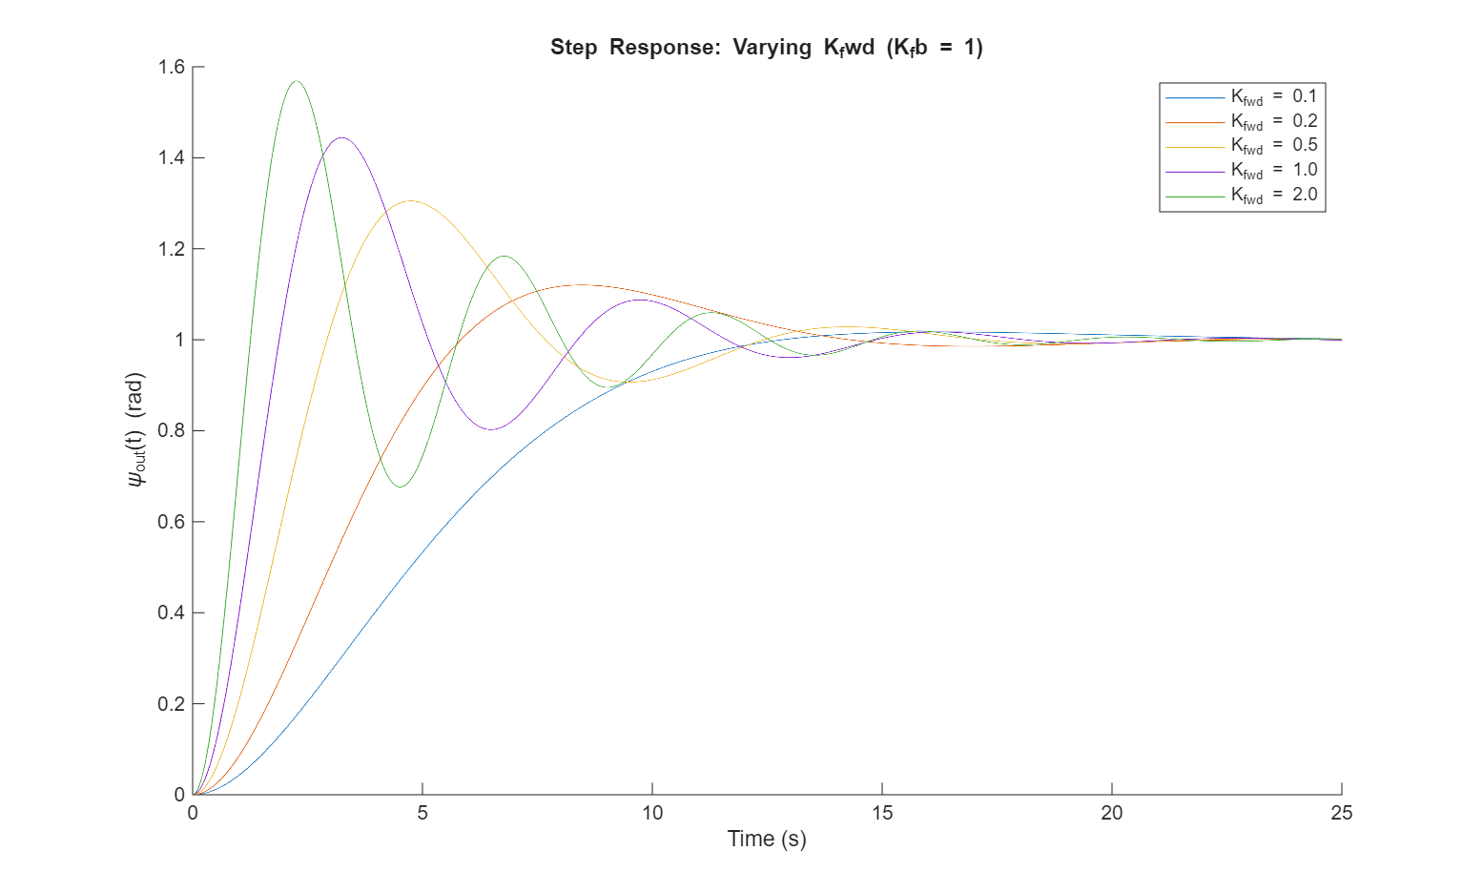

Figure 7: Varying K_fwd (K_fb=1).
Increasing the forward gain raises the natural frequency ($ω_{n}$) which gives a faster response and earlier peak but leaves the steady state angle unchanged at $\frac{1}{K_{fb}}$ rad, as expected from the DC gain expression. This matches results shown in Figure 7, where all curves converge to the same final value but with progressively faster and more oscillatory transients.

Section 2.6. Designing Gains to Meet the Panorama Specifications
Two design requirements must be satisfied simultaneously. The motor must provide the servo with full angular range, a 1V input must produce a $2π$ rad output. The DC gain of the close loop system is $\frac{K_{fwd}}{\left(K_{fwd} ∙ K_{fb}\right)}=\frac{1}{K_{fb}}$. A full camera sweep requires a 1V input to produce a complete $360°$ ($2π rad$) rotation, so the DC gain of the closed loop system must equal $2π\frac{rad}{V}$. Setting this equal to $2π$ gives $K_{fb}= \frac{1}{2π}$. Secondly, the motor rotation has a required peak time of 12 seconds. From the closed loop denominator $s^{2}+0.5s+K_{fwd} ∙ K_{fb}$, comparing with the standard form gives $ω_{n}^{2}=K_{fwd} ∙ K_{fb}$, and therefore $K_{fwd}=\frac{ω_{n}^{2}}{K_{fb}}$. To find $ω_{n}$, the peak time requirement $T_{P}=12s$ is substituted into $T_{P}=\frac{π}{w_{d}}$, where $ω_{d}= ω_{n}\sqrt{\left(1-ζ^{2}\right)}$, and $ζ=\frac{0.25}{ω_{n}}$, giving $ω_{d}=\sqrt{ω_{n}^{2}-0.0625}$. Rearranging:
$ω_{n}^{2}={(\frac{π}{T_{P}})}^{2}+0.0625$
With $K_{fb}=\frac{1}{2π}$ already known, $K_{fwd}=\frac{ω_{n}^{2}}{K_{fb}}$ is then fully determined.
Tp = 12; % Required peak time
Wn = sqrt((pi/Tp)^2 + 0.0625);
K_fb_final = 1 / (2*pi);
K_fwd_final = Wn^2 / K_fb_final;
% Final transfer function object
cameraTF = feedback(K_fwd_final * Gm, K_fb_final * Hp);
With these gains the closed loop denominator becomes $s^{2}+0.5s+K_{fwd} ∙ K_{fb}$, where $K_{fwd} ∙ K_{fb}=ω_{n}^{2}$. This simultaneously satisfies the full range mapping and the required peak time.

Section 2.7. Live Panorama Camera Sweep
With the cameraTF object finalised, the camera is commanded to sweep from $30° to 210°$. The angles are first converted to radians, then to the 0-1V input range using the full rotation mapping:
% Input is 0-1V for 0-2pi rad so V = angle_rad / (2*pi)
% Convert angles to radians
startAngle = 30 * (pi/180);
endAngle = 210 * (pi/180);
% Convert angles to voltages
startVoltage = startAngle / (2*pi);
endVoltage = endAngle / (2*pi);
[startIm, finalIm] = cameraPan(startVoltage, endVoltage, cameraTF);
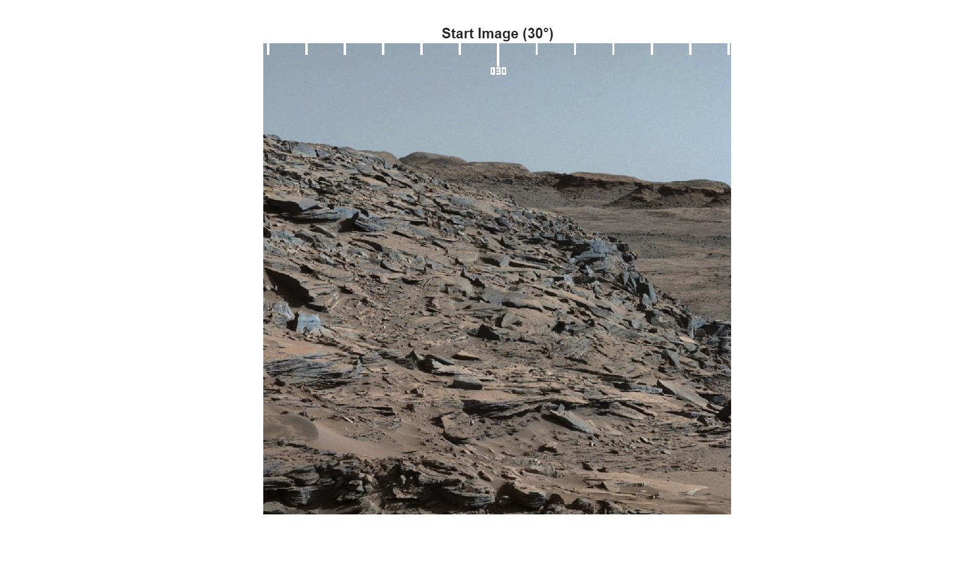
Figure 8: Start image of rocky Mars terrain captured at ψ=30°.

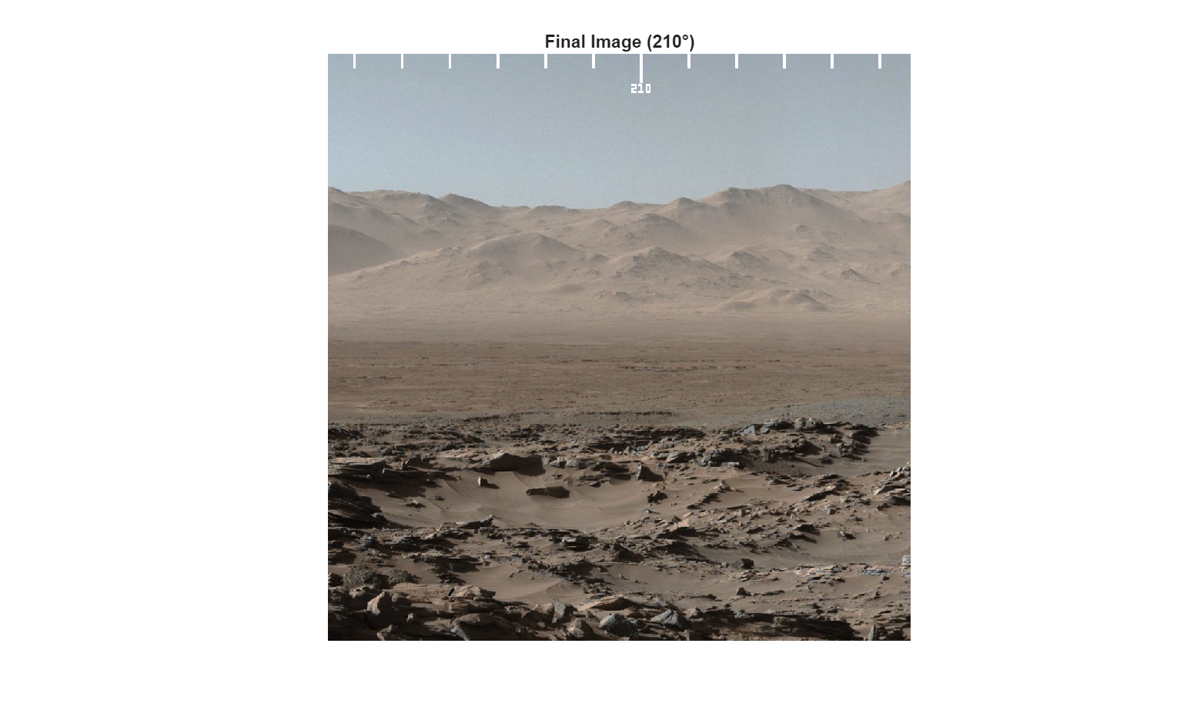
Figure 9: Final image of open Mars terrain captured at ψ=210°.
Both images displayed in Figure 8 and Figure 9 are sharp and in focus, indicating the camera’s angular velocity remained within acceptable limits during the pan, meaning there is no visible motion blur. The controller settled to the target angles within the specified peak time, confirming the gain design was successful. The underdamped transient behaviour is constrained enough that it does not degrade image quality during the sweep. However, it does mean that the panorama pans to roughly $220°$before panning back and settling at the target, $210°$ but this is safely within the overshoot margin that was calculated.

Section 3 – Image De-noising and Landing Site Selection
The images captured by the MARS-242 rover at each candidate landing site must first be denoised before they can be assessed. This ensures that the landing crew can clearly evaluate each location and make an informed decision.

Section 3.1. Received Image Signal
The rover took four pictures of different desired locations for the landing team to land. In MATLAB, the images are represented as 2D matrices,
but are stored in 1D so the contents of a singular image are stored in each row. This is how data is stored, making it easier to extract lots of different images from a singular variable. To view these in the MATLAB system, the 1D channel will need to be reshaped using the given function reshape and imshow to view as an image. The resizing converts the 1D row into a 2D matrix depending on the pixel arrangement of the image. Every digit of a 2D matrix represents a coloured pixel (grayscale in this case), arranging these pixels to create the desired image. For these images, they are 480 pixels tall by 640 pixels wide. Before resizing the first image, it needs to be extracted, otherwise reshaping the entire variable will result in a mix of all the images. The first image is in the first row, so only that row was extracted and stored. The noisy image is displayed in Figure 10:

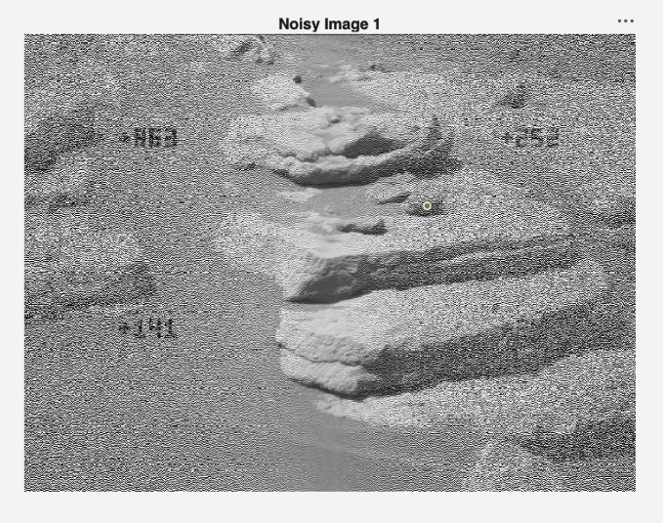
Figure 10: Noisy received image of first candidate landing site, prior to de-noising.
When observing Figure 10, there was a lot of static information on the left and right sides of the image. The centre looked unaffected by the noise, meaning at a certain frequency, there is no noise that disturbs the image quality. This sort of distribution show that there is a disturbance in the time and frequency domains of the transmitted signal.

Section 3.2. Time and Frequency Domains of the Image Signal
To understand what is happening in the image, a time vector and frequency vector must be created to visualise how the noise interrupts the image quality and how it can be filtered out. BASA’s signal reception system receives transmitted signals at a rate of:

$$f_{s}=1000 pixels/s$$

$$∴imSize=\left[480,640\right]$$

$$number of pixels=307200$$

$$receiving time=\frac{\left(number of pixels\right)}{f_{s}}=307.2 seonds$$

This receiving time was considered within the time vector, and the sampling frequency was considered within the frequency, with both having samples equal to the number of pixels being received and both applying the linspace function to create the two vectors. The bounds of the frequency vector were made to be
$$\left[-\frac{f_{s}}{2},\frac{f_{s}}{2}\right]$$
as this aligns with the fftshift function which was applied to the fft of the image signal. This centres the DC component at 0 Hz, as seen code below:

fs = 1000;
N = length(Image1);
t = (0:N-1)/fs;
f = linspace(-fs/2, fs/2, N);
Image1_Recieved = fftshift(fft(Image1));

Plotting the received one-dimensional signal within both the time and frequency domain the following is observed in Figure 10:

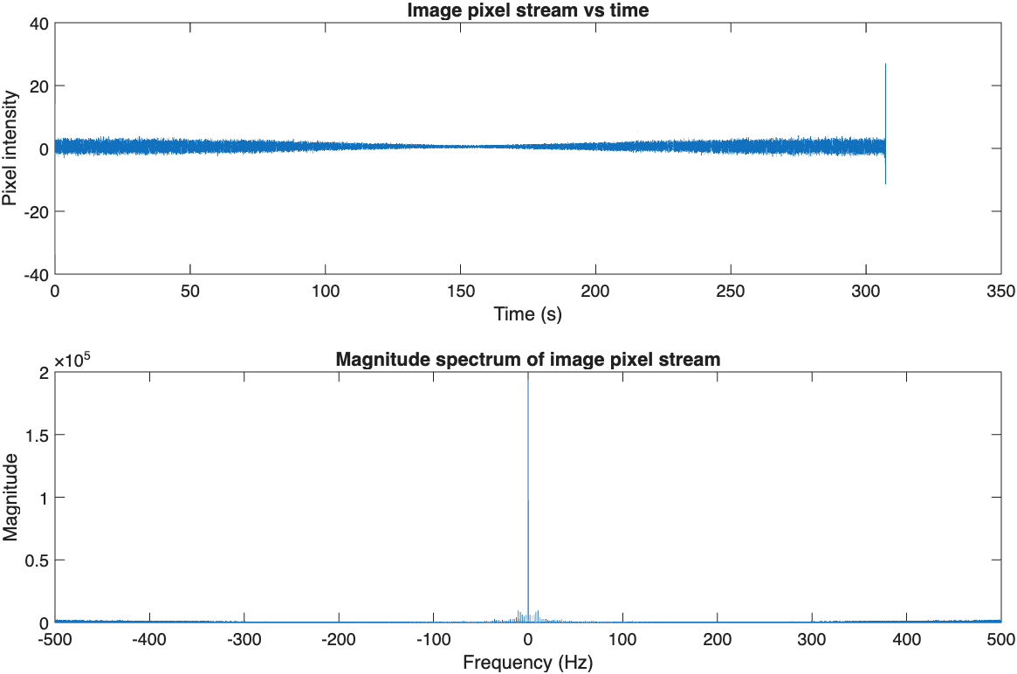
Figure 11: Time and Frequency domains of the signal for Image1 prior to de-noising.
In Figure 11, the image pixel stream (time vector) shows large pixel intensity at the start and end of the plot, skewing to the centre with lower intensity. This shows that the noise amplitude is relatively smaller compared to the signal, so visually in the image it is clear and in the time domain it appears reduced in variation. The more the pixel intensity fluctuates, the more noise is being produced.

The magnitude spectrum (frequency vector) shows the important frequencies at the 0 Hz range and continues out to just under 100 Hz, with a flat wideband noise floor. In signals, regions with low noise and smooth gradients produce low frequencies because the values of the pixels change slowly. The spike at 0 Hz is the brightness of the image and the frequent lower frequencies are the smoother regions of the image, which are at the centre of the image. There is a broadband floor that shows high energy at the higher frequencies above 100 Hz, meaning there is more noise. By completely removing the energy at the higher frequency areas, the noise on the image will be removed.

This gives insight into what sort of filter needs to be used to remove the unwanted noise. The filter will need to remove the energy at high frequencies above 100 Hz to ensure all the important information is retained.

Section 3.3. Analysis of BASA’s Filter Selection
BASA has a collection of four filters that can be chosen to help denoise the image, two passive filters and two active filters.

These filters are based on the Laplace transform, which is an integration technique that converts a real function variable, usually being time, into a complex-valued frequency function, or is s-domain. It converts complex differential equations into solvable algebraic equations. The domain model of the noisy signal is represented by:

$$X\left(s\right)=S\left(s\right)+N\left(s\right)$$
Where X(s) is the observed noisy signal, S(s) is the true signal free of noise, N(s) is the noisy component and s is the complex frequency variable.

H(s) is the Laplace function that removes the unwanted noise, and is modelled:

$$Y\left(s\right)=H\left(s\right)X\left(s\right)$$
that removes the noise parts of the signal and only keeps the important sections.

From the inspected signal, N(s) is mainly made up of middle to high frequency energy, meaning H(s) will need to block any frequencies above 100 Hz.

When choosing an appropriate filter to denoise the image signal, two considerations need to be kept in mind. The first consideration is understanding what type of filters they are, whether they are high-pass or low-pass. Only low-pass filters will be considered as it needs to remove frequencies higher than 100 Hz. High-pass filters allow high frequencies to pass through while low-pass filters do the opposite, allowing low frequencies to pass through. Keeping in mind that all the filters given are second order filters due to the use of two capacitors in the circuit.

The second consideration is at what frequency will the filter cut off, using the given resistor and capacitor values for each filter. As the passive filters uses 2 resistor and capacitor values, there will be two frequency poles that will allow high or low frequencies to enter.

Section 3.3.1. Analysis of Passive Filters
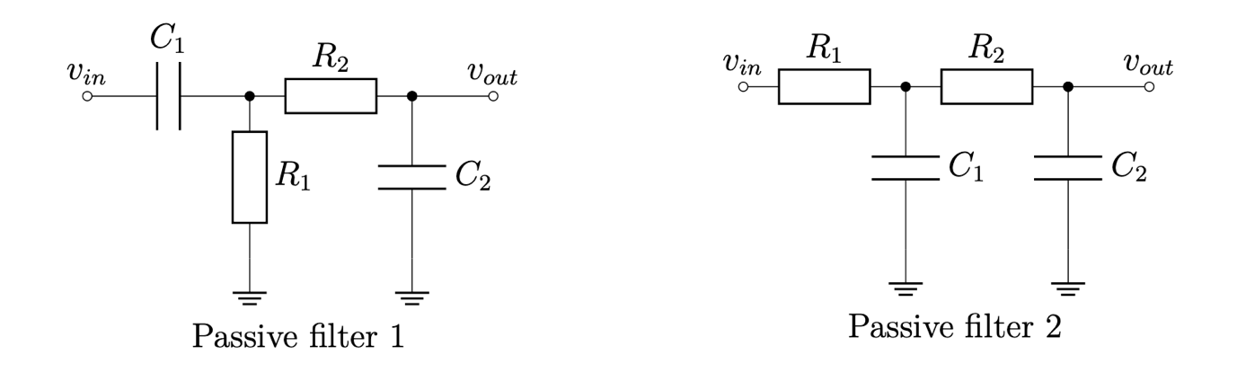
Figure 12: Topology of 2nd order high and low passive filters.
When analysing the passive filters in Figure 12, the transfer functions were not given, but they do not need to be considered as the topology of the circuit alone can be used to decipher the filter type. The first passive filter starts at the input and travels through the capacitor first, with the resistor going to ground. Capacitors direct the higher frequencies through the circuit, so this setup allows for high frequencies to be outputted, making this a high pass filter. The second passive filter begins with a resistor from the input, with both capacitors directing the higher frequencies to ground, only letting lower frequencies through, thus being a low pass filter. The cut-off frequency for the passive filters will result in two poles for the frequency to enter or avoid. This uses the formula:
$$f_{0}=\frac{1}{2πRC}$$
in its basic form for each RC₁ and RC₂.

Section 3.3.2. Analysis of Active Filters
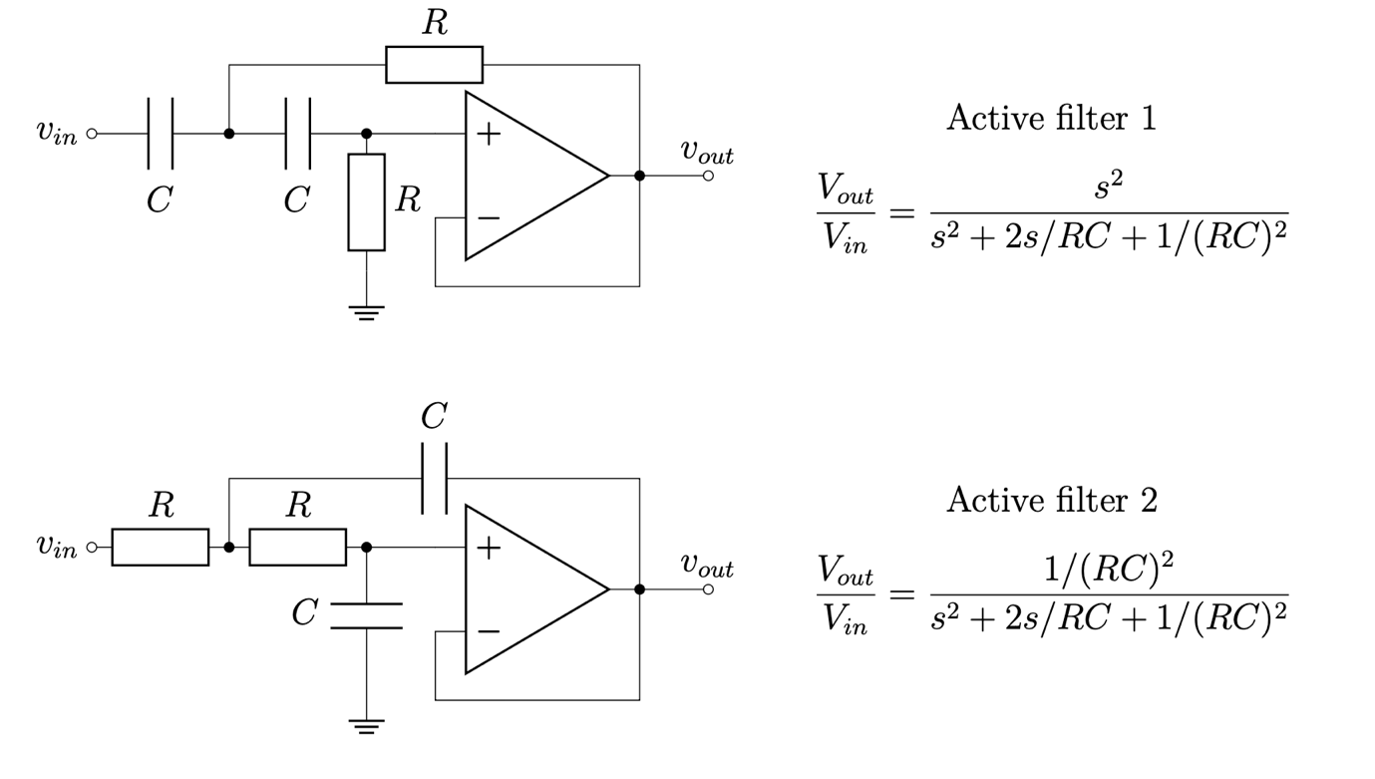
Figure 13: Topology of 2nd order high and low active filters with matching Laplace functions.
For the active filters in Figure 13, the transfer functions were provided, so the type of filter can be found by using their layout. In steady state sinusoidal analysis, the complex frequency variable is equal to:
$$s=jω$$
Depending on how much DC travels to the output determines whether it is a low or high pass filter. For the first active filter, when:

$$s=0≈H\left(0\right)=\frac{0}{{\left(RC\right)}^{2}}=0$$

DC is blocked so high frequencies pass through, making it a high pass filter. While for the second active filter, when:
$$s=0≈H\left(0\right)=\frac{\frac{1}{{\left(RC\right)}^{2}}}{{\left(RC\right)}^{2}}≠0$$

So low frequencies pass through, making it a low pass filter. For active filters, there is only one cut-off frequency, where all the capacitors are the same and all the resistors are the same. For the cut-off frequency, it uses the same formula:
$$f_{0}=\frac{1}{2πRC}$$

Section 3.3.3. Filter Selection and Justification

From Figure 11, all useful signals are situated from 0 Hz up to 100 Hz, while unnecessary noise is above 200 Hz. For the active filters, the cut-off frequency was at 194 Hz, while the passive filters had a cut-off frequency at 13.3 Hz and 33.9 Hz. The first active and passive filters are both high pass filters, so they will only allow frequencies above 194 Hz and 33.9 Hz respectively, thus removing the useful signal. The second passive filter has a strong emphasis on frequencies between 13.3 Hz and 33.9 Hz and has the potential to remove any useful signal outside of that section (between 33.9 Hz and 100 Hz). Meanwhile the second active filter allows all frequencies up to 194 Hz, removing any frequencies high, allowing it to retain all the important detail at the lower frequencies, making it the optimum filter.

Table 2 – Comparison of the four candidate filters against the signal bandwidth (0–100 Hz) and noise band (> 200 Hz).
Filter | Type | Cut-off freq. | Selected? | Rationale
Passive 1 | High-pass | 13.3 Hz, 33.9 Hz | No | Passes only frequencies above 33.9 Hz, removing the signal’s low-frequency content.
Passive 2 | Low-pass | 13.3 Hz, 33.9 Hz | No | Cut-offs are well below the 100 Hz signal band; useful content between 33.9–100 Hz is attenuated.
Active 1 | High-pass | 194 Hz | No | Blocks DC and low frequencies, removing the bulk of the image signal energy.
Active 2 | Low-pass | 194 Hz | Yes | Preserves the full 0–100 Hz signal band and attenuates noise above 200 Hz; chosen filter.

Section 3.4. Removing Noise to Clean the Image Signal
Now that the filter has been chosen, it can be applied to the image signal to clean the noise, making it clearer. To do this, the variables of R and C were implemented, then using the MATLAB format for the transfer function, it was split into the numerator and the denominator as seen in the below code:
R = 820;
C = 1e-6;

num = [1/(R*C)^2];
den = [1 2/(R*C) (1/(R*C)^2)];

To implement the transfer function to the image signal, it needs to be converted from an analogue transfer function to a digital one. H(s) is analogue because it models how a continuous time filter behaves, specifically with RC networks. The pixel stream is on a discrete-time signal, so the Laplace transform cannot be directly used and needs to be converted to the z-transform H(z) where discrete time systems are described (Oppenheim, 1999).

The bilinear transform is used to convert analogue to digital through the formula:
$$s=\frac{2}{T}\frac{1-z^{-1}}{1+z^{-1}}$$
Where T is the sampling period.

This maps the analogue poles into digital poles while preserving the overall filter shape. This also ensures that the digital filter will used the same cut-off frequency. The bilinear transform was used over other methods like impulse-invariance as this suffers from aliasing on filters that are not band-limited, with the bilinear avoiding this completely by mapping the entire s-axis (imaginary) onto the unit circle in the z-plane. This is at the cost of frequency warping, but because the cut off frequency is below the Nyquist frequency, 194 Hz to 500 Hz respectively, the warping effect is safely ignored.

The function uses the numerator, denominator and to convert into separate a and b variables that MATLAB can read. These variables are put through the filter function to clean the noisy image, which can be seen in the below code:
[b, a] = bilinear(num, den, fs);

Image1_filtered = filter(b, a, Image1);

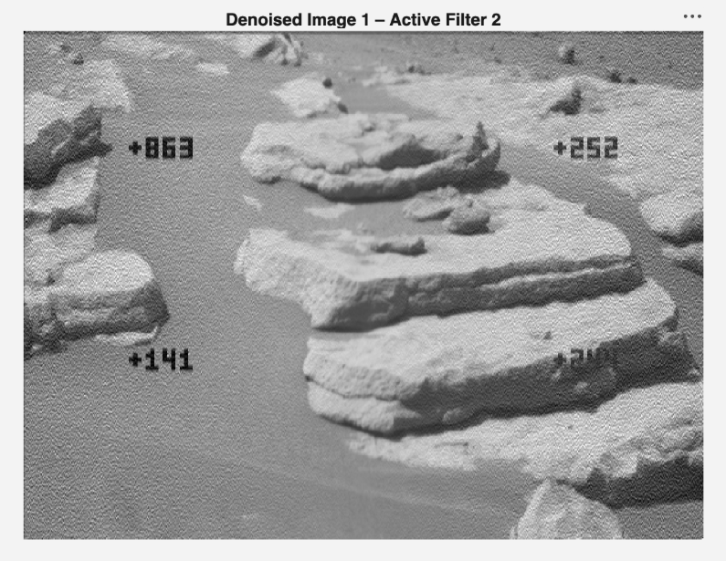
Figure 14: Cleaned received image of first candidate landing site after de-noising.

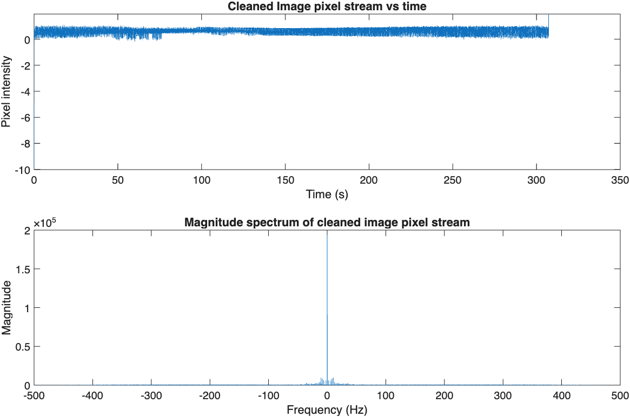
Figure 15: Time and Frequency domains of the signal for Image1 after de-noising.
The signal was reshaped and displayed in Figure 14, showing the clean version of the image. This is a big improvement as now the coordinates can be clearly read from the image, and the landscape can be interpreted to see where a good landing site would be for the astronauts. As seen in Figure 15, the pixel stream is much more compact, with the large swings of intensity up to 5 dropping down below 1 and the signal is much more consistent and even compared to the larger spikes at either end. The magnitude spectrum broadband floor is completely flat, successfully removing all the high frequency energy and leaving the smooth structure of the lower frequencies.

Section 3.5. Using Clean Image Signal to Deduce Final Landing Site

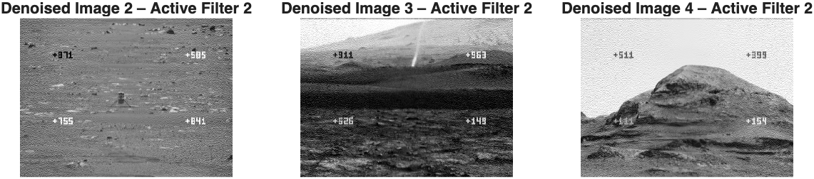
Figure 16: Cleaned received image of the 3 remaining candidate landing sites after de-noising.
Knowing that the filter works correctly, the same process has been applied to the rest of the images as seen in Figure 16. The criteria for choosing a suitable landing site will come under 6 mandatory requirements respectively: Smooth and flat terrain to avoid tipping or damage during landing, low rock abundance to prevent leg or wheel damage, gentle slopes for safe descent, safe elevation for atmospheric braking, acceptable ellipse size for landing uncertainty footprint (must fit within safe terrain), and favourable atmospheric conditions including winds, dust and density (Golombek, 2021). Images 1 and 4 did not satisfy 3 out of the 6 conditions immediately as they looked very rocky, high, and not on flat terrain. Image 3 satisfied 3 conditions but was removed as the terrain looked very uneven and there appears to be a crash-landed asteroid letting off smoke in the hills that could potentially change the atmospheric conditions. Stereoscopic data would provide better elevation data, making it easier to decipher a good landing area. The only appropriate landing site would be Image 2, satisfying at least 5 of the 6 conditions as it is in the middle of a plain, smooth terrain with no elevation and only small rocks, with an example shuttle proving it is safe to land in the image. Further research would be needed and time of the landing to know if the weather conditions would be satisfactory. The final recommendation for the MARS-242 landing site for the crew will be Image 2.

Conclusion

By integrating the subsystems developed throughout this project: demodulation, controls, and image processing, it can be concluded that this investigation successfully implemented the desired systems. These architectures effectively denoised and equalised audio signals from a multiplexed channel, applied control theory concepts to regulate the yaw angle of a servo motor, and filtered and processed images from the Mars rover. Ultimately, these components form a robust communications and control framework capable of guiding BASA’s mission to Mars.

Reflection
  - Group member 1: Krystian Rozanski
Demonstration of Concepts
My main task within this assignment was to design and implement Section 1, where I analysed how channel transfer functions and additive noise distort multiplexed audio signals within a space-environment simulation. To demultiplex and demodulate the five distinct audio channels, I applied my understanding of frequency-domain analysis to deduce carrier frequencies and bandwidths, executing this efficiently in MATLAB using a for loop alongside bandpass and lowpass filtering. When initial testing revealed heavy signal attenuation and inaudibility, I applied Linear Time-Invariant (LTI) system theory to diagnose the channel's frequency-dependent distortion. I extracted the channel's impulse response by stimulating it with a discrete Dirac delta function, transforming it into the transfer function $H(f)$ via the Fast Fourier Transform (FFT). To reverse the channel's distortion without causing catastrophic noise explosion where $H(f)→0$, I implemented a regularised zero-forcing equaliser using a stabilization parameter $ε$ and complex conjugates to correct phase anomalies. Finally, I isolated the remaining single-tonal sinusoidal noise interferences.
By treating these spikes as Dirac deltas in the frequency domain, I used MATLAB's abs and angle functions to extract their precise amplitudes and phases, allowing me to systematically subtract the noise components in the time domain. This task significantly deepened my practical mastery of signal processing theory and core MATLAB utilities, specifically fft, ifft, fftshift, abs, angle, bandpass, and lowpass.
Professional Discussion
Further exploration of this subsystem highlighted to me the critical importance of utilizing two-sided magnitude spectrums when deducing carrier frequencies and signal bandwidths. Initially, I utilized a one-sided magnitude spectrum under the mistaken assumption that the negative frequency domain was merely a redundant reflection. However, I now understand that in modulation and demodulation systems, frequency translation shifts both positive and negative frequency components. By neglecting the negative spectrum, I inadvertently caused spectral folding (aliasing) and overlapping in the positive region. This shifted my centre frequencies, distorted the bandwidths, and caused severe frequency-dependent attenuation, a diagnostic insight that directly explains why my demodulated audio in Section 2.7 of Assignment 1 suffered from distinct frequency attenuation.
Beyond frequency-domain visualization, this project significantly deepened my personal understanding of mathematical channel inversion and phase compensation. I learned that because a channel's transfer function $H(f)$ is complex, it introduces not only amplitude attenuation but also frequency-dependent phase distortion. When I investigated a standard zero-forcing equaliser, I discovered a critical engineering vulnerability: simply dividing by $H\left(f\right)$causes catastrophic noise enhancement at frequencies where the channel response approaches zero $(H\left(f\right)→0)$. Mastering the implementation of a regularised zero-forcing equaliser taught me how to circumvent this by using a stabilization parameter $(ε)$ to keep the noise floor stable. Furthermore, learning to utilize the complex conjugate of the transfer function $conj\{H\left(f\right)\}$ demonstrated to me how to mathematically neutralize phase anomalies while preserving the integrity of the signal's amplitude.
Reflecting on what I would do differently in future projects, I recognize that my current model relies too heavily on built-in MATLAB functions, which simplify the design by simulating ideal, brick-wall filters and lossless, linear modulation. In a real-world scenario, these components introduce severe physical impairments like amplifier non-linearities, phase noise, and thermal channel losses. To transition my work into a more robust and scalable architecture, I would shift away from ideal simulations, incorporate non-ideal hardware component modelling, and personally develop an adaptive estimation algorithm to actively rectify practical hardware and propagation losses.
Finally, Section 1.4 outlines a potential future improvement: integrating a Wiener filter for equalization, which preliminary research suggests would be highly effective for this model. However, because the noise power spectral density was outside the current scope, this implementation was left for future work.

  - Group member 2: Dylan Suhr
Demonstration of Concepts
In completing Section 2, I demonstrated my understanding of Laplace domain modelling and closed loop control system design applied to a real electromechanical problem. Beginning with Exercise 2.1, I derived the open loop step response of the DC motor transfer function $G_{m}(s) = \frac{1}{s(s+0.5)}$ analytically by hand, applying partial fraction decomposition and the inverse Laplace transform to obtain the time domain expression $ψ_{out}=-4+2t+4e^{-0.5t}$. Recognising that the presence of a pure integrator pole at $s = 0$ produces an unbounded ramp response under a step input was a key conceptual insight and it directly explained why the open loop motor alone was insufficient to hold a constant camera angle. I then demonstrated my understanding of feedback control by deriving the closed loop transfer function $F\left(s\right)=\frac{1}{(s^{2}+0.5s+1)}$ , identifying it as a second order system with complex conjugate poles at $s = -0.25 ± j0.968$. From this, I extracted the natural frequency $ω_{n} = 1 rad/s$ and damping ratio $ζ = 0.25$, classifying the system as underdamped, and calculated the time to peak ($T_{P}$), settling time ($T_{s}$), and percentage overshoot %OS using the standard second order formulae. In Exercises 2.5 and 2.6, I extended this analysis to a gain compensated system, working backwards from the design constraint of a target peak time to determine the required $K_{fb}$ and $K_{fwd}$ values that simultaneously achieved the correct DC gain of $2π rad/V$ and met the motion blur specification. Throughout, I implemented and validated each stage in MATLAB using tf objects, the lsim function, and dual axis plotting with yyaxis, reinforcing the connection between mathematical theory and simulation output.
Professional Discussion
Completing Section 2 taught me several important lessons about both the technical and practical aspects of engineering problem solving. The most significant challenge I encountered was in Exercise 2.6, where I had to work backwards from a physical performance requirement when I was given the peak time constraint from the design brief and had to determine appropriate gain values. Initially, I attempted to tune the gains by trial and error through the MATLAB simulations in Exercise 2.5, which gave me a qualitative feel for how $K_{fb}$and $K_{fwd}$ each affected damping and natural frequency respectively, but it was only by returning to the second order system equations analytically that I could derive the exact values needed. This reinforced for me that simulation is a tool for verification, not substitution for mathematical understanding. I also encountered unexpected MATLAB specific difficulties, such as the y-axis function automatically colouring axis labels to match plotted lines, which required explicitly overriding both y-Axis colour properties, and a script error where unformatted comment lines were being interpreted as function calls. These debugging experiences highlighted the importance of thoroughly reading error messages and understanding how MATLAB interprets code before execution. If I were to approach this section again, I would spend more time in the early exercises carefully reading the MATLAB documentation for the functions I was using, as many of the issues I encountered midway through could have been avoided. I would also start the gain design in 2.6 algebraically from the outset rather than beginning with trial and error, as the systematic approach ultimately proved both faster and more reliable.

  - Group member 3: Jamie Fowler
Demonstration of Concepts
My task in this assignment was to evaluate Section 3, which involved removing noise from 2D vector images using Fourier analysis and second-order filters. Through understanding how MATLAB stores images as 1D pixel streams, I was able to identify how white noise affected the high frequency components of the image signal and relate this to the large pixel-intensity variations in the time domain. I was also able to identify the elevated broadband floor in the frequency domain. I developed significant confidence in applying the Laplace transform and understanding how the transfer function $H\left(s\right)$ attenuates unwanted noise when applied to the received signal. This highlighted the importance of selecting an appropriate filter and analysing its topology to determine whether it was suitable for the required frequency range. I also learned how to convert an analogue filter model into a digital implementation using the bilinear transform. This was essential in giving the discrete nature of the pixel stream. Finally, by validating the filter through both spectral analysis and visual inspection, I strengthened my understanding of how to spot and confirm that a signal-processing method is functioning intentionally.
Professional Discussion
Section 3 highlighted several areas where I could improve my engineering workflow, particularly how I approached unfamiliar signal processing problems. One of the earliest challenges I encountered was understanding how the images were stored within the variable. I initially attempted to interpret the output visually without confirming the underlying data structure, which led to confusion when all four images overlapped in the viewer. This experience showed me the importance of inspecting the data format before beginning analysis, avoiding assumptions about how signals are arranged.
I also relied heavily on trial and error when constructing the time and frequency domains, making it clear that I need to adapt to a more structured approach. A similar issue occurred when I was analysing the filters. At first, I tried to decipher the full transfer function of each filter directly, focusing on the algebra rather than the behaviour of the circuits. This approach was inefficient and made the task more complex than necessary. It was only when I examined the filter topology and cut-off frequencies of both passive and active designs that I realised I could determine each filter as low or high pass far more effectively. This taught me to prioritise conceptual understanding before diving into the equations.
Another improvement area was recognising the difference between continuous and discrete time systems. I initially attempted to apply the transfer function $H\left(s\right)$ directly to the pixel stream, not realising that it was analogue and the bilinear transform was needed to convert it into a digital filter. This mistake highlighted the importance of reviewing the theory before coding, as misunderstanding the domain of the system led to unnecessary debugging.
Moving forward, I will start each task by viewing the data structure, reviewing the theory of the system and selecting the most appropriate analytical technique before implementing code. This structured approach will reduce the trial and error I encountered and improve the efficiency and accuracy of my engineering work.

References
Collins, D. (2016). FAQ: What is settling time in a motor-driven servo system? Motioncontroltips.Com. https://www.motioncontroltips.com/faq-what-is-settling-time-in-a-motor-driven-servo-system/
Golombek, M. (2021, March 25). Mars Landing Site Selection. National Academy. https://www.nationalacademies.org/cdn/materials/9fba0ba5-5f34-44f2-8377-19236b312ec6?utm_source=copilot.com
Low Pass Filter - Passive RC Filter Tutorial. (2018, May 15). Basic Electronics Tutorials. https://www.electronics-tutorials.ws/filter/filter_2.html
MATLAB Help Center. (2026). Shift zero-frequency component to center of spectrum - MATLAB fftshift - MathWorks Australia. Au.mathworks.com. https://au.mathworks.com/help/matlab/ref/fftshift.html
Oppenheim, A. V., Schafer, R. W., & Buck, J. R. (1999). Discrete-time signal processing (2nd ed.). Prentice Hall.
Salehi, M. S., & Proakis, J. (2007). Digital Communications. McGraw-Hill Education.
Ogata, K., Columbus, B., New, I., San, Y., Upper, F., River, S., Cape, A., Dubai, T., Madrid, L., Munich, M., Montreal, P., Delhi, T., Sao, M., Sydney, P., Kong, H., Singapore, S., & Tokyo, T. (n.d.). Modern Control Engineering Fifth Edition. https://repositori.mypolycc.edu.my/bitstream/123456789/5089/1/Modern%20Control%20Engineering%20%285th%20Edition%29.%202010.%20%28Katsuhiko%20Ogata%29%20%28z-lib.org%29.pdf
2.1: System Poles and Zeros. (2020, June 21). Engineering LibreTexts. https://eng.libretexts.org/Bookshelves/Industrial_and_Systems_Engineering/Introduction_to_Control_Systems_(Iqbal)/02:_Transfer_Function_Models/2.01:_System_Poles_and_Zeros
Waliullah, G. M., Bala, D., Hena, M., Abdullah, M., & Hossain, M. (2020). Performance analysis of zero forcing and MMSE equalizer on MIMO system in wireless channel. Journal of Network and Information Security, 8(1-2), 19–25. https://doi.org/10.21275/art20178890
Zywno, M. (2019). A supplement to a first course in feedback control. Pressbooks. https://pressbooks.library.ryerson.ca/feedback/

‌

Appendix
Appendix 1 – MATLAB code for Section 1

Initialisation
clear all; close all;
load DataA2 audioMultiplexNoisy fs sid;
audiowrite('audioMultiplexNoisy.wav', audioMultiplexNoisy, fs);

Question 1.1 — Visualise the Received Multiplexed Signal
Compute the double-sided magnitude spectrum using fftshift so that DC sits at the centre of the frequency axis.
samples = length(audioMultiplexNoisy);
t = linspace(0, (samples-1)/fs, samples);
AudioMultiplexNoisy = fftshift(fft(audioMultiplexNoisy)) / samples;
f_double = linspace(-fs/2, fs/2, samples);

figure('Name','Q1.1 - Multiplexed Signal');
subplot(2,1,1);
plot(t, audioMultiplexNoisy);
xlabel('Time (s)'); ylabel('Amplitude');
title('Q1.1 - Multiplexed Audio: Time Domain');
subplot(2,1,2);
plot(f_double, abs(AudioMultiplexNoisy));
xlabel('Frequency (Hz)'); ylabel('|X(f)|');
title('Q1.1 - Multiplexed Audio: Two-Sided Magnitude Spectrum');

Question 1.2 — Initial Demultiplexing Using Nominal Carriers
Carrier a bandpass edges derived from Figure 1
carriers = [24230, 40100, 56060, 72050, 8280];
bp_edges = [22280 26180;
36505 43375;
53070 58730;
68720 74820;
2730 13830];

signals = cell(1,5);
% Apply demodulation system developed in Assignment 1 2.7
for k = 1:5
fc_k = carriers(k);
bandwidth = (bp_edges(k,2) - bp_edges(k,1)) / 2;
bp = bandpass(audioMultiplexNoisy, bp_edges(k,:), fs);
demod = bp .* cos(2*pi*fc_k*t);
sig = lowpass(demod, bandwidth, fs) * 2;
signals{k} = sig;
audiowrite(sprintf('signal%d.wav', k), sig, fs);
end

figure('Name','Q1.2 - Demultiplexed Signals');
for k = 1:5
Sig_k = fftshift(fft(signals{k})) / samples;
subplot(5,2,2*k-1);
plot(t, signals{k});
xlabel('Time (s)'); ylabel('Amplitude');
title(sprintf('Signal %d - Time Domain', k));
subplot(5,2,2*k);
plot(f_double, abs(Sig_k));
xlabel('Frequency (Hz)'); ylabel('|X(f)|');
title(sprintf('Signal %d - Frequency Domain', k));
end
sgtitle('Q1.2 - Demultiplexed Audio Signals');

Question 1.3 Estimate Channel Frequency Response H(f)
x_imp = [1, zeros(1, samples-1)]; % Dirac Function
h = channel(sid, x_imp, fs); % Modulation of the dirac function onto the channel
H_f = fft(h)/fs; % FFT of the step re

figure('Name','Q1.3 - Channel Response vs Multiplexed Spectrum');
yyaxis left
plot(f_double, abs(H_f));
ylabel('|H(f)| - Channel Magnitude Response');
yyaxis right
plot(f_double, abs(AudioMultiplexNoisy));
ylabel('|X_mux(f)| - Signal Magnitude');
xlabel('Frequency (Hz)');
title('Q1.3 - Channel Response H(f) Overlaid with Multiplexed Spectrum');
legend('|H(f)|','|X_mux(f)|');

Question 1.4 — Channel Equalisation via Wiener Filter
The received signal Y(f) = H(f) * X(f) + N(f), where X(f) is the original transmitted signal and N(f) is additive noise.
A Wiener (regularised inverse) filter is used to recover X(f): X_eq(f) = Y(f) * H*(f) / (H(f)^2 + epsilon^2) The equalised signal is normalised to 0.9 peak amplitude to prevent clipping in subsequent processing.
Y_f = fft(audioMultiplexNoisy);
epsilon = 0.01 * max(abs(H_f));
X_eq_f = Y_f .* conj(H_f) ./ (abs(H_f).^2 + epsilon^2);
audio_eq = real(ifft(X_eq_f));
audio_eq = audio_eq / max(abs(audio_eq)) * 0.9;

% Demodulate again for comparison
signals_eq = cell(1,5);
for k = 1:5
fc_k = carriers(k);
bandwidth = (bp_edges(k,2) - bp_edges(k,1)) / 2;
bp = bandpass(audio_eq, bp_edges(k,:), fs);
demod = bp .* cos(2*pi*fc_k*t);
sig_eq = lowpass(demod, bandwidth, fs) * 2;
signals_eq{k} = sig_eq;
audiowrite(sprintf('signal%d_eq.wav', k), sig_eq, fs);
end

Audio_eq_plot = fftshift(fft(audio_eq)) / samples;

figure('Name','Q1.4 - Equalised Multiplexed Signal');
subplot(2,1,1);
plot(t, audio_eq);
xlabel('Time (s)'); ylabel('Amplitude');
title('Q1.4 - Equalised Multiplexed Signal (Time Domain)');
subplot(2,1,2);
plot(f_double, abs(Audio_eq_plot));
xlabel('Frequency (Hz)'); ylabel('|X(f)|');
title('Q1.4 - Equalised Multiplexed Signal (Frequency Domain)');

Question 1.5 — Additive Noise Removal and Carrier Correction
Recomputing samples, FFT, and audio vector
samples_eq = length(audio_eq);
FFT_eq = fft(audio_eq) / samples_eq;
audio_eq_clean = audio_eq(:);

% Tone list — [frequency_Hz signal_index]
% Frequencies identified from dominant spikes in the equalised multiplexed
% spectrum, observed in Figure 1
tone_list = [26999, 42125, 53516, 69798, 10524];

% Subtract each tone by reconstructing it from its measured amplitude and
% phase, finding the amplitude and angle through substituting the bin into
% the FFT, then removing it from the time-domain equalised signal
for i = 1:length(tone_list)
f_tone = tone_list(i);
noisy_bin = round(f_tone * samples / fs) + 1;
A = 2 * abs(FFT_eq(noisy_bin));
phi = angle(FFT_eq(noisy_bin));
audio_eq_clean = audio_eq_clean - A * cos(2*pi*f_tone*t(:) + phi);
end

% Re-demodulate all 5 signals using corrected carriers and bandpass edges
signals_clean = cell(1,5);
for k = 1:5
fc_k = carriers(k);
bandwidth = (bp_edges(k,2) - bp_edges(k,1)) / 2;
bp = bandpass(audio_eq_clean, bp_edges(k,:), fs);
demod = bp .* cos(2*pi*fc_k*t(:));
sig_clean = lowpass(demod, bandwidth, fs) * 2;
signals_clean{k} = sig_clean;
audiowrite(sprintf('signal%d_clean.wav', k), sig_clean, fs);
end

Q1.5 Plots — All Signals Before and After Noise Removal
figure('Name','Q1.5 - All Signals Before vs After Noise Removal');
for k = 1:5
Sig_Eq = fftshift(fft(signals_eq{k})) / samples;
Sig_Clean = fftshift(fft(signals_clean{k})) / samples;

subplot(5,4, (k-1)*4 + 1);
plot(t, signals_eq{k});
xlabel('Time (s)'); ylabel('Amplitude');
title(sprintf('Signal %d equalised — Time', k));

subplot(5,4, (k-1)*4 + 2);
plot(f_double, abs(Sig_Eq));
xlabel('Frequency (Hz)'); ylabel('|X(f)|');
title(sprintf('Signal %d equalised — Freq', k));

subplot(5,4, (k-1)*4 + 3);
plot(t, signals_clean{k});
xlabel('Time (s)'); ylabel('Amplitude');
title(sprintf('Signal %d de-noised — Time', k));

subplot(5,4, (k-1)*4 + 4);
plot(f_double, abs(Sig_Clean));
xlabel('Frequency (Hz)'); ylabel('|X(f)|');
title(sprintf('Signal %d de-noised — Freq', k));
end
sgtitle('Q1.5 - All Signals: Equalised vs De-noised');
Published with MATLAB® R2025b

Appendix 2 – Section 1
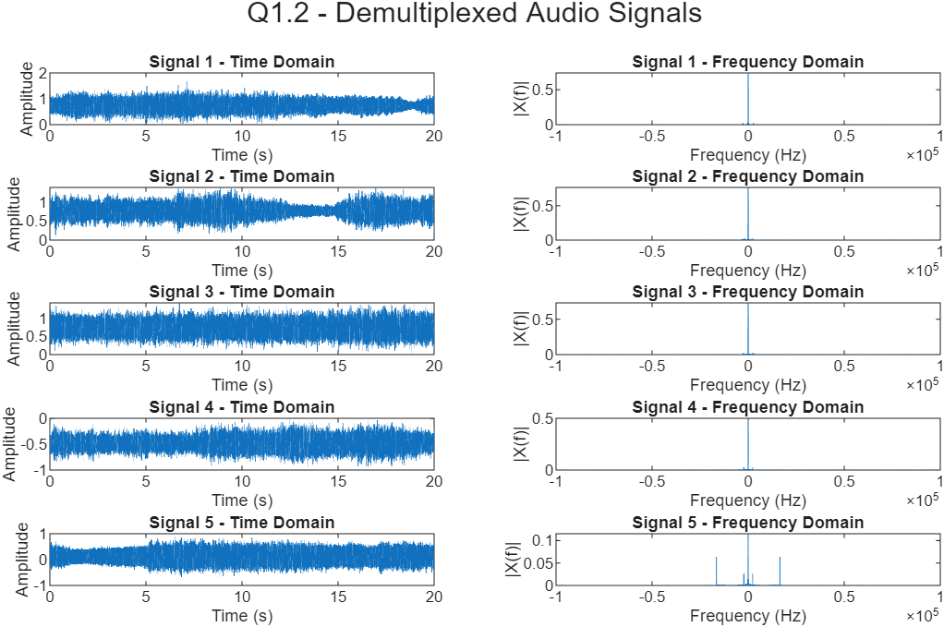
Initial Demultiplexed Signals
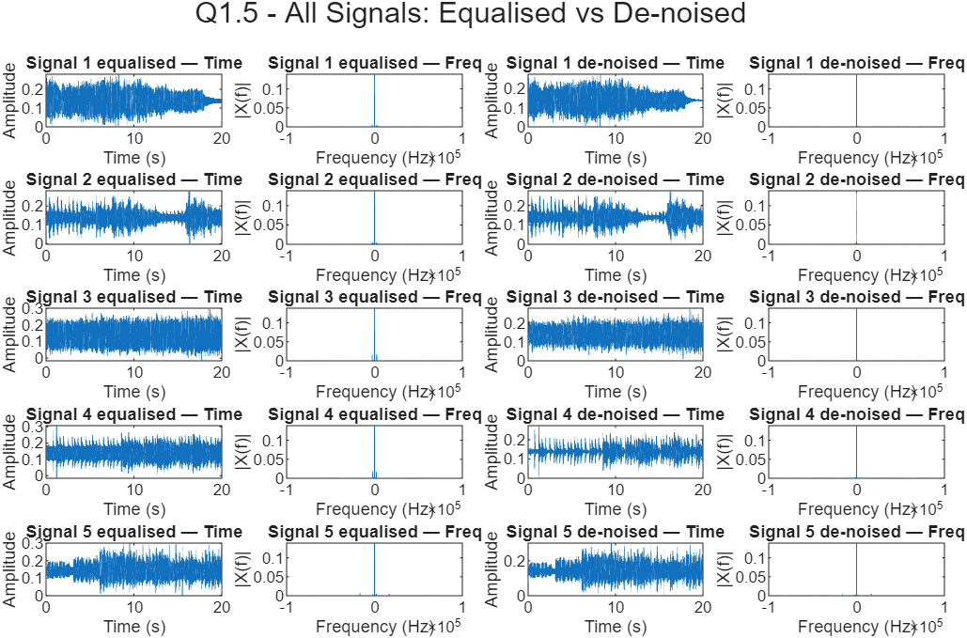
Equalised and Denoised Signals’ Frequency and Time domains

Appendix 3 – MATLAB Code for Section 2

Initialise workspace
clear all; close all;

% Begin writing your MATLAB solution below this line.

Ex 2.1
t = linspace(0, 25, 10000); % 10^4 samples

% Define transfer function Gm(s)
s = tf('s');
Km = 1;
alpha = 0.5;
Gm = Km / (s * (s + alpha));

vin_step = ones(size(t)); % Unit step input
psi_out = (-4) + (2*t) + (4*exp(-0.5*t)); % Step Response

figure(1);
yyaxis left; plot(t, psi_out, 'k'); ylabel('\psi_{out}(t) (rad)');
yyaxis right; plot(t, vin_step, 'r'); ylabel('V_{in}(t) (V)');
ax = gca; ax.YAxis(1).Color = 'k'; ax.YAxis(2).Color = 'k';
title('Open Loop Step Response'); xlabel('Time (s)');
legend('Step Response \psi_{out}(t)', 'Step Input v_{in}(t)');

Ex 2.3
K_pot = 1;
Hp = K_pot; % New transfer function
F = feedback(Gm, Hp); % F(s) feedback loop

disp('Poles of F(s):');
disp(pole(F));
disp('Order of F(s):');
disp(order(F));

psi_out_closed = lsim(F, vin_step, t);

figure(2);
yyaxis left; plot(t, psi_out_closed, 'k'); ylabel('\psi_{out}(t) (rad)');
yyaxis right; plot(t, vin_step, 'r'); ylabel('V_{in}(t) (V)');
ax = gca; ax.YAxis(1).Color = 'k'; ax.YAxis(2).Color = 'k';
yl = [min(psi_out_closed) - 0.1, max(psi_out_closed) + 0.1];
yyaxis left; ylim(yl); yyaxis right; ylim(yl);
title('Closed-Loop Step Response'); xlabel('Time (s)');
legend('Closed-Loop Response \psi_{out}(t)', 'Step Input v_{in}(t)');

Ex 2.5
Gain arrays
K_fb_vals = [0.1, 0.2, 0.5, 1, 2];
K_fwd_vals = [0.1, 0.2, 0.5, 1, 2];

% Vary K_fb while K_fwd = 1
figure (3); hold on;
for K_fb = K_fb_vals
fb_varied = feedback(1 * Gm, K_fb * Hp);
y1 = lsim(fb_varied, vin_step, t);
plot(t, y1, 'DisplayName', sprintf('K_{fb} = %.1f', K_fb));
end

title('Step Response: Varying K_fb (K_fwd = 1)');
xlabel('Time (s)');
ylabel('\psi_{out}(t) (rad)');
legend show;
hold off;

% Vary K_fwd while K_fb = 1
figure (4); hold on;
for K_fwd = K_fwd_vals
fwd_varied = feedback(K_fwd * Gm, 1 * Hp);
y2 = lsim(fwd_varied, vin_step, t);
plot(t, y2, 'DisplayName', sprintf('K_{fwd} = %.1f', K_fwd));
end

title('Step Response: Varying K_fwd (K_fb = 1)');
xlabel('Time (s)');
ylabel('\psi_{out}(t) (rad)');
legend show;
hold off;

Ex 2.6
Tp = 12; % Required peak time
Wn = sqrt((pi/Tp)^2 + 0.0625);
K_fb_final = 1 / (2*pi);
K_fwd_final = Wn^2 / K_fb_final;

% Final transfer function object
cameraTF = feedback(K_fwd_final * Gm, K_fb_final * Hp);

Ex 2.7
Input is 0-1V for 0-2pi rad so V = angle_rad / (2*pi) Convert angles to radians
startAngle = 30 * (pi/180);
endAngle = 210 * (pi/180);

% Convert angles to voltages
startVoltage = startAngle / (2*pi);
endVoltage = endAngle / (2*pi);

[startIm, finalIm] = cameraPan(startVoltage, endVoltage, cameraTF);

figure (5);
imshow(startIm);
title('Start Image (30°)');
imwrite(startIm, 'startImage.png');

figure (6);
imshow(finalIm);
title('Final Image (210°)');
imwrite(finalIm, 'finalImage.png');

% % Download Figures
% Save start image with title
figure;
imshow(startIm);
title('Start Image (30°)');
saveas(gcf, 'Figure_5A2.png');
close(gcf);

% Save final image with title
figure;
imshow(finalIm);
title('Final Image (210°)');
saveas(gcf, 'Figure_6A2.png');
close(gcf);

for i = 1:4
figure(i);
set(gcf, 'Color', 'w');
filename = sprintf('Figure_%dA2.png', i);
saveas(gcf, filename);
close(gcf);
end
Published with MATLAB® R2025b

Appendix 4 – MATLAB Code for Section 3
%%%% EGB242 Assignment 2, Section 3 %%
% This file is a template for your MATLAB solution to Section 3.
%
% Before starting to write code, generate your data with the ??? as
% described in the assignment task.

Initialise workspace
clear all; close all;
load DataA2 imagesReceived;

% Begin writing your MATLAB solution below this line.

3.1
Extract the first image from the imagesReceived matrix. Each row contains a full 1D pixel stream for one image.
Image1 = imagesReceived(1, :);
% Reshape the 1D pixel stream into a 480x640 2D grayscale image.
% This reconstructs the spatial layout of the image.
image1in2D = reshape(Image1, 480, 640);

% Display the noisy image to visually inspect the noise distribution.
figure;
imshow(image1in2D);
title('Noisy Image 1');

3.2
Sampling frequency of the received pixel stream (pixels per second).
fs = 1000;
% Number of samples (pixels) in the 1D image signal.
N = length(Image1);

% Create a time vector for plotting the pixel stream in the time domain.
t = (0:N-1) / fs;

% Create a frequency vector for FFT plotting, centred around 0 Hz.
f = linspace(-fs/2, fs/2, N);

% Compute the FFT of the image signal and shift it so DC is centred.
Image1_Recieved = fftshift(fft(Image1));

% Plot the time-domain pixel stream and its magnitude spectrum.
figure;
subplot(2,1,1);
plot(t, Image1);
xlabel('Time (s)');
ylabel('Pixel intensity');
title('Image pixel stream vs time');

subplot(2,1,2);
plot(f, abs(Image1_Recieved));
xlabel('Frequency (Hz)');
ylabel('Magnitude');
title('Magnitude spectrum of image pixel stream');

3.4
Define resistor and capacitor values for the selected active low-pass filter.
R = 820;
C = 1e-6;
RC = R * C;

% Define the numerator and denominator of the analogue transfer function H(s).
% This is a standard 2nd-order low-pass filter form.
num = 1/(R * C)^2;
den = [1 2/(R*C) (1/(R*C))^2];

% Create the analogue transfer function object (not used directly for filtering).
H = tf(num, den);

% Convert the analogue filter H(s) into a digital filter H(z)
% using the bilinear transform, preserving the cut-off frequency.
[b, a] = bilinear(num, den, fs);

% Apply the digital filter to the noisy image signal.
Image1_filtered = filter(b, a, Image1);

% Reshape the filtered 1D signal back into a 2D image.
Image1in2D_filtered = reshape(Image1_filtered, 480, 640);

% Display the denoised image.
figure;
imshow(Image1in2D_filtered);
title('Denoised Image 1 – Active Filter 2');

% Prepare frequency vector for the cleaned signal.
N_cleaned = length(Image1_filtered);
f_cleaned = linspace(-fs/2, fs/2, N_cleaned);

% Compute FFT of the filtered signal.
Image1Received_filtered = fftshift(fft(Image1_filtered));

% Plot the cleaned time-domain signal and magnitude spectrum.
figure;
subplot(2,1,1);
plot(t, Image1_filtered); hold on;
xlabel('Time (s)');
ylabel('Pixel intensity');
title('Cleaned Image pixel stream vs time');

subplot(2,1,2);
plot(f, abs(Image1Received_filtered));
xlabel('Frequency (Hz)');
ylabel('Magnitude');
title('Magnitude spectrum of cleaned image pixel stream');

3.5
Apply the same digital filter to the remaining images (2, 3, and 4).
% Image 2
Image2 = imagesReceived(2, :);
Image2_filtered = filter(b, a, Image2);
Image2in2D_filtered = reshape(Image2_filtered, 480, 640);

% Image 3
Image3 = imagesReceived(3, :);
Image3_filtered = filter(b, a, Image3);
Image3in2D_filtered = reshape(Image3_filtered, 480, 640);

% Image 4
Image4 = imagesReceived(4, :);
Image4_filtered = filter(b, a, Image4);
Image4in2D_filtered = reshape(Image4_filtered, 480, 640);

% Display all three cleaned images side-by-side for comparison.
figure;
subplot(1,3,1);
imshow(Image2in2D_filtered);
title('Denoised Image 2 – Active Filter 2');

subplot(1,3,2);
imshow(Image3in2D_filtered);
title('Denoised Image 3 – Active Filter 2');

subplot(1,3,3);
imshow(Image4in2D_filtered);
title('Denoised Image 4 – Active Filter 2');

% The best landing site from the images would be image 2 as it is a very
% flat area for the rover to land safely and explore without putting itself
% in danger of falling or heavy terrain.
Published with MATLAB® R2025b

Appendix 5 – Hand-working for Section 3.3
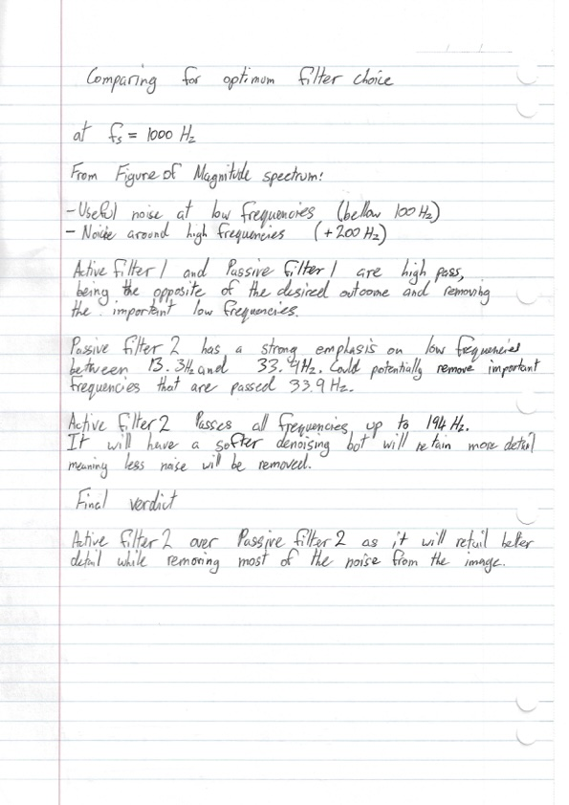
Hand working for Section 3.3. Part 1
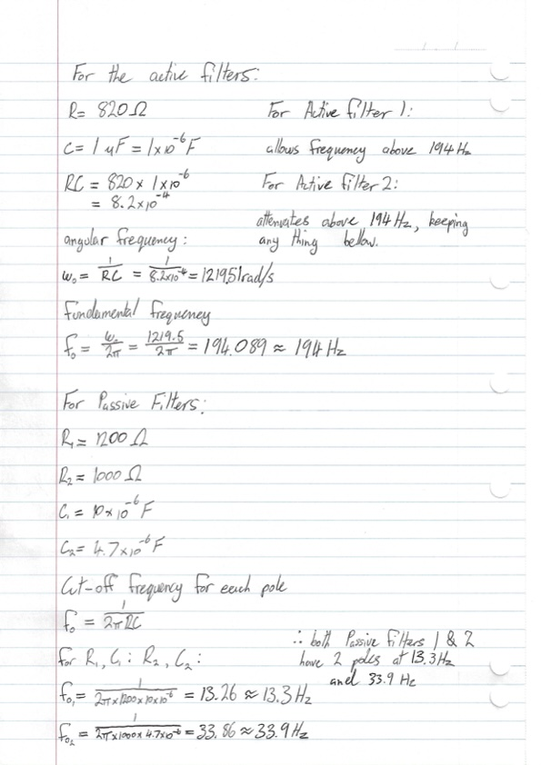
Hand working for Section 3.3. Part 2

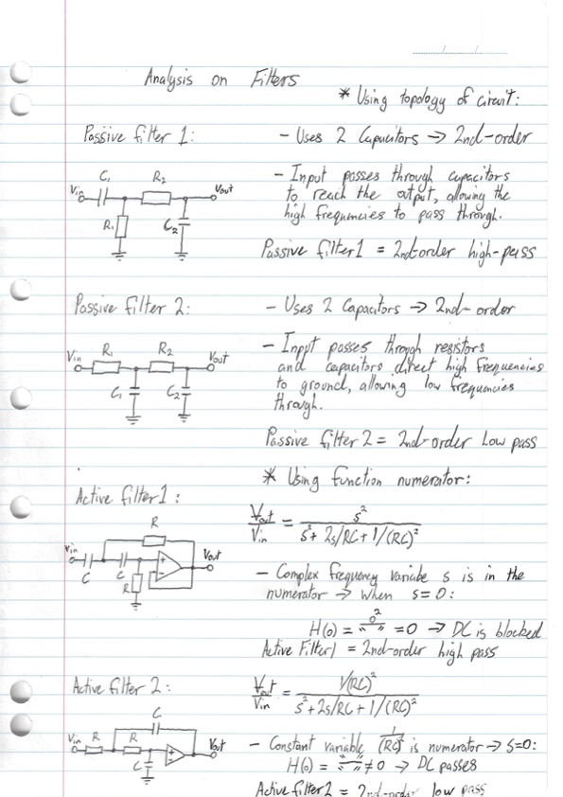
Hand working for Section 3.3. Part 3

Appendix 6 – Section 2 Handwritten Calculations

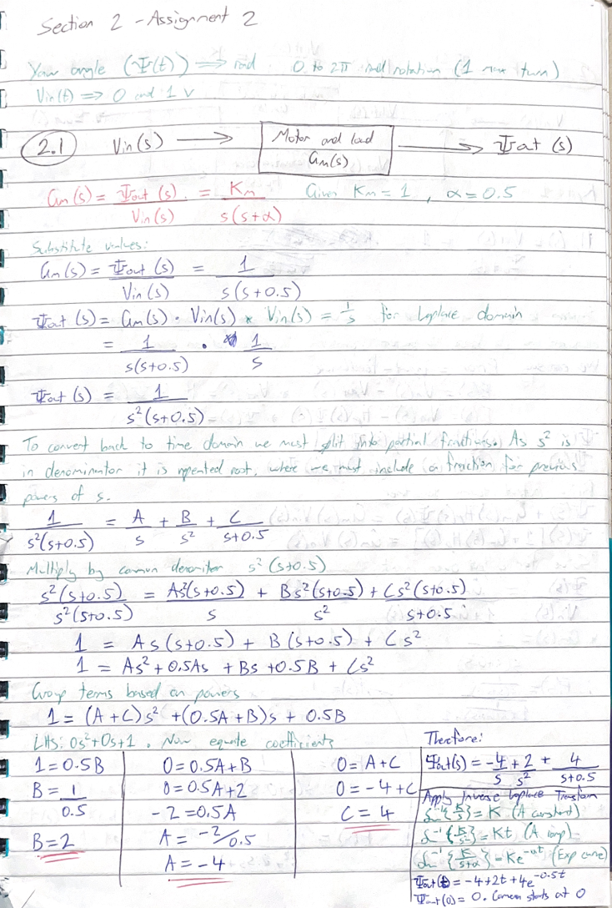
Hand working for Section 2 Part 1
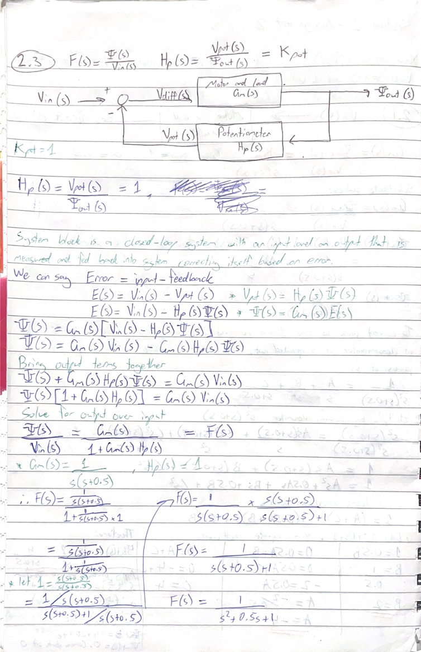
Hand Working for Section 2 Part 2
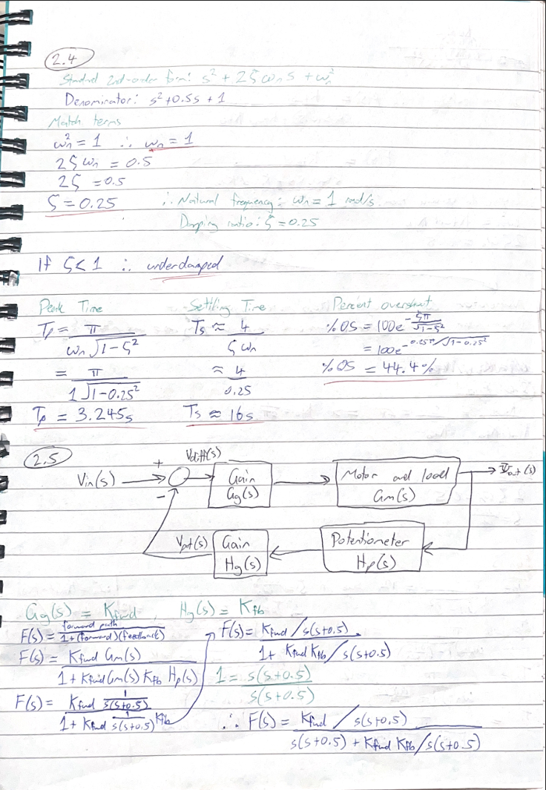
Hand working for Section 2 Part 3
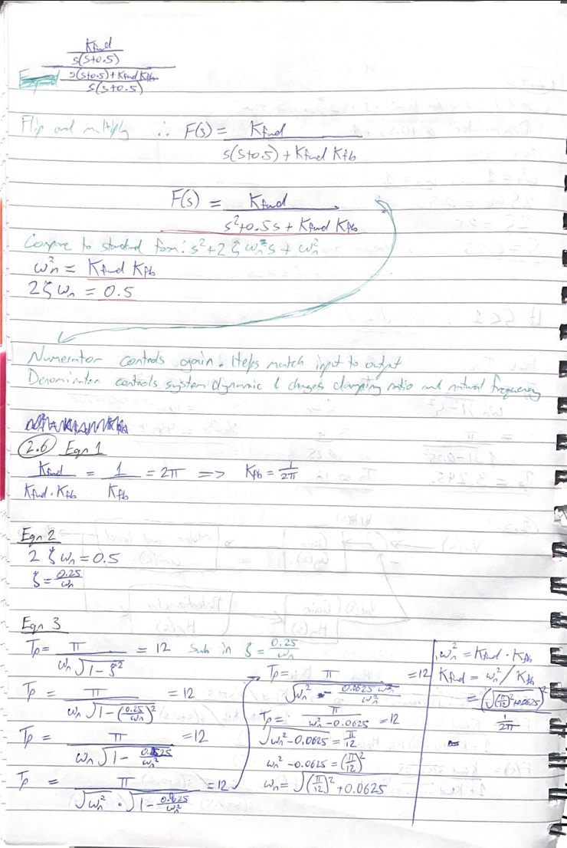
Hand Working for Section 2 Part 4

