Bike Share Programs

Krystin Sinclair

MS Student in Data Science, The George Washington University

NimaZahadat, Ph.D.

Professor of Data Science, The George Washington University

Abstract

Many cities have implemented a bike sharing system. The bikes can be used for daily commutes, touring a city, or exercise. There are different modes of thought on the rationale for bike share, from public health reasons to traffic and congestion mitigation. User perception of a bike sharing system benefits and negatives may impact the success of the system. Analysis has shown that where bike sharing has been implemented traffic has decreased, however it is unclear if there is an overall positive benefit to public health. There are various reasons to utilize bike share in the cities that they have been implemented in. Understanding how and why citizens and tourists are utilizing the bicycles will enable policy makers to properly promote and make changes to the system.

Introduction: Bike Share Programs

Urban planning and public transportation are important when it comes to the socio-economic stability of a city. A bike share can differ city by city, however a general definition can be found in the Institute for Transportation and Development’s The Bike-share Planning Guide which says “anyone can pick up a bike in one place and return it to another, making point-to-point, human powered transportation feasible” (Gauthier et al., 2014). Prices and rates to use the system depends on the city. In Washington DC the annual membership is only 85 dollars a year and all rides under 30 minutes are free (Capital Bikeshare Membership & Pass Options, 2017). For individuals with short commutes, this can be an inexpensive way to travel. A potential future analysis can be done on who uses DC Capital Bikeshare, why they use the service and where they go?

There is much research on bike commuting and bike share systems in cities around the world. Research covers topics in public health such as benefits of daily exercise and dangerous of riding without a helmet. There is also research on cycling to mitigate road congestion and lowering pollution. There are different pros and cons to bicycle sharing system in various cities. Cities cyclists’ numbers tend to change depending on weather, topography, type of cyclists, and how safe potential users view cycling in their city (Gauthier et al., 2014).

Literature Review and Research: Bike Share Programs

User perception impacts how people use a product and if they choose to use it at all. The bike share system is no exception. It is important to understand why people choose to cycle, to understand how to make a bike share system successful. Heinen, Maat, and Van Wee analyzed the Netherlands and if the work environment impacts the mode of transport taken by commuters. Employees that worked at offices which provide changing areas were more likely to bike to work. Even more correlated to bicycle commuting was the presence of bike storage space (Heinen, Maat, & Van Wee, 2012). This study and survey was not based on a bike share scheme. Potentially if a system were created, then the need for storage would no longer be necessary and more people would be able to commute via bicycle.

Before implementing a bike share system in an urban area, it is important for policymakers to understand what the users want from the system. Damant-Sirois, Grimsrud, and El-Geneidy performed an analysis that showcased several types of cyclists. They determined that there were four categories:dedicated cyclists, path-using cyclists, fair-weather utilitarians, and leisure cyclists. Each of these cyclists’ groups would have different wants and needs from a cycling program. The dedicated cyclists would cycle the most frequently, they tend to own their own bikes and are aware of bicycle safety, such as wearing a helmet and using a bike lane if offered. The path-using and fair-weather utilitarian cyclists might be convinced to use the bike share system to commute, if the conditions are right. This means that the fair-weather cyclists would tend to only use the system when it isn't raining and they had a bike path to use. The leisure cyclists would tend not to use the bicycles to commute, but might use them for exercise purposes and would most likely only use bicycles on warm sunny days and would prefer bike to segregate the bikes from the cars(Damant-Sirois, Grimsrud, & El-Geneidy, 2014)

The success of a bike share system does not only differ by the typology of bicyclists in the area, but by other aspects of the city as well. The weather of a city can affect the users’ perception of commuting via bicycle. According to Noland and Gebhardt, cold, precipitation, humidity and heat affect bicycle usage. Statistical models based on hourly weather data and hourly bike usage data show that for bike stations near metro stops, during hours of operation, the metro is a backup method for transportation. Specifically, during rain showers bikes are docked and riders favor the metro (Gebhardt & Noland, 2014). Not only does the weather affect how people view the bicycles; there is also a social interaction effect on city bicycle usage. A study by Haworth, Fishman and Washington found that the main reasons that pedestrians choose to bike is accessibility, safety and weather. Interestingly, accessibility seemed to be linked with spontaneity. Therefore, the need to sign up or go through a registration process may be a deterrent in the use of the bicycles. The ease of access to bicycles is a major reason that users use it (Haworth, Fishman & Washington, 2012).

Besides the access to a bicycle, safety is another reason that makes users hesitant to join a bike share program. One article suggests that the best way to get more people to cycle is to change the roads. If the road were safer for bicyclists, by creating more bike lanes or by lowering speed limits, then consumers may be more likely to try cycling. The same article discusses that there are many perceived benefits, such as physical health, less pollution and even the ability to avoid traffic or crowded public transit. However, the fear associated with road safety may deter potential users; which suggests that society views bikes as having many benefits for daily lives, but there is a fear attached with commuting/traveling via bike versus bus or car (Macmillan, et. al., 2014). A study by Buehler and Pucher also found that many city inhabitants feel unsafe biking in traffic and would prefer to bike in a segregatedbike lane. Their analysis differed from many other studies by suggesting that weather, public transportation and terrain were not the most crucial factors on cyclists’ decision to commute by bike. They found that the stronger correlation came from safety of bicycling, price of gas and number of cars in the city, distance to travel and number of students in the city. This was an analysis based on bicyclist commuters who own their own bikes, and not from users of a bike share system provided by the city (Buehler &Pucher, 2011). Potentially the two demographics have differing opinions or perceptions of the gains from bicycle usage

There are multiple reasons why consumers choose to use the bike share: the idea of not causing pollution, and not sitting in traffic. Hamilton and Wichman performed a case study on DC discovered that there was a 2-3% decrease in traffic congestion in certain neighborhoods. However, the same case study did not find any research to support that the increase in bike usage decreases local pollution (Hamilton & Wichman, 2015). The ides of it decreasing pollution stems from an assumption that individual drivers will choose to bike instead. Ma, Liu and Erdogan analyzed usage of the DC metro with the DC capital bike share program to see if the bicyclists were using the bike share as a substitute for the metro. A regression analysis showed a positive correlation between metro riders and capital bike sharers. This suggests that the bike share program works more as a compliment than a substitute to the metro system (Ma, Liu & Erdogan, 2015). Bao, Liu, Xu and Wang also found that bike sharing and the metro system worked in compliment with their analysis on New York City’s Citi Bike. This study analyzed New York City smart card data to understand the points of interest that cyclists travel to using the bike share. They found out that going out for food or shopping is one of the main reasons for using the bikes. The next highest-rankingusage was to commute to another form of public transportation. They also found that those that use the bike share system to get to a subway or bus stop, tend to do so during the typical rush hour times of day. Therefore, it can be assessed that commuting to work is a large part of the bike share system. And that the bike share system works in complement with other forms of public transportation (Bao, Liu, Xu, & Wang, 2017).

The knowledge of why people use bicycles helps urban planners to know where to place docking stations. Schoner and Levison viewed the bicycles network using linear regression models to discover key factors in bicycling commuting. The model determined that connectivity and directness were the most important variables. These findings can influence policy makers when they create new docking stations (Schoner & Levison, 2014). Sakar, Lathia and Mascolo compared cycling patterns across cities. This article sites the difference between supply and demand as the greatest shortfall of the bike share system in the cities that were studied. These researchers developed a forecasting algorithm based on city size, geography and bike share usage to determine how many bicycles will be at a given station (Sakar, Lathia & Mascolo, 2015). Understanding traffic patterns in the city also allows for better placement and maintenance of bike shares. A separate study by Vogel, Grieser and Mattfield viewed the intricate bike share docking system to see how it could improve the distribution of bikes based on data mining traffic information. They proposed that strategic planning and placement of the location of the bike docks are the key to proper distribution of bicycles throughout the city even though the bicycles are always in flux (Vogel, Grieser & Mattfield, 2011).

The location of bicycles is important because consumers want ease of use. Consumers also choose to cycle for their physical health. However, there are dangers to riding bicycles. Many articles discussed users not feeling secure when riding alongsidetraffic and preferred bike lanes or lower speed limits. Helmets are another way that cyclists can protect themselves.Zanotto and Winters conducted research on use of helmets in Vancouver after each bicycle was equipped with a free helmet. They surveyed adults at various bike share docking stations over the city. They used a regression analysis based on the survey data which found that 64% of bike share users used a helmet. They concluded that helmet usage is higher in cities with all aged helmet legislation, and higher with people who use their own personal bike.Bike share systems can increase helmet usage by providing helmets (Zanotto& Winters, 2017). Graves, Pless, Moore, Nathens, Hunte and Rivara researched head injuries by comparing bike sharing programs that offered helmets and those that did not. They found that the proportion of head related injuries from bike share injuries is 50% higher where bike helmets were not offered,this suggests that helmets should be available with the rentable bikes (Graves, Pless, Moore, Nathens, Hunte & Rivara, 2014)

Key Findings: Bike Share Programs

There are some negatives to the bike share system. Many people that participate do not have their own helmet. Some cities provide complementaryhelmets with the bikes, but many do not. There are dangers to bicycling in a city without a helmet. Many people do not feel safe enough to bike with city traffic in general. In DC there are very few bike lanes and bike routes. The cyclists are in regular traffic with cars. This can deter people from using a bike to get around. There is also some difficulty with where to put the docks; making sure that there are bikes in locations that need them is a job that requires both space, knowledge and to ensure safety of the bicycles. There are no docks in some areas of the city. Distance to a dock, from a home, can make people not use the bikes. Dock locations that are far from a person’s eventual destination can be a problem. Another issue is traffic of the bicycles. The bikes are always moving and there is a supply and demand issue at different areas of the city and various times of the day. The inability to find a bike near you or the inability to find an open dock can deter users.

There are many benefits to a capital bike share system. Biking to work is a wonderful way for individuals to attain physical activity in their daily lives. Biking to work is also better for the environment than driving a car. Biking to work does help alleviate traffic congestion on the roads. The idea of urban bicycle sharing allows more people access to bicycles. They no longer have to worry about where to safely store the bicycle. Overall the benefits of implementing a bike share system are worth the effort. It may be worth the extra effort of including helmets with the bike rentals and updating the city with bike lanes where possible, for an all-around better cycling experience.

There is a gap in the research on D.C.Capital BikeShare transit data and identifying the purposes of the trips. This analysis can identify if more trips are for daily commuting or for recreational purposes. Potentially information on trips weekend versus on a weekday could provide insight into the main reason the bicycles are used; as well as if there is an increase during typical rush hour times. It could also be useful to know if mostly members or non-members use the system. This will provide insights into who uses these bikes and why they use them.

Data and Datasets: Bike Share Programs

D.C. Capital BikeShare makes the transit data publicly available by quarter. The 2016 and 2017 datasets will be used for this analysis. All quarters of 2017 include 3,754,444 observations. All quarters of 2016 include 3,333,994 observations. The column contained in these datasets are bike number, member type, start date, start station, start station number, duration, end date, end station, and end station number. The date was in the format of Year/Month/Day Hour: Minute: Second. Each row of data provides information on one trip. Python was used for data analysis and visualization. The specifics of the datetime column were extracted to be analyzed separately. Figure 1 below shows the first five observations of the 2016 data set.

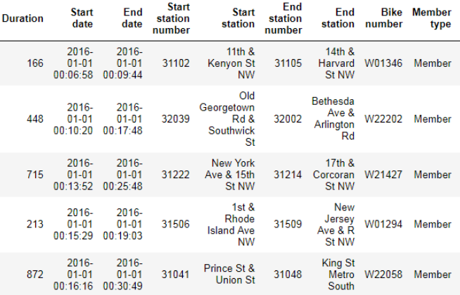

Figure 1.

There are some limitations to this data. It does not include any personal information

about the riders. There is no information regarding demographics or safety. These columns give no indication of any form of safety measure taken, such as wearing a helmet. It also does not provide information about the specifics of where the rider is going to and from. Therefore, the exact nature and purpose of the trip can only be inferred.

Data Analysis: Bike Share Programs

The data can be analyzed to understand who uses the bikes and why. The analysis dives into the number of members and the patterns and trends associated with when the trips are occurring. Overall, there are more trips in 2017 than in 2016. This may be a positive sign towards the usefulness of the program. As time moves on more trips can reflect positive perception from the public.

Membership type is an important part of the dataset. It provides insight into if the bicyclists are repeat users. D.C. Capital BikeShare has two types of membership. There is a 30-day membership and an annual membership (Capital Bikeshare Membership & Pass Options, 2017). There is no differentiation in the dataset to tell which type of membership the bicyclists have. For both 2016 and 2017 approximately three quarters of all trips are by bicyclists with memberships. This shows that most of the use of the bicycles is by people who have memberships. Therefore, they would have more accessibility to the bicycles and potentially use them more often. It could also mean that the shared bicycle program is used more by those that work and/or live in D.C. than byshort term visitors.

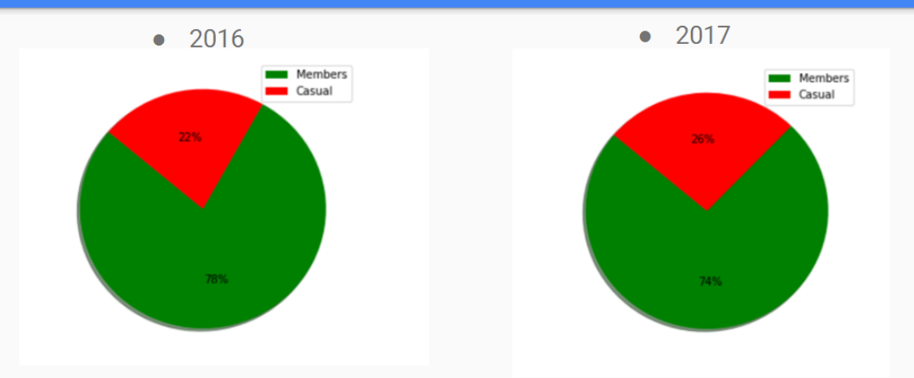

Figure 2

Another metric that can be used to gain insight into the working of the bike sharing system is duration of the trips. For both years the longest trips were about 1-day and the shortest were 1 minute. The average was 19 minutes for both years. This makes sense because the trips are at no additional cost if under thirty minutes. Also, this could be an indication, that people use the bikes to get that extra mile to work and/or home that the public transportation does not cover. The average trip duration is relatively short, which may be an indication that the bike share program is not being primarily used for physical exercise or for recreation purposes. This could indicate that it is being used as part of the daily commute.

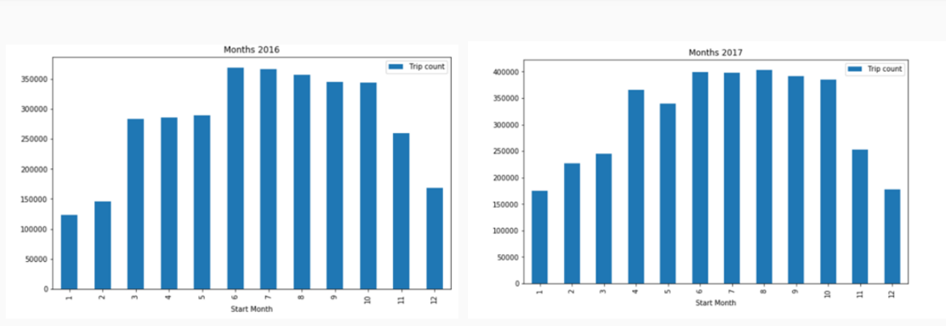There is a seasonality effect on bicycle usage. Not surprisingly, the nicer weather months have more trips. The winter shows the least number of trips, as it turns to spring the trip quantity increases, and hits its peak in the summer, and then in autumn in begins to decline. This cyclical pattern occurs in both 2016 and 2017. According to prior research, when the day is not considered to be fair-weathered many riders opt to take other forms of transportation to avoid the outdoors. Cold is considered one of the weather aspects that convinces cyclists to choose against riding a bicycle (Gebhardt & Noland, 2014). This trend also appears to exist in D.C. based on bike share program trips during the past two years. Figure 3 below shows this apparent trend.

Figure 3

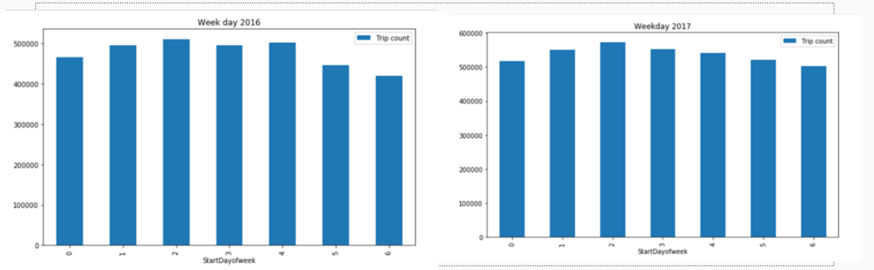The day of week appears to have less significance on cyclist’s decision-making. The graphs are using the python default of 0 through 6 to represent the days of the week. Zero is Monday. One is Tuesday and it continues as such until 6 which represents Sunday. The most apparent pattern that exists in both years is an increase on the first few days of the week, with a peak on Wednesday. Then there seems to be a slight decrease to plateau until Saturday. The weekend is then slightly below the weekdays. This pattern is not particularly strong. The difference in trip number from day to day is a very small percentage increase or decrease. This is interesting because no significant difference between days of the week, specifically weekday and weekends, shows that the bicycles are not only used for the typical 9-5 job commuting. They must be used for urban travel of differing purposes. Figure 4 below shows for both years the total number of trips by day of the week.

Figure 4

There are hourly trends. These trends seem to follow that of typical rush hour. There are two peaks one around seven to nine am and a second between four and six pm. The evening rush hour has the highest peak.More research can be performed to understand this trend. Perhaps surveying work places and discovering if people tend to have more energy in the morning and after the work day is completed. Another possible reason for the evening peak, is that the bikes are also being used as a means of transport to get to after work social activities. In figure 5 below, the hourly trends are shown for 2016 and for 2017.

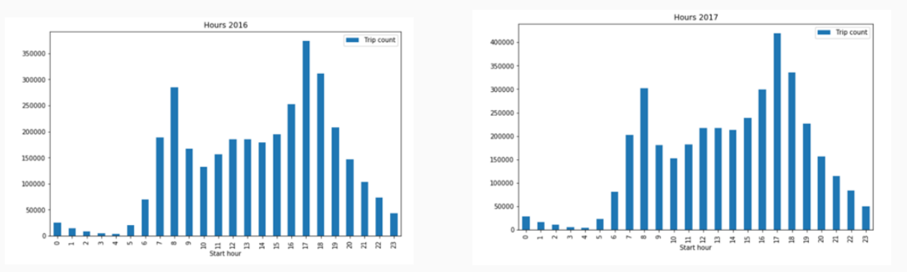Figure 5

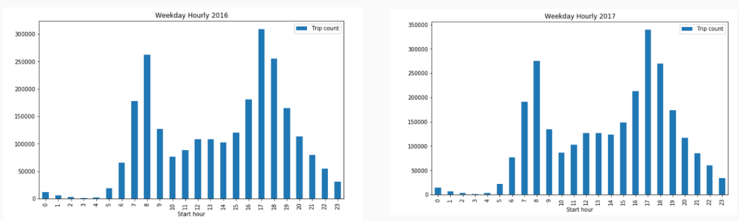Looking at the data hourly, just for the weekdays, the rush hour trend is obvious. Here the trends follow the same pattern for both 2016 and 2017. The highest peak is at the evening rush hour. According to a 2017 study of the New York City Citi Bike, the main reasons for using the bike share is to complete a commute that the public transit is not covering, or to get food and go shopping(Bao, Liu, Xu, & Wang, 2017). These are typical activities for after work hours. This reasoning could also exist in D.C. and would explain why the highest peak is of that timeframe. Figure 6, shown below, displays the hourly data for weekdays.

Figure 6

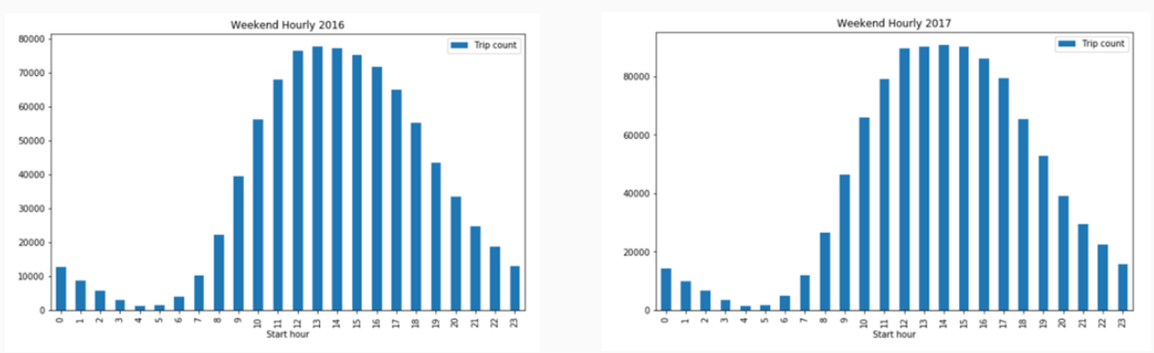Looking at weekend only hourly data, the trend is quite different from the weekday only hourly data. The trend is similar for both 2016 and 2017. There is one peak instead of two. The peak is around midafternoon. It is also plateaus for a longer stretch of time. This shows that in general in D.C. the traffic patterns differ on weekdays than weekends. Common knowledge would suggest that the weekends do not have rush hour times, because many schools and businesses are closed. This also suggests that the weekday pattern is due to the bicycles being used for the daily commute. Figure 7, shown below is graphical representation of 2016 and 2017 hourly data for weekends only.

Figure 7

Conclusions: Bike Share Programs

There have been many studies on the reasons for cycling and the usage of shared bikes. User perception has an impact on the success of a bike share program. Researchers found that bike shares do better in good weather and in cities with topography that is easy to ride on. They connect the already existing public transportation stations/stops. They are used by the cities commuting population as a different means of travel.Research on how the bikeshare systems are being used in one’s own city may provide urban planners with the information that they need to properly advocate for the correct ways to make improvements upon the system.

D.C. appears to operate in a similar fashion to these other cities where research has been compiled. The researched performed on New York City’s Citi Bike in 2017 showed that the bike share systems works in compliment with the other forms of public transit. Many commuters would use the bicycles to get that last bit of the journey completed to the office or home, that the bus or subway did not cover (Bao, Liu, Xu, & Wang, 2017). D. C. Capital BikeShare does appear to be used for daily commuting purposes. Most of the bicycle trips over 2016 and 2017 were from members of the programs, for both years it was about 75% of the bicycle trips were done by bicyclists with a membership. The alternative is to pay for single ride, 24-hour pass or a 3-day pass(Capital Bikeshare Membership & Pass Options, 2017). This has implications that the bicyclists using the shared bicycles are citizens of the city, instead of tourists. D.C. also had relatively low average duration, 19 minutes for both 2016 and 2017. This aligns with what other researchers have said about the bicycles being used to get that last mile that the metro or bus does not cover. Many trips are short ones. This may mean that is more likely to be used for commuting rather than exercise or recreation purposes. Finally, the key indicator that the bicycles are used by people who work in D.C. is that there is a huge trend that exists across the years where on weekdays a spike occurs during typical rush hour times. Therefore, it would make sense to conclude that the bikes may be used to get to and from work. This hourly pattern is not seen on weekends, increasing the strength of this claim. There clearly is a trend that leans towards daily commuting as a major part of its use.

D.C. Capital BikeShare does have similarities to other cities bike share systems. This transit data did show that the bikes are used during daily commutes. It is also used for general travel around a city, as much of the prior research suggests about various cities. This analysis did suggest that the average users are people who live or work in the city, and are not tourists.

Recommendations: Bike Share Programs

Future Research to increase knowledge of this subject and gain further understanding of the members of D.C. Capital BikeShare, would be essential before making any drastic changes, to how the program operates. One way to gain this information would be to survey the bicyclists at the docking locations. The survey can gain more insights into who the users are and why they use the bike share. This could provide evidence towards where bicyclists want bikes, if they have personal observations or opinions about improvements and there take on safety. The survey can cover the information that was a data limitation for the publicly available data provided by D.C. Capital BikeShare. This survey would ask question that pertain to the demographics of the bicyclists. A question about why bicycling was chosen at all would be good to ask. This can explain if cyclists, want physical exercise, to avoid traffic, to lower their carbon footprint or if they have a different reason to choose to bike. It should also include questions that ask about safety. These questions should include what type of safety precautions the bicyclists take. Do they wear helmet? Has the rider injured himself/herself while using the bicycle? If so, how serious was the injury and what caused it? The survey should also include questions regarding the type of terrain or topography that riders typically encounter and if they have any concerns. For example, would riders stop using the bicycle if multiple pot holes were in their route? Would riders be more willing to bike if bike lanes existed? Lastly, the survey should include questions that relate to the weather. This will allow urban planners to gain a better understanding of which weather patterns convince the riders choose to take a different type of transportation. A full and comprehensive questionnaire can inquire about a variety of topics that affect the cyclists, which will lead to a new understanding of the benefits and negatives of the system.

Contribution: Bike Share Programs

This analysis was performed to gain an understanding of the transit data associated with D.C. Capital BikeShare throughout 2016 and 2017. It is a showcase of the When part of the trips. This information can lead to inferences about the purposes of the trips and the general nature of the reasons that people choose to travel in the city. This can be used by urban planners to understand the best location for bike docks as well as when new bikes should be put into the system. Ideally, this would occur before the seasonal peak, to gain the most user attraction. Understanding the user, will give urban planners the information needed to properly advertise and maintain the system.

Biography

Krystin Sinclair is a current graduate student at George Washington University obtaining a Degree in Data Science. She received a Bachelor of Science in Applied Mathematics and Statistics from Bryant University. She is currently enrolled in a Data Mining class taught by Dr. Nima Zahadat. He is a professor of Data Science, Information systems security, and digital forensics at George Washington University. He started teaching in 2001 and has done research on many topics since then including information visualization, mobile security and memory forensics.

References

Bao, J., Xu, C., Liu, P., & Wang, W. (2017). Exploring Bikesharing Travel Patterns and Trip Purposes Using Smart Card Data and Online Point of Interests. *Networks and Spatial Economics,17*(4), 1231-1253. doi:10.1007/s11067-017-9366-x

Buehler, R., & Pucher, J. (2011). Cycling to work in 90 large American cities: New evidence on the role of bike paths and lanes. *Transportation,39*(2), 409-432. doi:10.1007/s11116-011-9355-8

Bullock, C., Brereton, F., & Bailey, S. (2017). The economic contribution of public bike-share to the sustainability and efficient functioning of cities. *Sustainable Cities and Society,28*, 76-87. doi:10.1016/j.scs.2016.08.024

Damant-Sirois, G., Grimsrud, M., & El-Geneidy, A. M. (2014). What’s your type: A multidimensional cyclist typology. *Transportation,41*(6), 1153-1169. doi:10.1007/s11116-014-9523-8

Fishman, E., Washington, S., & Haworth, N. (2012). Barriers and facilitators to public bicycle scheme use: A qualitative approach. *Transportation Research Part F: Traffic Psychology and Behaviour,15*(6), 686-698. doi:10.1016/j.trf.2012.08.002

Gauthier, A., Hughes, C., Kost, C., Li, S., Linke, C., Lotshaw, S., Mason, J., Pardo, C., Rasore, C., Schroeder, B., & Treviño, X.(2014). *The Bikeshare planning guide.* Retrived from https://www.itdp.org/wp-content/uploads/2014/07/ITDP_Bike_Share_Planning_Guide.pdf

Gebhart, K., & Noland, R. B. (2014). The impact of weather conditions on bikeshare trips in Washington, DC. *Transportation,41*(6), 1205-1225. doi:10.1007/s11116-014-9540-7

Graves, J. M., Pless, B., Moore, L., Nathens, A. B., Hunte, G., & Rivara, F. P. (2014). Public Bicycle Share Programs and Head Injuries. *American Journal of Public Health,104*(8). doi:10.2105/ajph.2014.302012

Hamilton, T., & Wichman, C. J. (2015). Bicycle Infrastructure and Traffic Congestion: Evidence from DCs Capital Bikeshare. *SSRN Electronic Journal*. doi:10.2139/ssrn.2649978

Heinen, E., Maat, K., & Wee, B. V. (2012). The effect of work-related factors on the bicycle commute mode choice in the Netherlands. *Transportation,40*(1), 23-43. doi:10.1007/s11116-012-9399-4

Ma, T., Liu, C., & Erdoğan, S. (2015). Bicycle Sharing and Public Transit. *Transportation Research Record: Journal of the Transportation Research Board,2534*, 1-9. doi:10.3141/2534-01

Macmillan, A., Connor, J., Witten, K., Kearns, R., Rees, D., & Woodward, A. (2014). The Societal Costs and Benefits of Commuter Bicycling: Simulating the Effects of Specific Policies Using System Dynamics Modeling. *Environmental Health Perspectives*. doi:10.1289/ehp.1307250

Motivate International, Inc. (2017). Capital Bikeshare Membership & Pass Options. Retrieved March 28, 2018, from https://www.capitalbikeshare.com/pricing

Sarkar, A., Lathia, N., & Mascolo, C. (2015). Comparing cities’ cycling patterns using online shared bicycle maps. *Transportation,42*(4), 541-559. doi:10.1007/s11116-015-9599-9

Schoner, J. E., & Levinson, D. M. (2014). The missing link: Bicycle infrastructure networks and ridership in 74 US cities. *Transportation,41*(6), 1187-1204. doi:10.1007/s11116-014-9538-1

Vogel, P., Greiser, T., & Mattfeld, D. C. (2011). Understanding Bike-Sharing Systems using Data Mining: Exploring Activity Patterns. *Procedia - Social and Behavioral Sciences,20*, 514-523. doi:10.1016/j.sbspro.2011.08.058

Zanotto, M., & Winters, M. L. (2017). Helmet use among personal bicycle riders and bike share users in Vancouver, BC. *American Journal of Preventive Medicine,53*(4), 465-472. doi:10.1016/j.amepre.2017.04.01