# Description

The *Airport Restriction Editor* (ARE) restrictiontype *Approach* gets an additional Action *Amend Min*

Huge code changes were done to cleanup the GUI. e.g. Restrictions were showing the previous values etc.

# How to Test

**Prepare:**

Use the previous version of OPUS. Select a notam from the “Location” and use the contextmenu(or press Alt+2) to open the ARE. Repeat the same for the “new” one

**General Behavior:**

If e.g. Runway restriction is being created the Runway needs to be defined by the User, no preselection will be done. This also applies also for Approach Types and AC Categories.

## Testcase:

## Restriction/Applies to: Airport

Available Actions: **CLOSE**, **OPEN**, **OVERRIDE**

Please try each combination of Restriction, Action

* **Result:** and check if the same Dialog controls are disabled(gray).

e.g. combination (Airport, Close)

**Previous Dialog:**

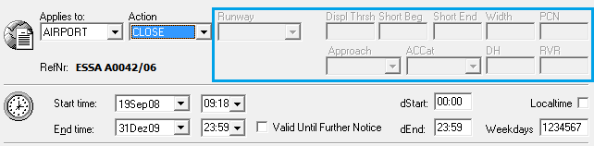

## Testcase:

## Restriction/Applies To: Runway

**Testing:**

Please try each combination of Restriction, Action

* **Result:** and check if the same Dialog controls are disabled(gray).

**Previous Dialog:**

Available Actions: **CLOSE, CLOSE LDG, CLOSE TKF**, **OPEN**

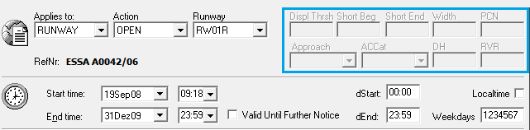

Action: **OVERRIDE**

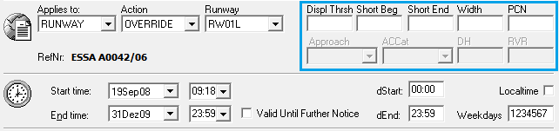

## Testcase:

**Restriction/Applies To:** Approach

**Testing:**

Please try each combination of Restriction, Action

* **Result:** and check if the same Dialog controls are disabled(gray).

**Previous Dialog:**

Action: **CLOSE**, **OPEN**

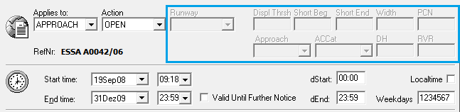

Action: **OVERRIDE**

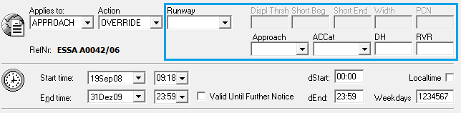

**New Dialog:**

Action: **OPEN**, **CLOSE**, **OVERRIDE**

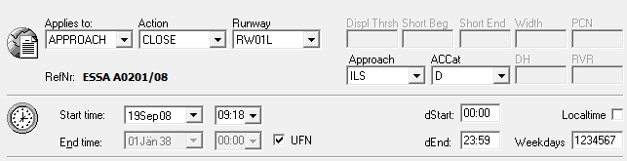

New Action: **AMEND MIN**

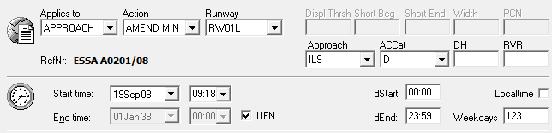

## Further Changes:

* Title of *Airport Restriction Editor* and *Navaid Outage Editor* added spaces
* Cancel Closing Dlg Option added, when closing Dlg and having unsaved changes.
* No more flickering of dialog ctrls when clicking between restrictions
* Valid Until Further Notice Checkbox renamed to UFN, because it matches the List Ctrl and the naming in “Restricted Area” Editor
* Action “Overwrite” renamed to “Override”
* List Ctrl Action “Override” is a kind of “open” action, thus its colored green
* The dbo.aptrestrnot.itemstatus was set to 1 in prev. version, but it was never used for the initial purpose. Initially the itemstatus=1 should indicate that the current item is being edited. Thus multiple users working on one notam will/may cause errors.
* **Testcase for Deletion of new items:**

Use a notam with no airport restriction assigned. Create two new restrictions, but don’t save them, mark the new for deletion, press the save button.

**Result:** All items marked for deletion will be deleted.

This was not working proberly in the prev. version

* **Testcase Button Refnr:**

Reference number/notam id is replaced by a button holding the same info. You got an idea that you’re able to goto the “other(linked to foreign notam)” ARE directly by pressing this button. (Use <ENTER> still works as in prev. version)

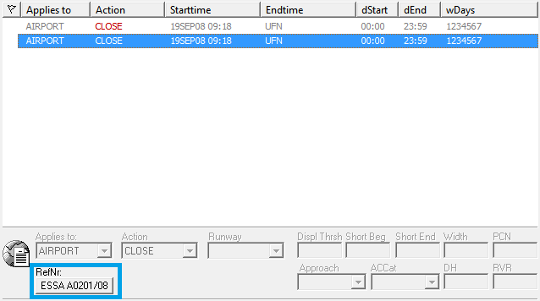

**Test:**

Selecte a foreign notam. The Ref.nr. button will be enabled. Use it and the ARE linked to this foreign notam will be shown.

Close the “foreign” ARE, instead use <ENTER. The “foreign” ARE will be shown again.

* **Testcase: Unchecked Notam and bold font:**

When a notam is unchecked, it is shown in bold font in OPUS. The same should apply for AR.

**Test:**

Open ARE linked to an unchecked notam. The restriction items have to be bold.

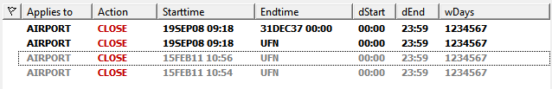

Open ARE linked to a checked notam. The restriction items are not bold.

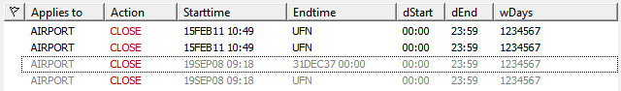

Foreign restrictions are grayed out and inherit the font of the current notam.