Extending DaisyRec 2.0 with CDAE
Warm-start full-ranking comparison on MovieLens 1M and Amazon Digital Music
Name: Yanyu Wen Student ID: [YOUR STUDENT ID]

1 Introduction
This project integrates Collaborative Denoising Auto-Encoder (CDAE) [1] into DaisyRec 2.0 and compares it with its EASE [2] and Multi-VAE [3] baselines under one reproducible warm-start full-ranking protocol. MovieLens 1M and the 2014 Amazon Digital Music ratings-only release provide dense movie and sparse e-commerce settings. Because they also differ in domain, scale and temporal coverage, results are interpreted as dataset-specific trends rather than causal effects of sparsity.

1.1 Data diagnosis and fixed decision rule
Dataset | Users | Items | Events | Density | Train  ratio | Warm test  interactions | Eval.  users
ML-1M | 6,040 | 3,260 | 998,539 | 5.071% | 0.797 | 105,699 | 1,152
Amazon Music | 5,729 | 9,267 | 65,344 | 0.123% | 0.800 | 4,065 | 1,294
The rule was fixed before modelling: retain DaisyRec's one-pass 10filter unless fewer than 500 warm-start test users remain. Both datasets pass. Amazon 5filter was rejected because 20,356 items require a 3.09 GiB float64 item matrix before EASE's inverse/storage overhead. The original Amazon file has 836,006 headerless rows; its SHA-256 is recorded in README.
Repository: github.com/Krystyna229/CA6124-Individual-Project

2 CDAE and non-destructive DaisyRec extension
For binary history xᵤ, CDAE applies training-only dropout and computes hᵤ = ReLU(W₁x̃ᵤ + vᵤ + b₁), where vᵤ is a user embedding; decoder logits are zᵤ = W₂hᵤ + b₂. Training uses full-history binary cross-entropy with optional L1/L2 penalties, while eval() disables corruption. ReLU and full-history BCE, rather than the original paper's sigmoid/tanh and negative-sampling variants [1], are deliberate DaisyRec integration choices.
CDAE subclasses AERecommender and reuses DaisyRec's data, optimizer, device and training utilities. The added evaluation options - day split, warm start, full ranking, NDCG@10 tuning and per-user metrics - are opt-in; defaults and existing baselines remain unchanged. Seven regression tests cover the original defaults and all new paths.

3 Experimental protocol
Ratings become implicit interactions after duplicate user-item removal. A deterministic boundary between complete calendar days is chosen nearest 80/20, keeping equal-date Amazon events together; Table 1 reports the resulting ratios.
Warm-start evaluation retains test users/items seen in training; tuning applies the same rule to its smaller training subset. Full ranking scores every training-seen item and masks prior positives. Final cohorts contain 1,152 ML-1M users / 105,699 interactions and 1,294 Amazon users / 4,065 interactions.
DaisyRec's tune.py (Optuna TPE, seed 2022) runs 20 trials per group on validation NDCG@10. Winners are retrained and tested once at K ∈ {1,5,10,20,30,50}. CDAE and Multi-VAE use Adam for 50 epochs without early stopping; their losses are BCE+L1/L2 and multinomial+KL, respectively. Multi-VAE anneals per mini-batch over 400 steps, so every searched cap is reached. EASE is closed-form.

3.1 Search spaces
Model | Search space
CDAE | d {16,32,64,128,256}; drop {0,.1,.3,.5,.7}; batch {64,128,256,512}; lr {5e-5,1e-4,5e-4,.001,.005,.01}; L2 {0,1e-5,1e-4,.001,.01,.1,1}
EASE | regularization {1,5,10,50,100,200,500,1000,2000}
Multi-VAE | d {32,64,128,256,512}; drop {0,.2,.5,.7,.8}; batch {64,128,256,512}; lr {5e-5,1e-4,5e-4,.001,.005,.01}; anneal {.05,.1,.2,.5}

4 Hyperparameter tuning
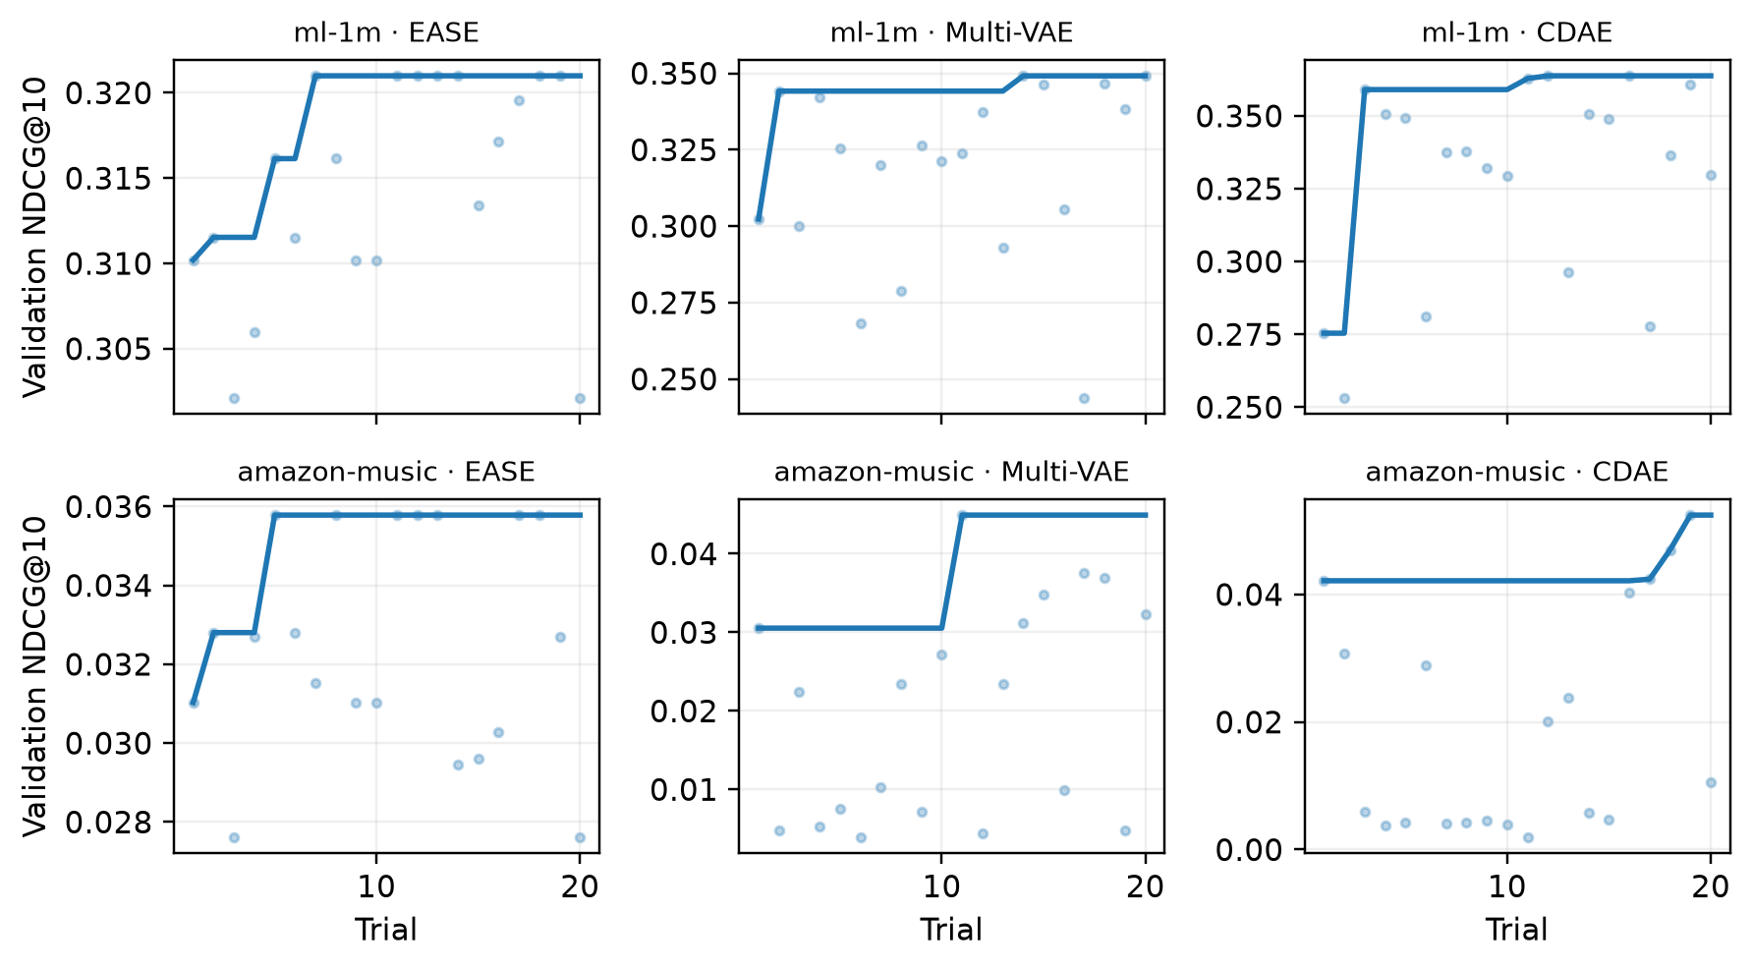
Figure 1. Individual trial scores and best-so-far validation NDCG@10 (20 trials per group).
Dataset | Model | Selected hyperparameters | Val NDCG@10
ml-1m | EASE | reg=10 | 0.3210
ml-1m | Multi-VAE | d=256, drop=0.7, batch=512, lr=0.0001, anneal=0.1 | 0.3492
ml-1m | CDAE | d=64, drop=0.3, batch=256, lr=0.0001, L1=0, L2=0 | 0.3638
amazon-music | EASE | reg=50 | 0.0358
amazon-music | Multi-VAE | d=512, drop=0.2, batch=512, lr=0.001, anneal=0.5 | 0.0449
amazon-music | CDAE | d=256, drop=0.1, batch=256, lr=0.005, L1=0, L2=0.1 | 0.0524
Amazon retains upper-bound optima (Multi-VAE d=512, anneal=0.5; CDAE d=256), so they are best tested settings rather than proven global optima; ML-1M Multi-VAE selects interior d=256 and anneal=0.1. Amazon is also less stable: 8/20 Multi-VAE and 10/20 CDAE trials fall below 0.01 NDCG@10 (4 and 8 below 0.005), while EASE remains within 0.0276-0.0358 and no ML-1M trial falls below 0.01.

5 Final test results
Dataset | Model | Recall@10 | NDCG@10
ml-1m | EASE | 0.0400 | 0.4625
ml-1m | Multi-VAE | 0.0459 | 0.4980
ml-1m | CDAE | 0.0433 | 0.4992
amazon-music | EASE | 0.0302 | 0.0415
amazon-music | Multi-VAE | 0.0253 | 0.0383
amazon-music | CDAE | 0.0286 | 0.0400
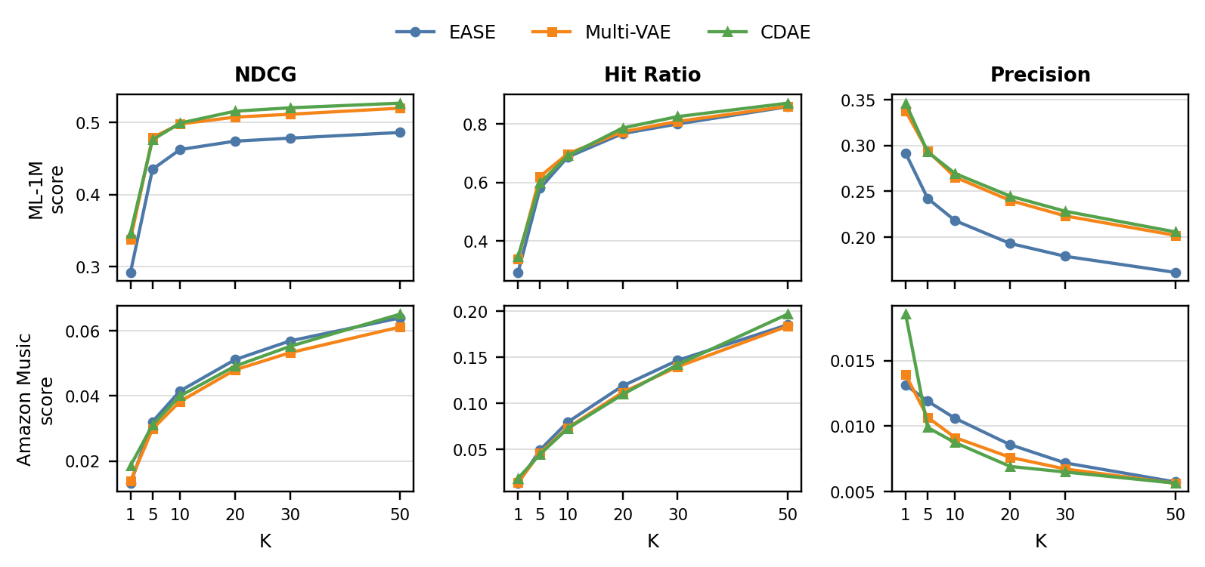
Figure 2. NDCG, Hit Ratio and Precision across ranking cut-offs under the same full-ranking protocol.

6 Analysis and limitations
On ML-1M, CDAE has the highest NDCG@10 (0.4992), but Multi-VAE leads Recall@10 (0.0459 versus 0.0433). Their paired NDCG difference is only 0.00120 and its 10,000-resample 95% CI [-0.0111, 0.0136] crosses zero; both neural models reliably exceed EASE. Metric choice therefore changes the top model, while the nearly overlapping Hit Ratio curves offer little separation.
On Amazon, EASE leads NDCG@10 (0.0415), followed by CDAE (0.0400) and Multi-VAE (0.0383). Yet all paired 95% intervals cross zero: EASE-CDAE [-0.0072, 0.0100], EASE-Multi-VAE [-0.0050, 0.0117] and CDAE-Multi-VAE [-0.0074, 0.0109]. Thus no pairwise winner is reliable on this cohort.
Amazon averages 11.4 interactions per user versus 165.3 on ML-1M; short histories may weaken KL-regularized Multi-VAE and increase neural tuning sensitivity, while EASE uses direct co-occurrence. This is explanatory rather than causal because the datasets differ on several dimensions. Limitations are one split/seed, 20 trials, boundary optima and warm-start scope: only 1,152/6,040 (19.1%) ML-1M and 1,294/5,729 (22.6%) Amazon users are evaluated. Full ranking avoids sampled-candidate bias [7], but cold-start performance remains unknown.

References
[1] Y. Wu et al., ‘Collaborative Denoising Auto-Encoders for Top-N Recommender Systems,’ WSDM, 2016.
[2] H. Steck, ‘Embarrassingly Shallow Autoencoders for Sparse Data,’ WWW, 2019.
[3] D. Liang et al., ‘Variational Autoencoders for Collaborative Filtering,’ WWW, 2018.
[4] Z. Sun et al., ‘DaisyRec 2.0: Benchmarking Recommendation for Rigorous Evaluation,’ TPAMI, 2023.
[5] F. Harper and J. Konstan, ‘The MovieLens Datasets: History and Context,’ TiiS, 2015.
[6] J. McAuley et al., ‘Image-based Recommendations on Styles and Substitutes,’ SIGIR, 2015.
[7] W. Krichene and S. Rendle, ‘On Sampled Metrics for Item Recommendation,’ KDD, 2020.

