Multiaccess webapp with data collection and cybersecurity

Features
- Register and login
- Create game rooms with customizable player limits
- Play real-time dice game
- Track game statistics (wins, play count, average game time)

Installation
To install and run a local copy:
- clone the repo
- install requirements.txt into a venv
- if absent add .env file in the main directory with content:
SECRET_KEY= your_key
ACCESS_TOKEN_EXPIRE_MINUTES=60
To run the project, activate the virtual environment and type the following code into the terminal.
fastapi run main.py
The web app will start on port 8000 within your local network.

User guide

Creating an active authorization token
To verify if you have an active token look at the top of the window. If token expiry shows 00:00 or --:-- you don’t have an active token.
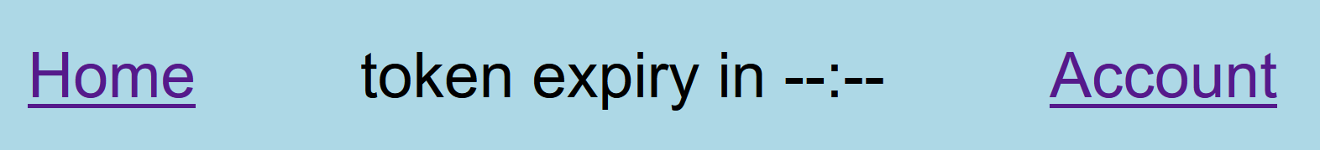
Figure 1 no active token
To create an active token, you need to log into an account. Navigate to the login page using a button on the home page.
If you don’t have an account:
Use the register button on the login page and set up an account, navigate to the login page from the registration page or via the home page and follow further instructions.
If you have an account:
Input your information and click log in. You will be transported to the account page. Changing pages does not affect your token.
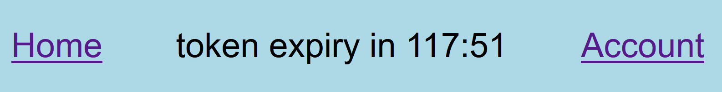 Figure 2 token active for 117 minutes 51 seconds

Removing an active authorization token
If you have an active authorization token you can remove it (log out) by navigating to the account page and clicking logout

Viewing data
To view user data, you need to have an active verification token.
If you have an active token:
Click on the account link at the top of the screen. You will be transported to the account page containing your information.

Joining a game
To play a game access the account page. To access the account page and play a game you need to have an active authorization token.
If you are creating a lobby:
Input a game name and maximum number of players click create game. You are now in the game room.
If you are joining a lobby:
If the lobby you want to join is visible, click the join button. You may need to reload the page If the lobby is invisible. Since the data on this page is on load the number of players in the game room can be inaccurate.

Using ingame chat
To use the ingame chat simply type the message in the appropriate input box ang click send. The messages are not stored anywhere, they are simply passed to other users by the server.

Playing the game
To play the game, all users in the lobby must set their status to ready using a button. Status of all players is displayed in the table on the left.
Once all players are ready the game will display turn information in the window. Players click a roll dice button until one of them reaches the end of the track.
After a game is concluded, players can leave the lobby or play another one by setting all their statuses to “ready”
Known issue: any number of players in the lobby can start a game, It’s best to wait until the lobby is full to set the status to ready.

Project construction

main Structure
ProjektTTe
auth
auth.py (all authorization functions)
config.py (loading token variables from .env)
.env (contains authorization variables)
database
database.py (creates the database and manages connection)
DB_main.py (main database functions)
models.py (stores ORM models)
dependencies
schemas.py (contains input data validation models)
game
websocket_handlers (handles all live features ex. game, chat, rooms)
static (contains static css and js files)
templates (contains html templates)
main.py (defines api routing paths and the app itself)

Tech stack
Framework: FastAPI
Rendering html: Jinja2Templates
Database: MySQL or SQLite with SQLModel(SQLalchemy ORM)
Data validation: Pydantic
Authentication: JWT(Json web tokens), Oauth2, Python-jose
Real-time: WebSockets
Hashing: pwdlib with argon2
Server: uvicorn

