25.01.2024.

I have set up the enviroment for RobotFramework, installing necessary dependencies and programs. e.g. Pycharm, Python, libraries for RF. Seleniumlibrary and another one that I don't remember the name.

26.01.2024.

Tooday I have learnt about the files function and structure in PC/RF, Andrii showed me how to update my Github properly and how to report my daily work. I did the very first file in the RF. Created own test case template.

28.01.2024.

Test cases for learning [Test Casy](https://docs.google.com/spreadsheets/d/1RUeZuRKpTYrjJy5RiQfqkVP3HT8U1T7azsL5lyfez1k/edit?usp=sharing), examining RF Documentation.

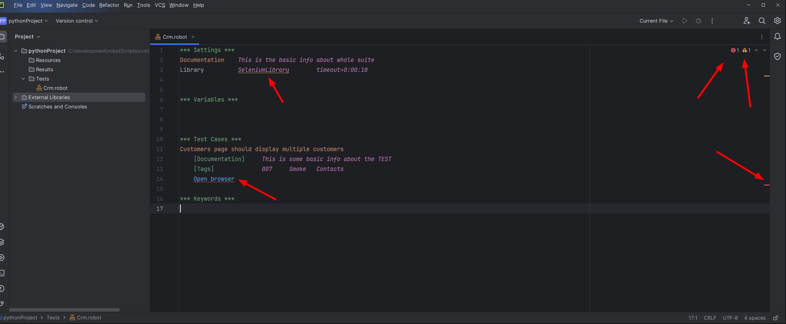Problems with reading Selenium Library

29.01.2024.

Niestety najpierw drobna awaria komputera, później zmiana w CV a ka nieniec ponowna próba aktywizacji RF tym razem na VSC zakończona kolejną porażką. Jutro poproszę Davida o pomoc bo jemu się to udało.

