**` `**

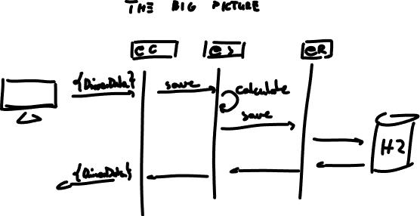

1. **Mob programming: model & project structure**
2. **Separate branches per layer**

**e.g. lukasz-controller, lukasz-service**

1. **Layers (start from your favorite)**
2. **Final project (merge layers & add acceptance t.)**

**DriverData**

**(**Sent from the client, mapped to Java and then to a relational table)

* 1. What is the vehicle owner's name?
  + **Prefix**
  + **First Name**
  + **Last Name**
  1. What is the vehicle owners **telephone number**?
  2. What is the vehicle owners Address?
  + **Address line 1** (Road)
  + **Address line 2** (Road)
  + **City**
  + **Postcode/Zip Code**
  1. What is the **vehicle type**?
  + Cabriolet
  + Coupe
  + Estate
  + Hatchback
  + Other
  1. What is the **engine size?**
* 1000
* 1600
* 2000
* 2500
* 3000
* Other
  1. How many **additional drivers** will use the vehicle (give the options 1, 2, 3, 4)?
  2. Will the vehicle be **used for commercial purposes**? (Yes/No)?
  3. Will the vehicle be **used outside the registered state**? (Yes/No)?
  4. What is the **current value** of the vehicle (range 0 - 50000)?
  5. **Date** **vehicle was first registered**?

**The business logic**

1. Using a **Test-Driven Development** approach create methods to calculate a series of factor values which will then be used in a calculation to find the quote amount. The methods should be for the following:

* The vehicle type factor which is calculated as:
* Cabriolet factor is 1.3
* Coupe factor is 1.4
* Estate factor is 1.5
* Hatchback factor is 1.6
* Other factor is 1.7
* The engine size factor is calculated as:
* 1000 factor is 1.0
* 1600 factor is 1.6
* 2000 factor is 2.0
* 2500 factor is 2.5
* 3000 factor is 3.0
* Other factor is 3.5

* The vehicle value factor is calculated as:
* <=5000 factor is 1.0
* else factor is 1.2
* The additional drivers factor which is calculated as:
* <2 factor is 1.1
* else factor is 1.2
* The commercial use factor which is calculated as:
* Yes factor is 1.1
* No factor is 1.0
* The outside state use factor which is calculated as:
* Yes factor is 1.1
* No factor is 1.0

1. Create a method to calculate the insurance quotation for the vehicle based on the factor values and the formula:

**100 * typeFactor * engineSizeFactor * additionalDriversFactor * commercialUseFactor * outsideStateFactor * vehicleValueFactor**

**Endpoints**

-get all driver records

-post a new driver record

-delete a driver record by id

-get a driver record by id

-update a driver’s telephone record by id

-update all driver’s details for a particular id

-extras: you decide

**Repository**

-basic (CRUD) + some extra methods using findBy, and, or etc.