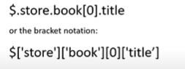

[

    {

        "type" : "intern",

        "id" : 101,

        “firstName”:“fname”,

        “lastName”:“lname”,

        “age”:“10”,

        “startDate”:”01/01/01”,

        “endDate”:”01/01/01”,

        “stipend”:”1000”

    },

    {

        "type" : "intern",

        "id" : 102,

        “firstName”:“fname”,

        “lastName”:“lname”,

        “age”:“10”,

        “startDate”:”01/01/01”,

        “endDate”:”01/01/01”,

        “stipend”:”1000”

    },

    {

        "type" : "employee",

        "id" : 1001,

        “firstName”:“fname”,

        “lastName”:“lname”,

        “age”:“10”,

        “workingExperience”:“4yrs”,

        “role”:”role1”,

        “dept”:”dept1”,

        “salary”:”1000”

    },

    {

        "type" : "manager",

        "id" : 10001,

        “firstName”:“fname”,

        “lastName”:“lname”,

        “age”:“10”,

        “dept”:“dept1”,

        “reportingTeam”:[

            “name1”,

            ”name2”

        ],

        “salary”:“1000”

    },

]

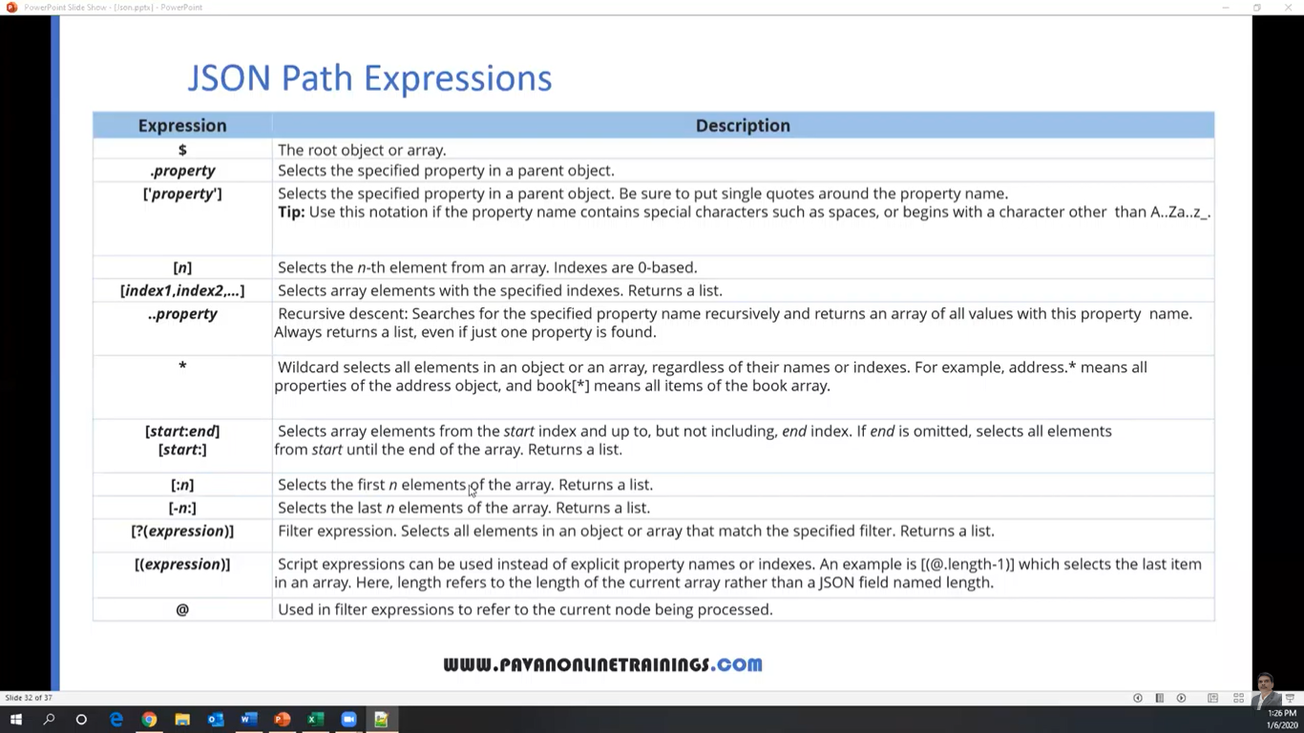

[JSONPath Online Evaluator](https://jsonpath.com/)

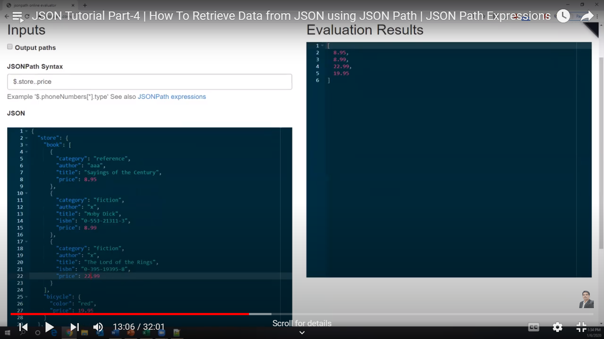

.. represents recursive expression

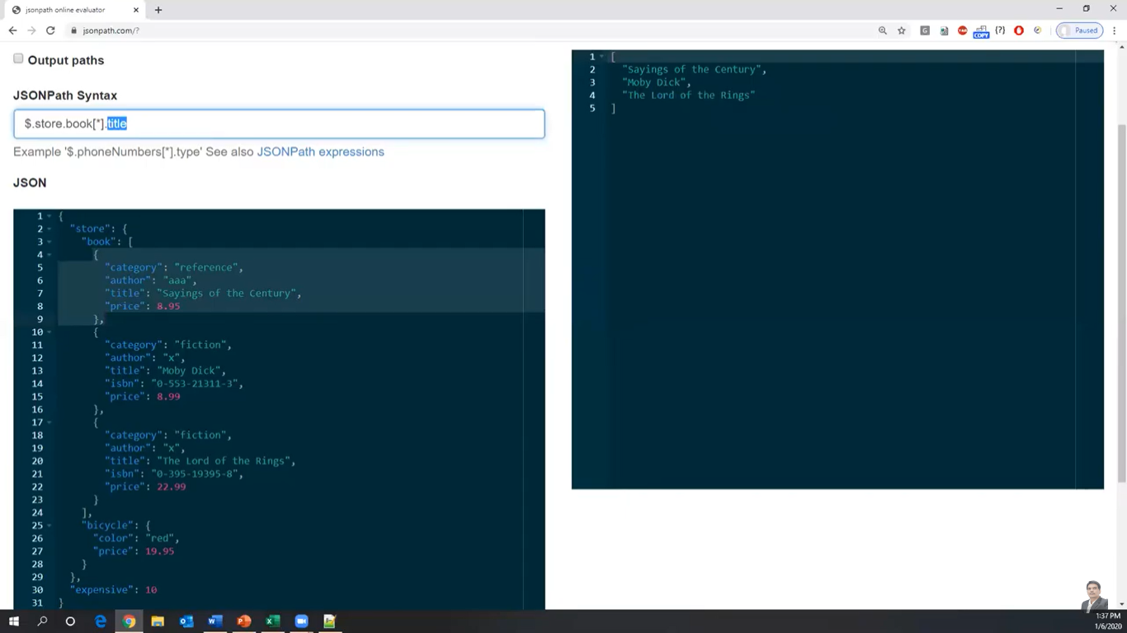

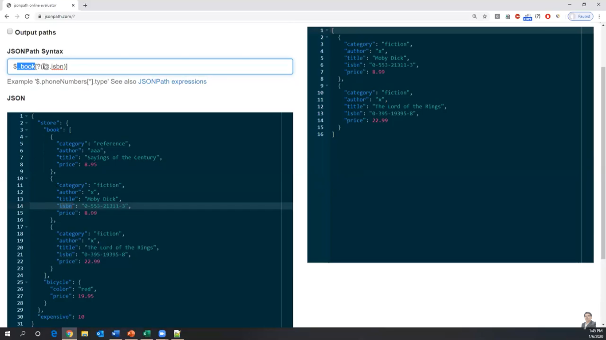filtering data with isbn key

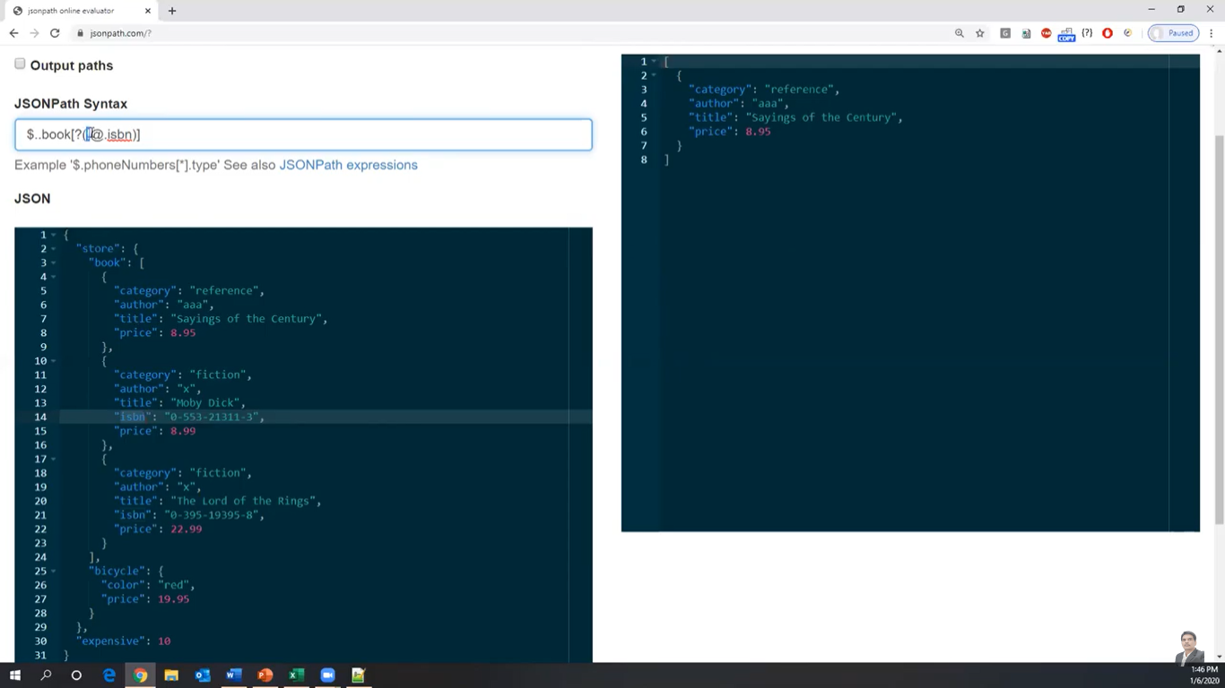books without isbn

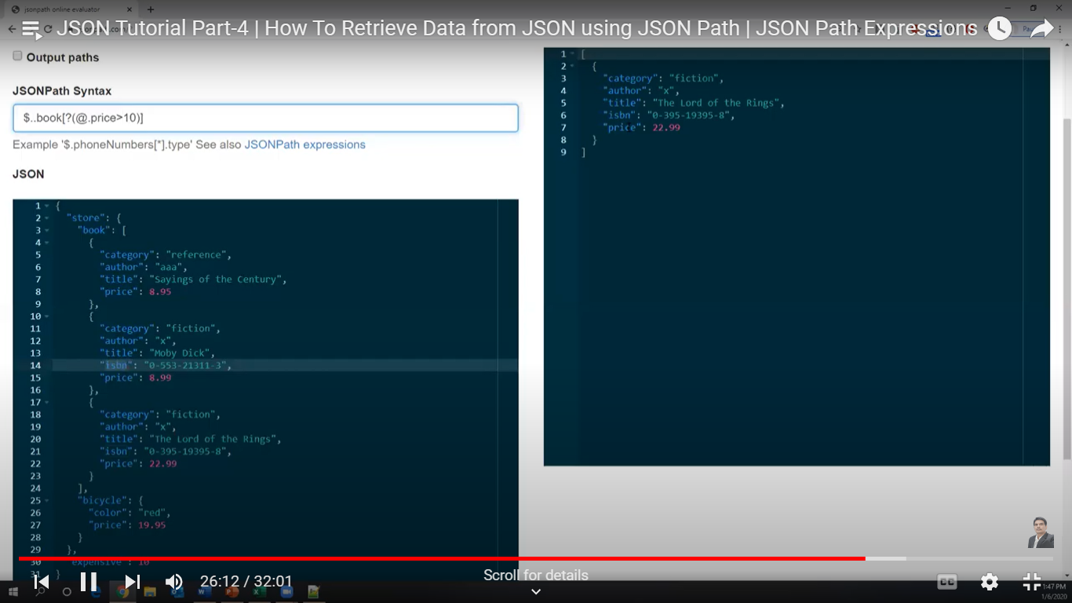

Price <10

**Plugin**: Jsonpath finder for google is an extension