**Business Model description**

Project consists of 4 jobs, 1 of them is master job:

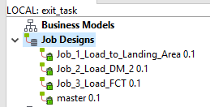

**Job_1** is responsible for just loading files from directory to DB, Landing area (wrk tables).

tDBRow component added to perform wrk_fct_purchase table truncate separately from load to DB as I’ve got iteration loading.

Here I also control load only for files not processed earlier by creating additional table in Oracle Purchase_files comparing files name vs directory.

Also each job has its own opening and closing connection:

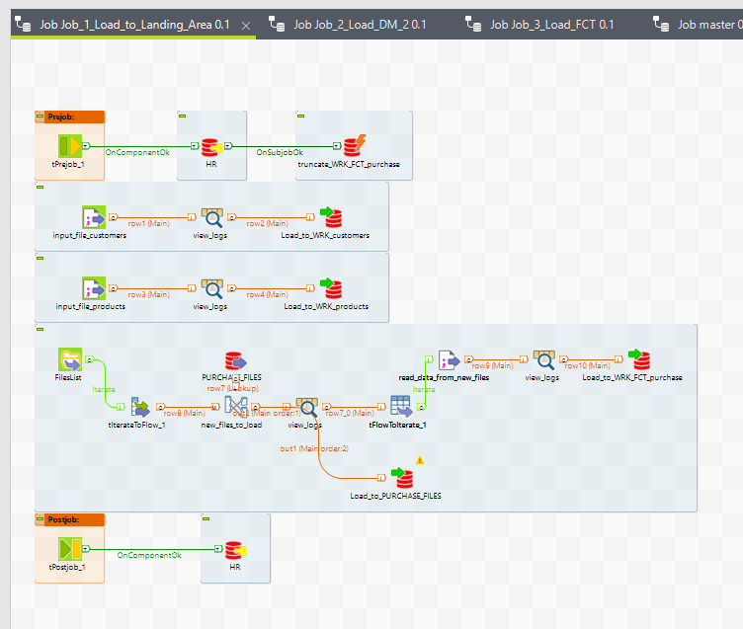

**Job_2** performs loading data from wrk tables to dm tables through MERGE update and insert to update the data if some characteristics changed and insert in case of new. These tables are supposed to be dimensions type1 – with overwriting old values in case of changes. That is for products and customers tables.

For loading data into Fact table additionally CLS table is created. Here columns comparison of wrk customers and products is performed with case statement to add new column and sequence is inserted.

Sequnce is used only in fct table in case of n/a data for customer and product to avoid duplicate records.

Sequence nextval is performed when left join wrk_fct_table on fct_table by paymentid,productid,customerid results in SK=null. That indicates new record and sequence is needed to be applied.

CLS_table is also truncated with each data load.

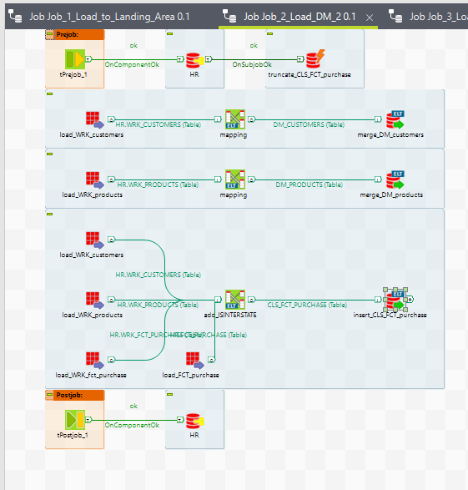

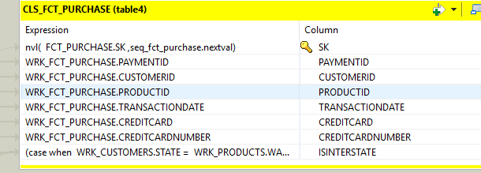

**Job_3** includes loading of FCT_PURCHASE table, here merge update and insert is applied in case of characteristics data such as credit card or others will might be updated (it depends of business requirements):

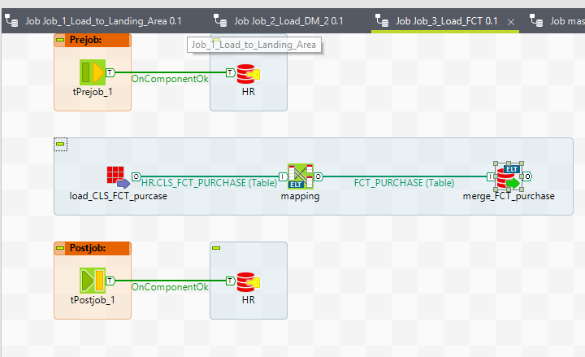

**Master** launches all previous jobs in specified order. Job fails if any subjob fails.

