|  |  |  |  |  |
| --- | --- | --- | --- | --- |
| **Медична_карта_пацієнта** | **Patient_medical_card** |  | **Листок_запису_діагнозів** | **Diagnoses_piece** |
| Номер_медичної_карти(PK) | Medical_card_number(PK) |  | Номер_листку_діагнозів(PK) | Diagnoses_piece_number(PK) |
| ПІП_пацієнта | SMN_patient |  | Номер_медичної_картки(FK) | Medical_card_number(FK) |
| Стать_пацієнта | Sex |  | Табельний_номер_лікаря(FK) | Doctor_code(FK) |
| Дата_народження_пацієнта | Date_of_birth |  | Дата_звернення | Refer_date |
| Тел_моб_пацієнта | Mobile_phone |  | Діагноз | Diagnosis |
| Тел_роб_пацієнта | Work_phone |  | Вперше_встановлений_діагноз(так/ні) | First_set_diagnosis(bit) |
| Місце_проживання_пацієнта | Home_address |  |  |  |
| Місце_роботи_пацієнта | Work |  |  |  |
| Особливі_відмітки_про_пацієнта | Special_notes |  |  |  |
| Група_крові_пацієнта | Blood_type |  |  |  |
| Резус_фактор_пацієнта | Rh_factor |  |  |  |
| Цукровий_діабет(так/ні) | Diabetes(bit) |  | **Лікарі** | **Doctors** |
| Інфекційні_захворювання | Infectious_diseases |  | Табельний_номер_лікаря(PK) | Doctor_code(PK) |
| Хірургічні_втручання(так/ні) | Surgery(bit) |  | ПІП_лікаря | SMN_doctor |
| Алергологічний_анамнез | Allergic_history |  | Спеціальність_лікаря | Specialty_doctor |
| Непереносимість_до_препаратів | Intolerance_to_drugs |  | Відділення_лікаря | Department_doctor |

|  |  |  |
| --- | --- | --- |
| CREATE TABLE IF NOT EXISTS `patient_medical_card` (  `medical_card_number` int(11) NOT NULL,  `SMN_patient` char(200) NOT NULL,  `sex` char(20) NOT NULL,  `date_of_birth` date NOT NULL,  `mobile_phone` char(12) NOT NULL,  `work_phone` char(12) NOT NULL,  `work` char(200) NOT NULL,  `home_address` char(200) NOT NULL,  `special_notes` char(200) NOT NULL,  `blood_type` int(1) NOT NULL,  `rh_factor` char(1) NOT NULL,  `diabetes` bit(1) NOT NULL,  `infectious_diseases` char(200) NOT NULL,  `surgery` bit(1) NOT NULL,  `allergic_history` char(200) NOT NULL,  `intolerance_to_drugs` char(200) NOT NULL,  PRIMARY KEY (`medical_card_number`)  ) ENGINE=InnoDB DEFAULT CHARSET=utf8; |  | CREATE TABLE IF NOT EXISTS `diagnoses_piece` (  `diagnoses_piece_number` int(11) NOT NULL,  `medical_card_number` int(11) NOT NULL,  `doctor_code` int(11) NOT NULL,  `refer_date` date NOT NULL,  `diagnosis` char(200) NOT NULL,  `first_set_diagnosis` bit(1) NOT NULL,  PRIMARY KEY (`diagnoses_piece_number`),  FOREIGN KEY (`medical_card_number`) REFERENCES `patient_medical_card`(`medical_card_number`),  FOREIGN KEY (`doctor_code`) REFERENCES `doctors`(`doctor_code`)  ) ENGINE=InnoDB DEFAULT CHARSET=utf8; |
|  | CREATE TABLE IF NOT EXISTS `doctors` (  `doctor_code` int(11) NOT NULL,  `SMN_doctor` char(200) NOT NULL,  `specialty_doctor` char(200) NOT NULL,  `department_doctor` char(200) NOT NULL,  PRIMARY KEY (`doctor_code`)  ) ENGINE=InnoDB DEFAULT CHARSET=utf8; |

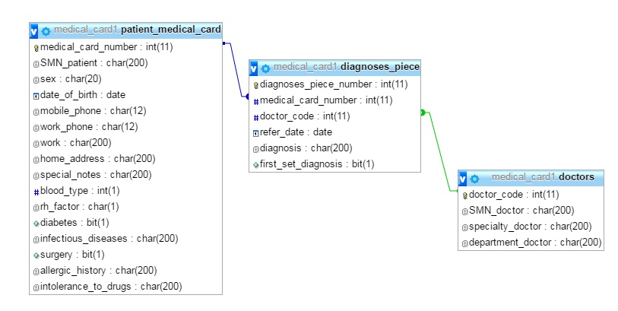

**Нормалізована БД**

|  |  |  |  |  |  |
| --- | --- | --- | --- | --- | --- |
| **Patient_medical_card** |  |  |  | **Diagnoses_piece** |  |
| Medical_card_number(PK) |  |  |  | Diagnoses_piece_number(PK) |  |
| Name_patient |  |  |  | Medical_card_number(FK) |  |
| Middlename_patient |  |  |  | Doctor_code(FK) |  |
| Surname_patient |  |  |  | Refer_date |  |
| Sex |  |  |  | Diagnosis |  |
| Date_of_birth |  |  |  | First_set_diagnosis(bit) |  |
| Mobile_phone |  |  |  |  |  |
| Work_phone |  |  |  |  |  |
| City_patient |  |  |  |  |  |
| Region_patient |  |  |  | **Doctors** |  |
| District_patient |  |  |  | Doctor_code(PK) |  |
| Street_patient |  |  |  | Name_doctor |  |
| Home_num_patient |  |  |  | Middlename_doctor |  |
| Flat_patient |  |  |  | Surname_doctor |  |
| Work_patient |  |  |  | Specialty_doctor |  |
| Special_notes |  |  |  | Department_doctor |  |
| Blood_type |  |  |  |  |  |
| Rh_factor |  |  |  |  |  |
| Diabetes(bit) |  |  |  |  |  |
| Infectious_diseases |  |  |  |  |  |
| Surgery(bit) |  |  |  |  |  |
| Allergic_history |  |  |  |  |  |
| Intolerance_to_drugs |  |  |  |  |  |

**Створення таблиць**

|  |  |  |
| --- | --- | --- |
| CREATE TABLE IF NOT EXISTS `patient_medical_card` (  `medical_card_number` int(11) NOT NULL,  `name_patient` char(200) NOT NULL,  `middlename_patient` char(200) NOT NULL,  `surname_patient` char(200) NOT NULL,  `sex` char(20) NOT NULL,  `date_of_birth` date NOT NULL,  `mobile_phone` char(12) NOT NULL,  `work_phone` char(12) NOT NULL,  `work_patient` char(200) NOT NULL,  `city_patient` char(200) NOT NULL,  `region_patient` char(200) NOT NULL,  `district_patient` char(200) NOT NULL,  `street_patient` char(200) NOT NULL,  `home_num_patient` char(200) NOT NULL,  `flat_patient` char(200) NOT NULL,  `special_notes` char(200) NOT NULL,  `blood_type` int(1) NOT NULL,  `rh_factor` char(1) NOT NULL,  `diabetes` bit(1) NOT NULL,  `infectious_diseases` char(200) NOT NULL,  `surgery` bit(1) NOT NULL,  `allergic_history` char(200) NOT NULL,  `intolerance_to_drugs` char(200) NOT NULL,  PRIMARY KEY (`medical_card_number`)  ) ENGINE=InnoDB DEFAULT CHARSET=utf8; |  | CREATE TABLE IF NOT EXISTS `diagnoses_piece` (  `diagnoses_piece_number` int(11) NOT NULL,  `medical_card_number` int(11) NOT NULL,  `doctor_code` int(11) NOT NULL,  `refer_date` date NOT NULL,  `diagnosis` char(200) NOT NULL,  `first_set_diagnosis` bit(1) NOT NULL,  PRIMARY KEY (`diagnoses_piece_number`),  FOREIGN KEY (`medical_card_number`) REFERENCES `patient_medical_card`(`medical_card_number`),  FOREIGN KEY (`doctor_code`) REFERENCES `doctors`(`doctor_code`)  ) ENGINE=InnoDB DEFAULT CHARSET=utf8; |
|  | CREATE TABLE IF NOT EXISTS `doctors` (  `doctor_code` int(11) NOT NULL,  `name_doctor` char(200) NOT NULL,  `middlename_doctor` char(200) NOT NULL,  `surname_doctor` char(200) NOT NULL,  `specialty_doctor` char(200) NOT NULL,  `department_doctor` char(200) NOT NULL,  PRIMARY KEY (`doctor_code`)  ) ENGINE=InnoDB DEFAULT CHARSET=utf8; |

