**Built-in algorithm:**

**Score train: 0.7667760998030203**

**Score test: 0.7775735294117647**

Gradient descent mode:

Score: 0.7697398657964887

Precision: 0.801467955603294

Recall: 0.7623020602758386

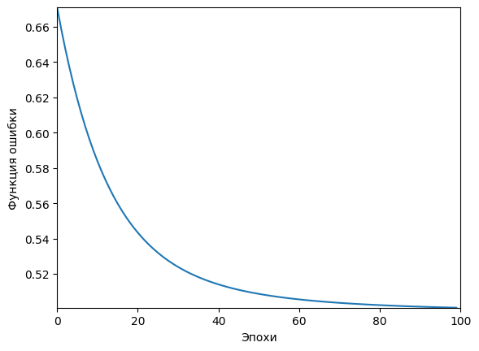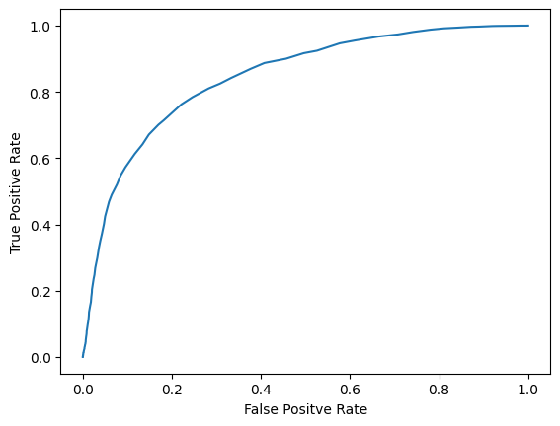

Nesterov momentum mode:

Score: 0.7700156264362533

Precision: 0.7886624421990067

Recall: 0.7840967137749021

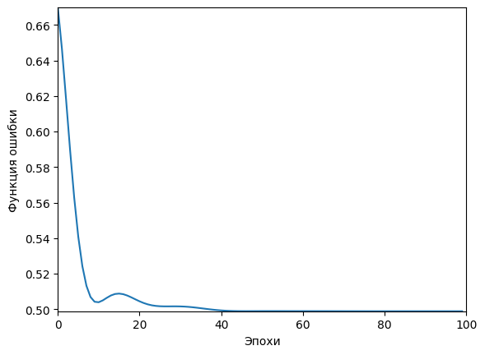

RMSProp mode:

Score: 0.7697398657964887

Precision: 0.801467955603294

Recall: 0.7623020602758386

