**Social Media Icons in Photoshop Using Font Awesome**



1. [Download](http://fortawesome.github.io/Font-Awesome/" \t "_blank) Font Awesome Font

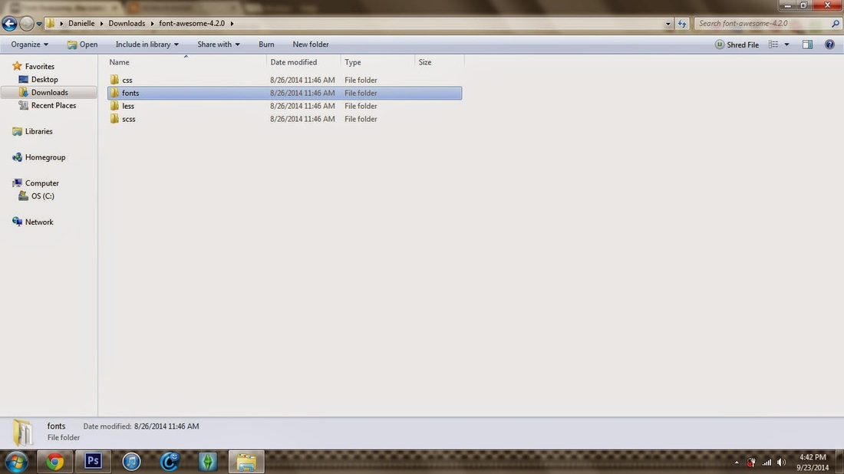

2. After you downloads Font Awesome-Fonts. Install before opening up PS.

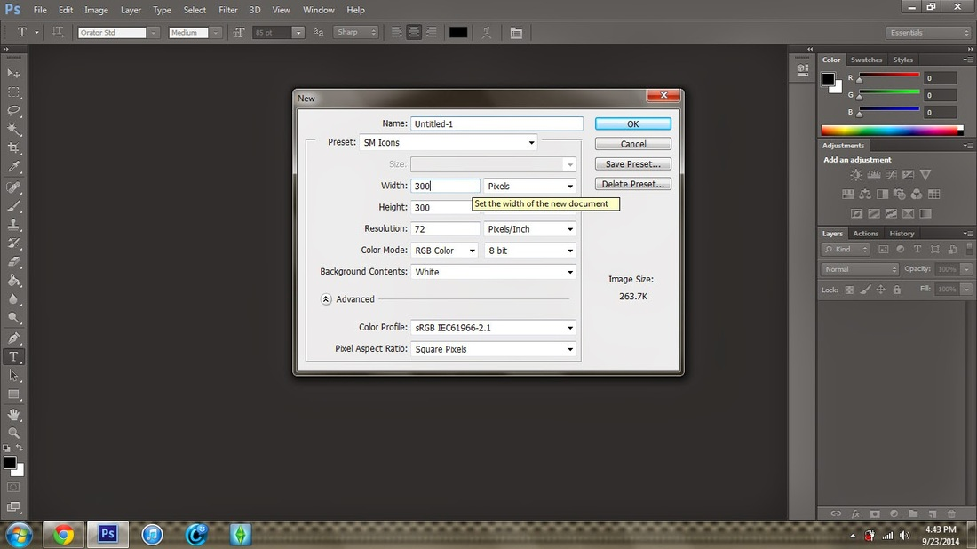

3. Open Ps. Make a new doc. 300x300 pixels.

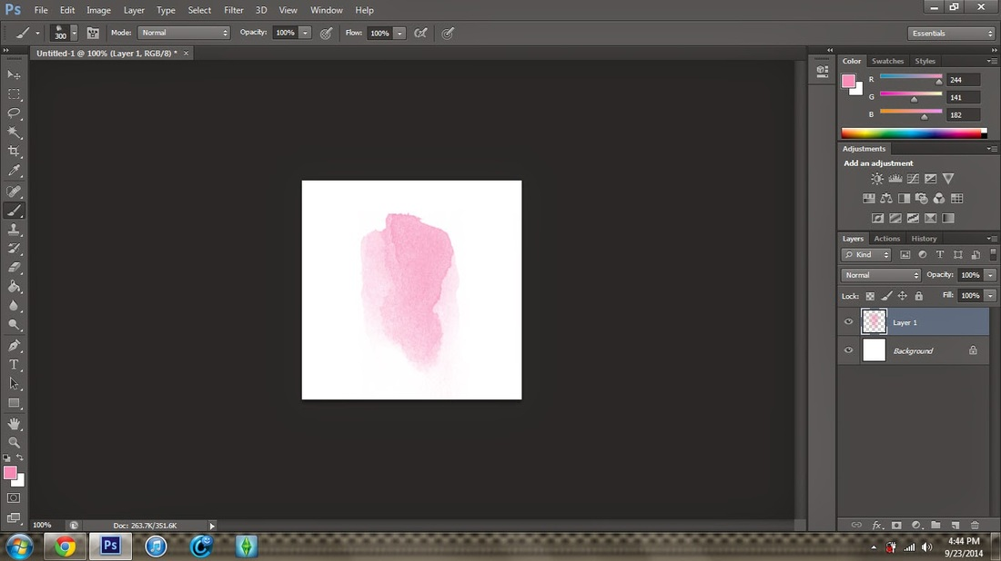

4. Make a new layers, Use your brush tools to make a background for your icon.

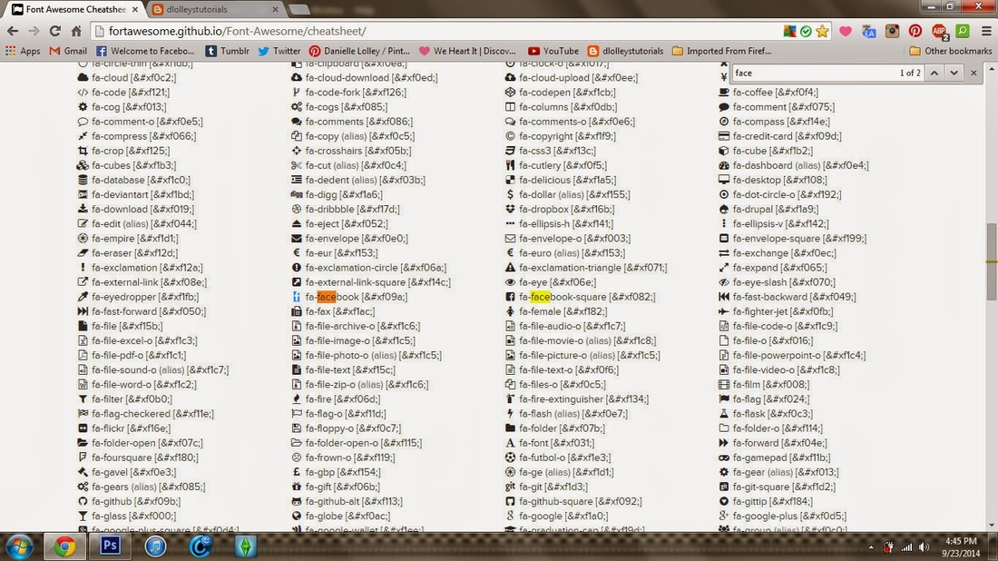

5. Go to[Font Awesome Cheatsheet](http://fortawesome.github.io/Font-Awesome/cheatsheet/" \t "_blank). On your keyboard hit CTRL+F to bring up the search bar and search for the icon you want to use. Copy the icon.

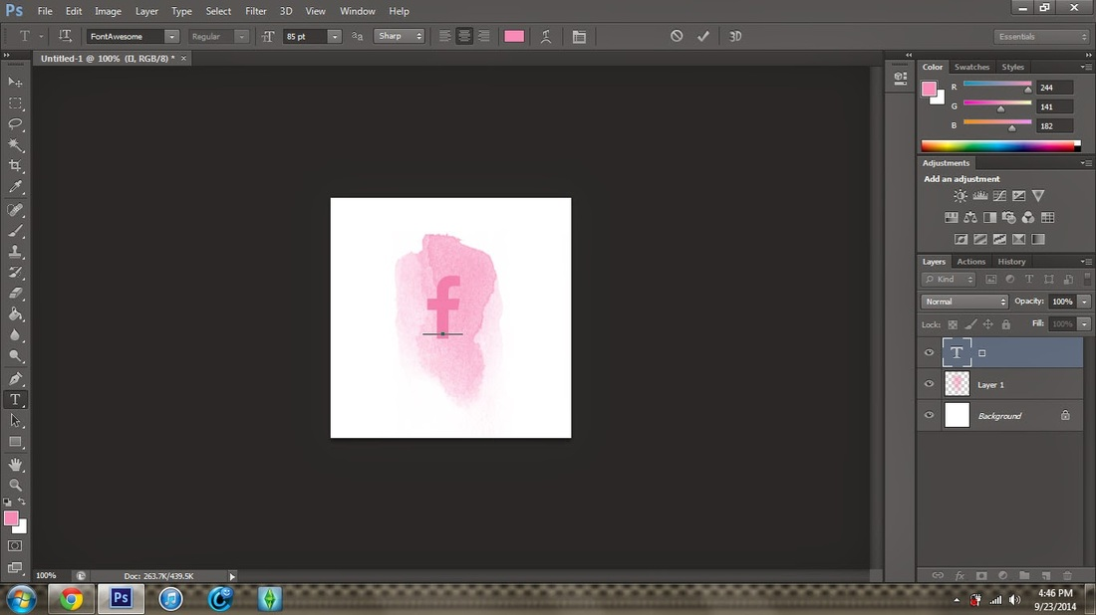

6. Choose Font Awesome in the fonts tool and paste the icon. Change the color etc.

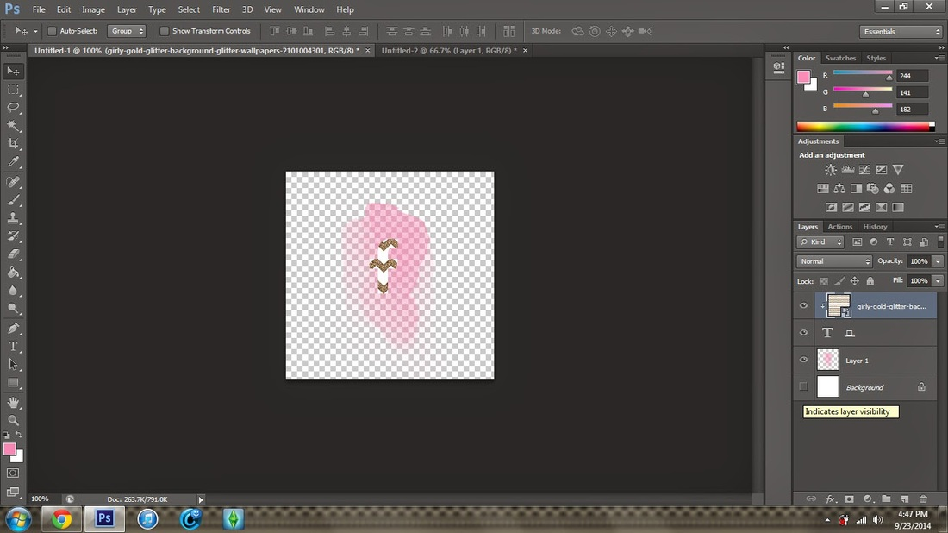

7. Turn your background layer off if you want it to be a png.

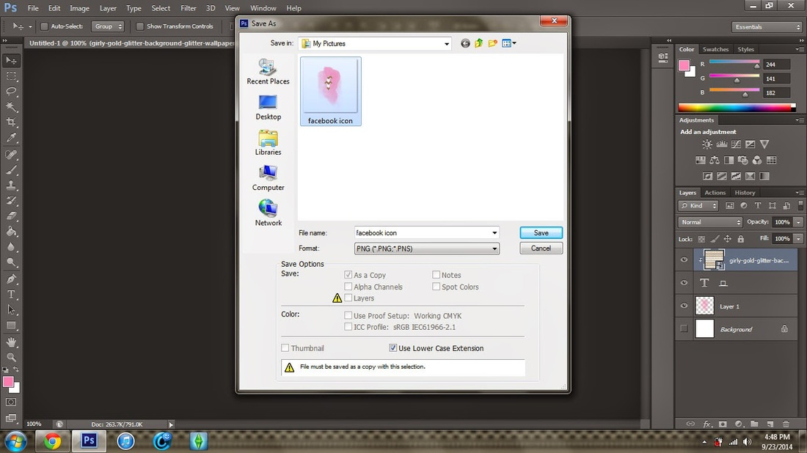

8. Save the icon as a PNG.  EXAMPLE...

